JL36 series coffee machine
Instruction Manual

Read the manual carefully before use and keep it safe

使用前请仔细阅读本操作手册，并妥善保管
使用前请仔细阅读本操作手册，并妥善保管
使用前请仔细阅读本操作手册，并妥善保管
广州技诺智能设备有限公司
Guangzhou Jetinno Intelligent Equipment Co.,Ltd.
www.jetinno.com
(86) 020-32038721
(86) 400-017-9997
Add: 4F, A Building, Creator Park, No.2,Tairui Rd, Science Park, Huangpu District, GZ, GD, PRC. 510663
地址：广州市黄埔区高新技术产业开发区 瑞泰路2号创造者园区A栋4F
目录
1 Introduction 4
1.1 Welcome to Use 4
1.2 Labels and symbols 4
2 General safety tips 6
2.1 Danger to users 6
2.2 Hazard to the machine 8
3 Product Description 9
3.1 Welcome to Use 9
3.2 Technical Data 10
3.3 Installation and commissioning 11
3.4 Installation 11
3.4.1 Place 11
3.5 Power Supply 12
3.5.1 Conditions 12
3.5.2 Connecting the Power Cable 12
3.6 Water interface/Drainage 13
3.6.1 Conditions 13
3.6.2 Water Inlet Conditions 13
3.7 Installation 13
3.7.1 Unpack the machine 13
3.8 Disassemble and dispose of scrap 14
4 Operation 14
4.1 Device Description 15
4.1.1 Device View 15
4.1.2 Accessories 17
5 Machine installation 18
5.1 Unpack 18
5.2 Remove the foam under the grinder 18
5.3 Check before power on 18
5.4 Connection 18
5.4.1 Connect the water supply 18
5.4.2 Connect the wastewater discharge pipe 20
5.4.3 Connect 20
5.5 Power on 20
5.5.1 Coffee Machine 20
5.5.2 Machine setting 20
5.5.3 Confirm water source method 21
5.5.4 Count 22
5.5.5 Diagnose 24
5.5.6 Machine State 25
6 First Run 25
6.1 Connecting to the Network 25
6.2 Connecting to the Server 27
6.3 Fill the box 28
6.4 Fill the milk box in the refrigerator with milk 28
6.5 Commissioning and calibration 29
6.5.1 Adjust the thickness of the grinder 29
6.5.2 Adjusting the temperature of hot milk and milk foam 29
6.5.3 Calibration of grinder 29
6.5.4 Fresh Milk Calibration 31
6.6 Product testing and adjustment 34
6.6.1 Selection List 34
6.6.2 Add recipe 35
6.6.3 Export recipe 35
6.6.4 Import recipe 36
6.6.5 Recipe edition 36
6.6.6 Delect recipe 37
6.6.7 Add new drinks 37
6.7drink 38
6.8 Setting the sales mode 41
6.9drink making 42
6.10 Operator Options 43
6.11 Set the date / time 45
6.12 Empty 45
6.12.1 Coffee residue box 45
6.12.2 Drip tray 46
6.13 Transportation condition 46
6.14 Power off 47
6.14.1 End of run 47
6.14.2 Longer downtime periods （More than 1 week） 47
7 Clean 47
7.1 Cleaning interval 48
7.2 Clean plan 49
7.3 Rinse daily 49
7.3.1 The whole machine rinse 49
7.3.2 Brewer rinse 50
7.3.3 Milk Circuit rinse 50
7.4 Cleaner 51
7.5 Daily machine cleaning 52
7.5.1 Display guided cleaning program 52
7.5.2 Clean the whole machine 53
7.5.3 Brewing clean 54
7.5.4 Milk Circuit cleaning 56
7.5.5 Automatic cleaning settings 57
7.5.6 Clean the coffee grounds box 57
7.5.7 Clean the water tray 58
7.5.8 Remove and clean the milk foam device and coffee outlet 58
7.5.9 Clean the wet air duct 60
7.5.10 Clean the touch screen 60
7.6 Clean every week 61
7.6.1 Clean Coffee Hopper 61
7.7 Empty the waterway 61
8 Preventive Measures 62
8.1 Cleaner 62
8.1.1 Use 62
8.1.2 Storage 63
8.1.3 Disposal of waste 63
8.2 Health Regulations 63
8.2.1 Water 63
8.2.2 Coffee 64
9 Safety and quality assurance 64
10 List of frequently asked questions 65
11 Certification 66

1 Introduction

Welcome to use
This user manual introduces the JL36 series product information and usage. If the coffee machine is not used in accordance with the relevant instructions in this manual, we will not be responsible for any losses caused by it. However, the user manual may not include all intended uses! For more information, please contact our customer service.
The performance of the equipment depends on proper maintenance and use. Please read the user manual carefully before the first commissioning, and keep the manual properly for reference at any time.The models applicable to this specification: JL 36 A and JL 36 B.
Wish you have a good time to use it!

Logos and symbols
 See also the "General Safety Tips" section.
The following signs and symbols are used in the instruction manual to indicate hazards and special matters：
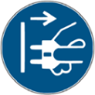


- Immediate danger situations, which may result in serious injury or death due to electric shock.
- Be sure to follow precautions to prevent such hazards.



- A general hazardous situation that can cause serious injury
- Be sure to follow precautions to prevent such hazards

- General dangerous situation, may cause minor injuries.
- Measures to prevent such hazards must be observed.


- Conditions exist that could cause damage to the machine.
- Measures to prevent such hazards must be observed.



- Fire hazard/combustible materials.
- Watch out for fire.

- Hot liquids. A dangerous condition that may cause burns. A hazard exists at the flow outlet location. Only symbols are used for identification below.
- Be sure to follow the precautions to prevent such hazards.

- Hot steam. Dangerous condition that may cause burns. The location of the water outlet creates this hazard. Only symbols are used in the following.
- Be sure to follow the precautions to prevent such hazards


- Hot surfaces. Dangerous conditions that can cause burns. Stream exit location.
- Location (optional) to create this hazard. Only symbols are used in the following.
- Be sure to follow the precautions to prevent such hazards.

- Crush hazard. Dangerous conditions that can cause splint injuries. Only symbols are used for identification below.
- Be sure to follow the precautions to prevent such hazards



- Poisoning hazard. A general hazardous condition that may result in injury from poisoning. In the following
- Be sure to follow the precautions to prevent such hazards.

General Safety Tips

Danger to users

Improper use of a coffee machine can result in minor injuries.
Be sure to follow the following:
Read the instructions carefully before use.
- Only allow technical service personnel to enter the maintenance area of the machine.
- Do not use the coffee machine if it is not working properly or is damaged.
- Do not change the built-in safety device.
- Do not touch hot machine parts.
- Children over 8 years of age and persons with physical, sensory, or intellectual impairments or who lack experience and cognition should only use equipment under constant supervision after learning how to operate it safely and understanding the risks associated with it.
- Do not allow children to tamper with machinery. Cleaning and user maintenance tasks must not be performed by children. Only persons familiar with and experienced with the equipment are allowed to perform such work, especially as it relates to safety and hygiene.
- Install the coffee machine in a place where it can be looked after and maintained at all times.
- Self-use and operation should be supervised by trained personnel to ensure compliance with maintenance regulations and to resolve usage issues at all times.
- Only coffee beans should be filled in the coffee bean tank, and only ground coffee beans should be added to the manual addition port (or cleaning tablets should be added during cleaning).
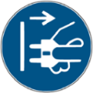
、

Electric shock hazard. Incorrect use of electrical equipment can result in an electric shock.
Be sure to observe the following：
- Work on electrical equipment should only be performed by electrical professionals.
- This machine must be connected to a circuit with a fuse protection (it is recommended to lay the wiring through a leakage protector).
- Please comply with the relevant low voltage directives and national or local safety regulations.
- Connections must be grounded in accordance with regulations to prevent electric shock.
- The voltage must be consistent with the instructions on the device nameplate.
- Do not touch live parts.
- Be sure to turn off the main switch and disconnect the device from the power supply before performing maintenance.
- All connectors of the device must be able to disconnect from the power grid. Disconnected connections must be visible at all times at the point of operation of the equipment, or power must be secured by locking.
- Only professional technical support personnel can replace the power cable.

- If the safety tips are not followed, there may be negligence in normal use, which will cause harm to personnel and the surrounding environment!
- Ventilation should be maintained around the machine or in the embedded structure without obstructions.
- There should be no inflammables around the machine.
- Do not use mechanical devices or other means to accelerate defrosting other than those recommended by the manufacturer.

- Do not damage the refrigeration circuit.

Drinks with additives or residues may cause allergies.
Be sure to follow the following：
- In the self-service application, express the possible use of allergenic additives through the coffee machine prompt board.
- In the case of a service person application, a trained person should inform you of possible allergenic additives.


Danger of poisoning from ingestion of cleaning agents.
Be sure to observe the following：
- Cleaning agent storage should be kept away from children and unauthorized persons
- Do not ingest cleaning agents.
- Do not mix cleaning agents with other chemicals or acidic substances.
- Do not add cleaning agent to the cup.
- Do not add cleaning agent to drinking tank (inside/outside).
- Cleaning agents and descaling agents should only be used for their stated purpose (see label).
- Do not eat or drink while using the cleaning agent.
- Good ventilation and venting must be ensured when using the cleaning agent.S
- Protective gloves should be worn when using the cleaning agent.
- Safety goggles should be worn when using detergent.
- Wash your hands thoroughly immediately after applying the detergent.


Read the package instructions carefully before using the cleaner. If a safety data sheet is not provided, you can ask the distributor for it (see Packaging of the cleaner).

High temperature liquid. Risk of burns in the exit area ofdrinks, hot water and steam.
During export or cleaning
Do not extend your hand below the flow outlet position.


Hot surface. High temperature exists in the flow outlet position, ES brewer and boiler.
- Only allow contact with handles pre-designed for output.
- Clean the ES brewer only after the coffee machine has cooled.


Squeeze \ scratch hazard. There is a risk of being crushed by touching any moving part.
- Only handles pre-designed for output are allowed to be touched.
- Do not reach into the opening of the coffee bean trough, powder trough, or brewer after starting the coffee machine.
- The blades on the grinder disk and the coffee trough opener blades are sharp and should be taken care of during cleaning.

Hazard to the machine


Improper use of the coffee machine can cause damage or contamination.
Be sure to follow the following：
- If the carbonate contained in the water is harder than 5°DKH, install a scale filter, otherwise it will damage the coffee due to calcification.
- For safety reasons, please note that the main water valve (coffee machine with tap water interface) should be turned off after shutdown, and the main switch should be turned off or the plug should be unplugged.
- Please comply with the relevant low voltage directives and/or national and local safety rules and regulations.
- If water injection is not possible, do not turn on the device. Otherwise you will not be able to refill the water boil and the pump will run "dry".
- It is recommended to install a ball valve in the water pipe when connecting to the direct drinking water to avoid water seepage hazards when the hose breaks.
- After a long shutdown (such as a corporate holiday), the coffee machine must first be cleaned and then turned back on for use.
- Protect the coffee machine from weather - empty the tank (frost, moisture, etc.)
- Troubleshooting should only be done by a technical service person.
- Use original parts for repairs.
- For visible external damage or leakage, contact your service partner immediately for replacement or repair.
- Do not rinse the machine with water or clean it with steam cleaner.

- Do not place the machine where it may be sprayed with water.

- Protect the ground.
- If you do not use the machine for a long time, it is recommended to use up all the coffee beans in the bean bin, otherwise the residual coffee beans will absorb moisture in the air, and it is easy to cause the grinder to block when grinding again；
- If the boiler is not regularly descaled, it will have the following effects: the heating speed slows down and the temperature is not enough; Abnormal coffee taste, resulting in boiler damage.

Proper use of the coffee machine can cause damage or contamination.
Be sure to follow the following points：
- Only coffee beans can be filled in the coffee bean tank, only finisheddrink powder can be filled in the powder tank, and only ground coffee beans can be added to the manual addition port (or cleaning tablets can be added when cleaning).
- Do not use freeze-dried coffee, otherwise it will cause the ES brewer to stick.
- If the coffee machine and its additional equipment are transported at a temperature below 10 ° C, the coffee machine and its additional equipment must be placed at room temperature for three hours after transportation, and then connected to the power supply and started. Failure to comply with this regulation may result in a short circuit hazard or damage to electrical components due to condensation.
- Use a hose kit (drinking water/wastewater hose) that is new or comes with the machine. An old hose kit must not be used。


Improper use of the coffee machine can result in injury；
Climbing on top of the machine is strictly prohibited

Product Description

Welcome to use
The JL36 is used to make and output various types of coffee drinks and milk drinks with syrup. The equipment is suitable for commercial use in hospitality, catering or similar establishments. The equipment is self-serving and unattended, and can be operated by non-professionals or by guests themselves. User maintenance should only be carried out by trained outside operators. If installation conditions can always be met, the device can also be used in a train station, gas station shop, or similar public place. The machine is not designed for outdoor installation or use.
Children over 8 years of age and persons with physical, sensory or intellectual impairments or who lack experience and cognition should only use the equipment under constant supervision after learning how to operate it safely and understanding the risks associated with it. Do not allow children to tamper with machinery. Cleaning and user maintenance tasks must not be performed by children. Only persons familiar with and experienced with the equipment are allowed to perform such work, especially as it relates to safety and hygiene.

In addition, refer to the terms and conditions of the manufacturer of the equipment and this instruction manual when using the coffee machine. Any other use or use beyond the limits is considered unreasonable use. The manufacturer shall not be liable for any loss arising therefrom.



- Hazard to machinery.
- Incorrect operation of the coffee machine may cause damage to the equipment, use the original formula, do not use other formulas.

Technical Data
Name parameters
Model number | JL36
JL36A Dimensions/weight | 300（W）*580 (H)*520（D)mm，22Kg
JL36B Dimensions/weight | 300（W）*580 (H)*520（D)mm ,20Kg
Rated voltage/frequency | AC220V-240V 50/60Hz
Basic configuration | JL36A-ST-MW / JL36B-ST-MW
Rated power | JL36A 3100W JL36B 1700W (Refer to the nameplate)
Daily production | 100cup
External length of the power line | >1.5m
Coffee machine operating  temperature/humidity | Temperature is 5℃-35℃，The relative humidity is less than 80%
Rated pressure | 0.6MPa
Communication interface | USB;optional WIFI，4G
Device display | 10.1-inch display screen + a touch screen
Coffee Hopper capacity | 1200g
Knife span | 500kg
Wastewater volume | 1L/Optional wastewater discharge
Coffee grounds box capacity | 40 coffee grounds cakes（8g），waste discharge optional
Hot water boiler, steam boiler | JL36A Thermal block, 1500W*2 JL36B Thermal block, 1500W*1
High water adjustment range | 80mm-180mm
Fresh milk module | Yes
Fresh milk refrigerator | Optional
Water supply method | Standard：2L water tank，Bottled water；optional：8Lwater tank；drinking water；
Pump | JL36A:2pumps， 1 for ES 1for Steam JL36B:1 pump for ES
Payment system | Wechat，Alipay；Optional:external other MDB devices
Operating system | Android

Installation and commissioning
Machines should be installed in accordance with the electrical and hygiene regulations in force in each country or locality. These include taking adequate backflow protection measures.


Sharp edges of packaging materials can lead to injury. Cutting nylon cable ties may make
Eye injury. Wear gloves when unpacking the machine and keep safety goggles on.


Contaminated water inlet pipes may pose a health hazard. It must be cleaned after installation, commissioning or commissioning again.
Before the initial output of drinks, clean according to the cleaning program guided by the display screen.
See "Cleaning" - "Daily Machine Cleaning" - "Screen Guided Cleaning Program".

Set Up

Locations

Hazard to machinery. The following conditions are suitable for placing a coffee machine. Failure to guarantee these conditions may damage the machine.
- Do not put the machine upside down, horizontally or vibrate the machine when handling, and do not move the machine at an Angle greater than 45°.
- Before the machine is installed, ensure that the refrigerator with fresh milk has been placed forward for at least 24 hours
- The mounting surface must be stable and flat, and will not deform under the weight of the coffee machine.
- The distance between the necessary energy interface set according to the site installation drawings and the machine position must not exceed 1 m。
4.1.2 Climatic conditions
- Hazard to the machines. The following climatic conditions are suitable for placing coffee machines. If these conditions are not guaranteed, the machine may be damaged:
- Please keep the surrounding temperature at 5℃ -35℃。
- The maximum relative air humidity is 10% RH-80% RH。
- Coffee machines are designed for indoor use only. Do not use outdoors to prevent weather effects (rain, snow and frost)！

Power supply

Condition
Electrical connections must be made according to the relevant regulations of the host country. The voltage at the installation site must be consistent with the voltage given on the nameplate.
Electric shock hazard! An immediate danger situation that can result in serious injury or death due to electrocution.
Be sure to observe the following:
- All power supply circuits must be turned off before touching the terminal!
- Leakage protection devices must be protected by fuses with amperage values indicated on the nameplate!
- All connectors of the device must be able to disconnect from the power grid.
- The JL15&30 series models can only be connected to a power supply with a system impedance of 0.293 ohms or less. Consult the authority of your system impedance information provider if necessary.
- Do not run the machine when the power cord is damaged. Replace the damaged power cord or plug immediately by a professional technical service person.
- It is recommended not to use an extension cable! If you must use an extension cable (minimum cross section: 1.5 mm²), follow the manufacturer's data (instruction manual) for the cord and local regulations.
- When laying out the power cables, make sure that the power cables will not trip people. Do not drag the cable at sharp or sharp corners, and do not clip the cable or leave it hanging in the air. In addition, cables should not be placed over hot objects and should be oil and corrosive cleaners resistant.
- Do not lift or pull the device through the power cord. Do not pull the plug out of the socket by pulling on the power cord. Never touch the power cord or plug with wet hands! Do not plug wet plugs into sockets!

Power connection cable

Danger to the user. There is a risk of electric shock and fire if the power connection cable is damaged or non-original!
Use an original power connection cable.
- Be sure to follow precautions against such hazards:
Country-specific original power connection cables can be purchased through service partners.
Power connection cables with fixed connections should be replaced by technical service personnel.

Water interface/drain

Conditions
Poor quality raw materials and poor water quality can damage the machine. Be sure to follow the precautions against such hazards.
Be sure to observe the following:
- The water used must be clean and pollution-free, with no more than 50 mg of chlorine per litre of water.
- Do not add reverse osmosis water or other corrosive water to the coffee maker.
- Carbonate hardness should not exceed 5-6°DKH (German carbonate hardness) or 8.9-10.7°FKH (French carbonate hardness).
- The minimum carbonate hardness is 5 °DKH or 8.9 °FKH. The PH is between 6.5-7.
- Use the new hose kit (clean water/waste water hose) that comes with the machine.
- The water source must be connected in accordance with current regulations as well as the regulations of the country in which it is located. If the machine is connected to a newly installed water pipe, the water pipe and water inlet hose must be thoroughly rinsed to prevent stains from entering the machine.
- The machine is connected directly to an external drinking water tank or waste water tank. Corresponding level monitoring is available.

Water intake conditions
Drinking water
Water Pressure | 0.1-0.6 MPa (1-6 bar) recommended
Water inlet temperature | Minimum | Greater than 0°C
 | Maximum value | 30°C

Installation


Unwrap the machine
Read the "Set Up" and "Power Supply" sections carefully before starting the installation!
Pay attention to the installation instructions that come with it！
- Unwrap the machine.
- Check the package to see if any accessories are left in it.
- Remove the accessories provided with the package.
- Auto Debugger Run debugger automatically the first time you turn it on. All installation items will be explained in it. Technical service personnel can start the debugging program at any time.

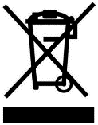
Disassembly and disposal of scrap
Proper disposal of coffee machines must be done in accordance with local regulations.
► Contact a service partner agency.


Operation
Hot liquid. Drinks made with this machine are hot drinks.
Do not put your hand under the outlet of the drink or into the machine during discharge中


High temperature steam. Risk of burns in the steam nozzle exit area.
Do not put your hand under the steam nozzle during output.


High temperature surface. Dangerous conditions that can cause burns. Drink outlets and water brewers present this hazard.
Do not grip the outlet of the drink or touch the surface of the boiling device while it is heating.

Hazard to the machine. Wrong operation may damage the touch screen.
Do not press the display with brute force, high pressure, or sharp objects.
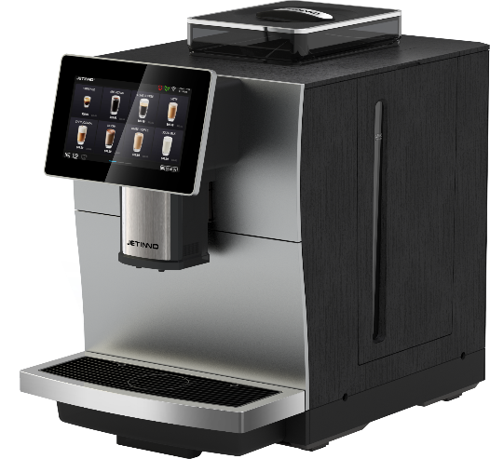

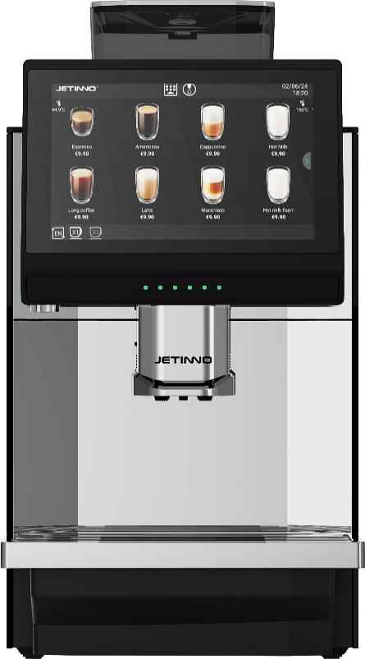
Equipment introduction
①
3.
1.

Machine external operating unit
③
coffee machine（front）
②
④

⑤

①Coffee Hopper、②Hot water mouth、③Touch + display、④Drink mouth、⑤Drip tray
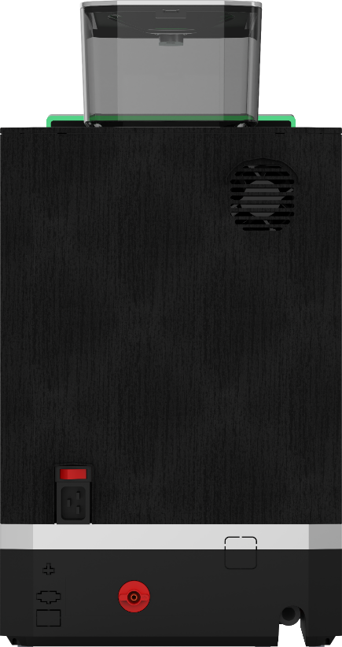
coffee machine（Back）

⑤
①
②
⑥
③

④
⑦

① barreled water and built-in water tank switch knob, but also barreled water inlet, ② power switch, ③ power cable connector, ④MDB device interface,⑤ machine heat dissipation, ⑥ direct drinking water inlet interface, ⑦ water tray waste water exhaust pipe。
Product interface

Company logo
Time/date
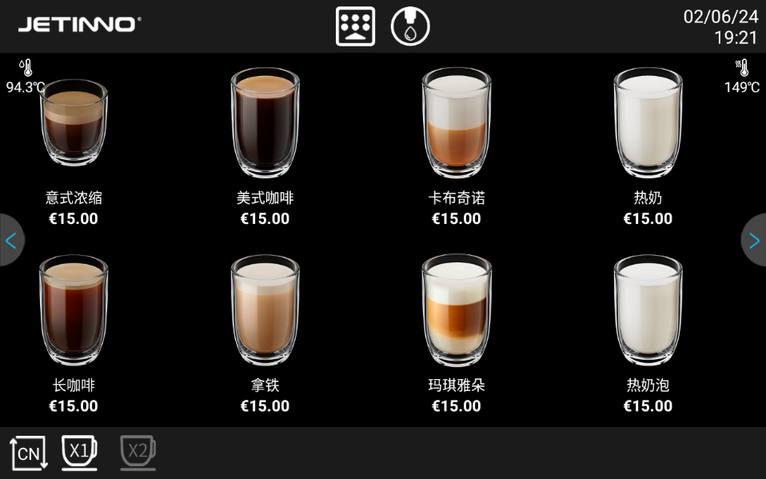
Hot water boiler temperature
Steam boiler temperature
Hot water button
Page turn button

Quick maintenance menu key button
Lower page button
Product button
Single/double cup toggle button

Product price
Product name
Language switch button

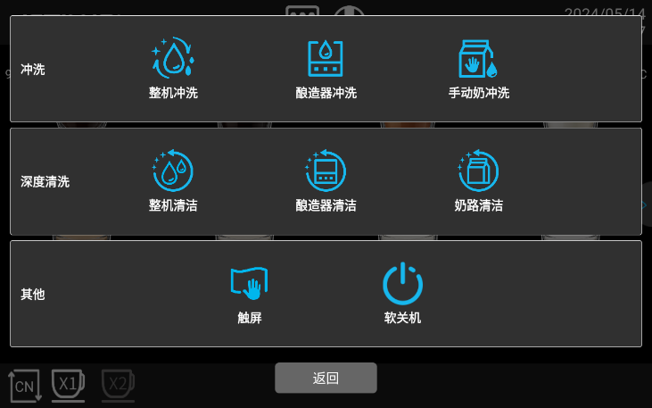
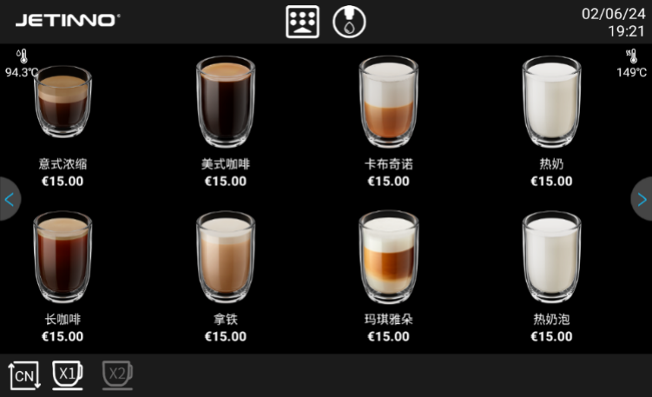
Quick maintenance interface

Quick maintenance menu key includes: washing (machine washing, brewer washing, manual milk washing), deep cleaning (machine cleaning, brewer cleaning, milk road cleaning,), other (touch screen, soft shutdown), functions. Refer to the following chapter for the specific usage method.
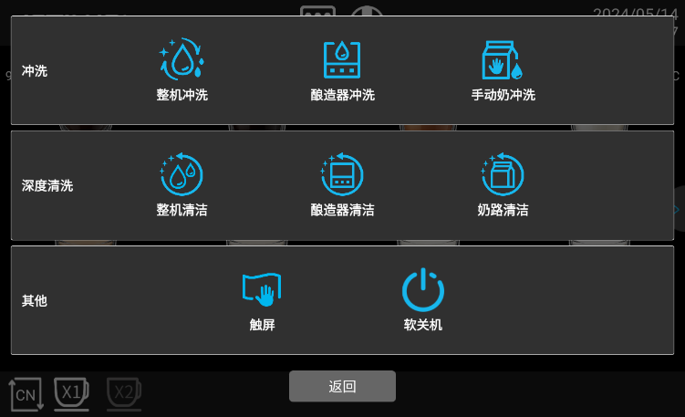
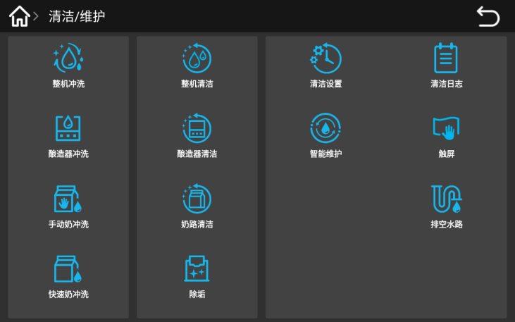

Tip: quick maintenance menu: machine washing, brewer washing, manual milk washing, machine cleaning, brewer cleaning, milk road cleaning, and machine background management: cleaning / maintenance menu, machine washing, brewer washing, manual milk washing, machine cleaning, brewer cleaning, milk road cleaning, the same function. So, the later sections are described in one of these ways.

Accessories
The spare parts with machine
Automatic coffee machine when supplying accessories e. g:
Graphic | Item name | Function | Product Parameter
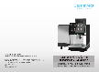 | Manual | Used for coffee machine use reference | 210mmx291mm
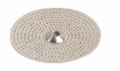 | Coffee maker, pack of consumable materials (seals, strainers, etc.) | For daily consumable replacement of coffee machine | Regular
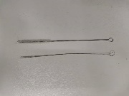 | Wash the fine inner hole clearly | Use when cleaning the milk foam | Hair diameter 3mm * total length 21cm  Hair diameter 6mm * total length 21cm
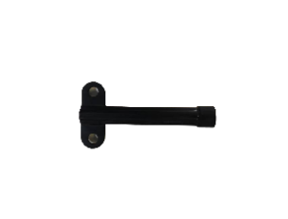 | Coffee maker debugging tool (grinder adjustment key) | A tool for adjusting the coffee machine | Routine
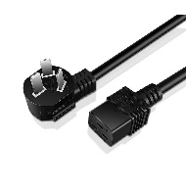 | Power cord | For coffee machine special function installation use | Three plug (10A)/Pin tail (left bend)
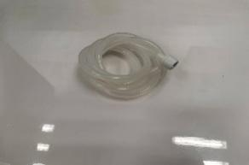 | Water pipe | For connecting to the bottled water | Routine
Optional accessories
Icon | Item name | Functional specifications | Product parameters
 | Milk cold bin | For refrigeration and fresh use | External dimensions (width * depth * height)：220mmx400.5mmx400mm
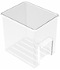 | Fresh Granny box | Container for holding fresh milk | Food grade, 5L
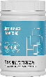 | Coffee System cleaning pills | For cleaning the coffee maker brewers | 2 g / tablet, 100 slices / can, 12 cans / box
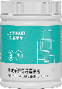 | Coffee maker milk system cleaning pills | Coffee maker milk system cleaning pills | 4g / slice, 120 tablets / vial, and 12 bottles / case
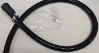 | drip disc efflux pipe | drip disc efflux pipe | /

Machine installation

Unwrap
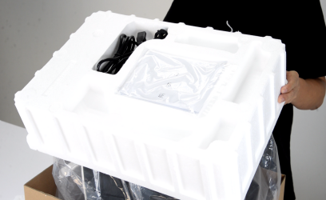
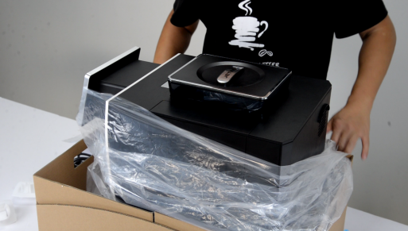
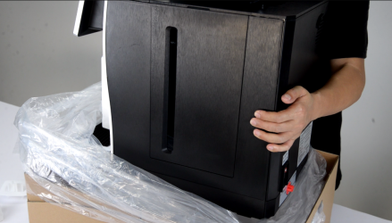
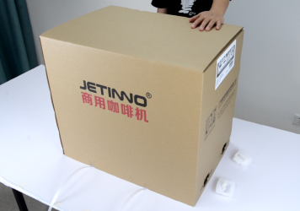

After receiving the machine, cut off the nylon belt, remove the four clips and pull out the carton up; remove the foam, open the PE bag and place the machine on the flat table.

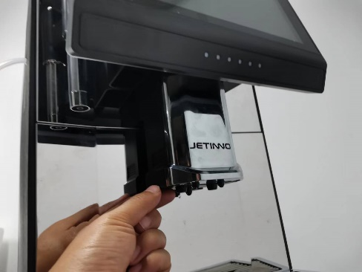
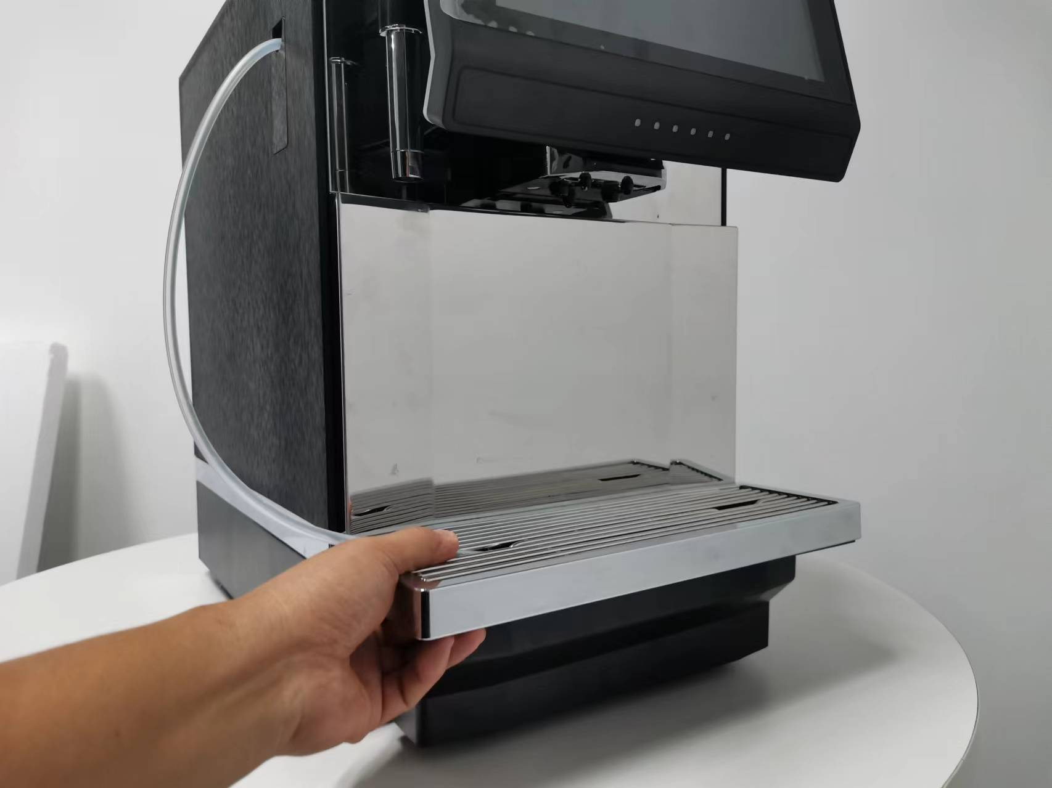
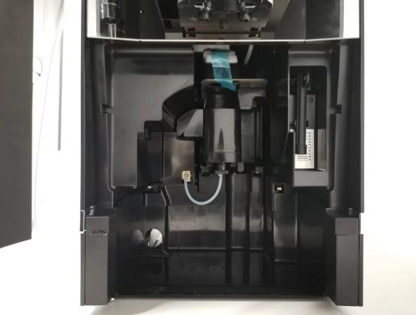
Remove the foam under the grinder

Push the mouth up to the end, pull out the drip plate, take out the foam below the mouth of the grinder.The machine has been tested before leaving the factory, so there will be a small amount of coffee powder, please feel free to use it.

Check before boot
Before starting the coffee machine, check whether the following preconditions are met.
- The main water valve is opened or the water is injected into the tank
- The Coffee Hopper was emptied and inserted correctly
- The water outlet is set correctly / drip tray placed correctly
- The power cord has the power supply connected

Add and connect

Pay special attention to the maximum amount added shall not contact with the container cap

Connect water supply
Water quality affects human health! The water source should meet the hygienic standards for domestic and drinking water
- Pay attention to the sanitation condition of the water pipes
- Clean related parts
- The water source connected to the machine should be easy to operate
- Direct drinking water to tighten the joint, in as to avoid water leakage
1、External water source
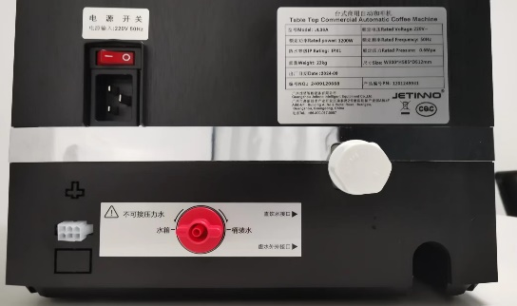
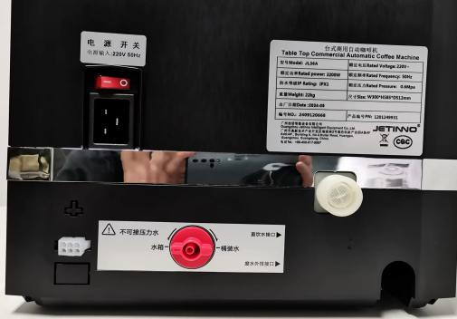
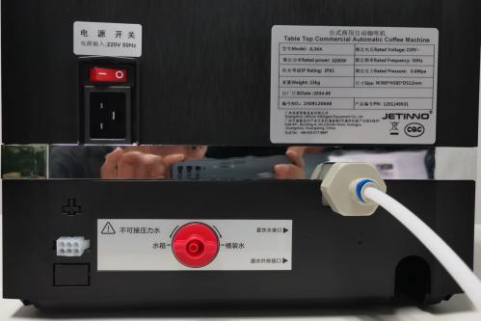

Unscrew the lid, remove the connector from inside the machine, rotate the connector clockwise on the inlet valve interface, insert the inlet pipe into the interface, and install the blue buckle.
A water pump operating without water may damage the machine.
Make sure that the main water valve is opened before startup.
Ensure sure the main water valve is closed.
2、Connect the water inside
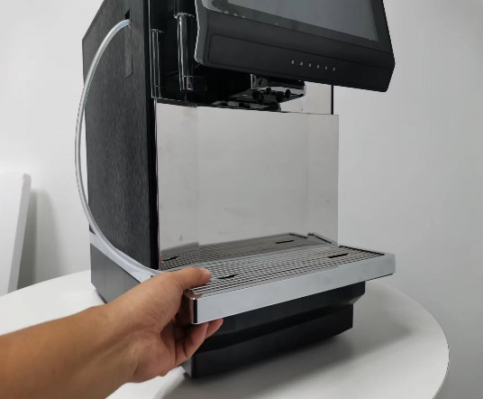
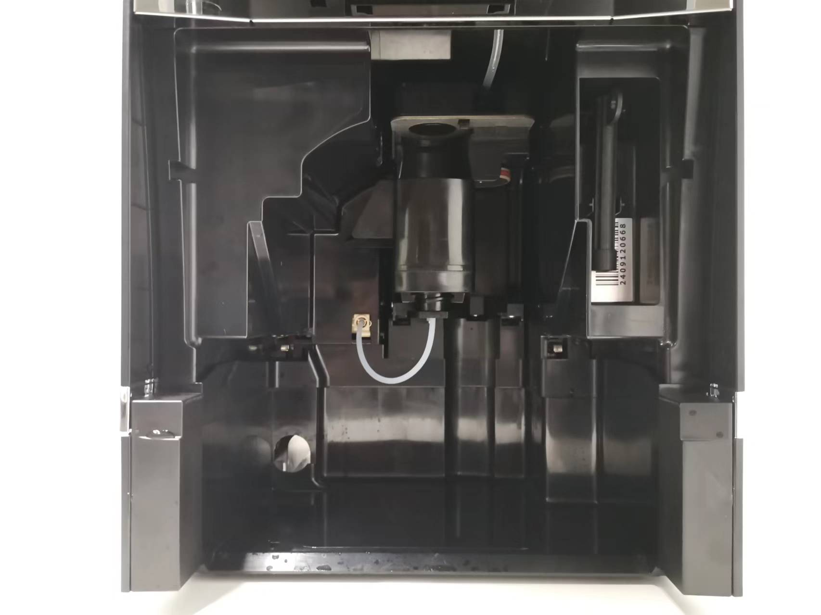
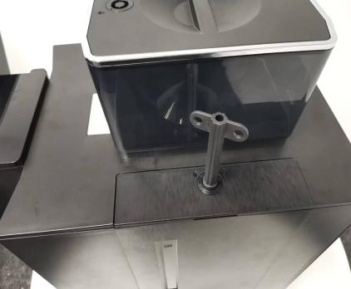
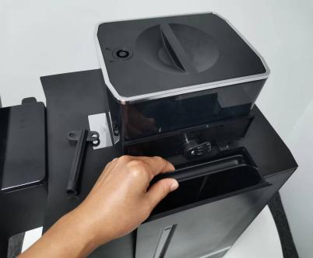

Pull out the water catch tray, take out the key, insert the lock hole of the tank cover, rotate clockwise, open the tank cover, raise the tank upward, inject clean water into the tank, and load the tank back to the machine. The machine has a water level detection board and a water shortage screen.
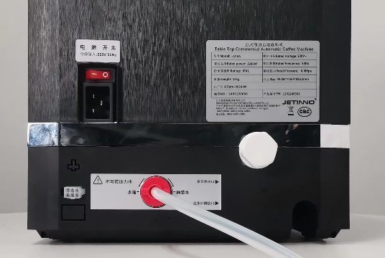
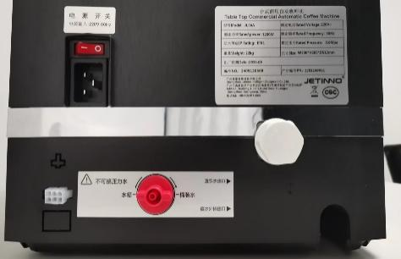
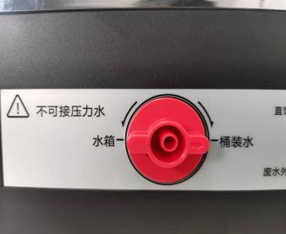
3、Barrelled water

Open the bottled water and the built-in water tank to switch the knob- -> The arrow points to the bottled water, remove the white pipe from the machine, and insert the tube into the interface until it is inserted to the bottom. Put the other end into the bottled water.

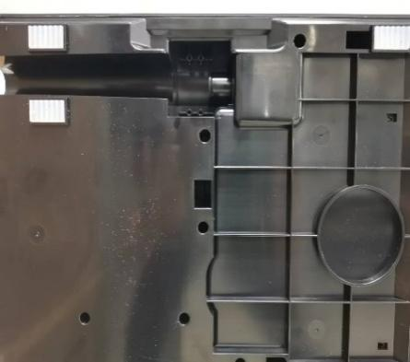
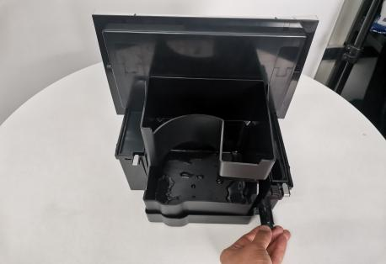
Connect the wastewater discharge pipe

If the drainage function outside the drip tray needs to be connected to the waste water pipe, the waste water discharge pipe is installed at the bottom of the machine and fixed with 4 screws. The other end of the waste water pipe is inserted into the drainage pipe or water tank. Pull out the drip tray, plug out the drip tray, and load the drip tray back to the machine.

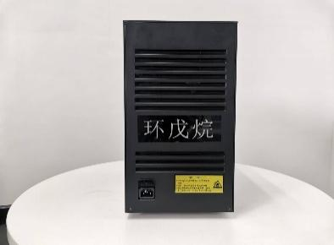
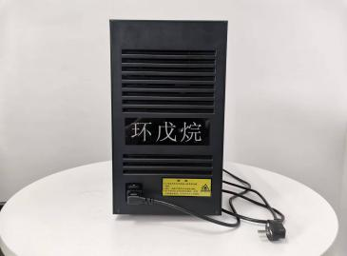
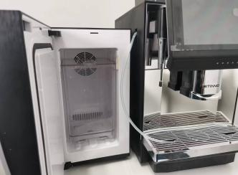
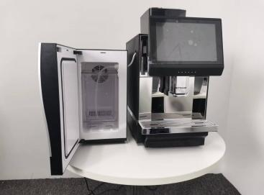
Connect fridge

Plug the female end of the refrigerator power cord into the socket of the machine; plug the other end of the power cord into the socket of the power supply; open the refrigerator door, take out the rubber plug, insert the milk tube into the interface on the left side of the refrigerator, straighten the milk tube, and close the refrigerator door.

Power on

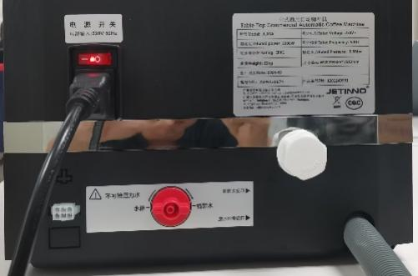
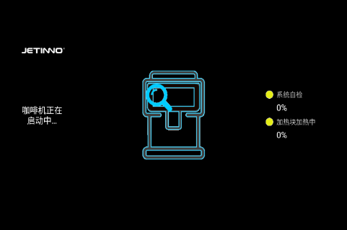
Coffee machine

Plug the female end of the machine's power cord into the machine's socket; plug the other end of the power cord into the power socket; check the machine's power connection and turn on the power switch. The machine starts, displays the main interface, and begins heating. When the required temperature is reached, the machine is ready.

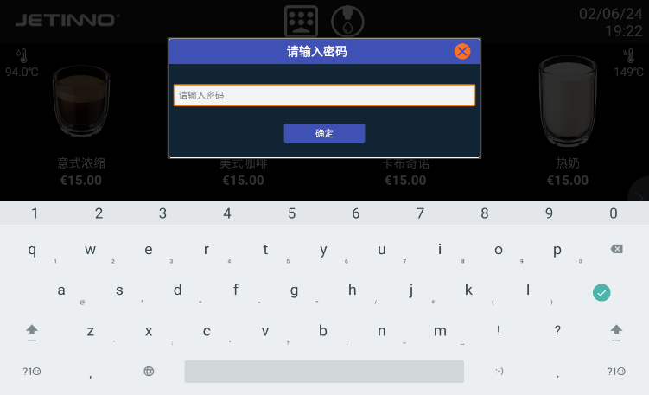
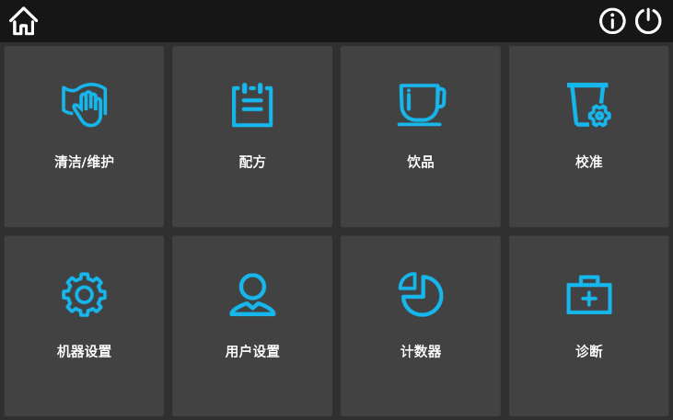

Machine setting

Long press, in the upper left corner of the screen, enter the password in the pop-up dialog box: test9527, click "OK", click "Machine Settings"
Machine settings include: regular, payment method, fresh milk options
General function: including the following functions: hot water boiler temperature, water source selection, the first cup of coffee preheating, waste residue full alarm, all sensor switches, waste water drainage mode, energy saving mode, lamp setting, fan setting
Payment method: free, QR code payment, cash, MDB swipe card
Fresh milk: fresh milk system setting, the factory has been set up.

Confirmation of water source method
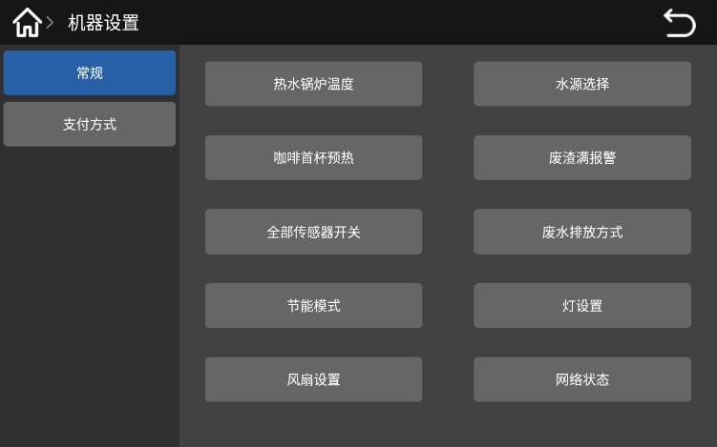
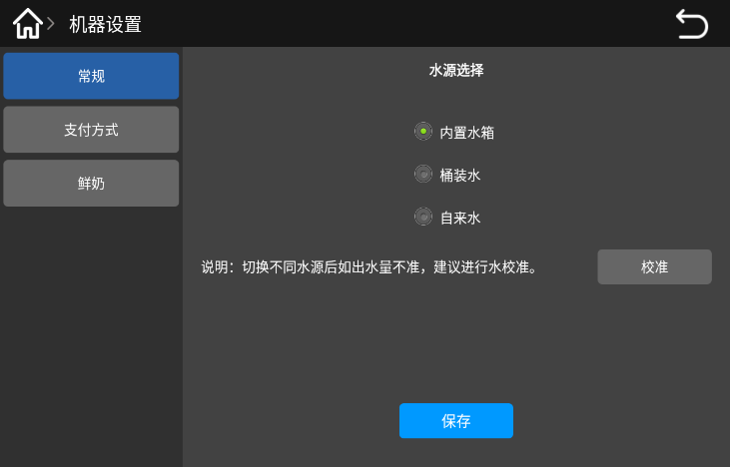

In the pop-up interface, select "General" and click "Water Source Selection" to select the correct water supply method (corresponding to the actual water source connection method）
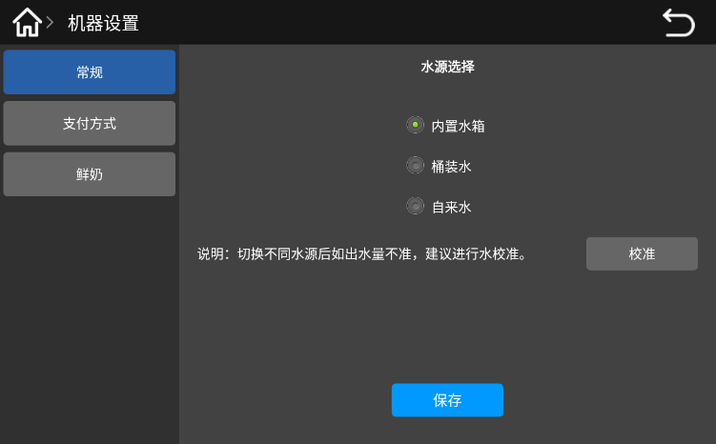
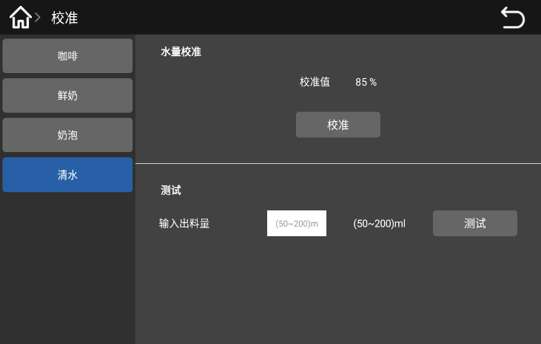

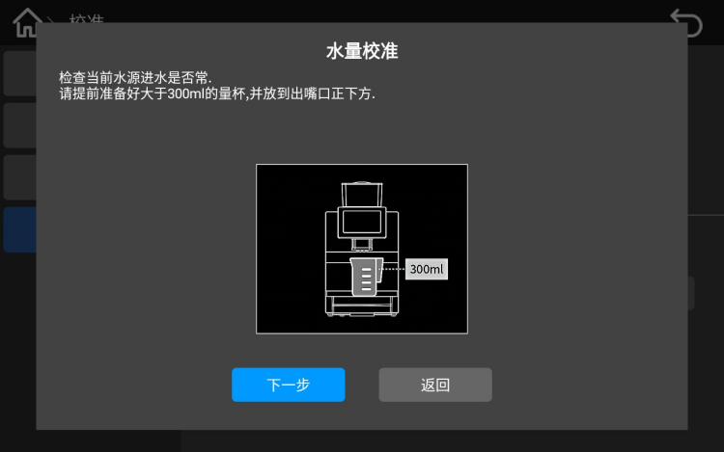
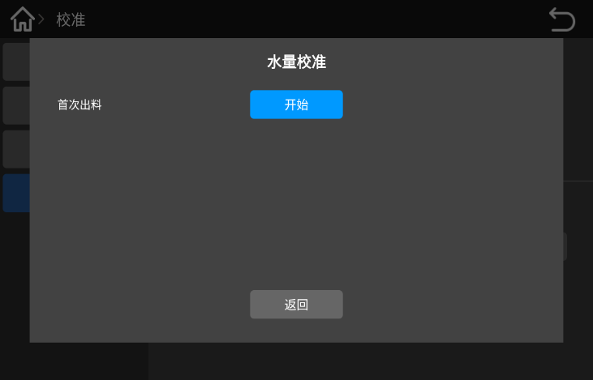
Using different water sources, the water source needs to be calibrated. Click the "Calibration" button. In the pop-up calibration interface, select "Clean Water" and click the "Calibration" button。

Place the empty cup (more than 300ml) under the hot water outlet and click "Next"; In the pop-up interface, click "Start" button
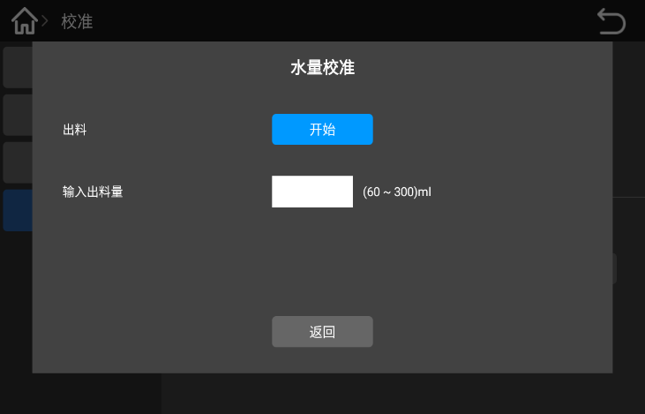
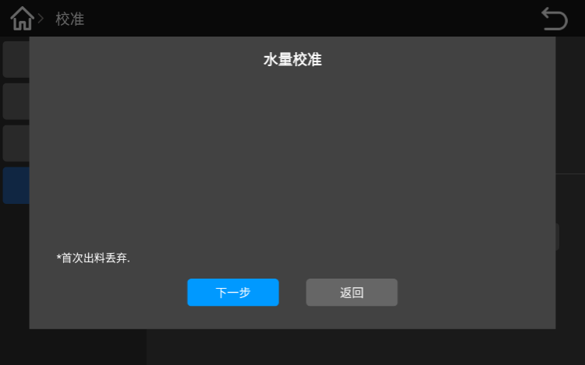

When the water is out, empty the water in the cup and put the cup back under the mouth and click "Next"; In the interface, click "Start" button. When the water is out, take the cup with water and read the value of the hot water in the cup
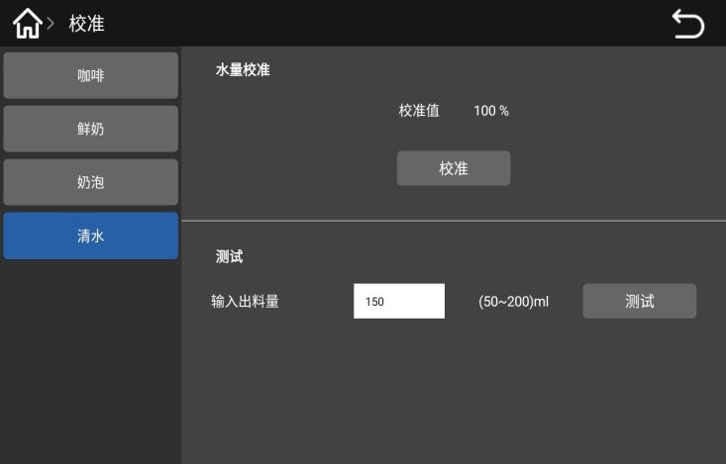
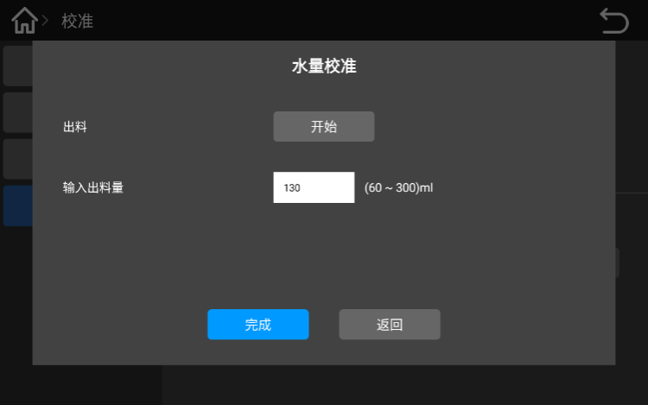

Enter the real value into the blank behind the screen "input quantity" and click "Finish it."Empty the water in the measuring cup，Place the measuring cup back to the hot water under the mouth，In the screen, below "Test", "Enter Out-> 50-200ml"，Input the amount of water to be tested (e. g. input 100ml),Click the “Test” button，When the water is out, take off the measuring cup and the eye reads out the value of the hot water in the value of the test，When approaching the test value, the error is very small and the water quantity has been calibrated. If the error is very large, please do the water quantity calibration again.

Counting
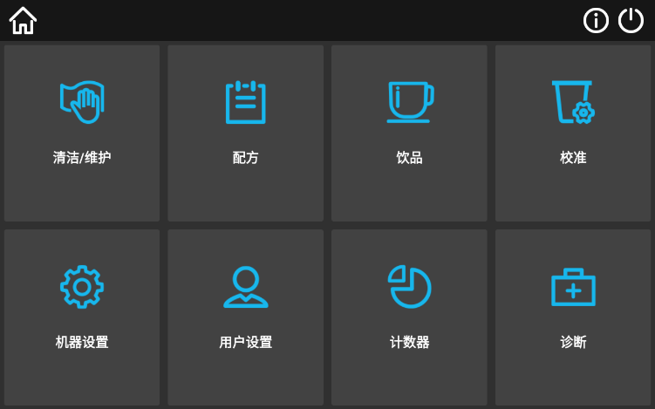
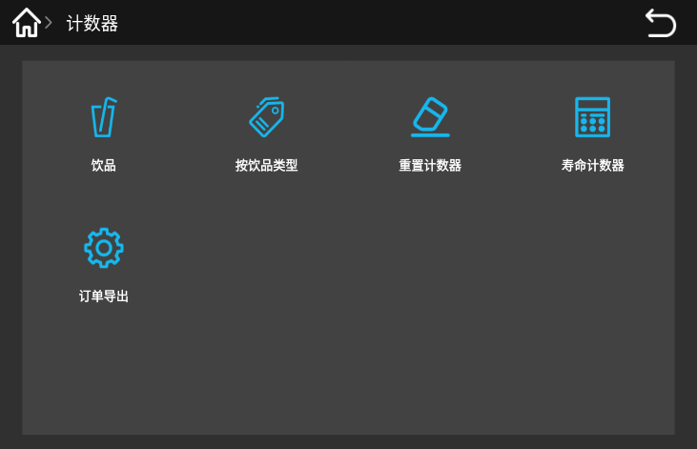

Enter the background of the machine and click "counter". In the pop-up dialog box, drink count, count by drink type, reset counter, life counter and order export functions include
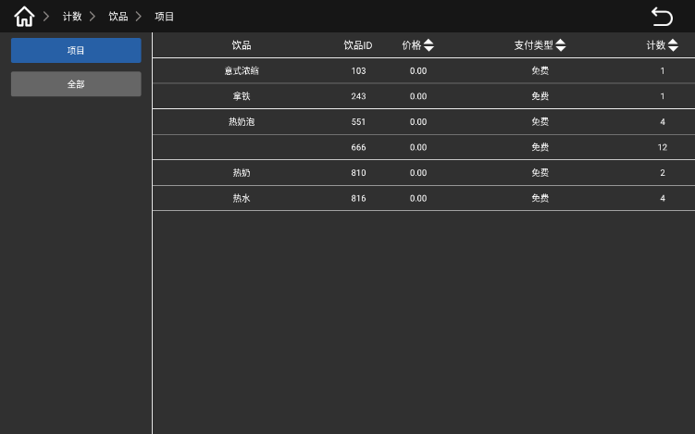
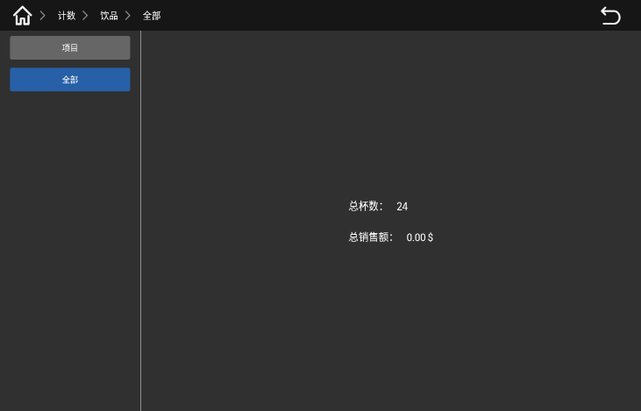

Click "drinks", [item] counting mode interface [All] Count mode interface
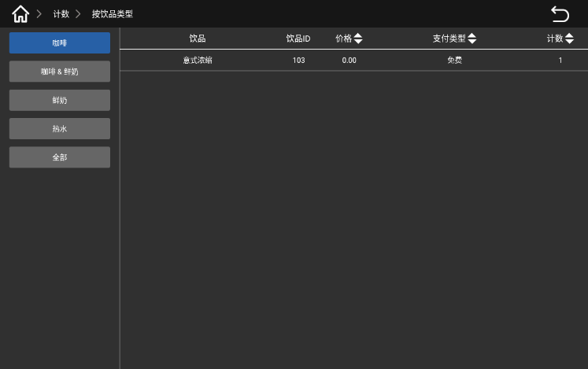
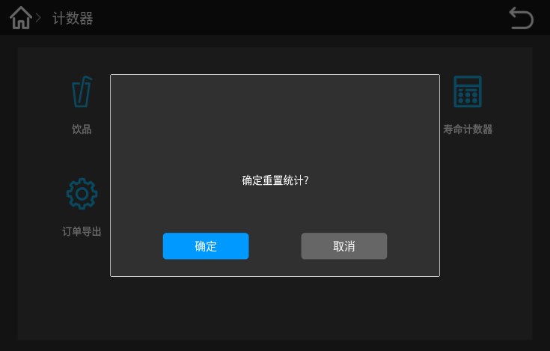

Counting interface by drink type Reset the counter interface
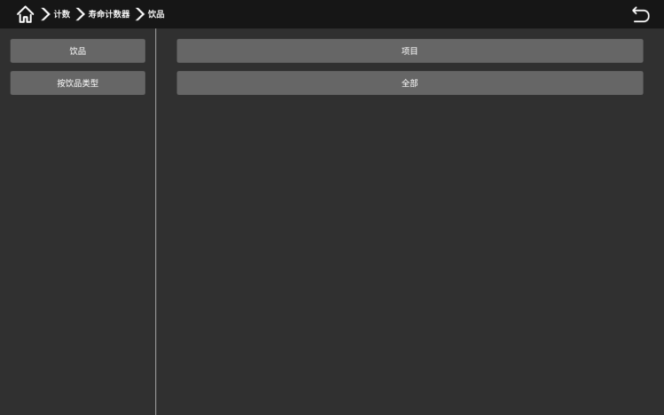
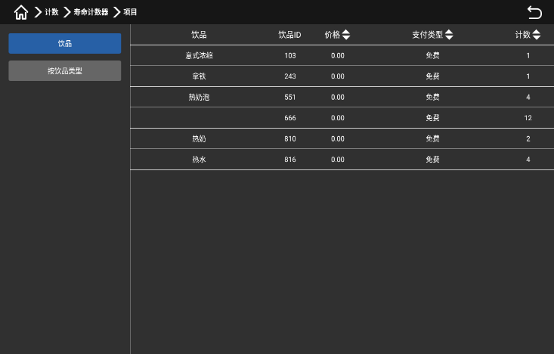

Count the life counter bydrink type

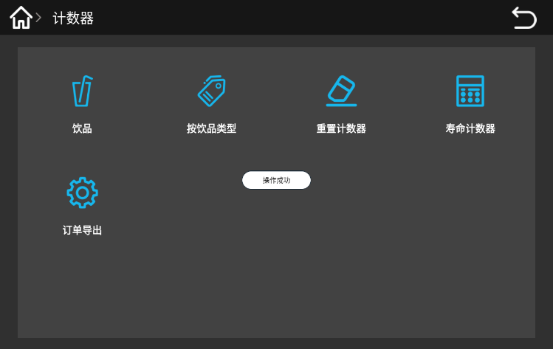

Click on "Export order"，After a successful operation, the data will be imported into the internal storage of the machine.Exit the APP and copy it out in the specified folder below the Explorer.

Diagnose
Long press，The upper left corner of the screen，Enter the password in the outgoing dialog box：test9527，Click “OK”。
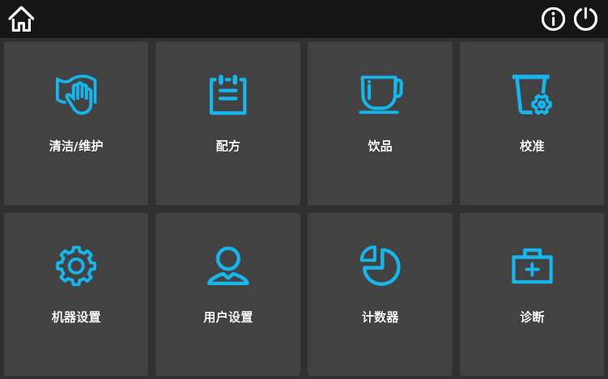
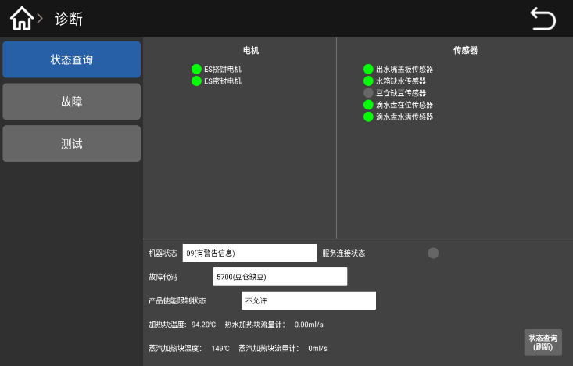

Enter the background management interface，Click "Diagnostics"，Diagnosis features include status query, fault, testing。Status query: The user can check the status of all the parts of the machine here；
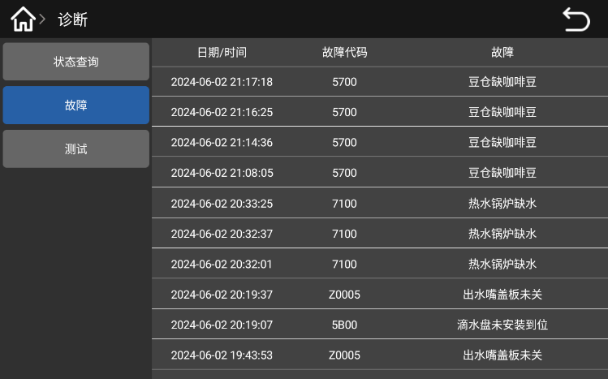
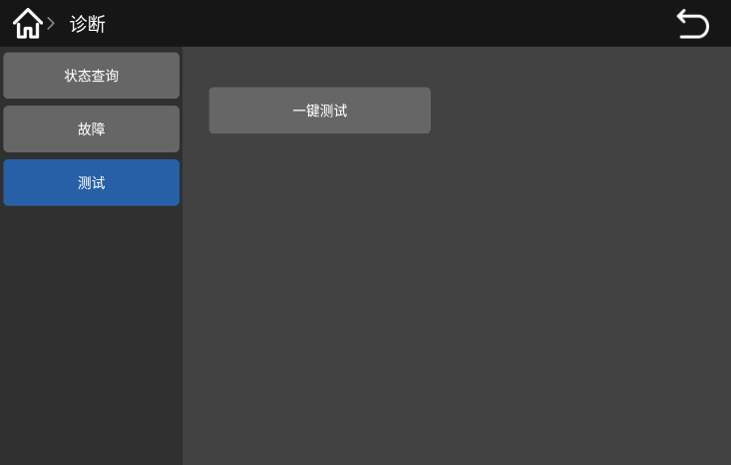

Error-Current error list：The user can check for the current fault；Test-> One-click test，It is mainly used for one-key test function before factory test, including sensor test,drink production test, water source test, cleaning test, etc

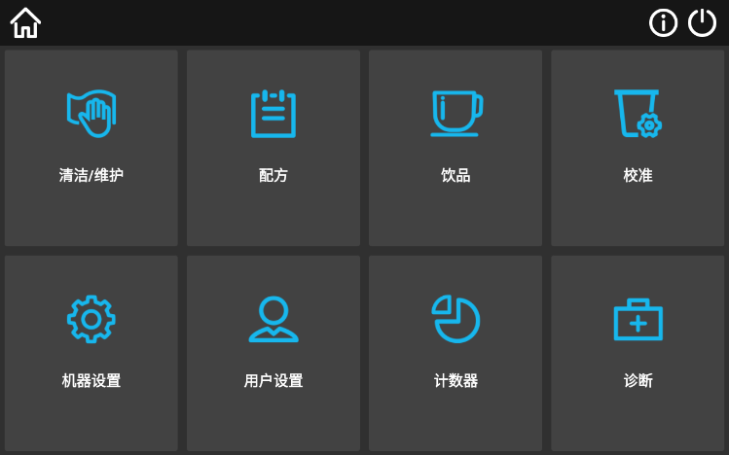
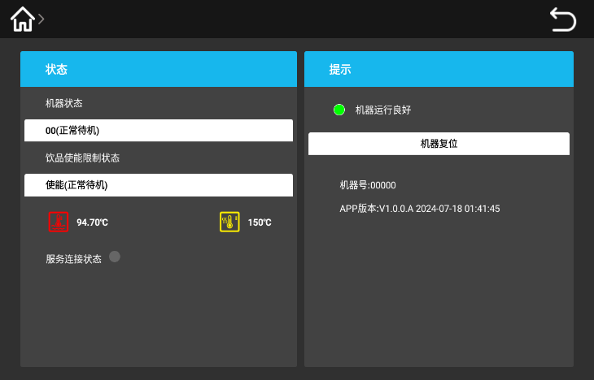
Machine state

Enter the background management interface，Click on the information icon，Go to the “Status Details”，follow the machine to do the process；Click the "Machine reset" button，The machine will automatically re-detect it。

First run

Linked network
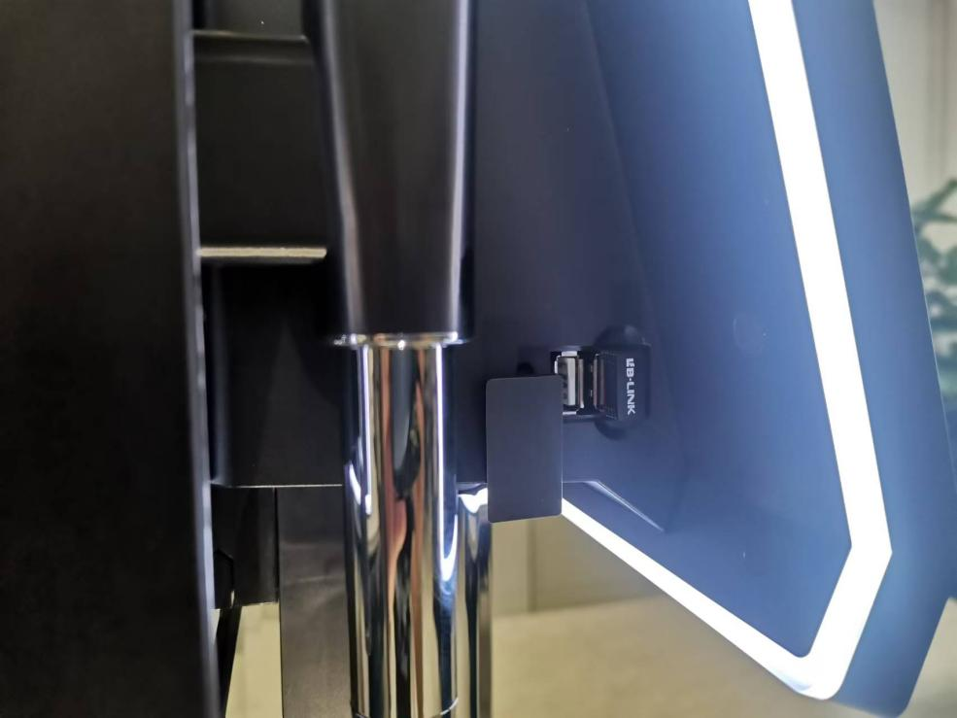
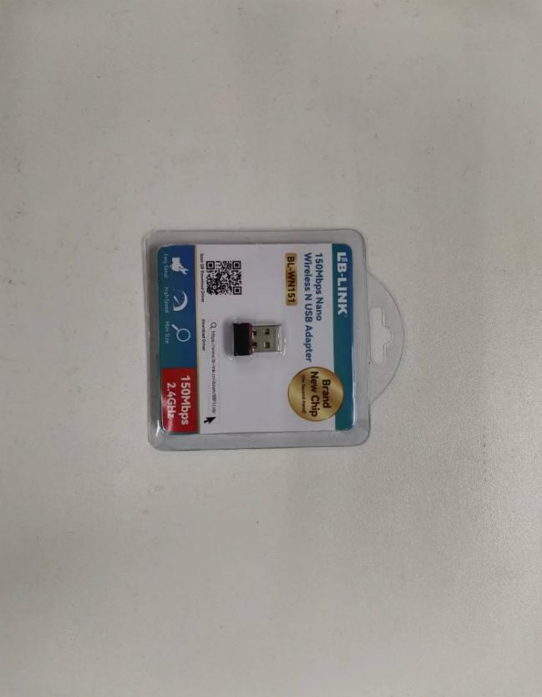
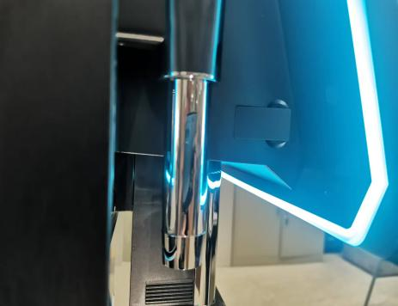
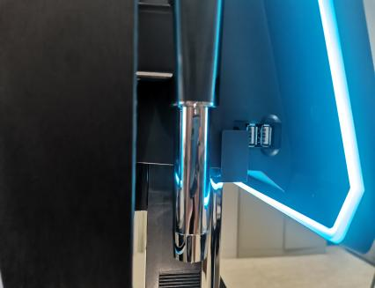

Inside the machine，Remove the signal receiver (option parts).Open the glue plug on the left side of the display screen，Insert the signal receiver into the first USB port.
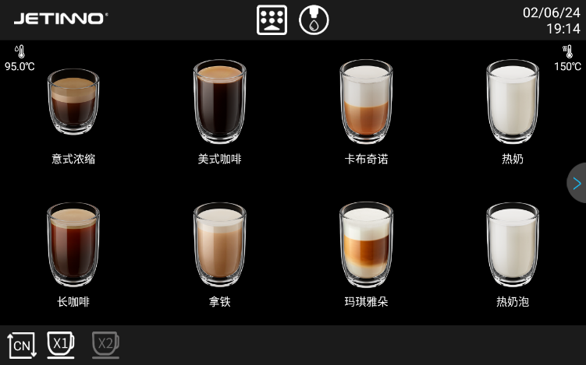
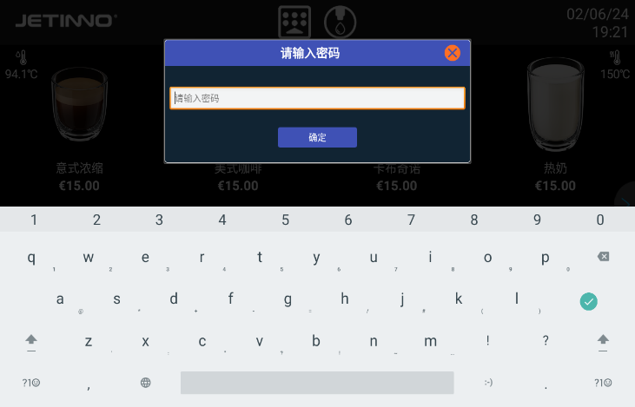

Long press the upper left corner of the screen，enter the password in the outgoing dialog box,the password：test9527，click“ok”
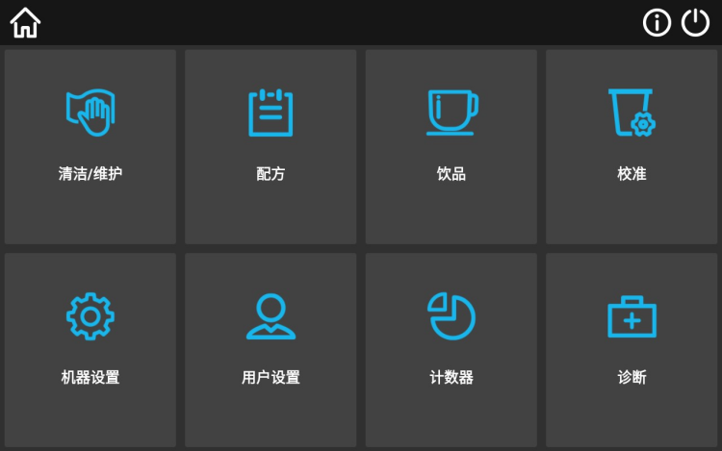

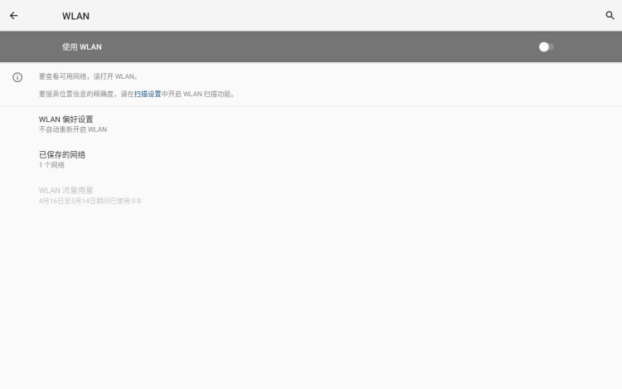
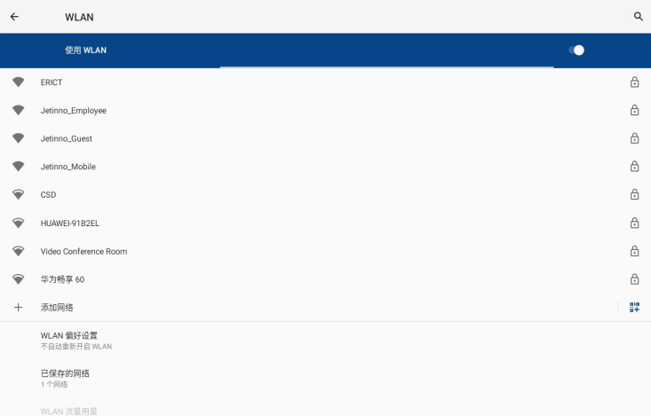
Enter the background management interface，click“settings”，select“Common”，Click“Network status”按钮。

Select“WLAN” in the pop-up interface,turn on the switch,then machine will automatically search for WIFI

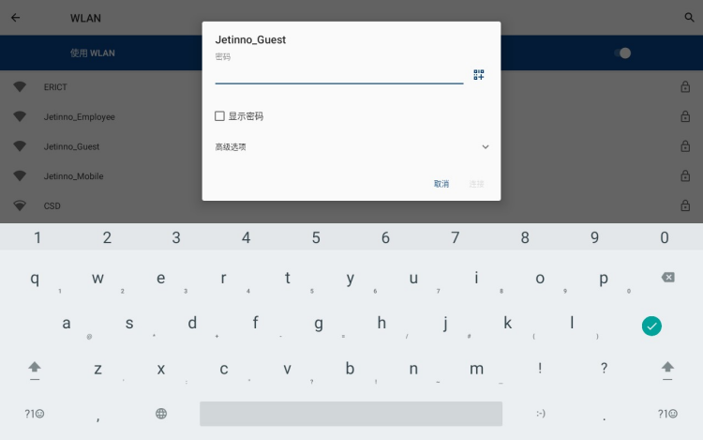
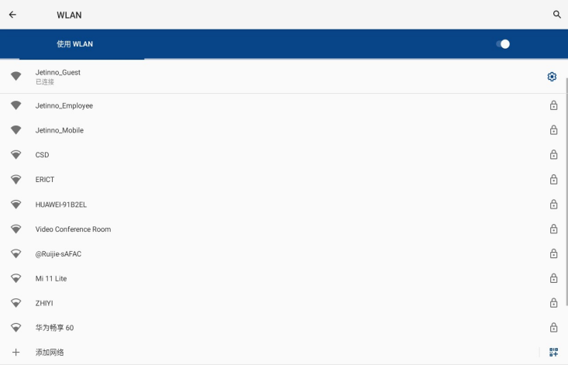

Select the Wifi，enter the password in the pop-up interface，click“connect”.After connected，click the arrow on the upper left corner of the screen,back to the machine management background
Tips：When used the offline mode, you can ignore the network without connection.

Connect the server
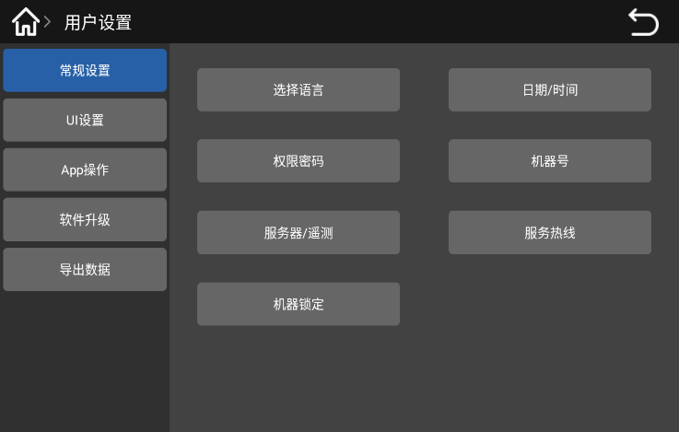
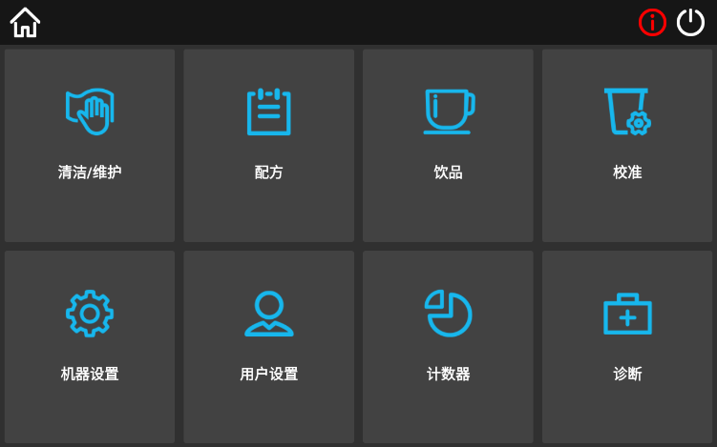

Click“User settings”->“general setting”，Click“Server/remote”button。
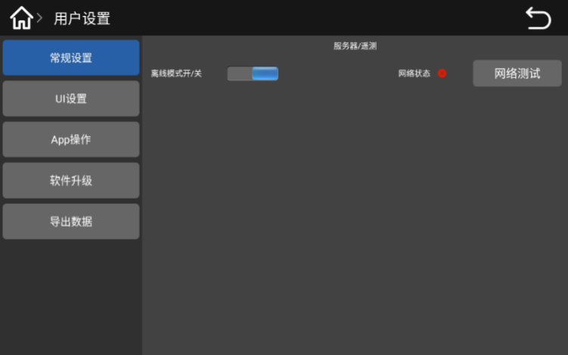
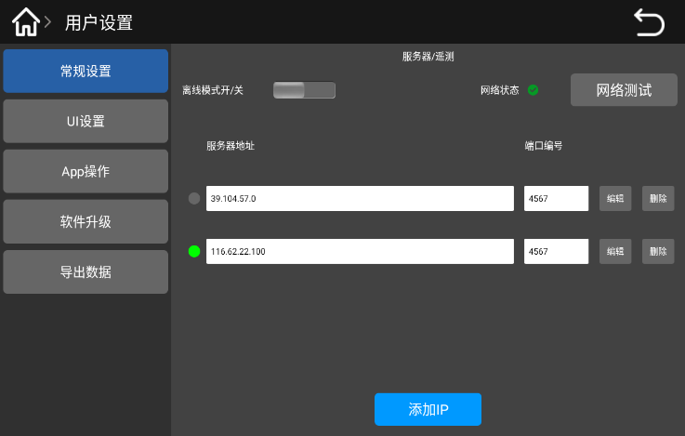

Click in the interface“Offline mode open/close”and turn off the offline mode，then the server address and the port number are displayed，confirm whether the IP address and port are correct，or add new IP address and port.Click the back button on the upper right corner of the screen，return to the previous level menu.
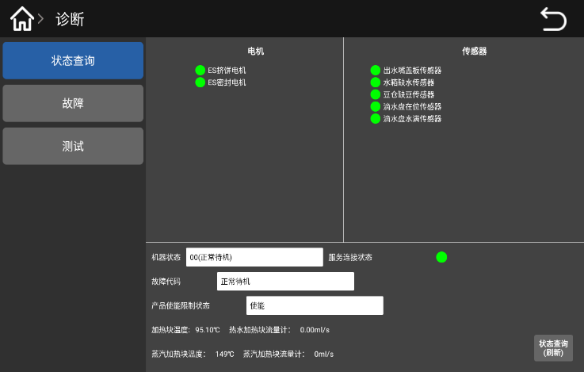



Click "Diagnostics"->"Status query"，check：sever connect statue；The service connection status appears in green ，means the server connect success；the service connection status is gray ，means the server connect fail,need to contact local operator or agent to check whether this machine register on the server.
Tips：When used the offline mode, you can ignore the network without connection.

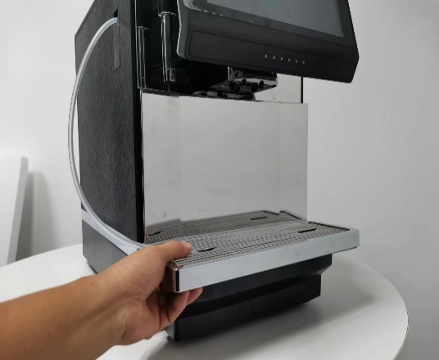
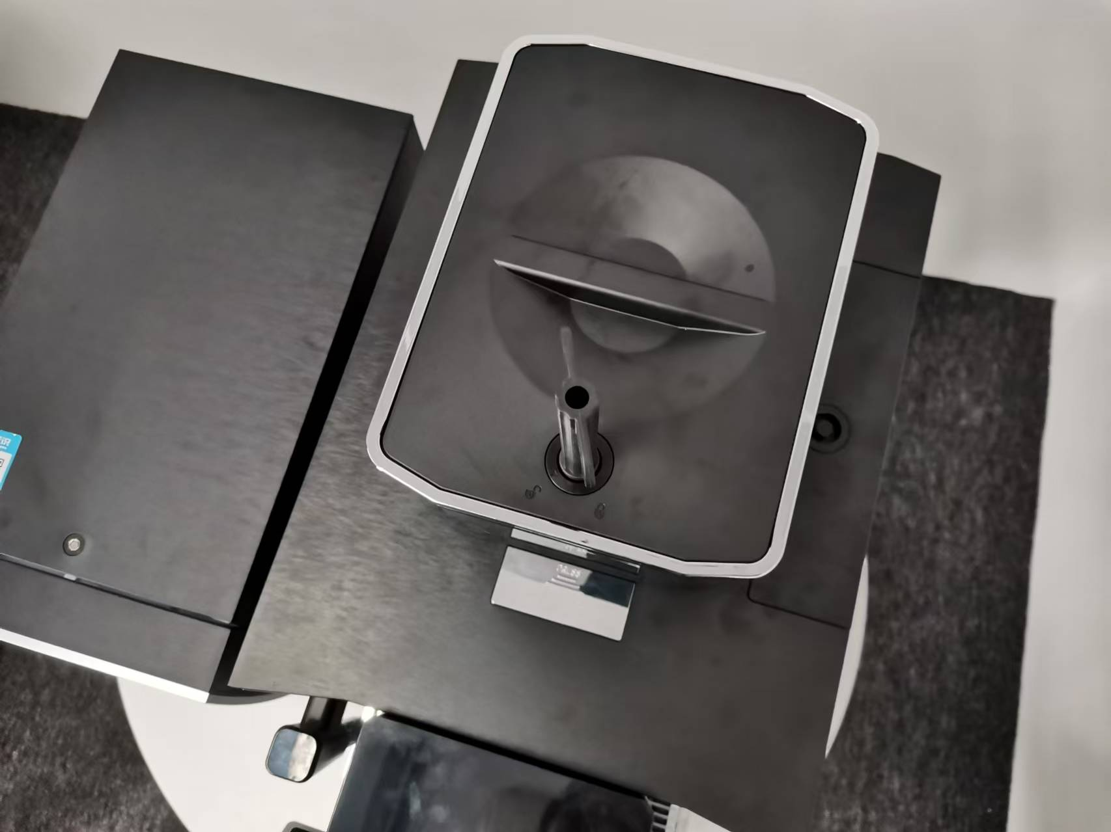
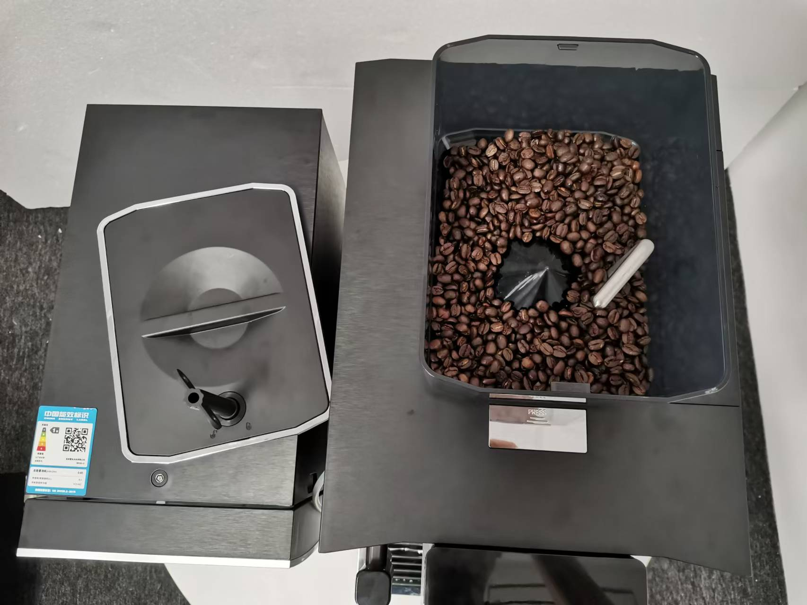
Fill the canister

Pull out the drip tray, remove the key, insert the key into the bean box cover, turn the key, remove the bean box cover; add coffee beans and cover the bean box cover.
Coffee bean

The rotating disc of the grinder can cause injury.
Do not put your hand into the Coffee Hopper when the coffee machine is turned on.

Adding a foreign body may cause a grinder blockage or damage to the grinding equipment!
Do not put any items other than coffee beans into the Coffee Hopper

Fill the milk to the milk box in the fridge
Contamination of milk tubes may cause health hazards.
After installation commission or run again,need to clean
Open the refrigerator door, pull out the milk tube, unplug the milk tube joint, take out the milk tube and milk box and rinse under the faucet, dry and put back to the machine

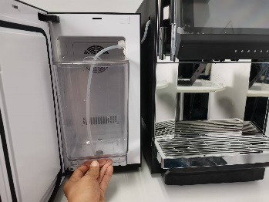
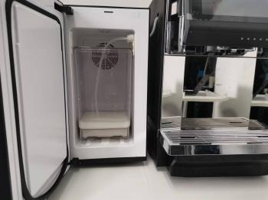
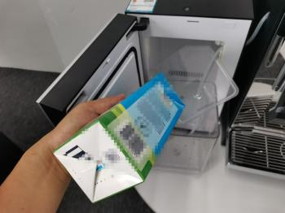
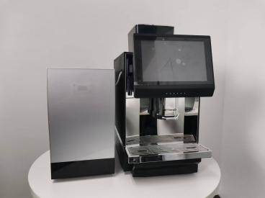

Open the refrigerator door, remove the milk carton, remove the lid, pour the milk into the milk carton, and close the refrigerator door; inject the cooled milk into the milk carton if necessary.
Noted：The height of the fresh milk liquid level added in the milk box should be lower than the height of the outlet nozzle。
No fresh milk this ignored。

Commissioning and calibration
Grinder calibration
Before adjusting the grinder, prepare (low value) electronic weighing！
Grinder thickness adjustment
Initial calibration empty coffee beans（Empty the residual powder before adjusting the grinder）

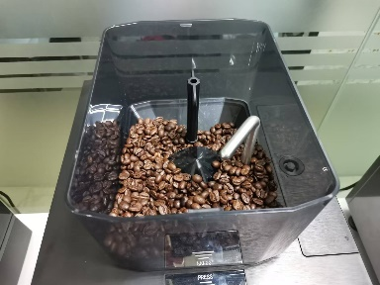
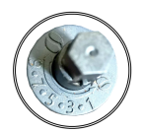
Grinder thickness adjustment

Take out the water drop，and take the key，insert the key into bean box，remove the lid of the ben box；Insert the key into the adjustment knob，press down to the bottom and rotate it，The larger the number of the gap, the thicker the grinding, the smaller the number of the gap, the finer the grinding.
。

Hot milk and milk foam
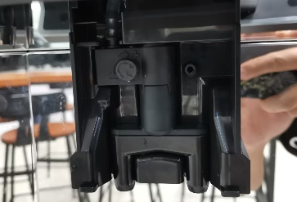
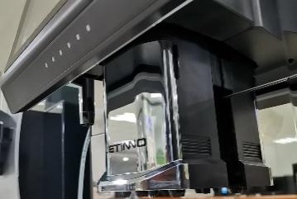

Press the lock on either side of the outlet mouth cover，Remove the nozzle cover assembly，adjust the knob，clockwise rotation，the temperature of the milk and the milk foam will rise，at the same time, the flow is reduced，as the flow rate slows down, the bubbles in the milk will become larger, with the possibility of splashing；anti-clockwise rotation，temperature of the milk and the milk foam will decrease，At the same time, the flow rate will increase, the flow rate will become faster, and the milk foam will be more delicate and thick. Recommended fine-tuning, the range is not easy to be too large.

Grinder calibration
Calibration，it’s the software function for the physical characteristic and baking degree of coffee bean.Before calibration,need to prepare electronic scale and cups。

Not doing the calibration will cause abnormal powder production by the machine!
Before calibration, it is necessary to produce the powder first and fill the powder outlet of the grinder. Export dissatisfaction will lead to inaccurate calibration.



Because each part or material has different physical properties，so each time replace the canister motor or different coffee beans need to recalibrate.During calibration, the quantity in the canister/box should be greater than 1 / 3 of the volume of the canister/box.
Calibration step of Grinder：

Long press the upper left corner of the screen，enter the password:test9527，Click "OK"
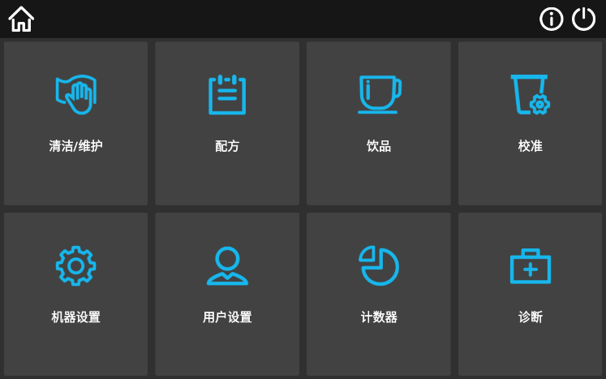
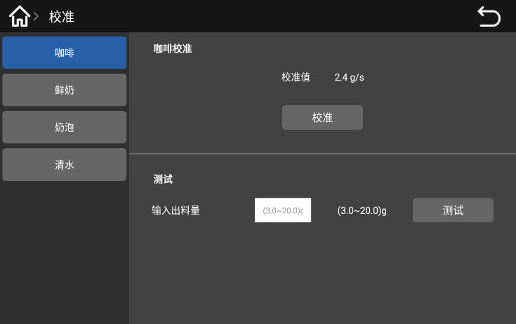

Enter the machine management background.Click the “Calibration” button，Click on the "Coffee" option，Click the Calibration button。
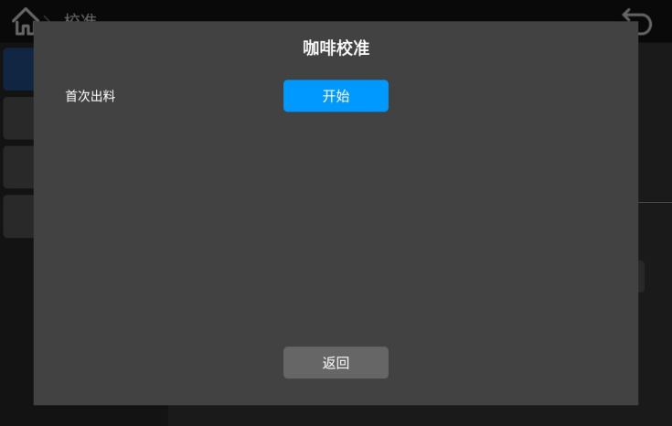
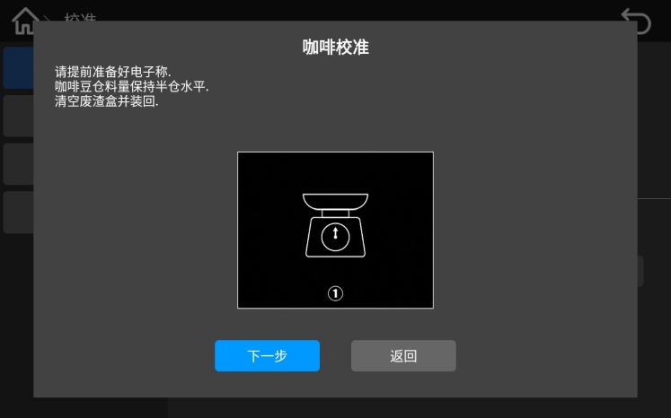
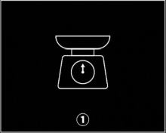
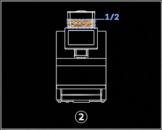
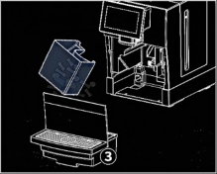

Follow the interface prompts，prepare the electronic scale，Coffee Hopper quantity to maintain half warehouse level，empty the waste bin and put it back in place，then click on the "Next" button，click the "Start" button in the pop-up interface
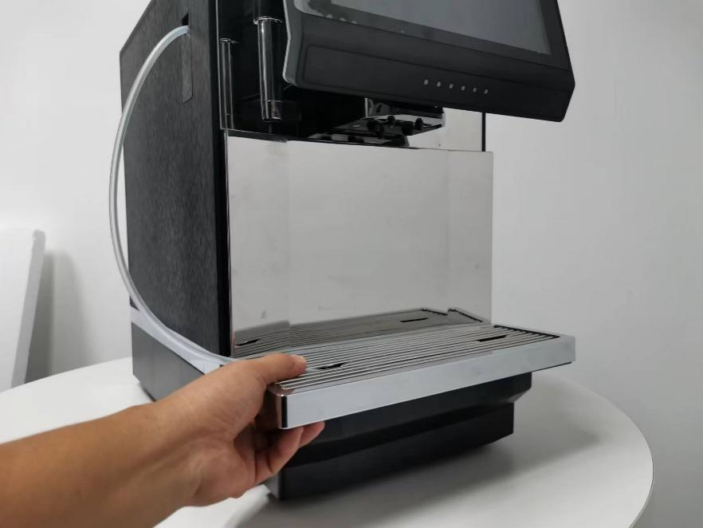
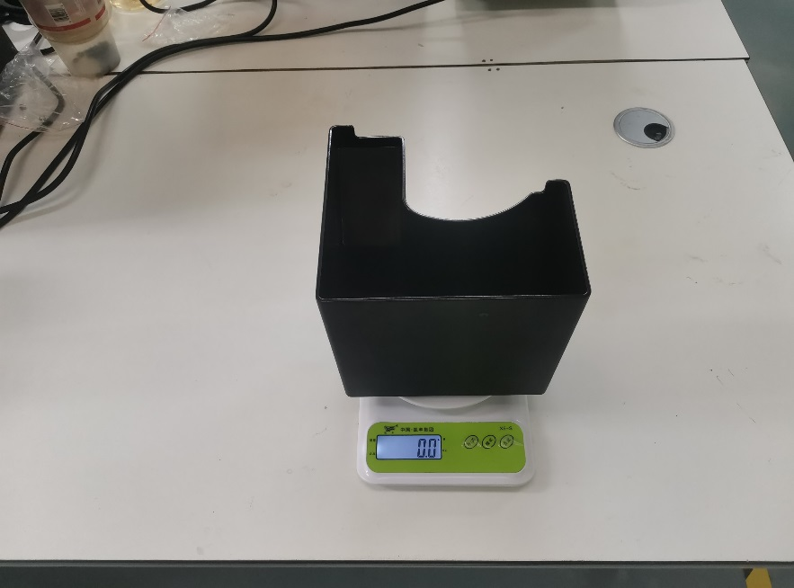


When the machine is end running，pull out a drop of water，then pull out the waste bin on the scale to weigh it（need to clean the weight of the waste bin to get the net weight of coffee powder）。
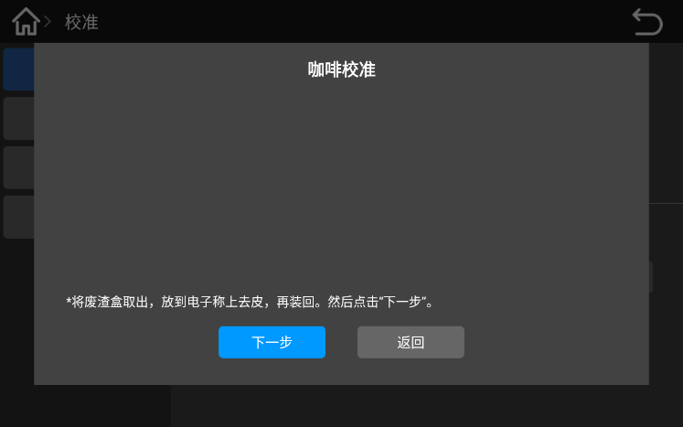
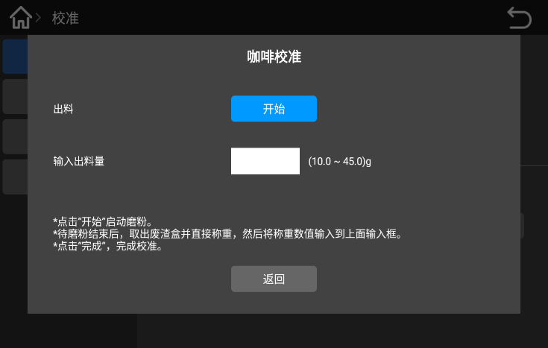

Put the waste bin back to machine。Click“Next step”button；click the "Start" button in the pop-up interface，start the grinding and wait for the grinding to finish，Pull out the drip tray and take out the waste bin.
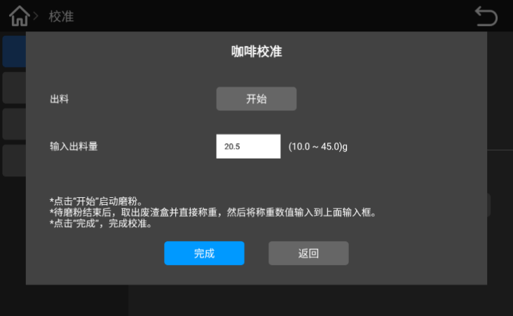
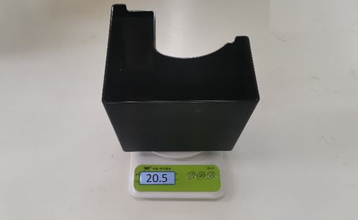

Place the waste bin on an electronic scale and weigh it，then fill the weighing value in the blank of "input powder quantity". Click“finish”button.

Fresh milk calibration
Different milk concentrations are different, and the fresh milk needs to be calibrated. Ensure enough fresh milk during calibration。
Fresh milk calibration steps：
Long press the upper left corner of the screen，enter the password:test9527，Click "OK".

- Hot milk calibration
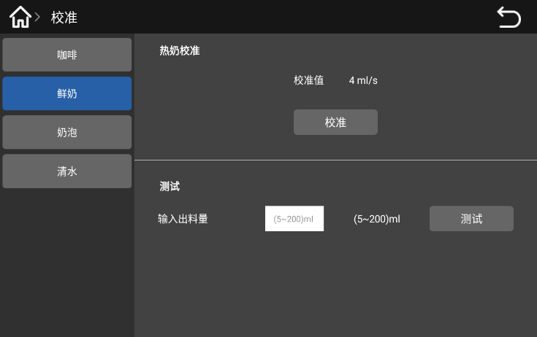

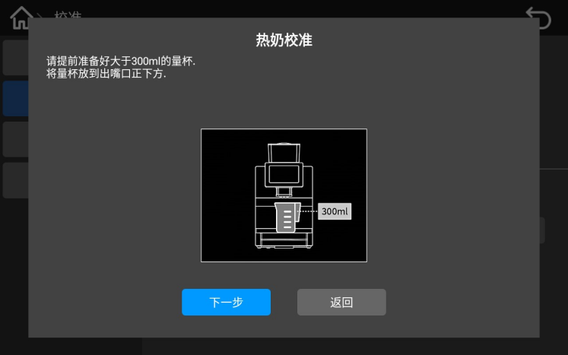
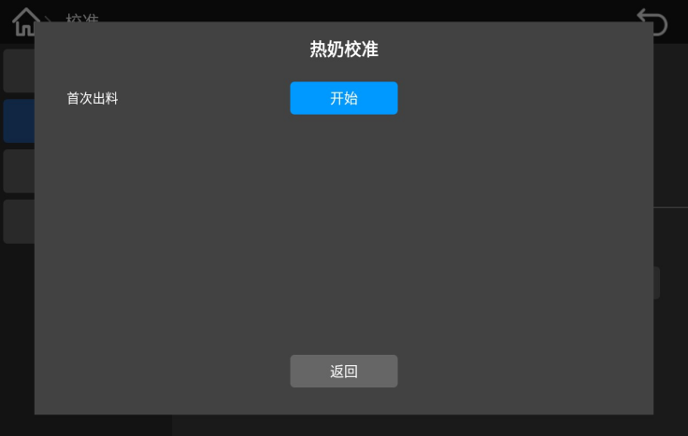
On machine management background, click "Calibration", "Fresh Milk" option and "Calibration" button。

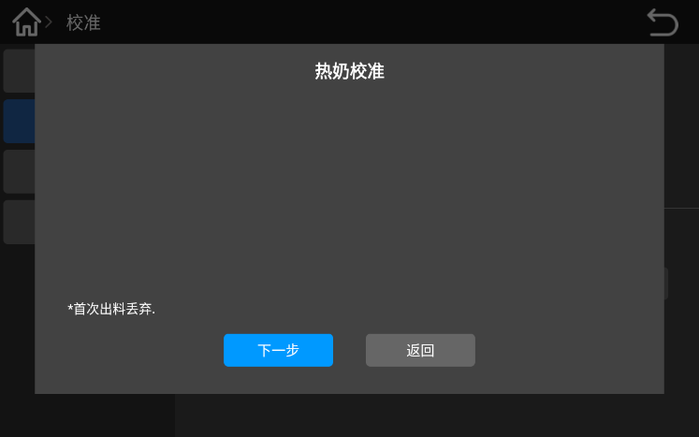
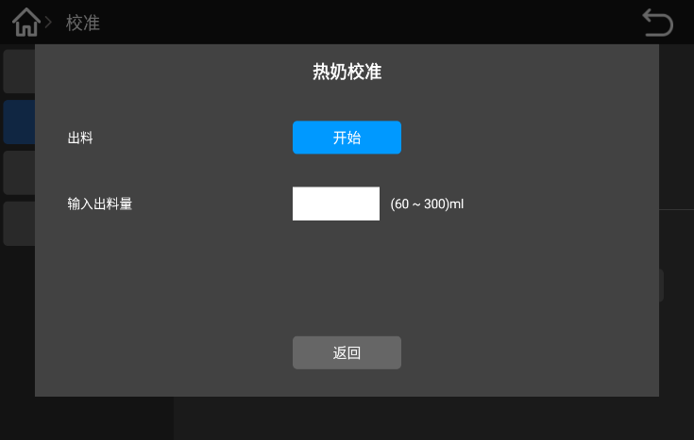
According to the interface prompts, prepare a 300ml measuring cup in advance, place the measuring cup directly under the outlet, then click "Next" button; click "Start" button, wait for the end of the program until the outlet stops feeding。

Remove the milk from the first measuring cup，rinse and place it directly under the outlet，then click the Next button; click the Start button in the display。

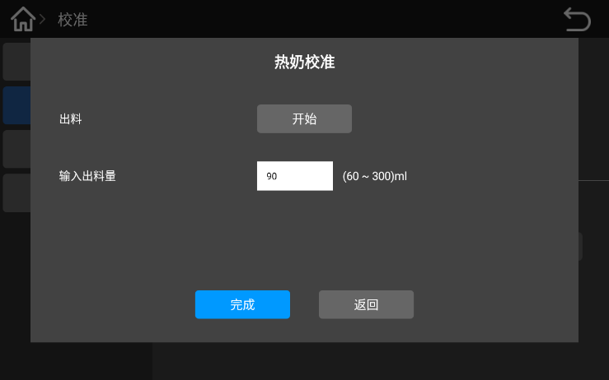
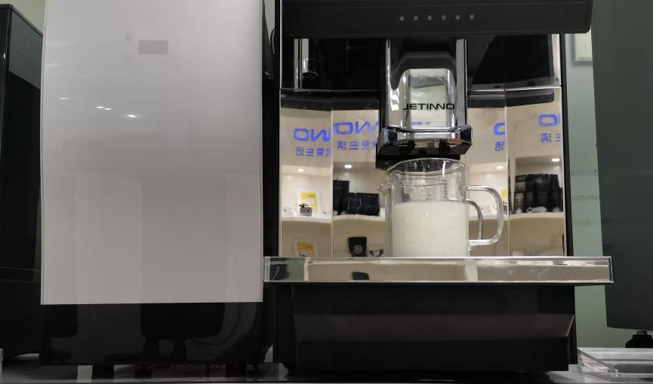

After the hot milk finish，check the value of the hot milk in the measuring cup，fill in the blank with input put quantity，and click the Finish " button。
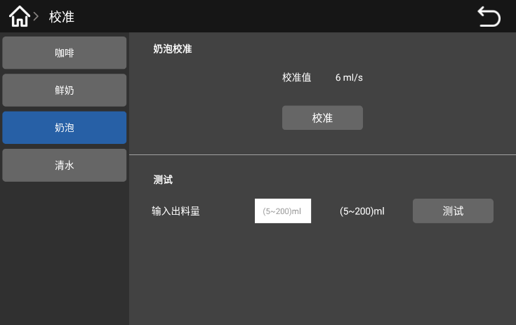
2、Milk foam calibration

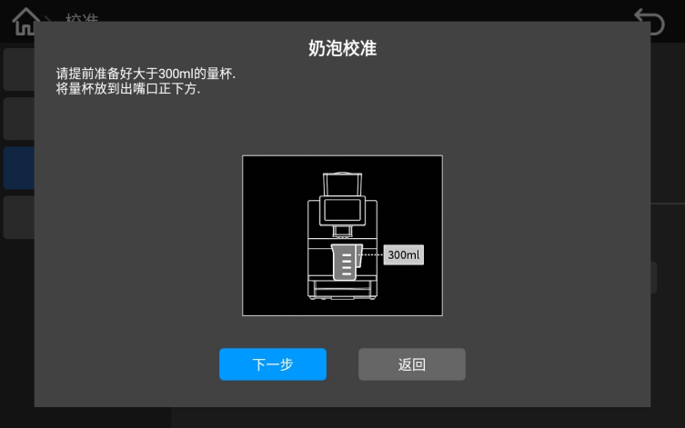
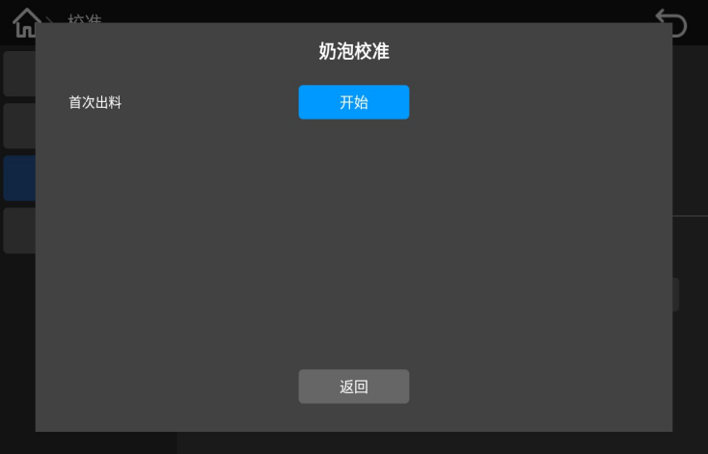
Enter machine management background.Click“calibration”，click“milk foam”option，then click“calibration”button。

According to the interface prompts, prepare a 300ml measuring cup in advance, place the measuring cup directly below the outlet, then click "Next" button; click "Start" button, wait for the end of the program until the outlet stops the milk foam。
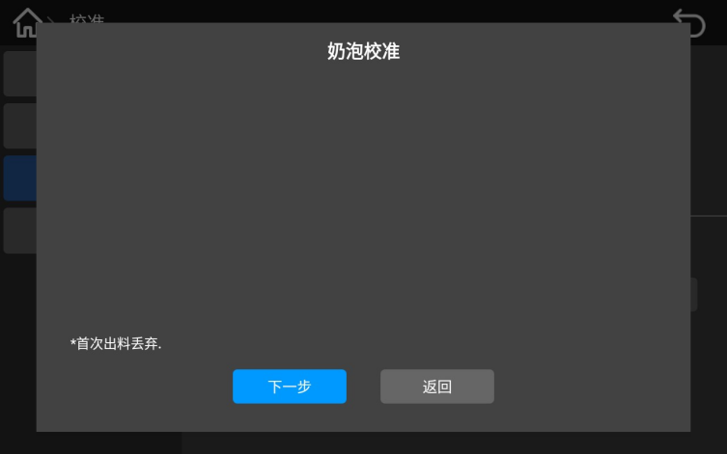
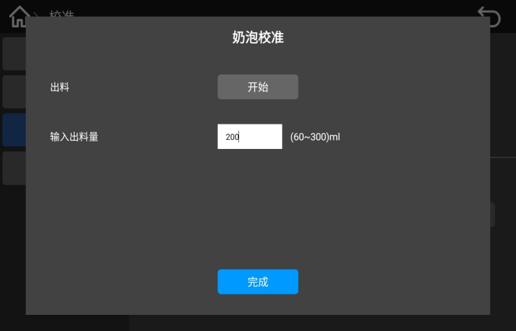

Remove the milk foam in the first measuring cup, rinse the cup and place it directly below the outlet; click the "Next" button; click start in the interface. After the milk bubble is out, check the value of the milk bubble in the measuring cup, fill in the read value in the blank of "input output quantity", and click the "Finish" button.

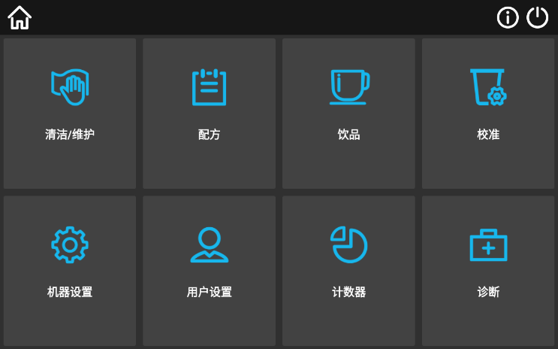
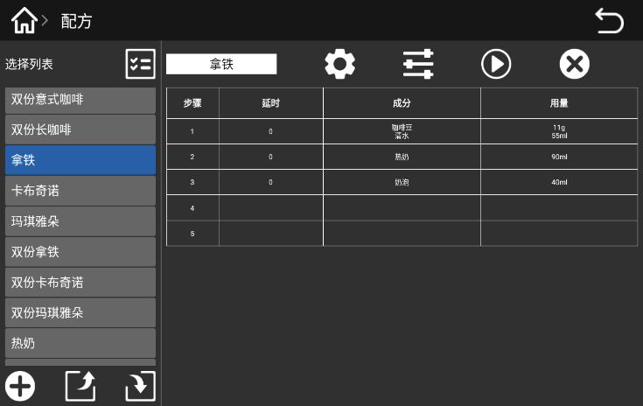
Product testing and adjustment







Click on "Recipe"，Choosing the corresponding drink will pop up the corresponding formula，Click " Test ”can test drinks；recipe interface include“select list ”、“add recipe ” “export recipe ”、 “import recipe ”、“Setting ”，“Edit ”、“Test ”、“Delete ”Enter the recipe interface，choose product，click“Edit”，Can adjust the water volume of drinks (ml), material quantity (g), hot milk, milk foam, discharge time (s). After modifying "Save", you can directly click "Test".

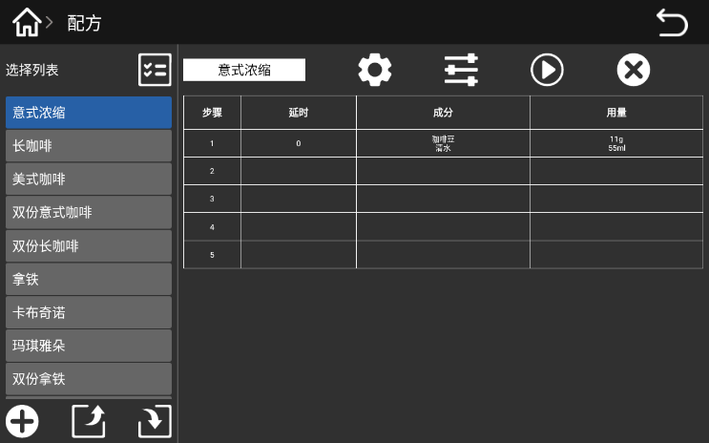
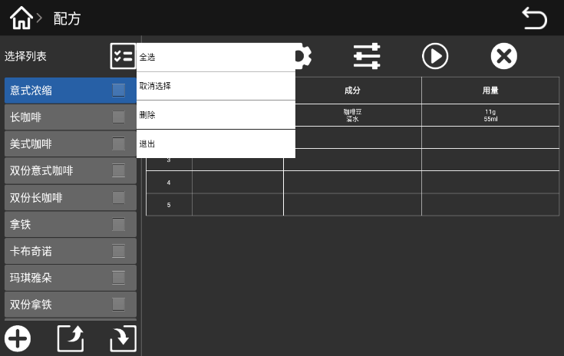
Select list

The selection list includes: select all, unselect, delete, exit, button; you can delete the formula in the recipe list.

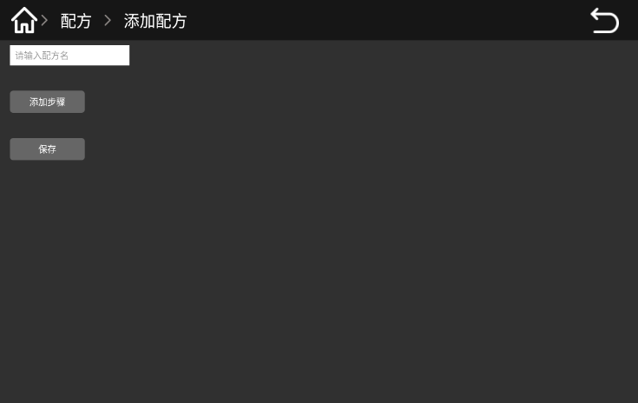
Add recipe

Enter the recipe interface，Click the "Add recipe" button，then input the recipe name.
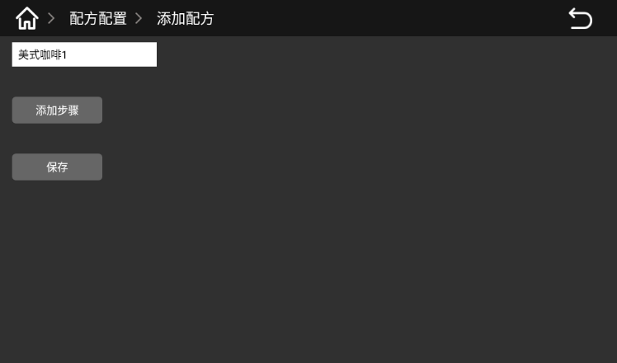
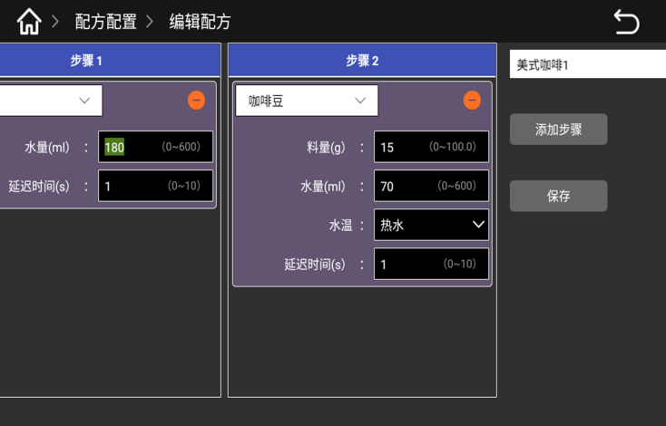

Click“add step”，input the parameter in the pop-up interface，the rate of water&powder，confirm the recipe is ok，click“save”button，Select the new recipe in the recipe interface and click the "Test" button，taste it and modify the recipe until you satisfy.

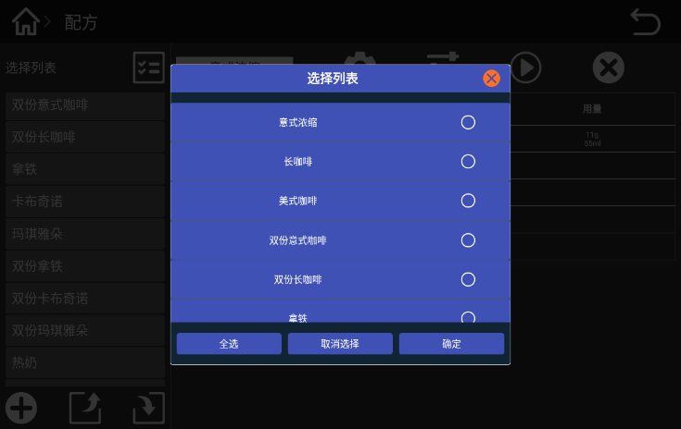
Export recipe

Click“Export recipe”button，select the recipe need to be exported (it can be single, multiple, all)，then click“ok”button，the exported recipe is stored inside the machine-Jetinno file，named it according the date such as 2024_05_13_12_11.Recipe

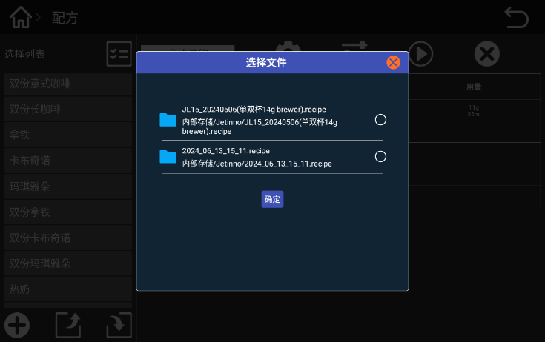
Import recipe

Click“Import recipe”button，Select the recipe file to be imported in the pop-up dialog box——The corresponding formula is selected according to the brewer configured by the machine（14g brewer/20g brewer），then click “ok”.
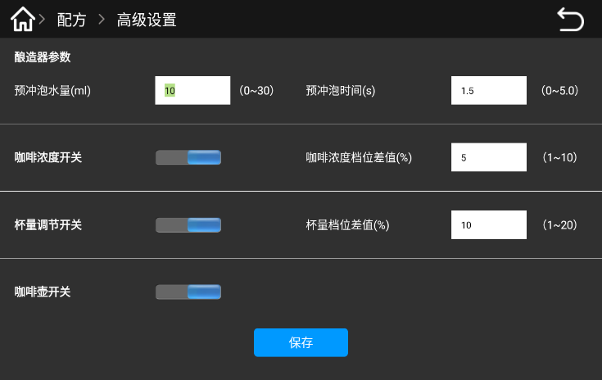
Recipe setting

Click“recipe setting”button，in the pop-up dialog box is the advanced setting of the recipe：Set the pre-brewing water quantity, time, coffee concentration level difference (%) and cup size level difference (%) in the brewer parameters。

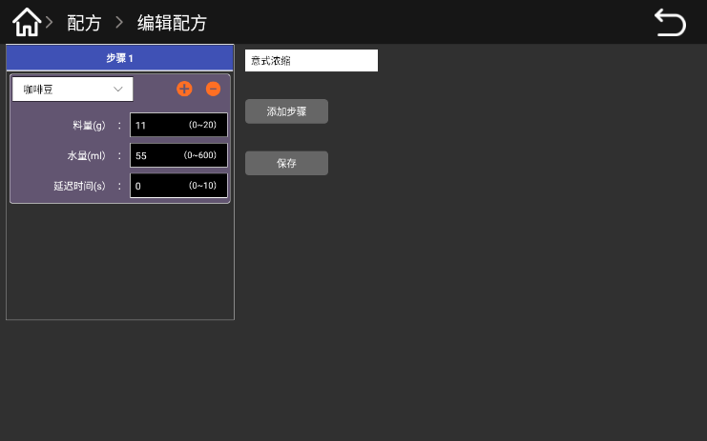
Recipe edit

Click “Edit”button，can modify the water volume and powder quantity，after modify the parameter click“save”button.And click“test”button can make the drink可以制作饮品。

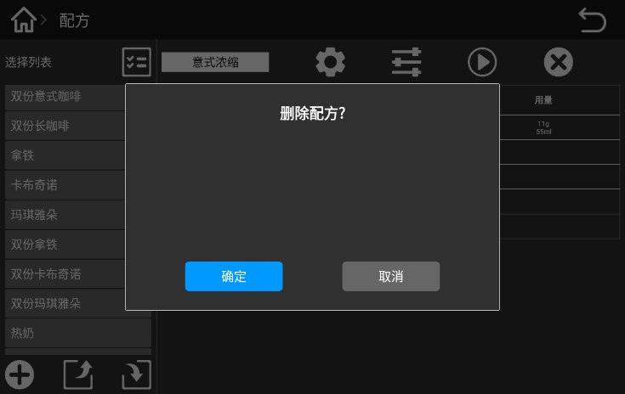
Delete recipe

Click on the "Delete" button，then click“ok”button.The recipe for all drinks will be deleted and all drinks will not exist，background "drink" management interface and UI（order）interface will be blank.
Tips:：If you accidentally delete the recipe，you can import the default recipe file on the Jetinno folder.

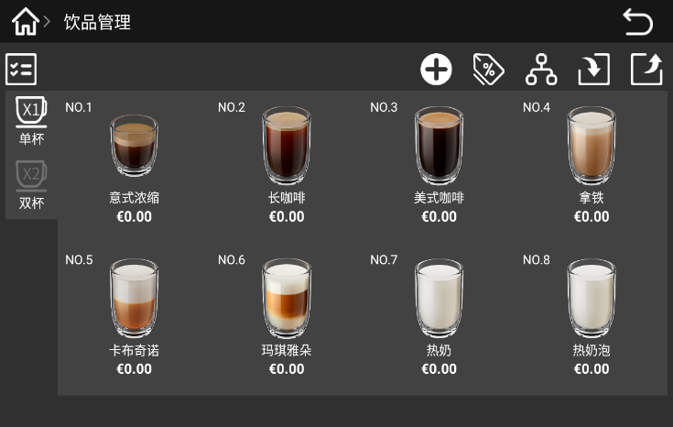
Add drinks

Click“Drinks”button，then click“add drinks”.
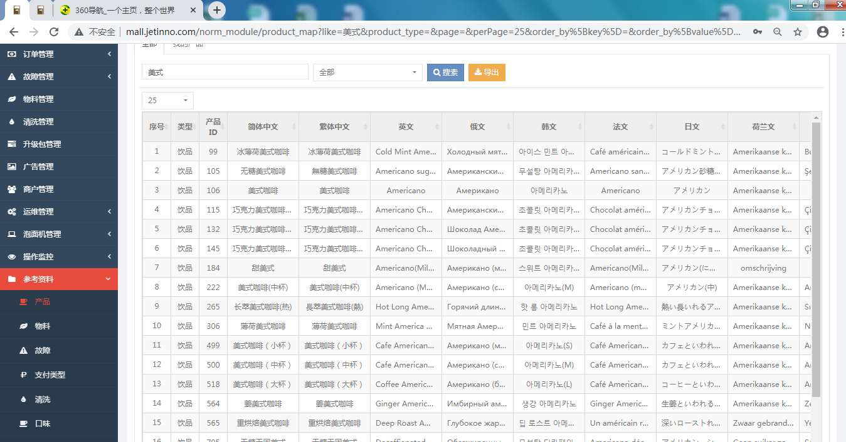
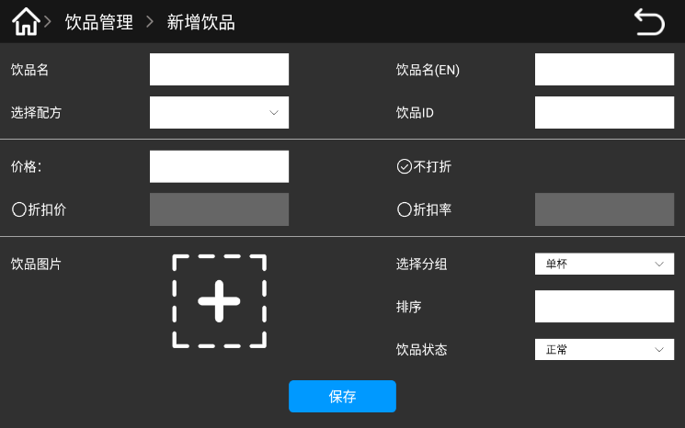

Enter the drink name and drink ID in the pop-up interface、（The drink ID and the name can be obtained through the network management background-reference materials-after search，The drink ID and name can be customized when the machine uses the offline mode or the sales data is not counted）.Choose the recipe，Enter the drink production time, price, ranking, selection of drinks pictures and drink status、single cup / double cup、then click “save”button.New drinks will be displayed in the drinks management interface；click the upper left corner back to the order interface，the new drinks will be displayed.

Drkins

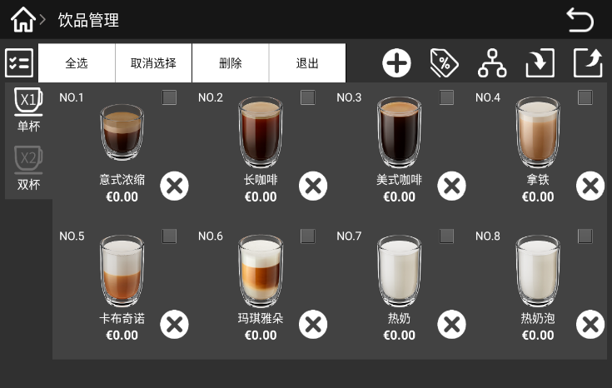
Enter the machine management background，Click "Drink" button，Drink management includes: selection list, single-cup / two-cup switch, adding new drinks, drink price, drink grouping, importing products, exporting products, and editing drinks。

Click“select list”，The pop-up dialog box contains all, select, unselect, delete, exit, button; select the drinks to delete the drinks in the drink list。
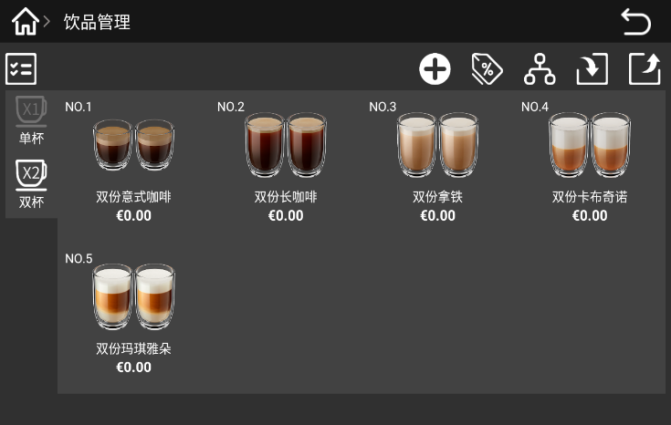

Click“Single cup”button，it will be highlighted，and will display the single cup drinks.Click the "Double cups" button to highlight the double drinks.
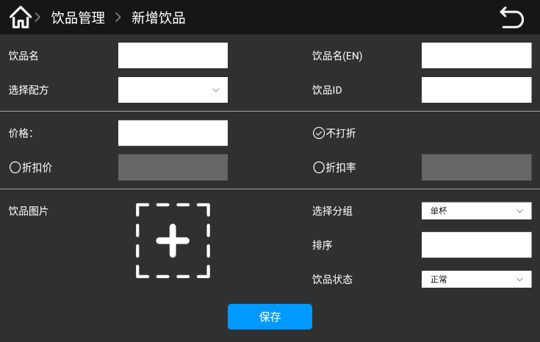

Click“Add drink”button，select the corresponding recipe，Enter the drink name, drink ID, drink production duration, price, ranking, select a picture of the drink, drink status, single cup / double cup、after confirmation, click the "save" button to add the new drinks.
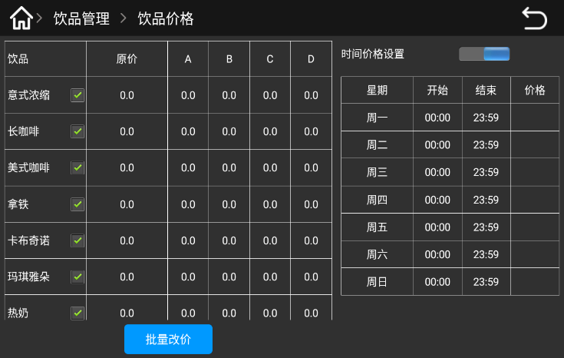
Tips：Before adding a new drink, the first new drink in the drinks setting。

Click“price”button，In the pop-up interface, you can change the price in batch and set different prices in different time periods；Set the price of a single product. Just click the price after the drink name, enter the price in the pop-up interface, and click the "Save" button
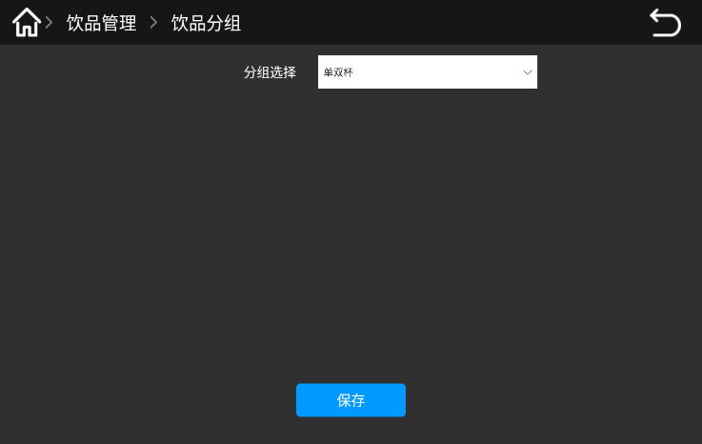

Click the "Drink Group" button to group the drinks in the pop-up interface. After grouping, click the "Save" button.
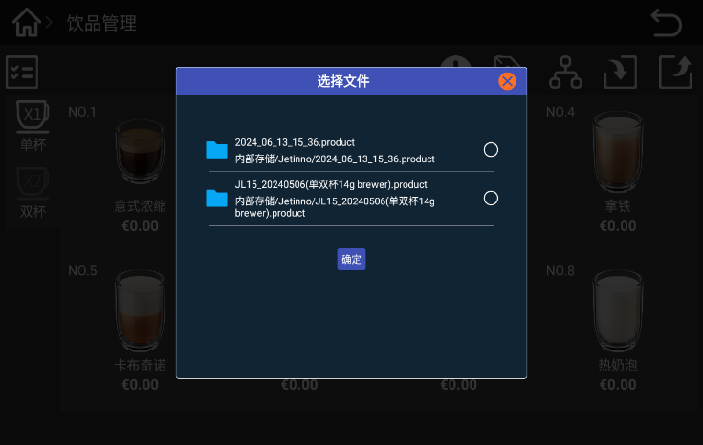

Click the "Import Drink" button, select the drink to be imported in the displayed dialog box, and then click the "OK" button. Import drinks You can select a new drink file to import a new drink list from the configuration file.
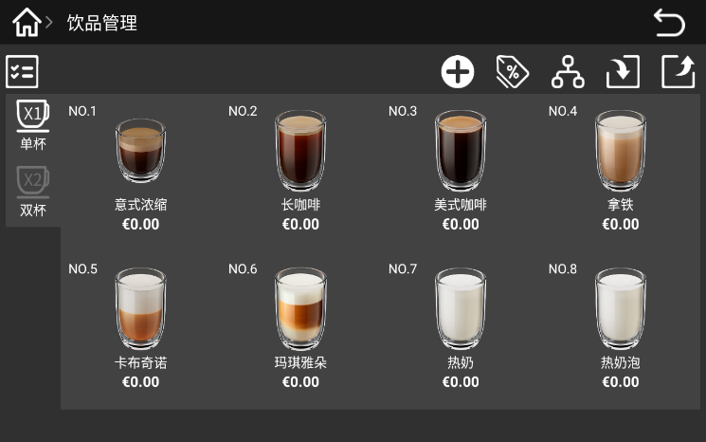
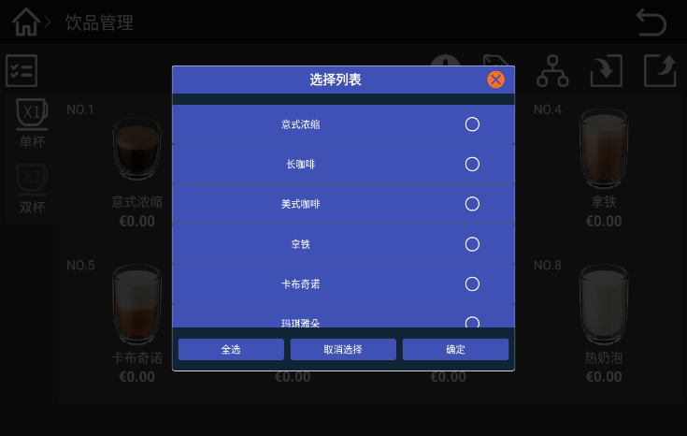

Click the "Export Drink" button, select the drink to be exported (either single, multiple, all) in the pop-up dialog box, and then click the "OK" button, the exported drink is stored in the machine, named after the current time on the machine.When using the Export-out button, it is recommended to export both recipes and drinks.When using the import in button, pilot the recipe and then guide the drink.
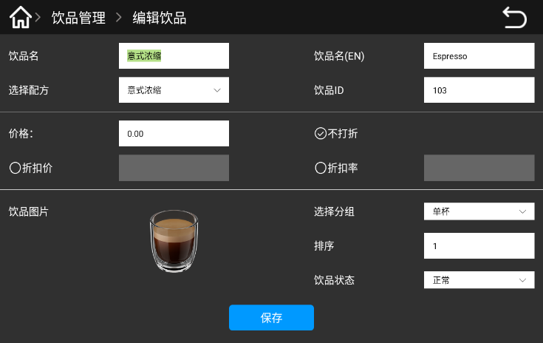

Click“Drinks”button，In the pop-up interface, you can edit the drink, modify the name, price, discount, group, sort, normal/off the shelf. If you choose to take a drink off the shelf, the drink will not be displayed in the sales interface.

Set sales mode
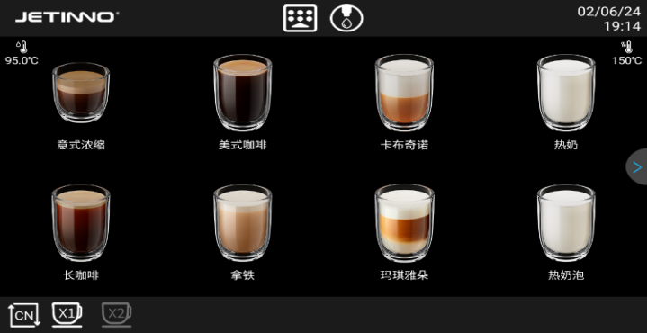
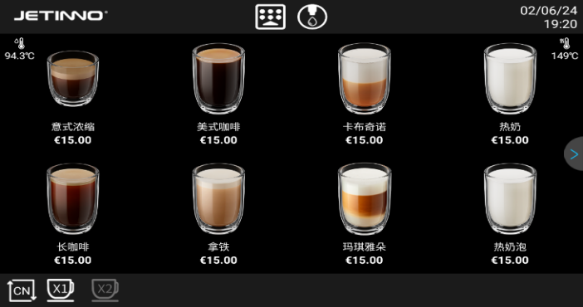

Free mode–No product price Pricing mode-with the price
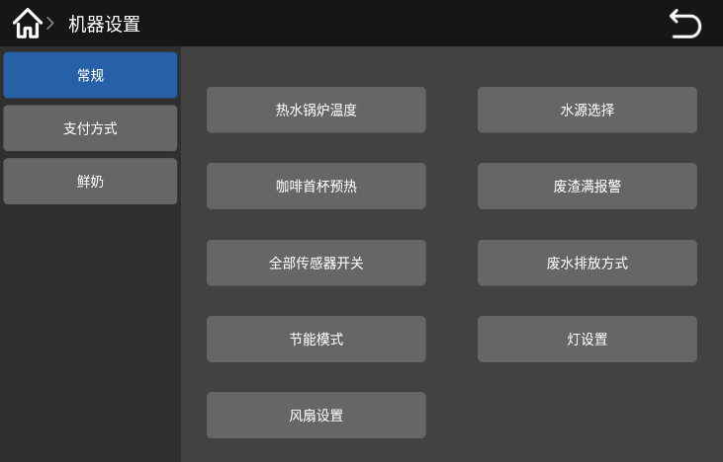

Enter the management background，click“machine setting”，then choose“payment mode”option.
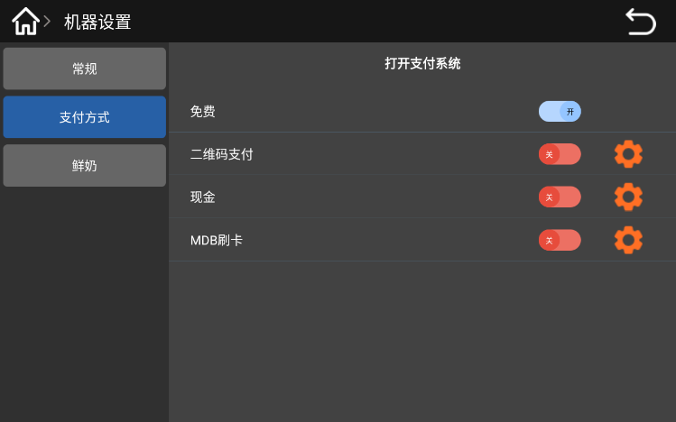
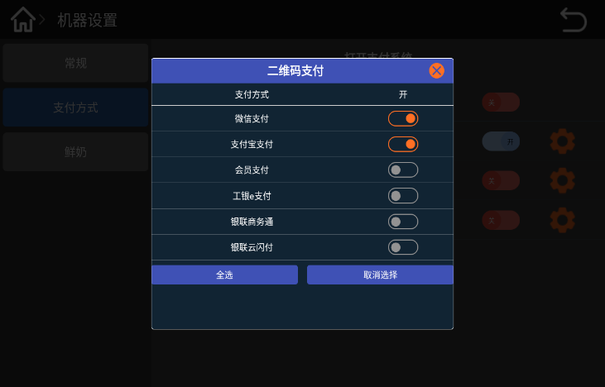

If open the free mode，it means no need to pay; Click the "QR code payment" switch, select the payment method (wechat Pay, Alipay Pay) in the pop-up dialog box, and turn on the switch;When the external payment device has been connected, click the "cash, MDB card" switch to open the payment mode，After ordering, the machine can only make the product after the successful payment.
Offline mode switch: Offline mode in free mode; offline mode in payment mode to ensure normal network. Reference to the previous section 6.2 for connecting to the server.

Drink making
Place the cup under the outgoing mouth, and select a drink from the display screen；
Adjust the taste and cup size in the touch screen, and then confirm；
In free mode or set to the price to 0, the machine directly drinks; in payment mode, several payment methods (WeChat, Alipay, credit card payment, cash payment）；
After the payment, the machine automatically starts making drinks；.
After the beverage is made, there will be a prompt on the touch screen interface；

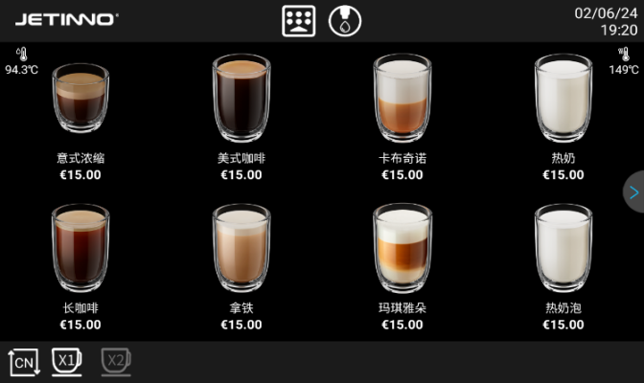
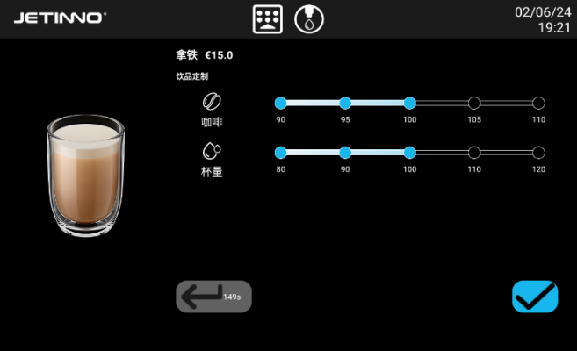

1、Product list page 2、Concentration and cup volume adjustment.
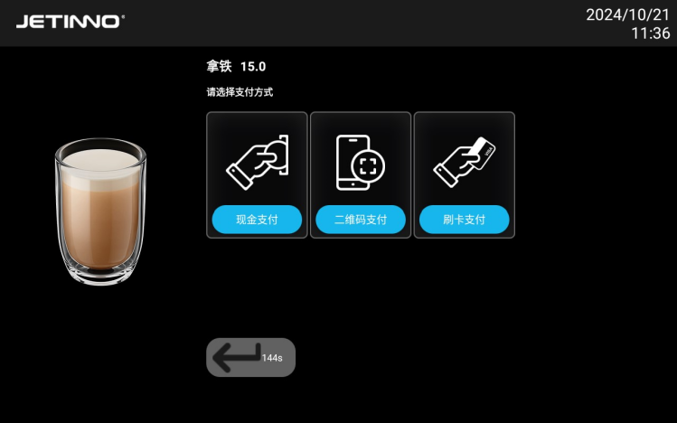
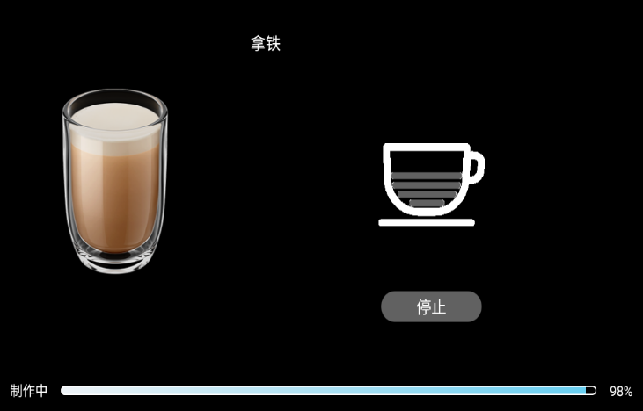

3、Payment page, QR code, cash, MDB payment 4、Product production page

User Settings
User settings include: general settings, UI settings, APP operations, software upgrades, export data options。
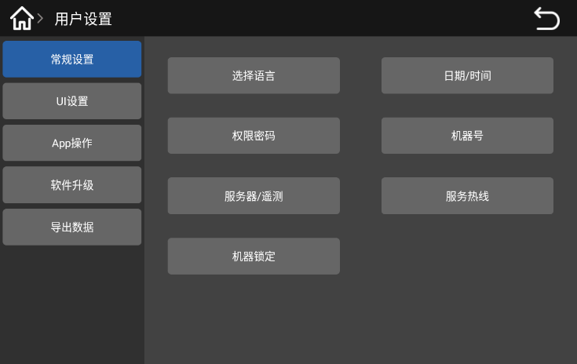

General settings: you can set the machine language, date / time, user rights, machine number, server / telemetry, service hotline, and machine lock.
UI setting: display switch, point single mode, custom UI

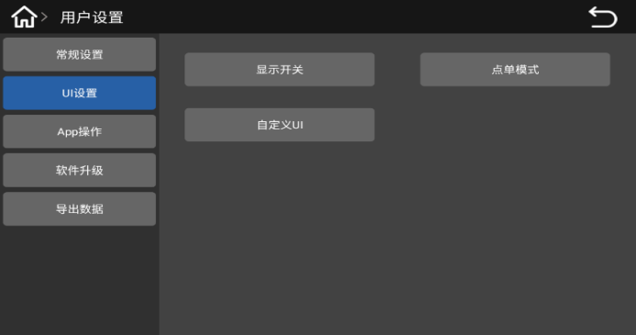
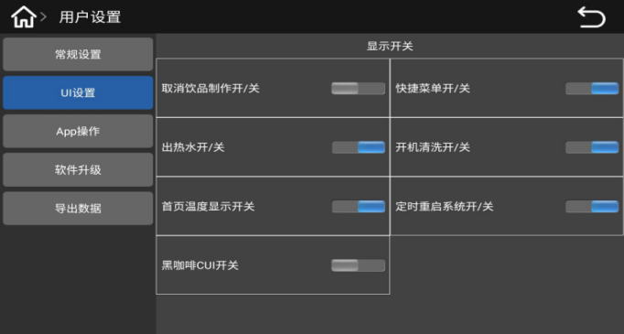

The display switches include: cancel the drink production on / off, on / off the shortcut menu on / off, hot water on / off, boot cleaning on / off, home page temperature display on / off, regular restart system on / off, black coffee CUI on / off
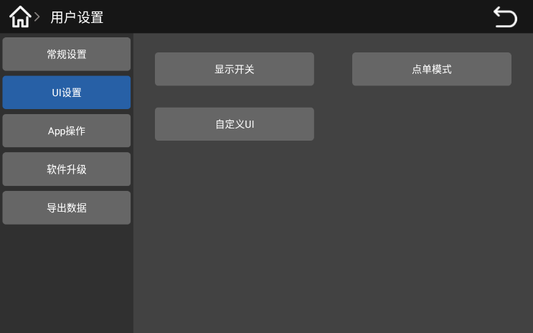
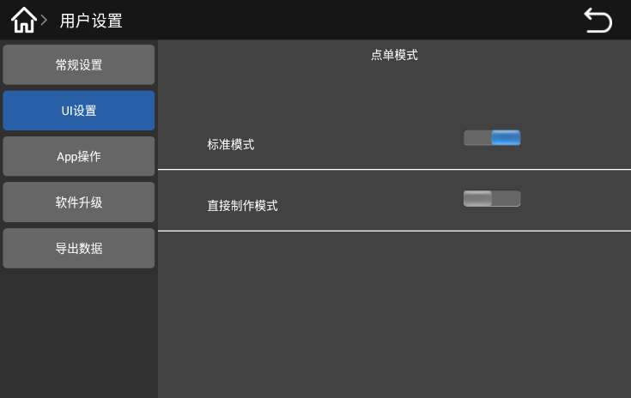

Order mode: standard mode, direct production mode
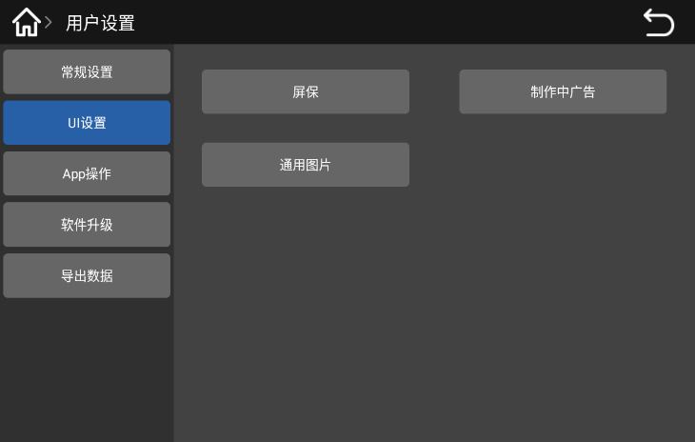

Custom UI: screensaver, advertising in production, general pictures
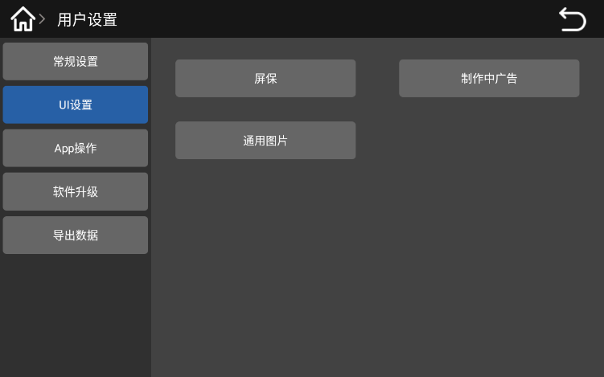
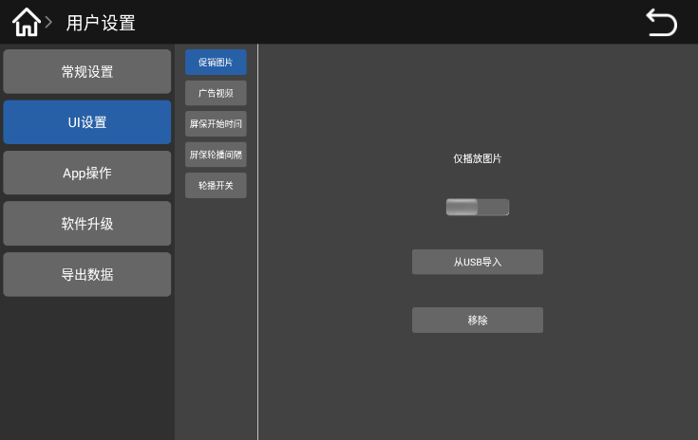

Screensaver: promotional pictures, advertising videos, screen warranty start time, screen warranty rotation interval, rotation switch, import and removal functions
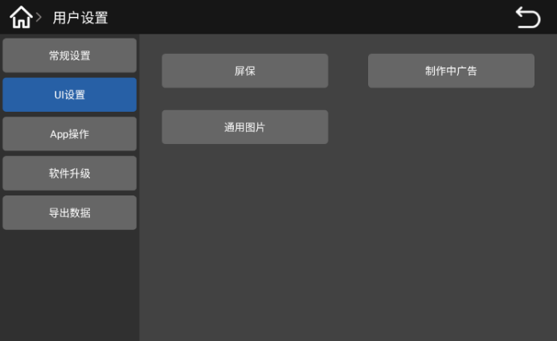
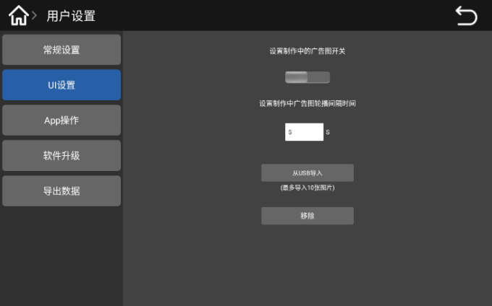

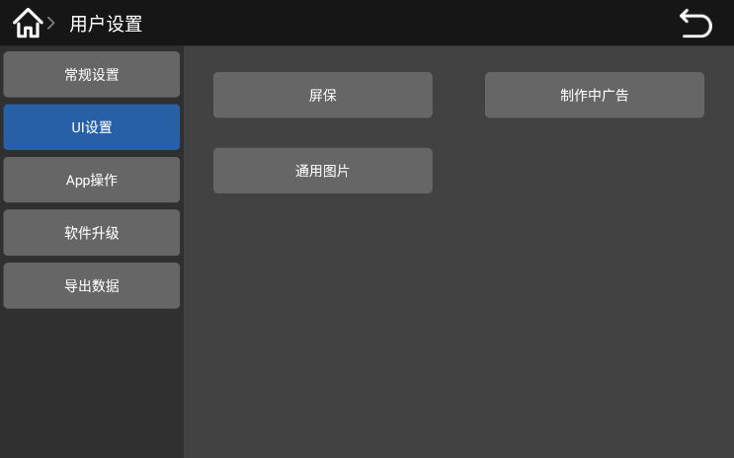
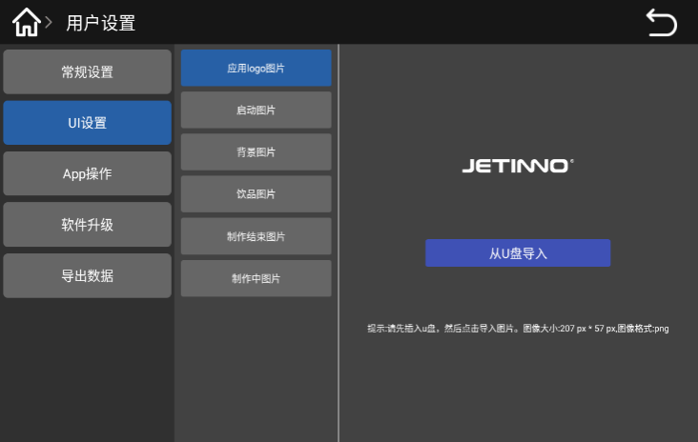
In the production of advertising: set the switch of the advertising picture in production, set the advertising picture in production, the rotation broadcast interval time, import and remove button。

General picture: Apply logo picture, start picture, background picture, drinks picture, finished picture, and picture in production; copy the picture into the U disk, insert the USB interface on the right side of the display screen, and click the import button from U disk on the interface.
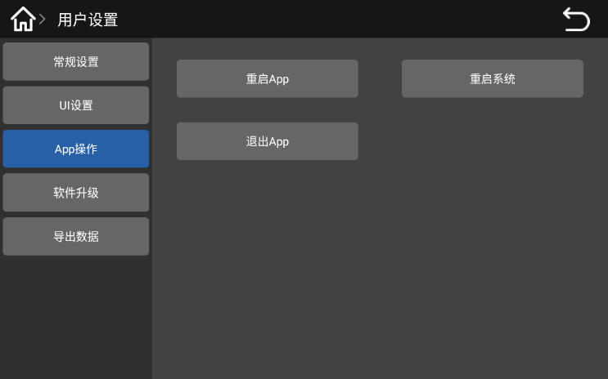
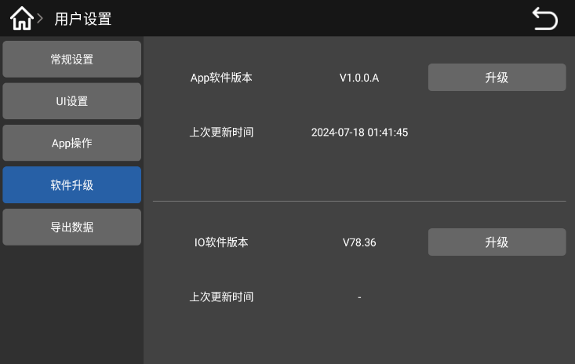

APP operation: restart APP, restart the system and exit APP; software upgrade: APP upgrade and IO software upgrade, copy the upgrade package to the U disk, insert the U disk into the USB interface on the right side of the display, click the upgrade button, select the upgrade package, click the OK button, and wait for the upgrade to be completed.

Set the date / time
When the user receives the machine connection network, the machine system time is automatically updated and synchronized with the local time; when used offline, the updated system time cannot be synchronized with the local time, so the local time must be set manually. The specific methods are as follows：
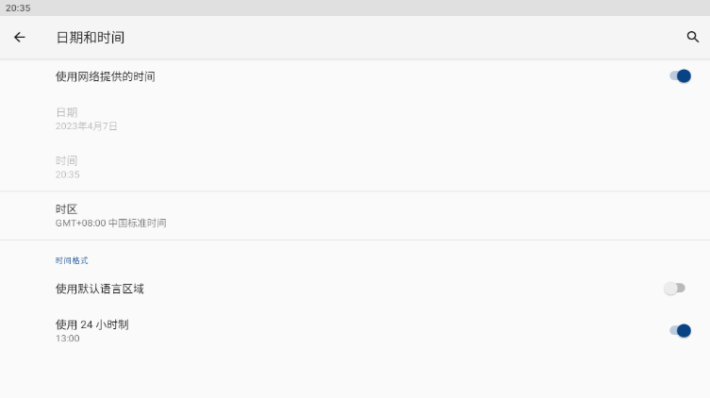
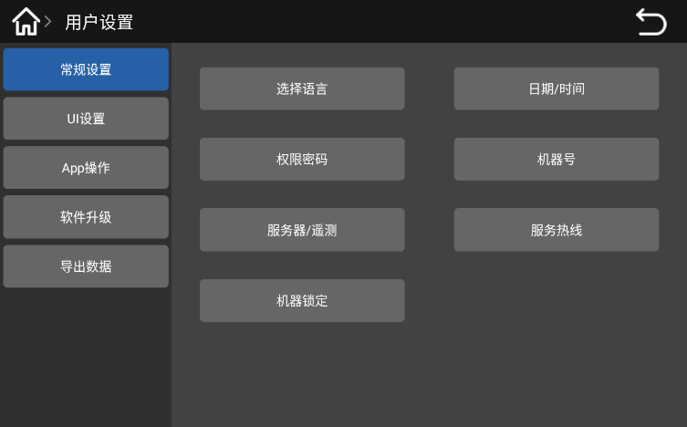

Enter the background of the machine and click "User Settings-> General Settings-> Date Time". In the pop-up interface, use the time switch provided by the network to open, and the system time will be automatically updated and synchronize with the local time；
In offline mode, click Use the time switch provided by the network to turn it off, and manually Set Date, Set Time and Select Time Zone.Click ，Return to Android interface，click“Coffee”icon，re-enter the application.

Empty


Coffee waste bin
High temperatures may cause damage
Do not use the dishwasher to clean the powder residue cartridge

► Remove the coffee waste bin from the machine.
► Empty the coffee waste bin and clean it
► Dry or wipe the waste bin and push back into the machine to the innermost position。
The machine is ready to run.

Water drip tray
Push the outgoing mouth up to the top position
Pull out the drip tray outward。
Before removing the drip tray, ensure that the drink output does not occur。


Transportation condition
Improper transportation of the coffee machine may result in injury
Pay attention to the general health and safety instructions
► Before changing the position, please disconnect the drinking water source and empty the water channel, refer to Section 7.7。
► Check the ground for obstacles and bumps before changing the position
Improper transportation may cause damage to the machine.
The following points must be noted when replacing the machine position with a trolley：
• Considering safety factors, do not push the cart, only drag
• Can only tow the carts, not the tractor vehicles
The manufacturer shall not be liable for any damage caused by the misuse of the cart or the failure to comply with the instructions for use

Power off

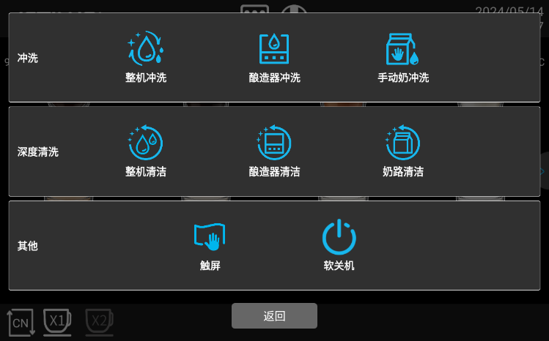
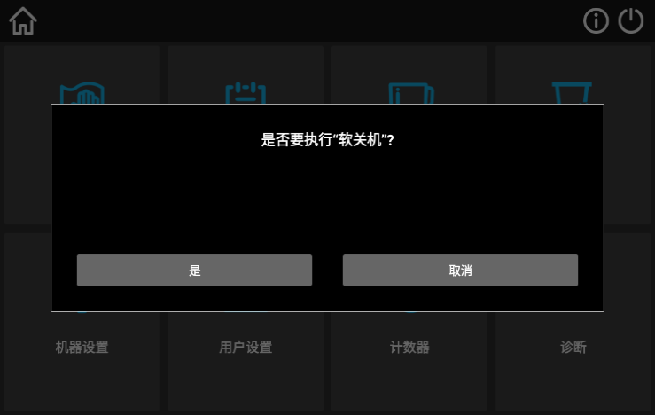
End of run

Click the "Quick Maintenance menu" button on the screen，click on the "soft shutdown" button，then click “Yes”， machine automatically turns off the machine after performing the automatic flushing，At this point, the application exits, and the display screen closes. When you need to start, long press the screen, and the application starts.
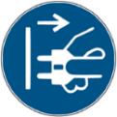
In the standby mode, the machine is still powered on
Do not remove the chassis
Power off the machine before the maintenance operation
► If not started, start machine cleaning in the machine background management (cleaning will begin)
► Do daily and weekly cleaning, when required.
► Empty down and clean the drip tray。
See the Clean-up section for specific data
After the automatic cleaning, close the machine door, small door, and unplug the power plug.

Long downtime (more than 1 week)
In case of long downtime such as vacation, the coffee machine and other ancillary equipment must be turned off
► Perform Fresh Milk Cleaning in the Cleaning section
► Pull out the power plug or turn off the switch on the device to power off the machine

Clean
Thorough cleaning and maintenance are the basic requirements to meet the food hygiene conditions. Only regular maintenance, cleaning and maintenance (twice a week or to improve the cleaning frequency), can the machine provide superior taste drinks and satisfy the customers

Cleaning interval
Cleaning interval
everyday | erveryweek | Custom | Custom
wash；rinse；rinsing；flush(ing)；lash
X |  |  |  |  | The whole machine rinse | 7.3.1
X |  |  |  |  | Brewer rinse | 7.3.2
X |  |  |  |  | Hand milk washing | 7.3.3
Deep cleaning
X |  |  | X |  | Clean the whole machine | 7.5.2
X |  |  | X |  | Brewing cleaner | 7.5.3
X |  |  | X |  | Milk road cleaning | 7.5.4
X |  |  |  |  | Timed cleaning (set time cleaning) | 7.5.5
Manual cleaning
X |  |  |  |  | Clean coffee residue box | 7.5.6
X |  |  |  |  | Clean the drop of water | 7.5.7
X |  |  |  |  | Clean the tray | 7.5.7
X |  |  |  |  | Clean the foam | 7.5.8
X |  |  |  |  | Clean coffee mouth | 7.5.8
X |  |  |  |  | Clean the wet air duct | 7.5.9
X |  |  |  |  | Clean the touch screen | 7.5.10
 | X |  |  |  | Clean Coffee Hopper | 7.6.1
 | X |  |  |  | Clean the coffee maker and the refrigerator exterior
 |  | X |  |  | Clean the water tank (use bottled water, direct drinking water)
 |  | X |  |  | Remove the brewer for the cleaner | Refer to the maintenance manual
conventional signs
Every day： |  |  |  |  | Perform at least once a day and increase the number if necessary
Every week： |  |  |  |  | Perform at least once a week and increase times if necessary
Custom： |  |  |  |  | According to the demand (when contamination occurs)
Custom： |  |  |  |  | According to the demand (when contamination occurs)

Clean plan
The following two cleaning plans are available for technical service personnel configuration：
• “Jetinno Intelligent Default " (standard) cleaning plan
• A "Manual" cleaning plan。

The cleaning intervals described in this chapter conform to the cleaning plan. These Settings comply with the Health Management Code for Existing Vending machines.
When the cleaning level is set to None, the operator is responsible for performing the necessary cleaning work.
The screen displays messages about pending or executed cleaning, depending on the configuration selected in the cleaning plan

Wash everyday

The whole machine rinse
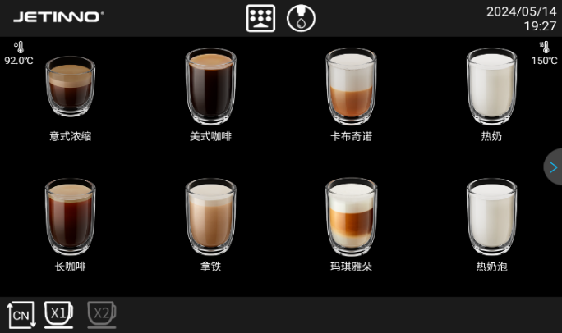
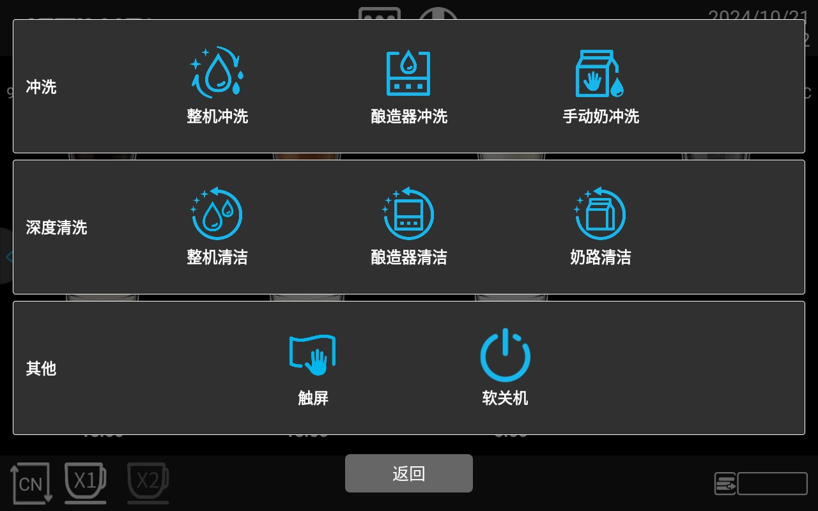
The whole machine flushing is to flush the whole water system of the machine, including brewer module flushing and milk circuit module flushing; the whole machine flushing takes about 2 minutes。

Click the "Quick Maintenance menu button" button, and click the "complete machine flush" option in the pop-up interface。
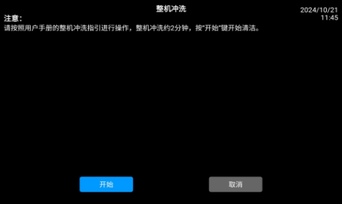
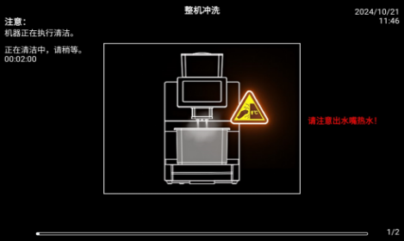
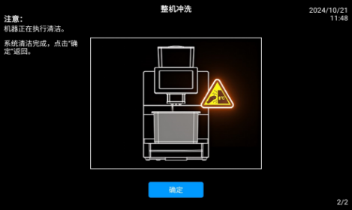

Click "Start" button to perform the washing procedure, click "Cancel" and press to return to the previous layer; click "Start" button, the machine is cleaning, please wait..., the interface prompts: system cleaning is complete. Click on the "OK" to return to the point order interface.
Tips: customized or special function models-with a steam rod, the machine in the whole machine washing, the steam bar does not steam, to avoid burns

Brewer rinse

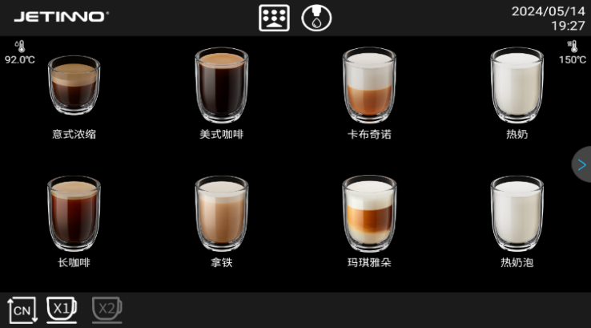

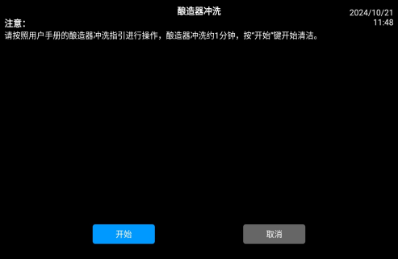
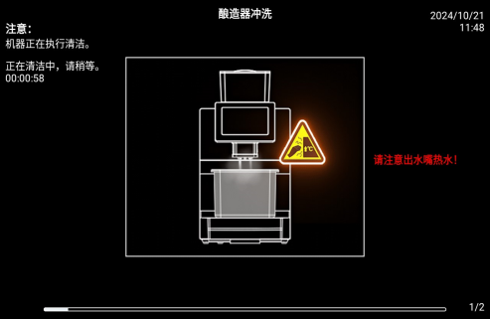
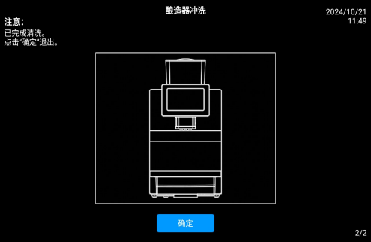
Click the "Quick Maintenance menu button" button，then Click the “Brewer Flush”option。

In the pop-up box, there are "OK" and "cancel" buttons, click "OK" to execute the washing procedure, click "cancel" to return to the previous layer; click "OK" button, the machine is cleaning, please wait..., complete, the interface prompts: finished cleaning, click "OK", return to the order interface

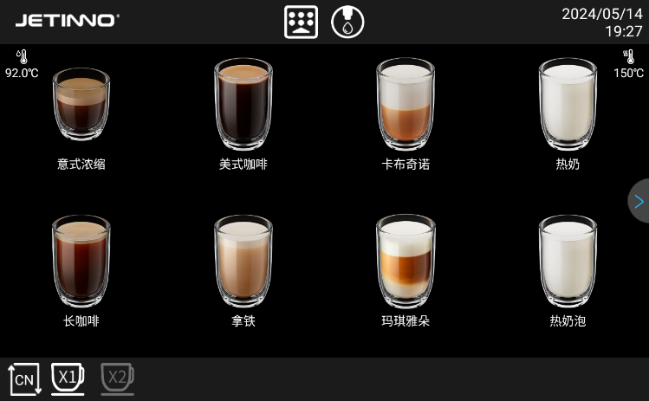
Milk Circuit flushing

Click the "Quick Maintenance Menu" button, in the pop-up interface, select and click "Milk Circuit rinse"。
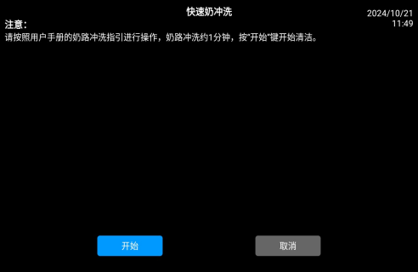
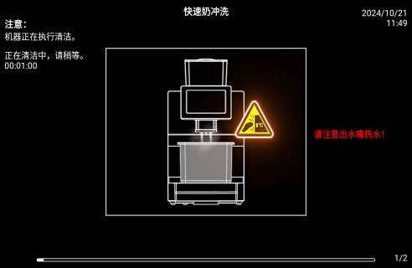
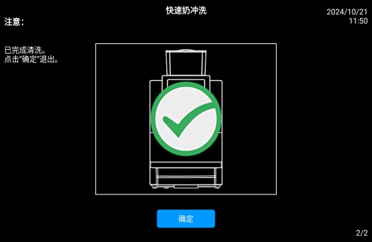

In the pop-up box, there are "OK" and "cancel" keys, click "OK" to execute the washing procedure, click "cancel" to return to the previous layer; click "OK" button, the machine is cleaning, please wait..., after completion, the interface shows: finished cleaning, click "OK", return to the order interface.

Cleaner

Cleaners can cause poisoning！
Only the cleaners recommended by the equipment manufacturer are allowed
Cleaners should be kept away from the children

Do not eat or touch detergent with hand
The instructions and the package must be carefully read before using the detergent. If the safety data sheet is not provided, please request it from the dealer.

Use of the wrong detergent may damage the machine！
Conduct daily and weekly cleaning with only the detergent recommended by the manufacturer
Brewer cleaner cleaning pills
Information
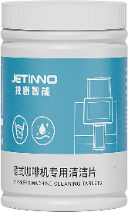 | Use | Coffee machine system cleaning
 | Clean purpose | Remove the oil residue in the coffee system
 | Use interval | If you make 30 cups of coffee a day, it is recommended to use one piece every two days. If you make more than 100 cups a day, it is recommended to use one piece a day
Information
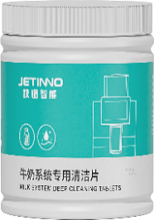 | Use | The Milk Circuit system is clean
 | Clean purpose | Remove the residues in the Milk Circuit system
 | Use interval | Daily (recommended before half an hour)
Milk stain cleaning pills: They dissolve quickly in warm or cold water. Contains cationic surfactant to improve the safety and strength of cleaning. Mix ratio: mix 1 piece with 250 ml of water

There is a danger of scald injury. When the machine, the drink outlet output hot water
Do not extend your hand under the drink outlet during machine flushing

Daily machine cleaning

Display screen guides the cleaning program
Prepare the equipment required for cleaning
Brewer cleaning piece [1 piece].
Milk stain cleaning pill [1 tablet].
Household washing aid.
Clean Kitchen Clean Towel [2 pieces]
Collect containers

Start the cleaning program
Cleaners can cause poisoning. Cleaned machine parts are contaminated with detergent
Physical health causes harm
Please wear the gloves during the cleaning procedure.

High temperature liquid will be output during the cleaning program operation. Do not extend your hands to the flow outlet position during the cleaning period
Below, otherwise there is a risk of scald.
The blockage of the wastewater drainage will cause the drip tray to overflow
Check the waste water drain outlet of the drip tray before the cleaning procedure begins

Cleaning procedures can be interrupted at any time. The coffee machine is not running ready after cleaning interruption. Forced cleaning procedure. Restart the interrupted cleaning program as soon as possible.
Start the cleaning program in the maintenance menu. The touch screen will guide the user to all the necessary actions。

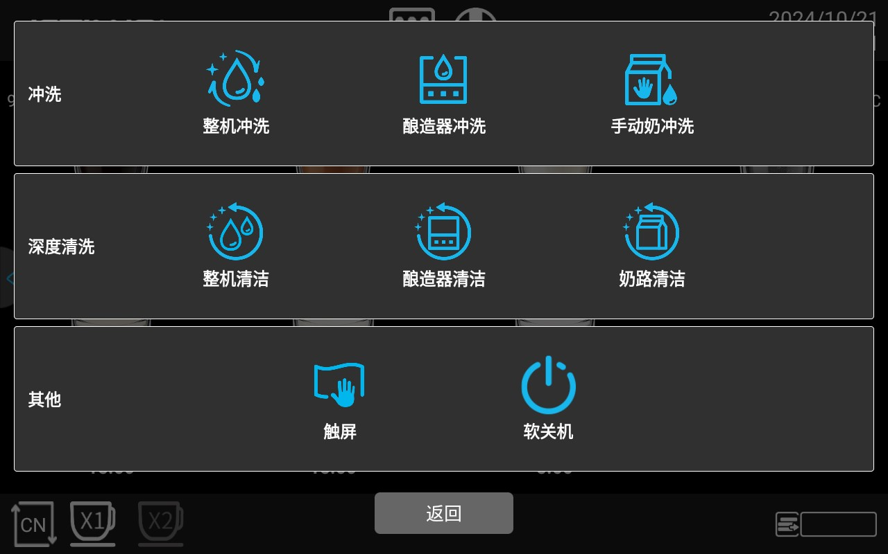
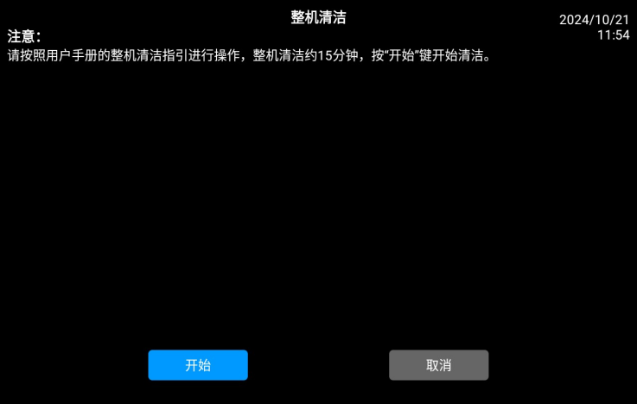
Clean the whole machine

Click the “Quick Maintenance Menu " button，select“Clean the whole machine”.Select "OK" in the displayed dialog box to go to the next step, select "Cancel" to return to the previous layer menu; click "OK" to go to the next step。
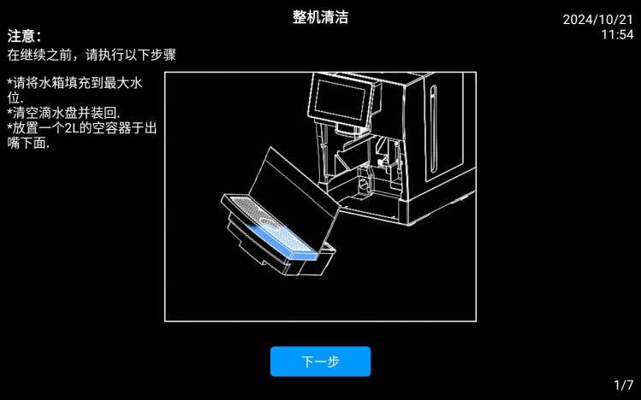
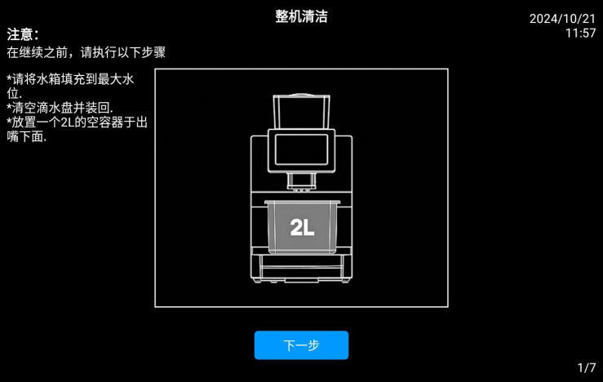

Press the screen prompt: "Please fill the tank to the maximum water level (the machine is connected to bottled water or direct drinking water can ignore this step), pull out the drip tray, empty the drip plate, waste residue box and put it back, place a 2L empty container under the outlet mouth", and click the "Next" button.
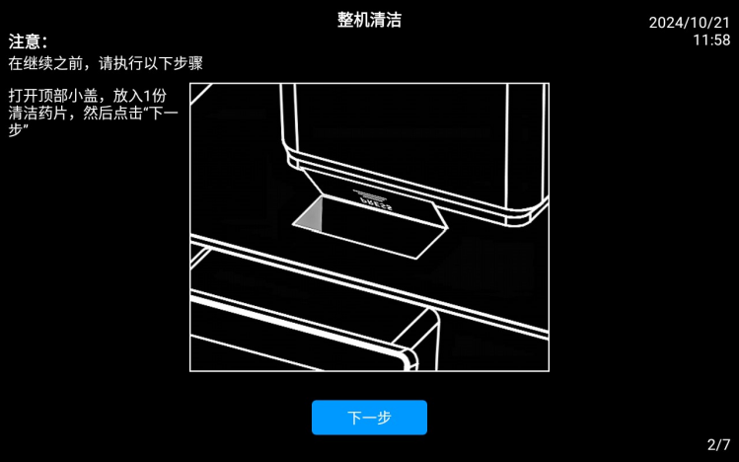
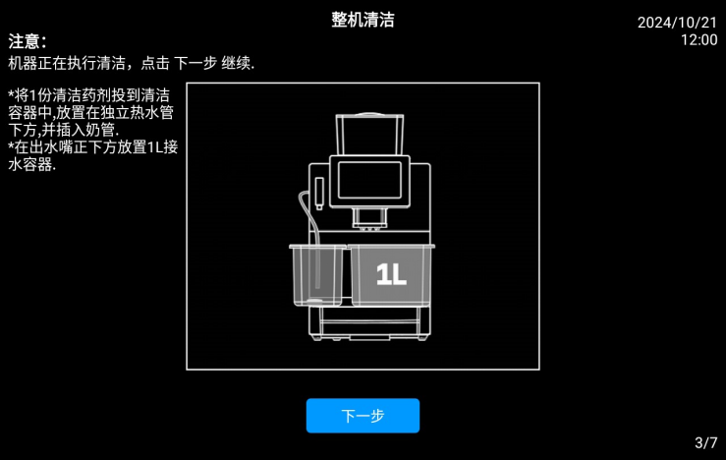


Press the screen prompt, open the top cover, add 1 cleaning pill, and click "Next" button. In the pop-up interface, it is prompted to throw 1 cleaning agent into the cleaning container, place it under the independent hot water pipe, and insert the milk tube; place 1L water container under the outlet nozzle. Click the Next step button

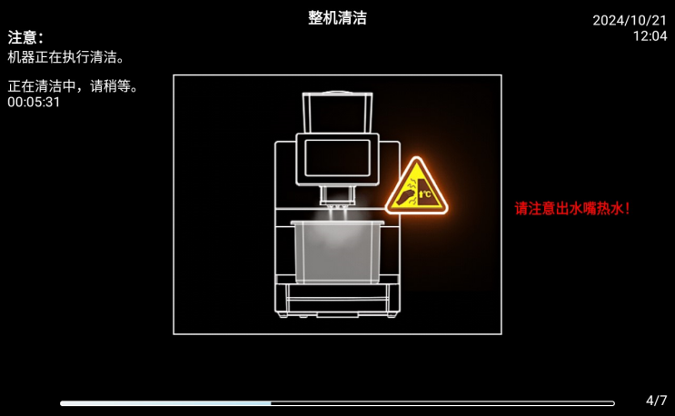
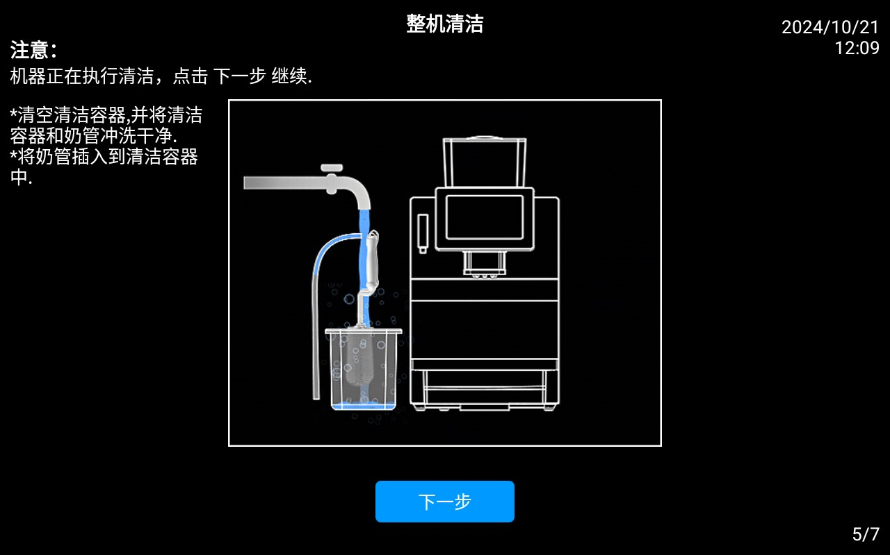

The machine is in the cleaning, please wait. After the progress is completed, a new interface will pop up. Press the screen prompt: empty the cleaning container, rinse the cleaning container and milk tube, insert the milk tube into the cleaning container, and click "Next".
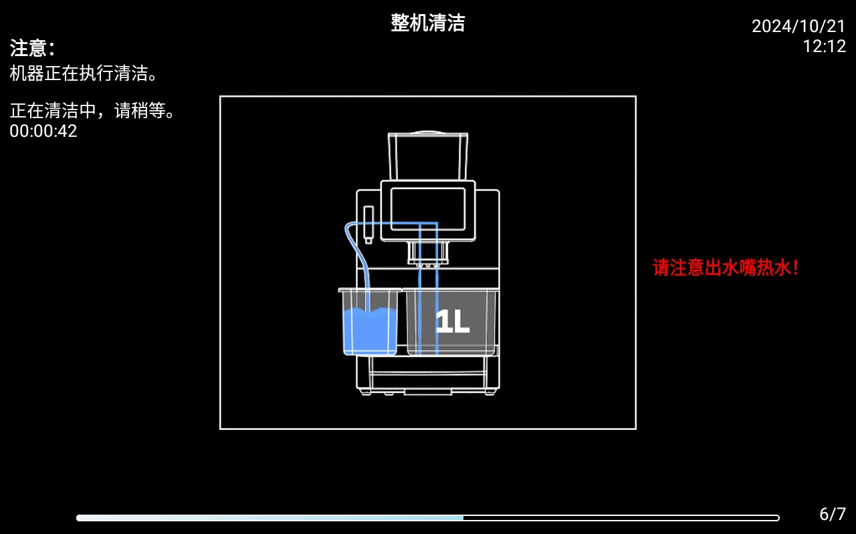
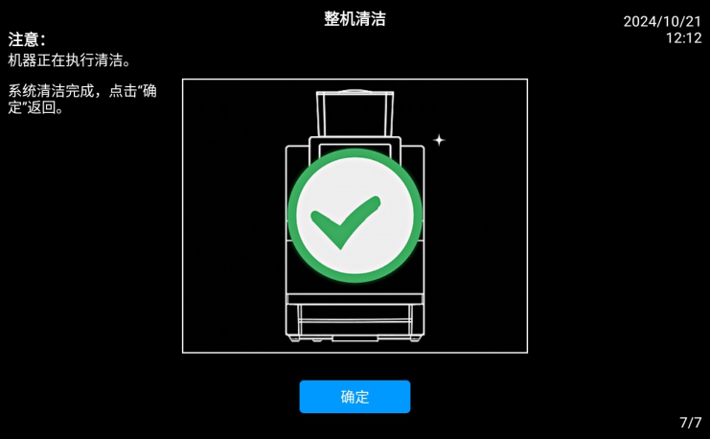

The machine is performing the cleaning process. In the process of cleaning, please wait later. After the progress bar is complete, proceed to the next interface. After the system is cleaned, remove the cleaning box, insert the milk tube into the refrigerator interface, put it in the milk box, close the refrigerator door, click the "OK" button on the interface, and return to the upper menu.

Brewer clean
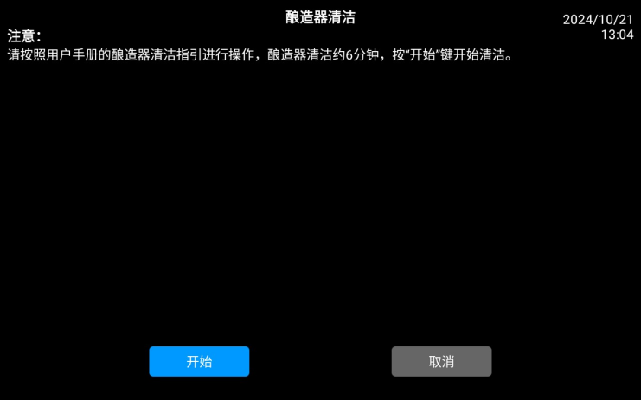

Click the “Quick Maintenance Menu button”，In the pop-up interface, select the Brewer Clean. In the displayed dialog box, select [OK] to go to the next step, select [Cancel] to return to the previous layer menu; click [OK] to go to the next step.

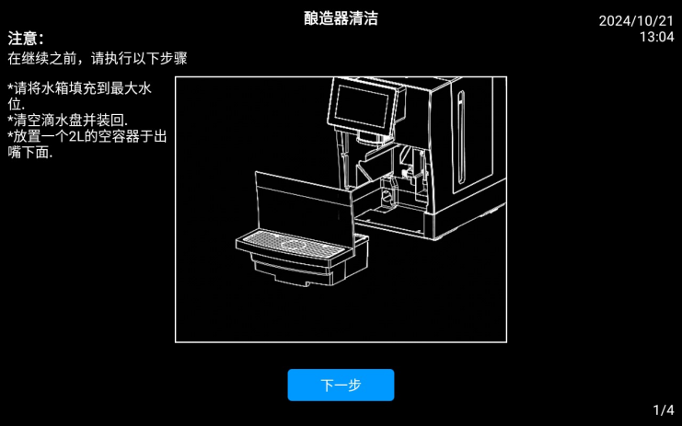
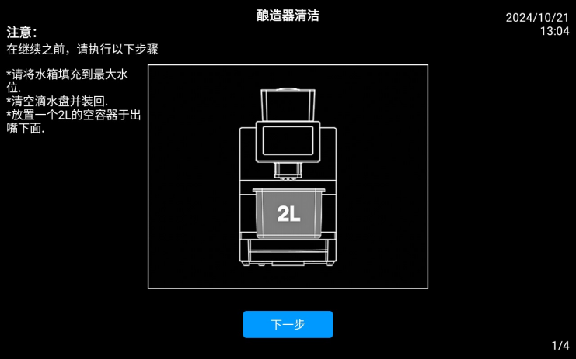

Press the screen prompt: "Please fill the tank to the maximum water level (the machine is connected to bottled water or direct drinking water can ignore this step), pull out the drip tray, empty the drip drop, waste residue box and put it back, place a 2L empty container under the outlet mouth", and click the "Next" button。
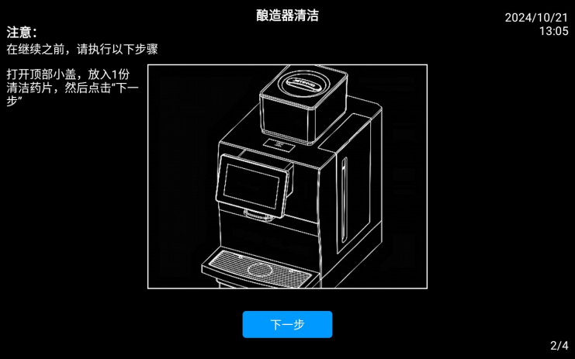
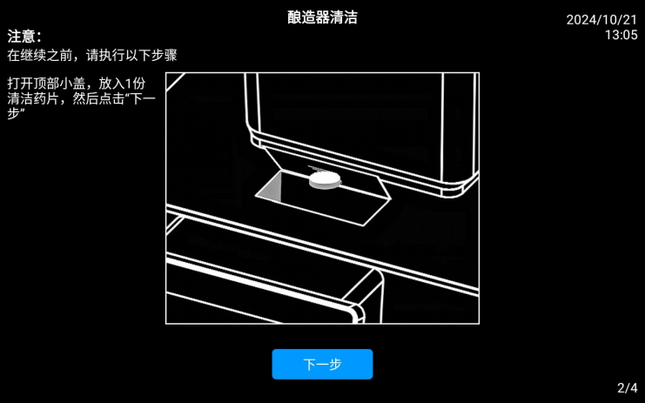

Press the screen prompt, open the top cover, add 1 cleaning pill, close the lid, and then click the "Next" button

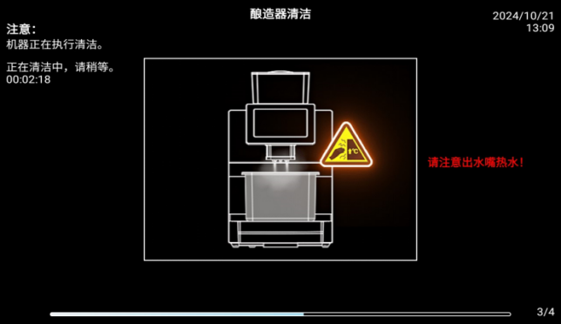
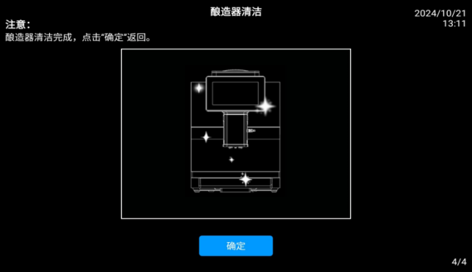

The machine performs the brewer cleaning procedure. The brewer cleaning time takes a few minutes, wait patiently until the end of the program, the interface prompts: the brewer is cleaned, click "OK", and return to the beverage interface.

Milk Circuit clean
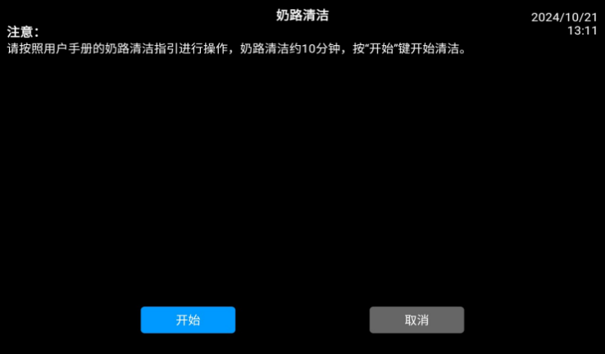
Clean daily, put the milk stain cleaning agent to the cleaning box, and insert the milk tube into the cleaning box. The specific methods are as follows：

Click the “Quick Maintenance Menu button”，In the pop-up interface, select "Milk Clean"。In the displayed dialog box, select [OK], select [Cancel] to return to the previous menu; click [OK] to proceed to the next step；
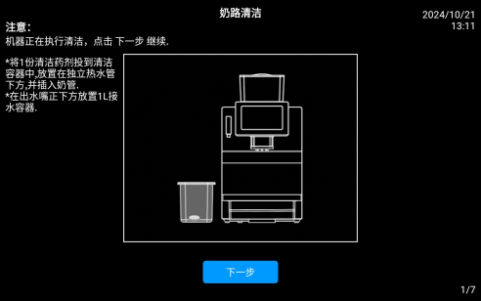
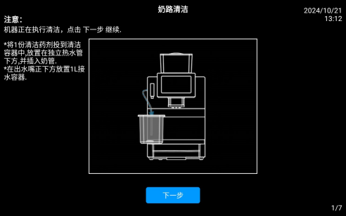
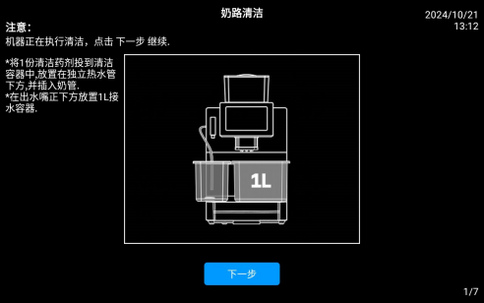

Follow the screen, place 1 piece of cleaning agent into the cleaning container, place it under the independent hot water pipe and insert the milk tube; place the 1L water container under the outlet nozzle and click "Next"；
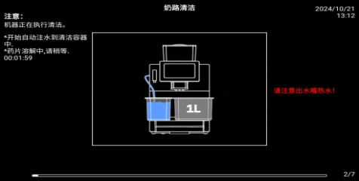
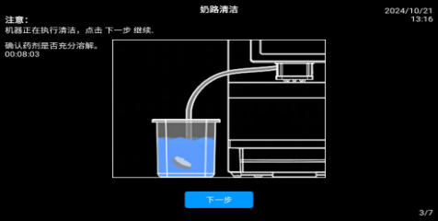
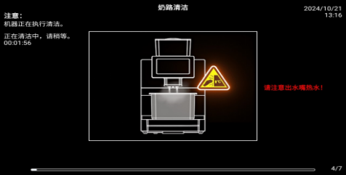

The machine is performing cleaning, start automatic water injection into the cleaning container, tablets dissolving, please wait. Confirm that the agent is fully dissolved. Click "Next" after dissolution, the machine is cleaning, please wait

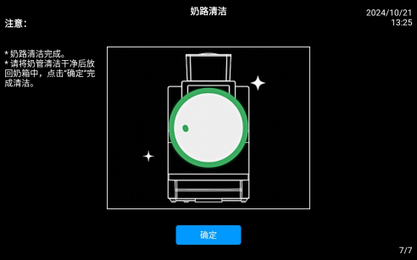
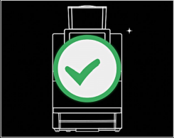

Empty the cleaning container, rinse the cleaning container and milk tube, insert the milk tube into the cleaning container and click "Next"; the machine is cleaning, please wait until the Milk Circuit is cleaned. Please clean the milk tube and put it back in the milk box. Click "OK" to complete the cleaning

Automatic cleaning setting

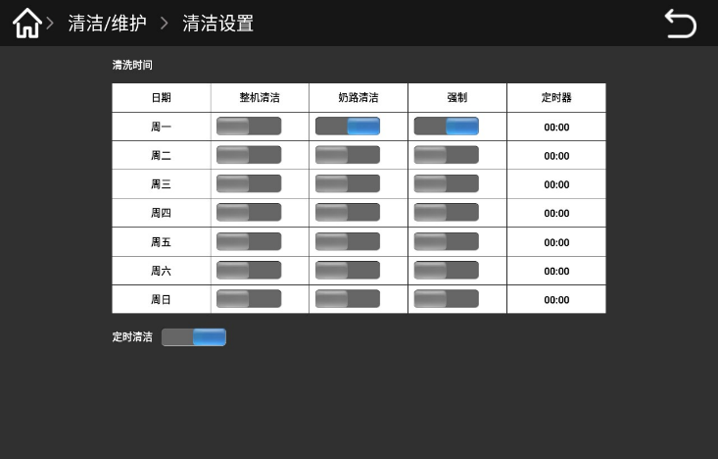
Long press the upper left corner of the screen, enter the password in the displayed dialog box (tester: test9527), and click "OK". Click on the "Clean / Maintenance"。
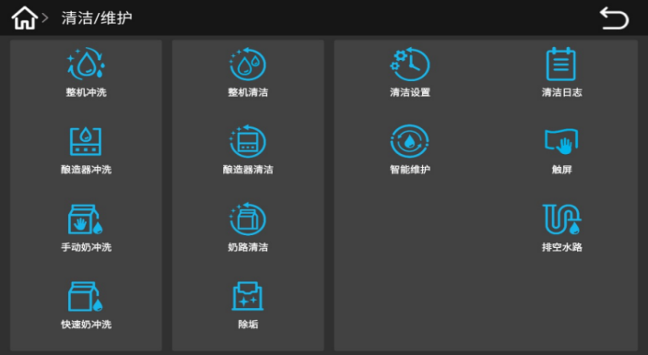

Click "Clean Settings", in the pop-up interface, open "regular cleaning" on / off, set the automatic cleaning time, Monday to Sunday, automatic cleaning can be set for a certain period of every day
Clean the machine, milk road, choose one of the open / off；
Forced open / close: open, set the automatic cleaning time is up, the interface will pop up prompt: "cleaning time is up, please continue to clean" click "the OK" button. Follow the instructions to clean the machine to be used normally。
Forced to open / close: close, set the automatic washing time, the interface appears on the prompt: "cleaning time is up, please continue to clean", there are two keys in the pop box "OK or cancel", click "OK" to perform the washing program, click "Cancel" to return to the UI interface, the machine can be used normally

Clean coffee waste bin
Coffee waste in coffee waste bin can easily lead to mold formation. If the plaque spreads to the machine, the coffee may be contaminated
So the coffee grounds boxes must be cleaned every day.

High temperatures may cause damage
Do not use the dishwasher to clean the coffee waste bin

Cleaning method of the coffee waste bin：
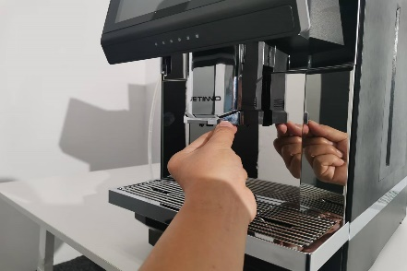
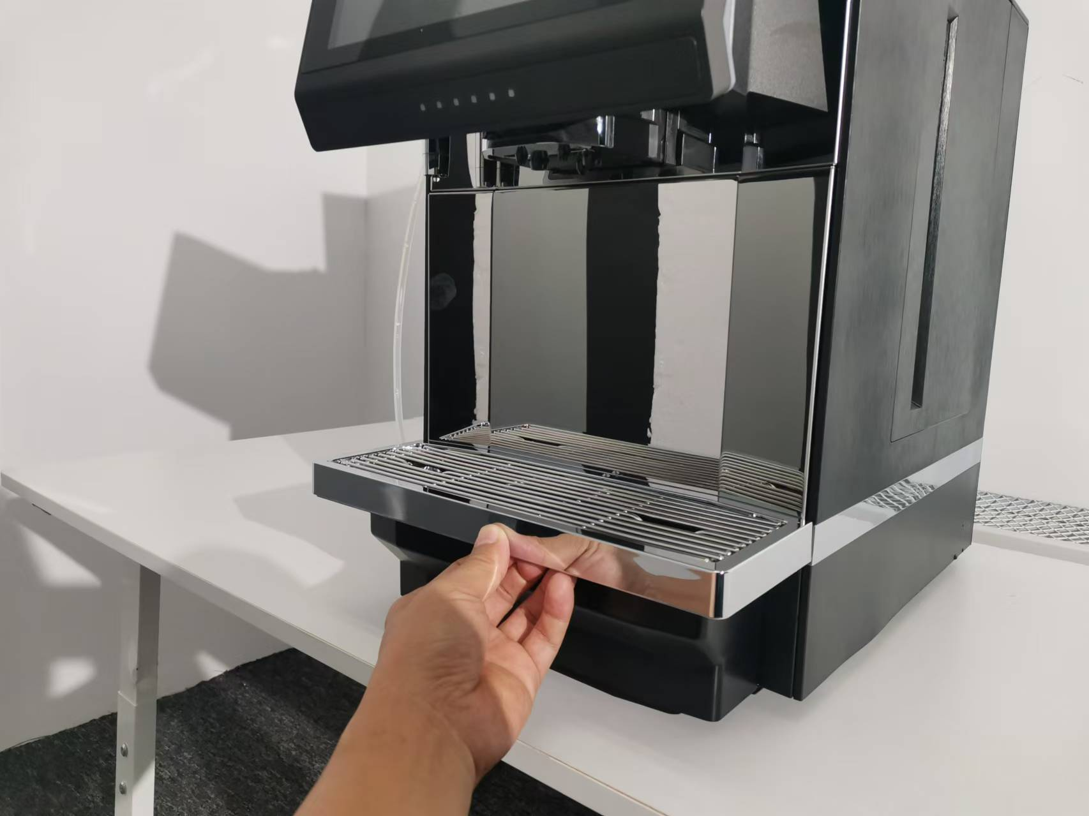
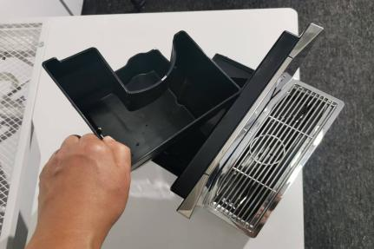
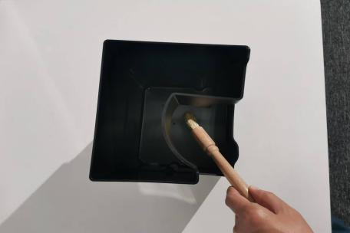

Push the mouth up to the top, remove the drip tray from the machine, remove the coffee grounds box, pour out the coffee grounds, and clean the coffee grounds box thoroughly with water and household cleaner. Dry with a clean towel and rearrange the coffee grounds box into the machine.

Clean the water drip drop

Precipitates and bacteria can contaminate the wastewater boxes.
Wash and clean the wastewater bin daily.

Drip tray cleaning method：
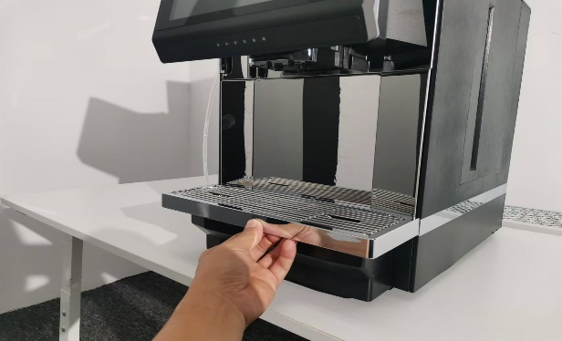
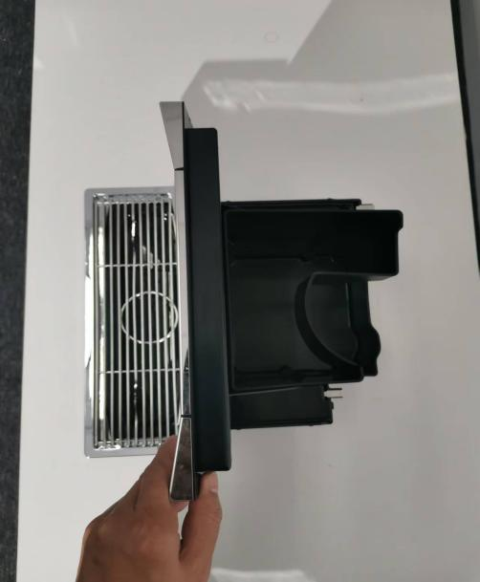
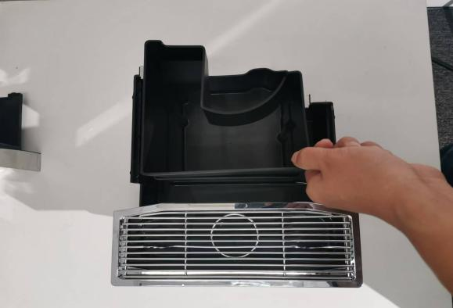

Push it out up to the top，remove the drip tray from the machine，take out the gear plate，remove the coffee waste bin，pour out the coffee waste。
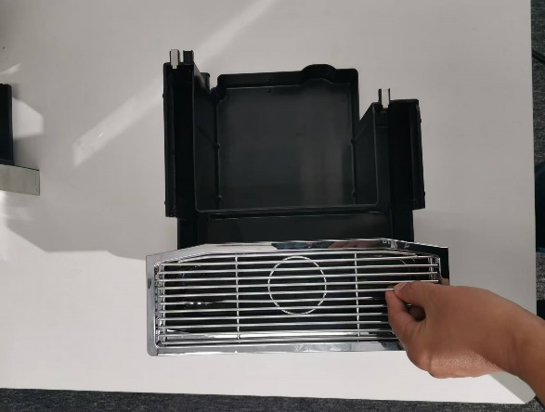
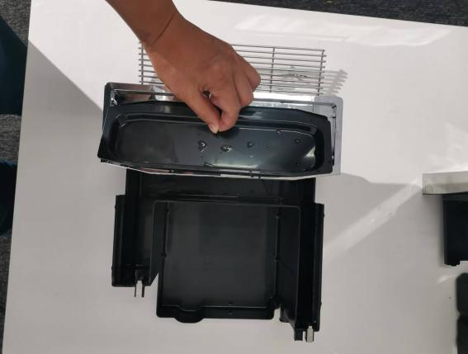
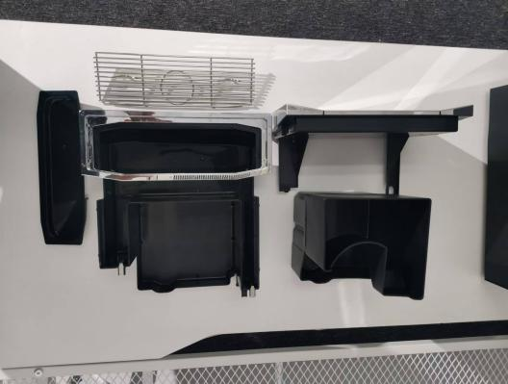

Wash the grid, waste water anti-sprinkling board, drip plate under the faucet thoroughly with a brush and wipe it with a towel,reload the dry drip tray assembly into the machine and confirm that it is in place

Disassembly and cleaning of the milk frother and coffee nozzle
1、To ensure the normal operation of the milk frother and for hygienic reasons, if you have made milk before, please be sure to clean the milk circuit on the same day. For operation methods, refer to 7.5.4 Milk Circuit Cleaning
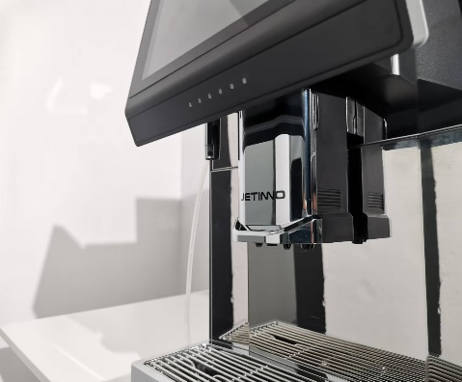
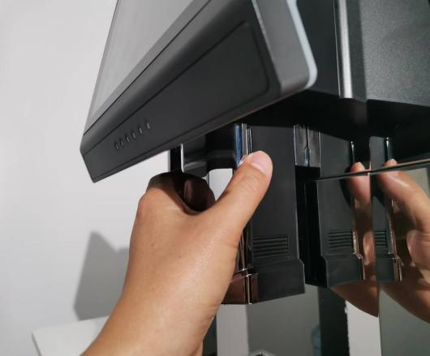
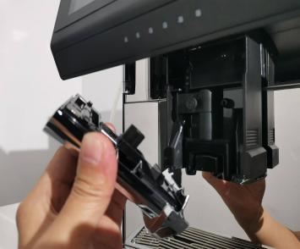
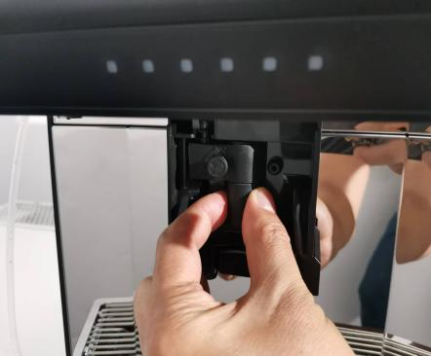
- Manually disassemble and clean the milk frother, the specific method is as follows：

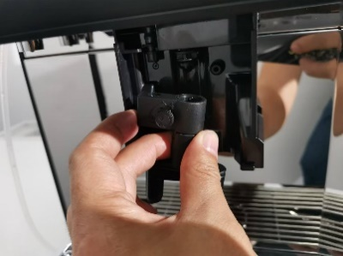
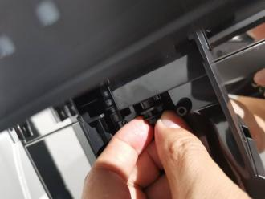
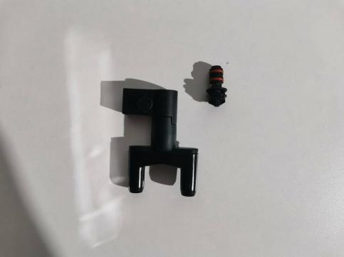
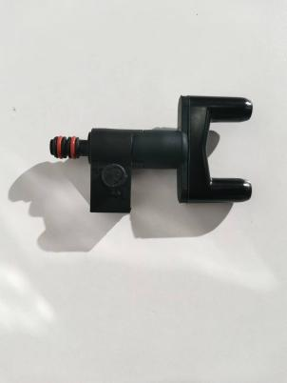
As shown in the figure above: Press the buckles on both sides of the nozzle cover and pull it outward to remove the nozzle cover assembly, grab the fresh milk nozzle sealing cover and pull it outward to remove the milk frothing device assembly

As shown in the figure above: remove the milk heating chamber, milk outlet assembly and steam nozzle; remove the steam nozzle and insert it into the milk heating chamber. The milk frothing assembly is disassembled.
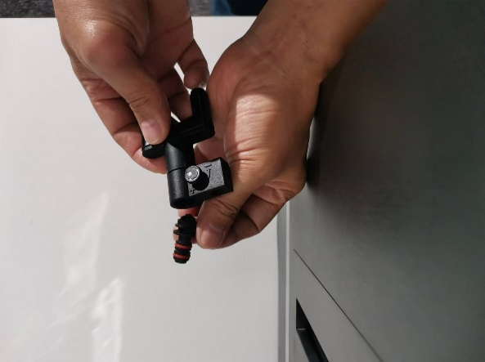
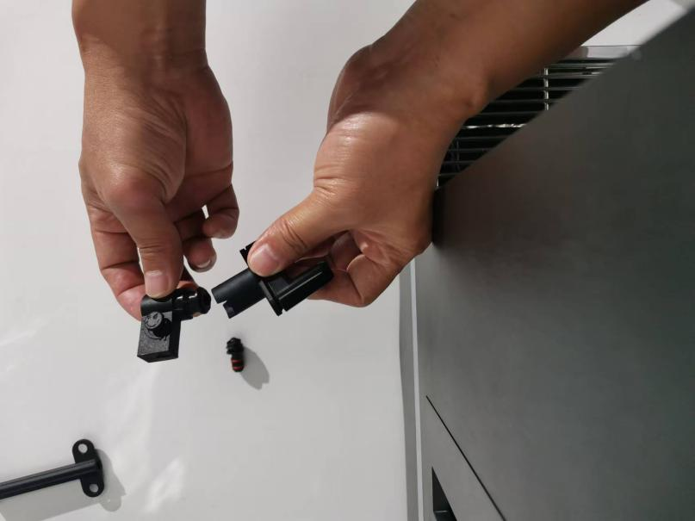
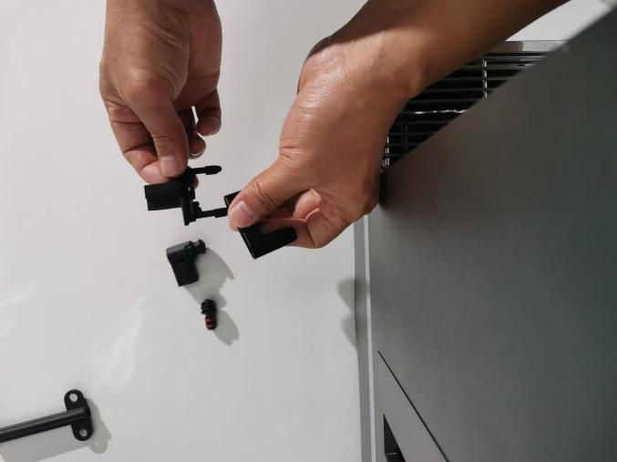
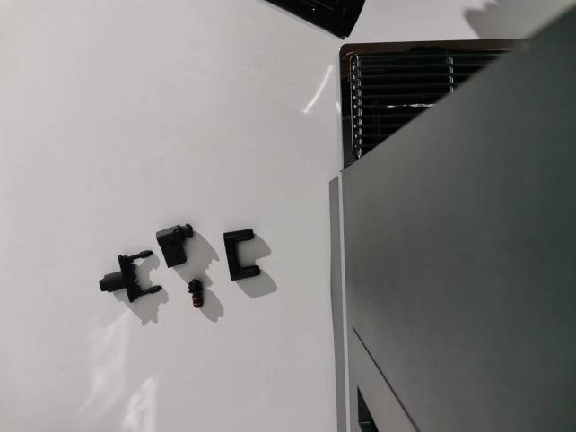

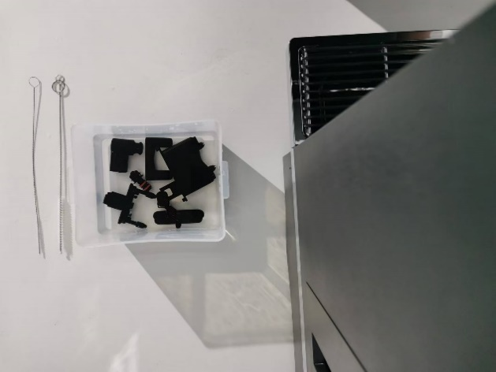
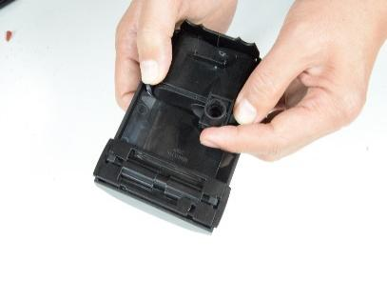
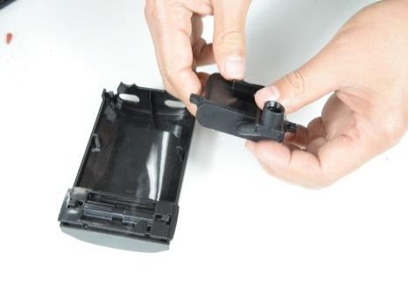
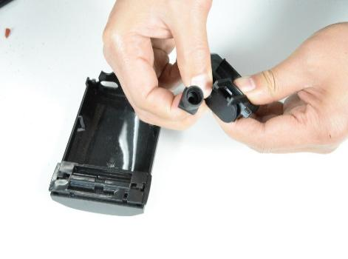
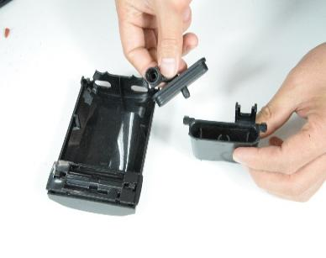
Disassemble the milk foam device into a single part: remove the steam nozzle, separate the fresh milk heating chamber, the fresh milk outlet, and seal the fresh milk outlet cover.

Disassemble the coffee spout into individual parts: press the buckle with the thumbs of both hands, and use the index fingers to pull out the coffee spout, and take out the coffee spout rubber sleeve and the spout. Soak the disassembled parts (steam nozzle, milk heating chamber, milk spout, milk spout sealing cover, coffee spout rubber sleeve, coffee spout) in 500ml (water + 1 tablet of milk cleaner) of milk cleaning solution overnight, and then rinse；
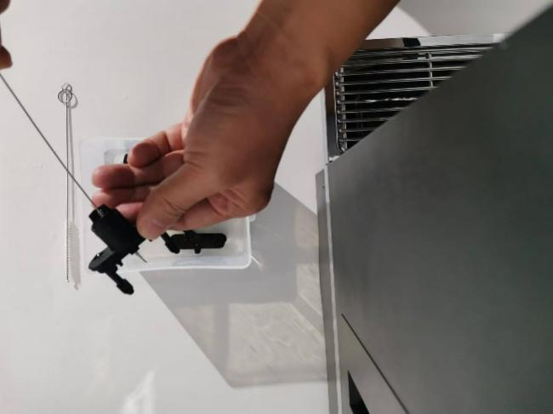
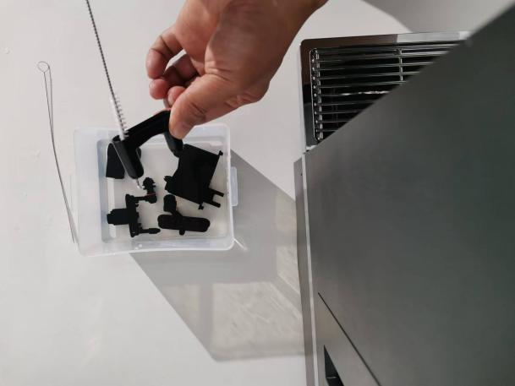
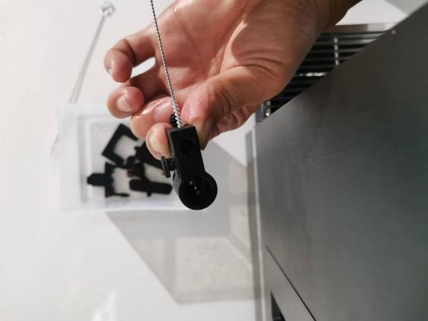
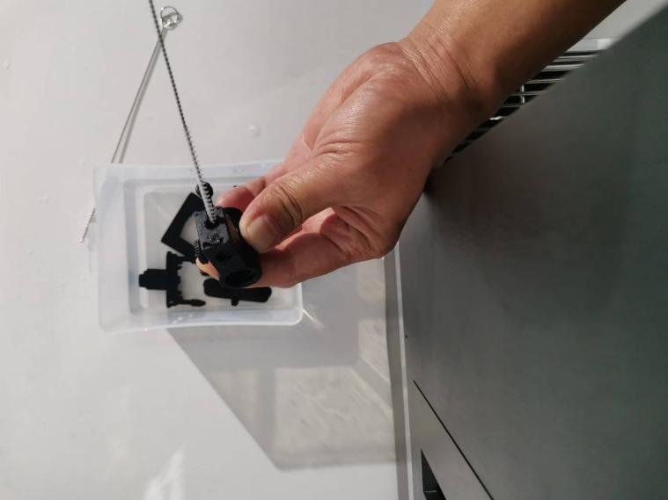
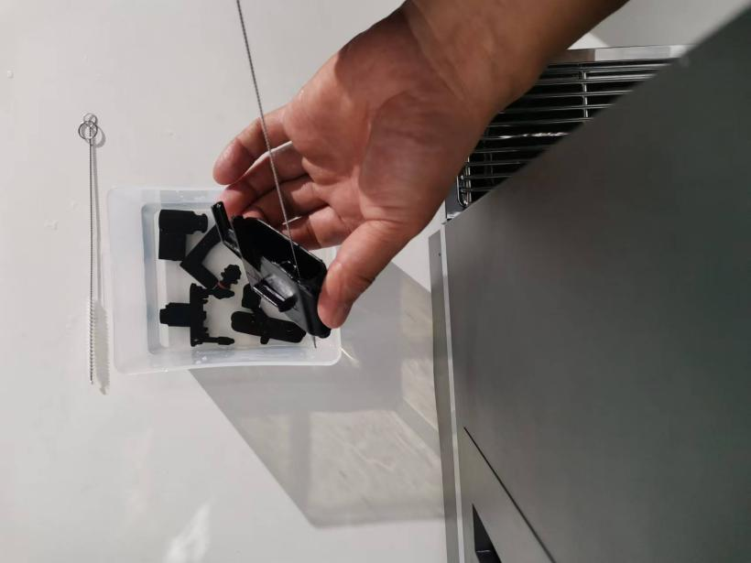

During the rinsing process, if you find milk or coffee scale, insert a cleaning brush into the hole to scrub it. When cleaning the milk inlet, remember the position indicated by the screw mark, then turn it counterclockwise to the bottom, and then use a brush to clean the milk inlet. After rinsing, turn the temperature adjustment screw back to its original position.
After cleaning, restore the machine and install the parts in the opposite way to how they were removed.

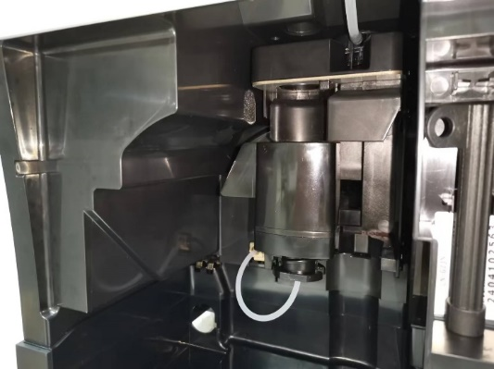
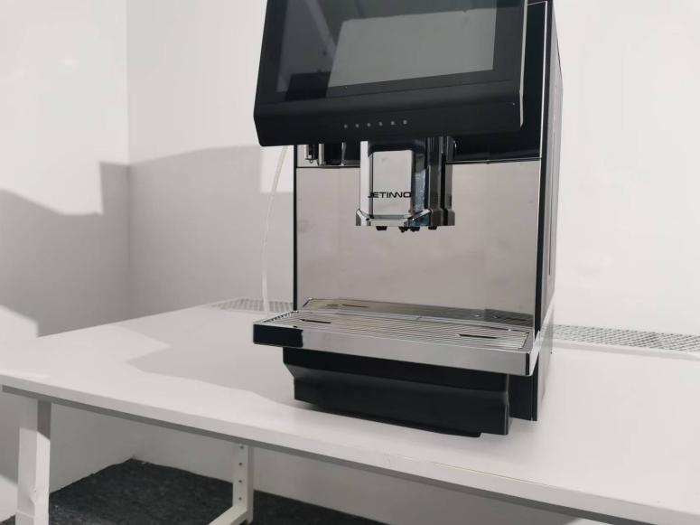
Clean the wet air duct

Push the spout upwards to the top, pull out the drip tray, remove the sponge, and shake off the coffee powder on the sponge.
Sponge cleaning cycle recommendations:
1. If the number of cups per day is less than 30, clean it every 3-5 days;
2. If the number of cups per day is greater than 30 but less than 70, clean it every day;
3. If the number of cups per day is greater than 70, it is recommended to remove the sponge. The sponge has resistance, and continuous use will generate a lot of water vapor, which is difficult to remove moisture.

清洁触摸屏
Risk of scalding if drinks are accidentally dispensed during cleaning
Before cleaning, lock the screen; click the "Touch Screen" button
Damage to the touch screen during cleaning
Stains cannot be removed by using the grinding method. Do not press the display with brute force, large pressure or sharp items.

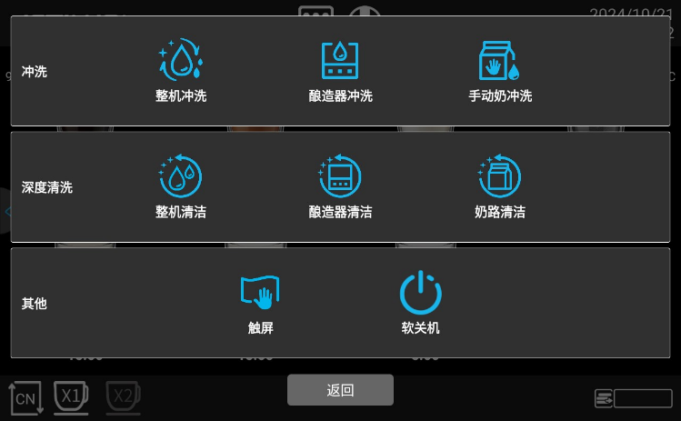

Click the "Quick Maintenance Menu" button, and in the pop-up interface, click the "Touch Screen" option. After locking the screen, wipe the screen with a soft cloth.

Weekly cleaning

Clean Coffee Hopper
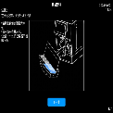
The rotating grinding blades of the grinder and the blades that open the coffee bean container are very sharp and can cause injury.
Do not reach into the coffee bean container when the coffee machine is switched on. Wear gloves when cleaning
Coffee Hopper scratch
Grinding and grinding by means of stain remover shall not be used
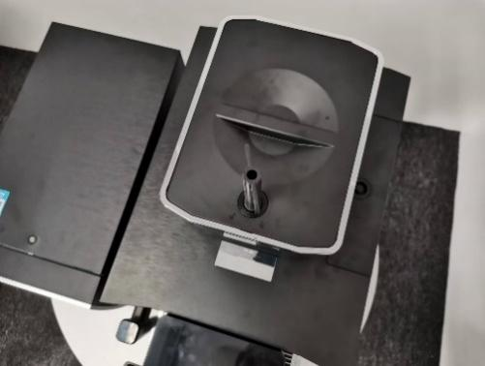
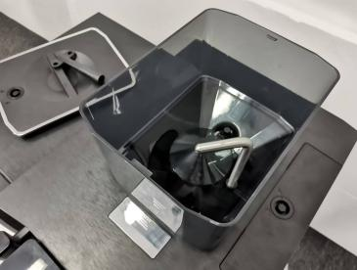
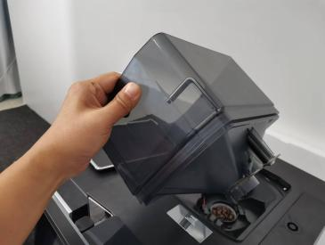

Pull out the drip tray, remove the key, insert the key into the bean box cover, turn the key, and remove the bean box cover.Turn the metal rod clockwise to unlock it and lift up the Coffee Hopper. Pour out the coffee beans and wipe them with a wet wipe containing 75% alcohol or a clean towel. After wiping, put the bean box back into the machine to restore it.

Empty the waterway
1、The heating block needs antifreeze protection when transporting it. When the temperature is below zero degrees Celsius, the waterway must be emptied. The specific method is as follows：

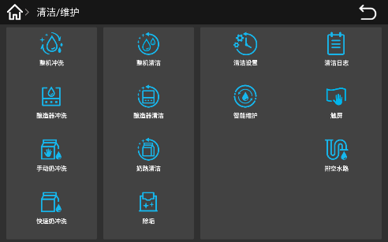
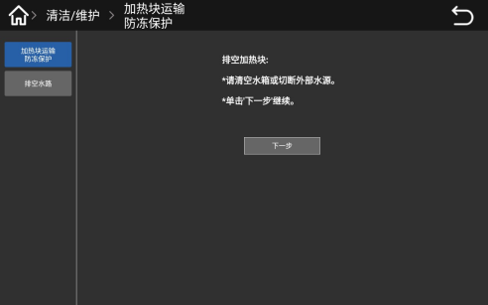
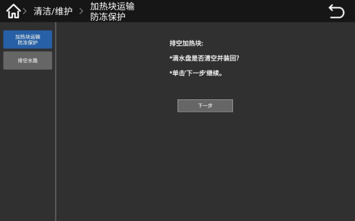
Long press the upper left corner of the screen, enter the password: test9527 in the pop-up dialog box, and click "OK". Select "Cleaning/Maintenance" .

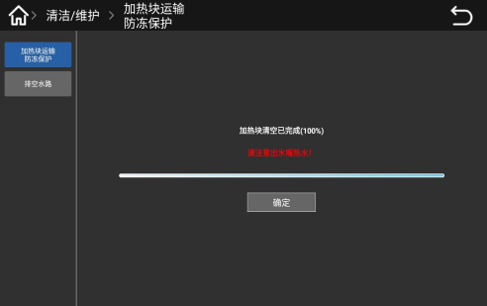
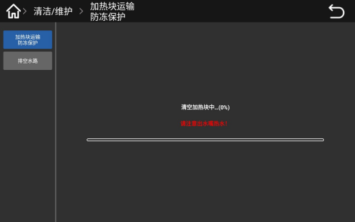
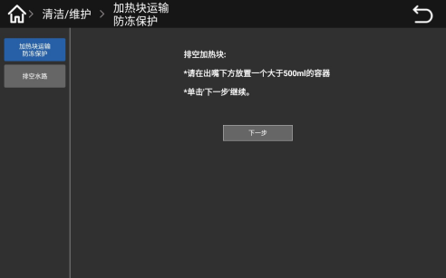
In the pop-up interface, click "Drain Water", select and click the "Boiler Transport Antifreeze Protection" button, follow the prompts on the interface: empty the water tank or cut off the external water supply, and then click "Next". Click the "Next" button, and follow the instructions on the pop-up interface: Is the drip tray emptied and reinstalled? Click the "Next" button.

Follow the prompts in the pop-up interface: Place a container larger than 500ml under the outlet, click "Next", the waterway emptying begins, there is a progress bar in the interface, when the progress is completed, the interface prompts: "Boiler emptying has been completed 100%, click the "Confirm" button.
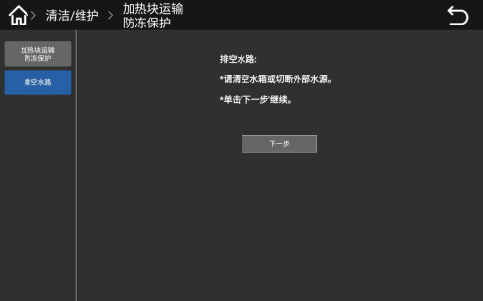
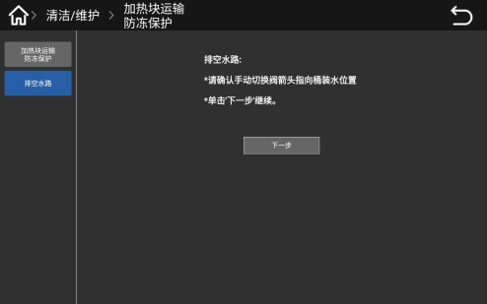
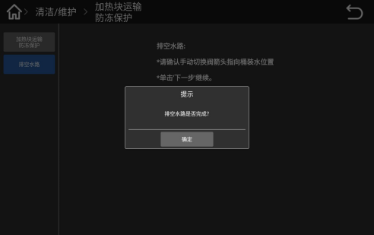
2、Empty the waterway

In the pop-up interface, click "Drain Water Circuit", follow the prompts on the interface: empty the water tank or cut off the external water source, and then click "Next" to continue. Follow the prompt on the interface: "Please confirm that the arrow of the manual switch valve points to the bottled water position" Click "Next" to continue, when the water is drained, a prompt pops up on the screen: Is the draining of the water circuit completed? After confirmation, click the "OK" button.

Precaution

Cleaner

Use

- Danger of poisoning if cleaning agents are ingested.
- Please observe the following points:
- Keep cleaning agents away from children and unauthorized persons.
- Do not ingest cleaning agents.
- Do not mix cleaning agents with other chemicals or acids.
- Do not add cleaning agents to cups.
- Do not add cleaning agents to drinking water tanks (internal/external)。
- Cleaning agents and scale remover can only be used for the specified purposes (see labeling)
- Do not eat or drink water when using the cleaning agent
- Good ventilation and exhaust must be ensured when using the cleaning agent
- Wear protective gloves when using the cleaning agent
- Wear goggles when using descaling agents
- Wash hands thoroughly after using detergent
Before using a cleaning agent, read the instructions on the packaging carefully. If a safety data sheet is not provided, you can ask your dealer for one (see the packaging of the cleaning agent).

Storage
Be sure to follow the following points：
- Please store it beyond the reach of children and unauthorized personnel
- Pay attention to heat prevention, light and moisture prevention when saving
- Conserved separately from the acidic substances
- Only only in the original packaging
- Keep the detergent separately
- Do not store them with food or drinks
- Compliance with the relevant local laws and regulations on the storage of chemicals (cleaners)

Waste treatment
If it cannot be recycled, the detergent and its storage must be discarded in accordance with local law

Health regulations

Water
Potential health hazards resulting from incorrect use of water！
The water source should meet the hygienic standards for domestic and drinking water
Be sure to follow the following points：
Water must be clean and pollution-free
- Do not add back water or other corrosive water to the coffee machine
- Carbonate hardness shall not exceed 5-6 DKH (German carbonate hardness) or 8.9-10.7 FKH (French carbonate hardness)
- The total hardness value, must always be higher than the carbonate hardness
- The minimum carbonate hardness is either 5 DKH or 8.9 FKH
- The maximum chlorine content was 50 mg per liter
- PH 6.5-7 (pH neutral)
- With filter unit (internal & external)

Coffee
Failure to use your coffee properly may damage your health！
Be sure to follow the following points：
- Check the package for damage before filling
- Close the top cover of the Coffee Hopper immediately after being added
- Coffee should be stored in dry, cool, and dark places
- Coffee should be stored separately from the detergent
- The earliest purchased product should be used first ("early entry and early exit" principle)
- The package shall be well sealed after opening to keep the product in the package fresh and prevent its contamination

Safety and warranty
If the user does not comply with the use and installation instructions of the machine, the manufacturer shall not bear any responsibility for the possible damage to the coffee machine
Observe the instructions for use.
The installation site shall be kept dry and waterproof; prohibited in the open air; the machine shall only be used for designated raw material packages; other raw materials shall be considered abnormal, and the manufacturer shall not be liable for any damage caused thereby.
Whether the Buyer has the warranty rights and the specific warranty rights that the Buyer may enjoy shall depend on the agreement between the buyer and the seller. Failure to comply with the operation instructions loses the warranty rights
The warranty is not fulfilled in the following circumstances：
- Natural losses occurring in all components
- Machine defects caused by nonoperation, cleaning and maintenance regulations (e. g. operating instructions and cleaning and maintenance)
- Defects caused by no use of original accessories or third party accessories, incorrect installation or hasty use
- Defects caused by improper modification or repair of the machine by the user or a third party without our permission
- Machine defects due to improper or incorrect use

List of common questions
Problems | Possible causes | Solutions
The coffee outlet flow velocity is too slow | The coffee outlet flow rate is too slow | Adjust the grinder and rotate it toward the larger number.
 | The powder is much larger than expected | Recalibrate the grinder
 | Filter blocked | Clean the brewer with cleaning tablets or replace the filter
 | Leakage (lower plunger damaged) | Replace the plunger or brewer
 | Brewer O-ring leaking | Replace the O-ring
Drip tray contamination | No cleaning for a long time | Wash the drop of water
 | The outlet mouth is not installed correctly | Check and reinstall it
Coffee flows too fast | The coffee powder is ground too thick | Adjust the grinder
 | Dose was far less than expected | Recalibrate or check the formulation settings
The coffee waste bin is full | Since the last empty, the total number of coffee residue cakes has reached 40 slag cakes | Pull out the drip tray, take out the coffee grounds box, empty the grounds bin
Boiler filling failed | Stop machine for long time (water valve is not on) | Open the water valve to restart the machine
 | Using the machine for the first time, the waterway system has air | Power off and try again to exhaust the gas
Lack of coffee beans | The box has ran out of coffee beans | Add some coffee beans to the Coffee Hopper
 | Coffee beans have too much grease to stick together | Coffee beans in the mixing box
The drop tray is not installed | Drip tray is not installed in place | Reinstall the drip tray
 | The magnet is lost or damaged | Replace the sensor \ magnet
Drip tray is full | The water in the drip tray is full | Pull out the drip tray, and empty the waste water
 | Drip disc water level monitoring metal sheet is dirty | Clean and monitor the metal sheets and dry it
Can't suck milk | The milk box is empty | Check the milk box with milk
 | Steam line or steam outlet is blocked | Deep milk system cleaning with potions
 | The steam pipeline is damaged | Disassemble the steam line or outlet, check and replace it
 | The milk foam device temperature adjustment knob is adjusted too tight | Release the foam temperature adjustment knob to place
 | The foam device is blocked | Remove foam device and clean all holes; replace new foam
The coffee machine requires descaling | Make the set water or cup quantity, and the threshold value can be modified in the background menu of the machine. | Click the prompt button to remove the scale. Reference to the instruction manual for the specific operation method

Authentication
Meet the standards：
GB 4706.1-2005 ;
GB 4706.72-2008 ;
GB4806-2016 。
Pass the CQC certification

