JL32 series coffee machine
Instruction Manual

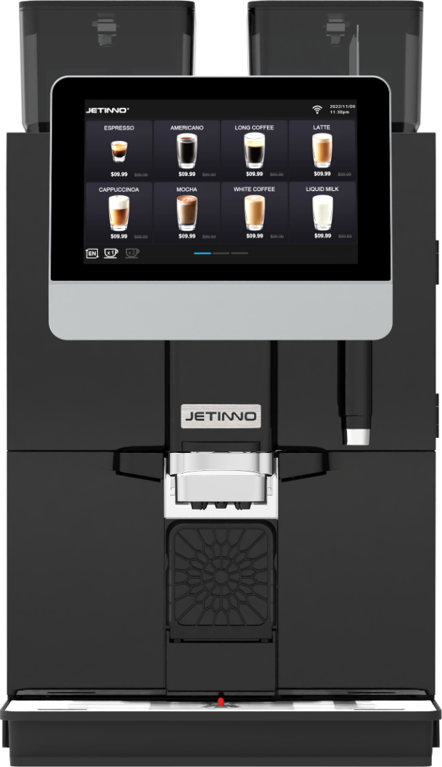

Read the manual carefully before use and keep it safe

使用前请仔细阅读本操作手册，并妥善保管
使用前请仔细阅读本操作手册，并妥善保管
使用前请仔细阅读本操作手册，并妥善保管

Guangzhou Jetinno Intelligent Equipment Co., LTD
Guangzhou Jetinno Intelligent Equipment Co.,Ltd.
www.jetinno.com
(86) 20-32038721
(86) 400-017-9997
Add: 4F, A Building, Creator Park, No.2,Tairui Rd, Science Park, Huangpu District, GZ, GD, PRC.
510663Add: 4F, Building A, Creator Park, No.2 Ruitai Road, High-tech Industrial Development Zone,
Huangpu District, Guangzhou
Contents
1 Introduction 4
1.1 Welcome to use 4
1.2 Logos and symbol 4
2 General Safety Tips 5
2.1 Danger to users 5
2.2 Hazard to the machine 8
3 Product Description 9
3.1 Welcome to use 9
3.2 Technical Data 10
4 Installation and commissioning 11
4.1 Set Up 11
4.1.1 Locations 11
4.1.2 Climatic conditions 11
4.2 Power supply 12
4.2.1 Conditions 12
4.2.2 Power connection cable 12
4.3 Water interface/drain 13
4.3.1 Conditions 13
4.3.2 Water intake conditions 13
4.4 Installation 13
4.4.1 Unwrap the machine 13
4.5 Disassembly and disposal of scrap 14
5 Operations 14
5.1 Equipment introduction 15
5.1.1 Machine external operating unit 15
5.1.2 Product configuration parameters 16
5.1.3 Accessaries 17
5.2 Unpackaging 18
5.3 Check before turning on 18
5.4 Add and connect 18
5.4.1 Connecting water source 18
5.4.2 Connecting the external wastewater pipe 19
5.4.3 Refrigerator connection 20
5.4.4 Refrigerator power supply connection 20
5.5 Turning on 20
5.5.1 Coffee Machine 20
5.6 Network connection 21
5.7 Server connection 22
5.8 Setting Date/Time 23
5.8.1 Counters 24
5.8.2 Diagnostic 25
5.8.3 Machine Reset 27
6 First use 28
6.1 Filling canister 28
6.2 Adding milk to the milk box in the refrigerator 29
6.3 Debugging and calibration 29
6.3.1 Method for adjusting the thickness of coffee bean grinding powder 29
6.3.2 Grinder calibration 30
6.3.3 Fresh milk calibration 31
6.3.4 Powder calibration 32
6.4 Product Testing and Adjustment 33
6.4.1 New Recipe 34
6.4.2 .New drink 34
6.5 Drink management 36
6.6 Drink production 36
6.7 Operator Options 37
6.8 Empty 40
6.8.1 Coffee grounds bin 40
6.8.2 Water tray 40
6.9 Transportation conditions 40
6.10 Turning off 41
6.10.1 Operation end 41
6.10.2 Long downtime (over 1 week) 41
7 Cleaning 42
7.1 Cleaning interval 42
7.2 Cleaning plan 43
7.3 Daily rinsing 43
7.3.1 Brewer rinsing 43
7.3.2 Milk system rinsing 44
7.3.3 Mixer rinsing 44
7.3.4 Automatic rinsing settings 45
7.3.5 Cleaning of water tray 46
7.3.6 Cleaning of waste bin 47
7.3.7 Disassembling and cleaning the milk frother 47
7.4 Regular cleaning 48
7.4.1 Cleaning agents 48
7.4.2 Display screen guided cleaning program 49
7.4.3 System cleaning 49
7.4.4 Milk system cleaning 51
7.4.5 Brewer Cleaning 52
7.4.6 Deep cleaning mixer 53
7.4.7 Cleaning touch screen 54
7.5 Clean the coffee bean container weekly 54
7.6 Empty waterway 55
7.7 Descaling 55
8 List of Common Problems 60
9 Preventive measure 61
9.1 Cleanser 61
9.1.1 Use 61
9.1.2 Storage 62
9.1.3 Disposal of waste 62
9.2 Health Regulations 62
9.2.1 Water 62
9.2.2 Coffee 62
9.2.3 Finished drink powder 63
10 Safety and Quality Assurance 63

Introduction

Welcome to use
This instruction manual gives you the information of JL32 and other products and how to use them. If you do not use the coffee machine according to the relevant instructions in this manual, we do not assume any responsibility for the loss caused by this. However, all intended uses may not be included in the instruction manual! For more information, please contact our customer service.
Equipment performance depends on proper maintenance and use. Please read the instruction manual carefully before the first commissioning and keep the instruction manual for easy access.
This manual is applicable to: JL32A、JL32B、JL32C.
Wish you a happy use!

Logos and symbol
 See also the "General Safety Tips" section.
The following signs and symbols are used in the instruction manual to indicate hazards and special matters:



- Immediate danger situations, which may result in serious injury or death due to electric shock.
- Be sure to follow precautions to prevent such hazards.



- A general hazardous situation that can cause serious injury.
- Be sure to follow precautions to prevent such hazards.


- General hazardous conditions that can cause minor injuries.
- Be sure to follow precautions to prevent such hazards.


- Conditions exist that could cause damage to the machine.
- Be sure to follow the precautions to prevent such hazards.


- Fire hazard/combustible materials.

- Watch out for fire.


- Hot liquids. A dangerous condition that may cause burns. A hazard exists at the flow outlet location.
- Only symbols are used for identification below.
- Be sure to follow the precautions to prevent such hazards.


- Hot steam. Dangerous condition that may cause burns. The location of the water outlet creates this hazard. Only symbols are used in the following.
- Be sure to follow the precautions to prevent such hazards




- Hot surfaces. Dangerous conditions that can cause burns. Stream exit location.
- Location (optional) to create this hazard. Only symbols are used in the following.
- Be sure to follow the precautions to prevent such hazards.


- Crush hazard. Dangerous conditions that can cause splint injuries.
- Only symbols are used for identification below.
- Be sure to follow the precautions to prevent such hazards


- Poisoning hazard. A general hazardous condition that may result in injury from poisoning. In the following
- Identification by symbol only.
- Be sure to follow precautions to prevent such hazards.

General Safety Tips

Danger to users

Improper use of a coffee machine can result in minor injuries.
Be sure to follow the following:
Read the instructions carefully before use.
- Only allow technical service personnel to enter the maintenance area of the machine.
- Do not use the coffee machine if it is not working properly or is damaged.
- Do not change the built-in safety device.
- Do not touch hot machine parts.
- Children over 8 years of age and persons with physical, sensory, or intellectual impairments or who lack experience and cognition should only use equipment under constant supervision after learning how to operate it safely and understanding the risks associated with it.
- Do not allow children to tamper with machinery. Cleaning and user maintenance tasks must not be performed by children. Only persons familiar with and experienced with the equipment are allowed to perform such work, especially as it relates to safety and hygiene.
- Install the coffee machine in a place where it can be looked after and maintained at all times.
- Self-use and operation should be supervised by trained personnel to ensure compliance with maintenance regulations and to resolve usage issues at all times.7
- Only coffee beans should be filled in the coffee bean tank, and only ground coffee beans should be added to the manual addition port (or cleaning tablets should be added during cleaning).


Electric shock hazard. Incorrect use of electrical equipment can result in an electric shock.
Be sure to observe the following:
- Work on electrical equipment should only be performed by electrical professionals.
- This machine must be connected to a circuit with a fuse protection (it is recommended to lay the wiring through a leakage protector).
- Please comply with the relevant low voltage directives and national or local safety regulations.
- Connections must be grounded in accordance with regulations to prevent electric shock.
- The voltage must be consistent with the instructions on the device nameplate.
- Do not touch live parts.
- Be sure to turn off the main switch and disconnect the device from the power supply before performing maintenance.
- All connectors of the device must be able to disconnect from the power grid.
- Disconnected connections must be visible at all times at the point of operation of the equipment, or power must be secured by locking.
- Only professional technical support personnel can replace the power cable.


If the safety tips are not followed, there may be negligence in normal use, which will cause harm to personnel and the surrounding environment!
- Ventilation should be maintained around the machine or in the embedded structure without obstructions.
- There should be no inflammables around the machine.
- Do not use mechanical devices or other means to accelerate defrosting other than those recommended by the manufacturer.
- Do not damage the refrigeration circuit.

Drinks with additives or residues may cause allergies.
Be sure to follow the following:
- In the self-service application, express the possible use of allergenic additives through the coffee machine prompt board.
- In the case of a service person application, a trained person should inform you of possible allergenic additives


Danger of poisoning from ingestion of cleaning agents.
Be sure to observe the following:
- Cleaning agent storage should be kept away from children and unauthorized persons.
Do not ingest cleaning agents.
Do not mix cleaning agents with other chemicals or acidic substances.
Do not add cleaning agent to the cup.
Do not add cleaning agent to drinking tank (inside/outside).
Cleaning agents and descaling agents should only be used for their stated purpose (see label).
Do not eat or drink while using the cleaning agent.
Good ventilation and venting must be ensured when using the cleaning agent.
Protective gloves should be worn when using the cleaning agent.
- Safety goggles should be worn when using detergent.
- Wash your hands thoroughly immediately after applying the detergent.

Read the package instructions carefully before using the cleaner. If a safety data sheet is not provided, you can ask the distributor for it (see Packaging of the cleaner).



High temperature liquid. Risk of burns in the exit area of drinks, hot water and steam.
During export or cleaning do not extend your hand below the flow outlet position.



Hot surface. High temperature exists in the flow outlet position, ES brewer and boiler.
Only allow contact with handles pre-designed for output.
Clean the ES brewer only after the coffee machine has cooled



Squeeze \ scratch hazard. There is a risk of being crushed by touching any moving part.
Only handles pre-designed for output are allowed to be touched.
Do not reach into the opening of the coffee bean trough, powder trough, or brewer after starting the coffee machine.
he blades on the grinder disk and the coffee trough opener blades are sharp and should be taken care of during cleaning.

Hazard to the machine

Improper use of the coffee machine can cause damage or contamination.
Be sure to follow the following:
If the carbonate contained in the water is harder than 5°DKH, install a scale filter, otherwise it will damage the coffee due to calcification.
For safety reasons, please note that the main water valve (coffee machine with tap water interface) should be turned off after shutdown, and the main switch should be turned off or the plug should be unplugged.
Please comply with the relevant low voltage directives and/or national and local safety rules and regulations.
If water injection is not possible, do not turn on the device. Otherwise you will not be able to refill the water boil and the pump will run "dry"
It is recommended to install a ball valve in the water pipe when connecting to the direct drinking water to avoid water seepage hazards when the hose breaks.
After a long shutdown (such as a corporate holiday), the coffee machine must first be cleaned and then turned back on for use.
Protect the coffee machine from weather - empty the tank (frost, moisture, etc.).
Troubleshooting should only be done by a technical service person.
Use original parts for repairs.
For visible external damage or leakage, contact your service partner immediately for replacement or repair.
Do not rinse the machine with water or clean it with steam cleaner.

Do not place the machine where it may be sprayed with water.
   Protect the ground.
If you do not use the machine for a long time, it is recommended to use up all the coffee beans in the bean bin, otherwise the residual coffee beans will absorb moisture in the air, and it is easy to cause the grinder to block when grinding again;
If the boiler is not regularly descaled, it will have the following effects: the heating speed slows down and the temperature is not enough; abnormal coffee taste, resulting in boiler damage.

Proper use of the coffee machine can cause damage or contamination.
Be sure to follow the following points:
Only coffee beans can be filled in the coffee bean tank, only finished drink powder can be filled in the powder tank, and only ground coffee beans can be added to the manual addition port (or cleaning tablets can be added when cleaning).
Do not use freeze-dried coffee, otherwise it will cause the ES brewer to stick.
If the coffee machine and its additional equipment are transported at a temperature below 10 °C, the coffee machine and its additional equipment must be placed at room temperature for three hours after transportation, and then connected to the power supply and started. Failure to comply with this regulation may result in a short circuit hazard or damage to electrical components due to condensation.
Use a hose kit (drinking water/wastewater hose) that is new or comes with the machine.
An old hose kit must not be used

Improper use of the coffee machine can result in injury;
Climbing on top of the machine is strictly prohibited.

Product Description

Welcome to use
The JL32 is used to make and output various types of coffee drinks and milk drinks with syrup.
The equipment is suitable for commercial use in hospitality, catering or similar establishments. The equipment is self-serving and unattended, and can be operated by non-professionals or by guests themselves. User maintenance should only be carried out by trained outside operators.
If installation conditions can always be met, the device can also be used in a train station, gas station shop, or similar public place. The machine is not designed for outdoor installation or use.
Children over 8 years of age and persons with physical, sensory or intellectual impairments or who lack experience and cognition should only use the equipment under constant supervision after learning how to operate it safely and understanding the risks associated with it. Do not allow children to tamper with machinery. Cleaning and user maintenance tasks must not be performed by children.
Only persons familiar with and experienced with the equipment are allowed to perform such work, especially as it relates to safety and hygiene.

Addition, refer to the terms and conditions of the manufacturer of the equipment and this instruction manual when using the coffee machine. Any other use or use beyond the limits is considered unreasonable use. The manufacturer shall not be liable for any loss arising therefrom

Hazard to machinery.
Incorrect operation of the coffee machine may cause damage to the equipment, use the original recipe, do not use other recipes.

Technical Data
Name Parameters
Model | JL32 series
weight | 30kg
Rated voltage/frequency | AC220-240V/50-60Hz
Rated power Total power | 2700W
Fused current | 16A
Coffee machine operating  temperature/humidity | 5℃-40℃/10%RH-90%RH
communication interface | USB;WIFI;4G
Device display screen | 10.1-inch display touch screen
Support cup height | Less than 160mm
Coffee bean storage capacity | 1500g
Powder canister capacity | 2pcs，Capacity：2L + 3L（milk powder 1kg、chocolate powder1.2kg）
Drip tray capacity | 0.6L
Waste bin capacity | 40pcs cakes（8g/pcs）
Water tank capacity | 4L
Hot water boiler capacity/power | 700CC\2700W
Steam boiler power | 1400W
Coffee bean no bean detection function | YES


Installation and commissioning
Machines should be installed in accordance with the electrical and hygiene regulations in force in each country or locality. These include taking adequate backflow protection measures.


Sharp edges of packaging materials can lead to injury. Cutting nylon cable ties may make
Eye injury. Wear gloves when unpacking the machine and keep safety goggles on.

Contaminated water inlet pipes may pose a health hazard. It must be cleaned after installation, commissioning or commissioning again.
Before the initial output of drinks, clean according to the cleaning program guided by the display screen.
See "Cleaning" - "Daily Machine Cleaning" - "Screen Guided Cleaning Program"

Set Up

Locations

Hazard to machinery.
The following conditions are suitable for placing a coffee machine.
Failure to guarantee these conditions may damage the machine.
Do not put the machine upside down, horizontally or vibrate the machine when handling, and do not move the machine at an Angle greater than 45°.
Before the machine is installed, ensure that the refrigerator with fresh milk has been placed forward for at least 24 hours.
The mounting surface must be stable and flat, and will not deform under the weight of the coffee machine.
The distance between the necessary energy interface set according to the site installation drawings and the machine position must not exceed 1 m

Climatic conditions

Hazards to machinery.
The following climatic conditions are suitable for placing coffee machines. If these conditions are not guaranteed, the machine may be damaged.
Be sure to observe the following conditions:
The ambient temperature should be maintained at 5 ° C - 40 ° C.
The maximum relative air humidity is 10%RH-90%RH.
Coffee makers are designed for indoor use only. It must not be used outdoors to protect it from the weather (rain, snow and frost)!

Power supply

Conditions
Electrical connections must be made according to the relevant regulations of the host country. The voltage at the installation site must be consistent with the voltage given on the nameplate.

Electric shock hazard! An immediate danger situation that can result in serious injury or death due to electrocution.
Be sure to observe the following:
All power supply circuits must be turned off before touching the terminal!
Leakage protection devices must be protected by fuses with amperage values indicated on the nameplate!
All connectors of the device must be able to disconnect from the power grid.
The JL32 series models can only be connected to a power supply with a system impedance of 0.293 ohms or less. Consult the authority of your system impedance information provider if necessary.
Do not run the machine when the power cord is damaged. Replace the damaged power cord or plug immediately by a professional technical service person.
It is recommended not to use an extension cable! If you must use an extension cable (minimum cross section: 1.5 mm²), follow the manufacturer's data (instruction manual) for the cord and local regulations.
When laying out the power cables, make sure that the power cables will not trip people.
Do not drag the cable at sharp or sharp corners, and do not clip the cable or leave it hanging in the air. In addition, cables should not be placed over hot objects and should be oil and corrosive cleaners resistant.15
Do not lift or pull the device through the power cord. Do not pull the plug out of the socket by pulling on the power cord. Never touch the power cord or plug with wet hands! Do not plug wet plugs into sockets!

Power connection cable

Danger to the user.
There is a risk of electric shock and fire if the power connection cable is damaged or non-original!
Use an original power connection cable.
Be sure to follow precautions against such hazards:
Country-specific original power connection cables can be purchased through service partners.
Power connection cables with fixed connections should be replaced by technical service personnel.

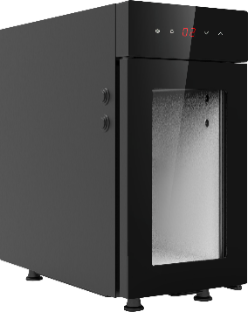
Connection value
1. Refer to the nameplate on the machine.
2. Optional device
Refrigerator: When using a coffee machine to make coffee drinks,
The refrigerator is specifically used to refrigerate milk.
Pre cooled milk (2-5 ℃) can be used.
Only specialized milk system cleaners can be used.

Water interface/drain

Conditions

Poor quality raw materials and poor water quality can damage the machine.
Be sure to follow the precautions against such hazards.
Be sure to observe the following:
The water used must be clean and pollution-free, with no more than 50 mg of chlorine per litre of water.
Do not add reverse osmosis water or other corrosive water to the coffee maker.
Carbonate hardness should not exceed 5-6°DKH (German carbonate hardness) or 8.9- 10.7°FKH (French carbonate hardness).
The minimum carbonate hardness is 5 °DKH or 8.9 °FKH. The PH is between 6.5-7.
Use the new hose kit (clean water/waste water hose) that comes with the machine.
he water source must be connected in accordance with current regulations as well as the regulations of the country in which it is located. If the machine is connected to a newly installed water pipe, the water pipe and water inlet hose must be thoroughly rinsed to prevent stains from entering the machine.
The machine is connected directly to an external drinking water tank or waste water tank.
Corresponding level monitoring is available.

Water intake conditions
Water Pressure | 0.05 MPa - 0.6 MPa (0.5 - 6 bar) recommended
Inlet temperature | Minimum | 5°C
 | Maximum value | 30°C

Installation


Unwrap the machine
Read the "Set Up" and "Power Supply" sections carefully before starting the installation!
Pay attention to the installation instructions that come with it!
■ Unwrap the machine.
■ Check the package to see if any accessories are left in it.
■ Remove the accessories provided with the package.
Auto Debugger Run debugger automatically the first time you turn it on. All installation items will be explained in it. Technical service personnel can start the debugging program at any time.

Disassembly and disposal of scrap
Proper disposal of coffee machines must be done in accordance with local regulations.

► Contact a service partner agency.

Operations


Hot liquid. Drinks made with this machine are hot drinks.
Do not put your hand under the outlet of the drink or into the machine during discharge.



High temperature steam. Risk of burns in the steam nozzle exit area.
Do not put your hand under the steam nozzle during output.


High temperature surface. Dangerous conditions that can cause burns. Drink outlets and water brewers present this hazard.
Do not grip the outlet of the drink or touch the surface of the boiling device while it is heating.

Hazard to the machine. Wrong operation may damage the touch screen.
Do not press the display with brute force, high pressure, or sharp objects.

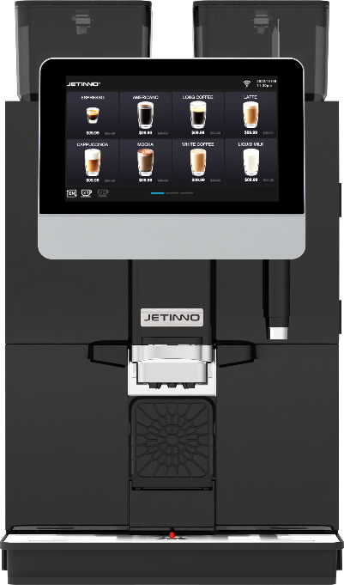
F
A

Equipment introduction

Machine external operating unit
B
[A] coffee bean container
[B] 10.1-inch touch screen (operation interface)
[C] product spout
G
[D] cup holder
[E] water tray
C
[F] powder canister
H
D
[G] Hot water spout
[H] Built-in water tank
E

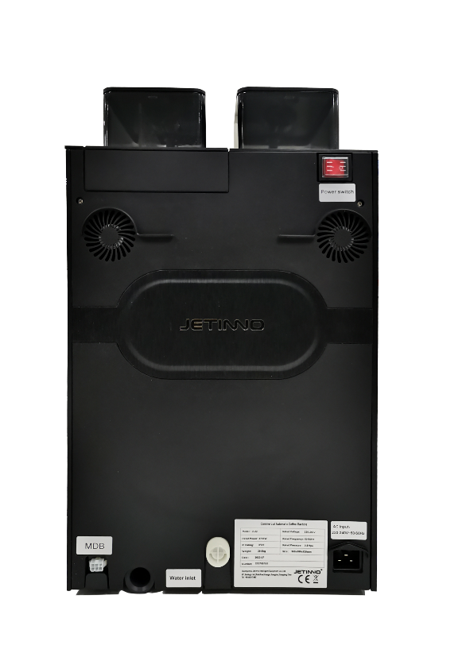
M
[ J ] Dehumidifying fan
[ K ] External interface for water tray
N
J
(please open the rubber plug for tray)
[ L ] MDB socket
[ M ] Power switch
K
[ N] Cooling fan
O
[O ] External water source inlet
L
[ P] Power cord socket
P

Product interface
Date/Time
Language switch
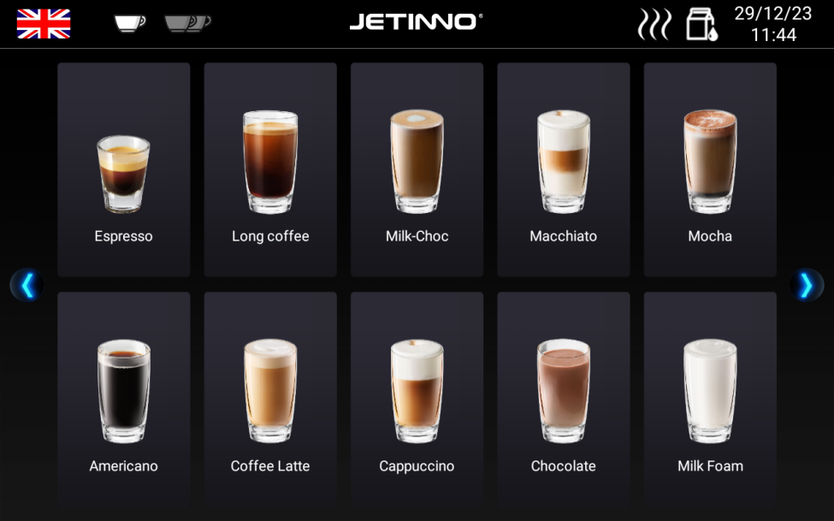
Milk rinsing
Single/double cup toggle button

Brewer rinsing

Page down
button

Page up button

Product button

Product name

Product configuration parameters
Product configuration parameters
Product name | JL32A | JL32B | JL32C
Model+Config | JL32-ES3C-FV | JL32-ES1C-FV | JL32-ES3C
Recommended daily cups  （cup/day） | 200 | 200 | 200
External dimensions (width * height * depth) | 350*620*560mm | 350*620*560mm | 350*620*560mm
Net weight of equipment | 30kg | 29kg | 29kg
Voltage/Frequency | 220-240V 50/60Hz | 220-240V 50/60Hz | 220-240V 50/60Hz
Rated power | 2900W | 2900W | 2700W
Operation interface | 10.1 "Touch screen (Horizontal) | 10.1 "Touch screen (Horizontal) | 10.1 "Touch screen (Horizontal)
Coffee bean container | 1x 1500g | 1x 1500g | 1x 1500g
Grinder | 1x Jetinno PGH64 | 1x Jetinno PGH64 | 1x Jetinno PGH64
Italian high-pressure brewer | P20(Double layer filter) | P20(Double layer filter) | P20(Double layer filter)
Instant canister | 1x 3L + 1x 2L | / | 1x 3L + 1x 2L
Mixer | 1 pcs | / | 1 pcs
Hot water boiler | 700ml, 2700W | 700ml, 2700W | 700ml, 2700W
Steam boiler | Thermal block, 1400W | Thermal block, 1400W | /
Pump model | 2x piston pump | 2x piston pump | 1x piston pump
Drink spout height | 165mm(With low cup holder) | 165mm(With low cup holder) | 165mm(With low cup holder)
Independent hot water pipe | Yes | Yes | Yes
Fresh milk foam module | Yes(Simultaneously producing fresh coffee and milk) | Yes(Simultaneously producing fresh coffee and milk) | /
Fresh milk freezer | Optional,4L | Optional,4L | /
Waste bin capacity | 40 pcs cakes（8g），  Optional waste discharge | 40 pcs cakes（8g），  Optional waste discharge | 40 pcs cakes（8g），  Optional waste discharge
Water tray capacity | 0.6L，Optional waste discharge | 0.6L，Optional waste discharge | 0.6L，Optional waste discharge
Water supply method | Standard configuration: 4L built-in water tank; Optional: Direct drinking water; | Standard configuration: 4L built-in water tank; Optional: Direct drinking water; | Standard configuration: 4L built-in water tank; Optional: Direct drinking water;
Networking methods | Deerror WiFi, optional 4G | Deerror WiFi, optional 4G | Deerror WiFi, optional 4G
Payment system | Payment function: WeChat, Alipay; Optional external MDB devices | Payment function: WeChat, Alipay; Optional external MDB devices | Payment function: WeChat, Alipay; Optional external MDB devices
OS | Android | Android | Android
IOT | Optional, SaaS Internet of Things  Cloud based remote management system | Optional, SaaS Internet of Things  Cloud based remote management system | Optional, SaaS Internet of Things  Cloud based remote management system
Authentication | CE,CB,CQC | CE,CB,CQC | CE,CB,CQC

Accessaries
Subsidiary accessaries
Fully automatic coffee makers come with the following accessories when supplied:
Graphical  representation | Item name | Functional  specifications | Product parameters
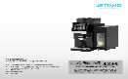 | User manual | For coffee machine  use reference | 210mmx291mm
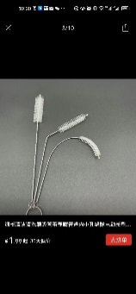  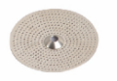 | Coffee maker, pack of  consumable materials  (seals, strainers, etc.) | For daily consumable  replacement of coffee  machine | Regular
 | Small inner hole cleaning brush | Use when cleaning milk tube, milk foam, inner hole | Gross diameter 3mm* Total length 21cm Gross diameter 6mm* total length 21cm
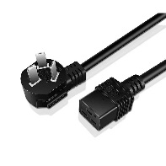 | Power cord | For coffee machine  special function  installation use | Three plug (16A)
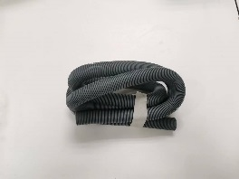 | Installation accessories for coffee machine (drain pipe outside the water tray) | Used for the installation and use of special functions in coffee machines | Inside diameter 20, outside diameter 23
Optional accessories
Graphical  representation | Item name | Functional  specifications | Product parameters
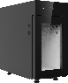 | Milk cold bin | For refrigeration  and fresh use | 260（W）x600(H)x426(D)mm,capacity 9L
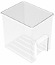 | Fresh Granny box | Container for  holding fresh milk | Food grade, 5L
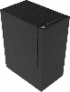 | Payment side cabinet (customizable) | External payment device side cabinet | Customize specific currencies according to the MDB protocol
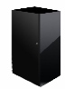 | Bottom cabinet (customizable) | Bottom cabinet for placing coffee machine | Customizable
 | Coffee system cleaning  pills | Used to clean  coffee machine  ES brewer | 2 g/tablet, 100 tablets/can, 12  cans/box
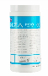 | Coffee maker milk  system clean tablets | For cleaning the  milk system | 4g/ tablet, 120 tablets/bottle, 12  bottles/case

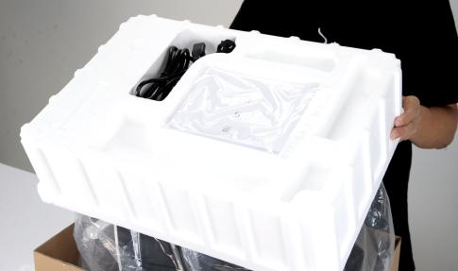
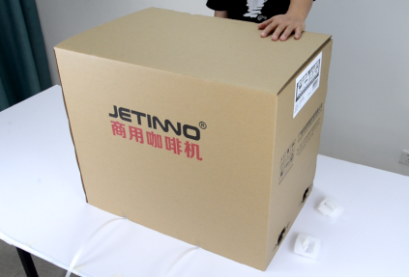
Unpackaging

After receiving the machine, unpack the packaging, remove the foam, peel off the PE bag, and lift the machine onto a flat tabletop.

Check before turning on
Check that the following prerequisites are met before turning on the coffee machine.
 The main water valve has been opened or the tank has been filled with water.
 The waste water outlet is properly set/the water tray is properly placed.
 Bean containers are filled.
 Coffee grounds box emptied and properly inserted.
 The power cord is connected to the power supply.


Add and connect
Special care must be taken when replenishing that the maximum amount of filling must not cause the container lid to come into contact with the contents.

Connecting water source

Water quality affects human health! Water sources must meet the sanitary standards for drinking water
Pay attention to the sanitary condition of water pipes.
Wash the relevant parts.
The water source to which the machine is connected should be easy to operate.
Tighten the joint for direct drinking water to avoid water leakage.
A、Internal water source (water tank)
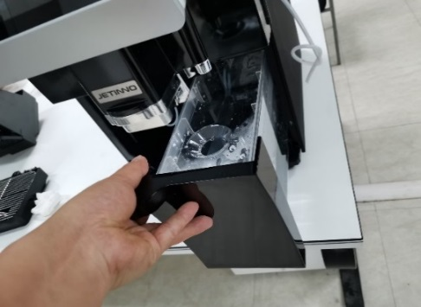
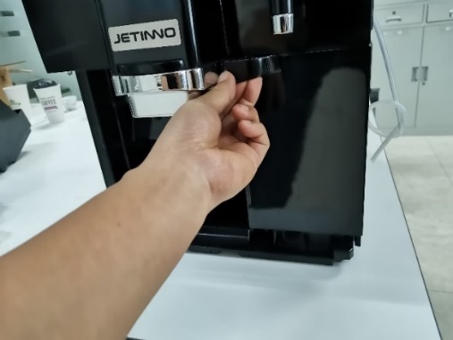
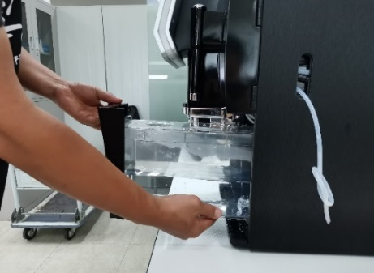

Pull out the water tank, remove the tank cover, fill the tank with clean water, and install the tank back into the machine. The water tank has a water level detection, and there is a prompt on the water shortage interface.
B、External water source (direct drinking water)
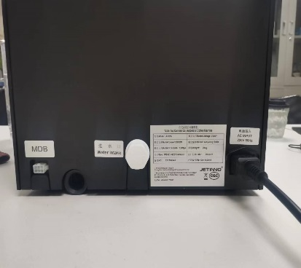
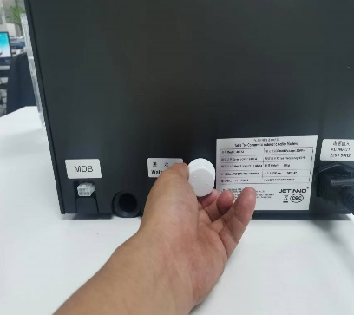
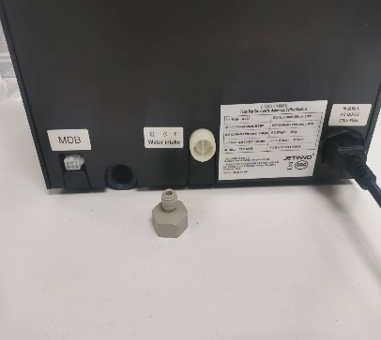
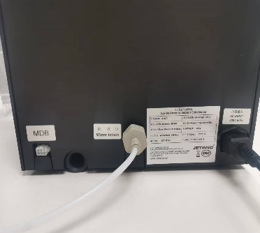

Install the water pipe to the inlet connection and tighten it clockwise to ensure that the rubber seal is inserted.
Note: The system deerrors to receiving water from internal sources.
The external water source has two ways of direct drinking water and barreled water, which are two ways to choose one, and the customer connects the water source according to the demand of the order. If you need to connect another water source, open the back cover of the machine, adjust the pressure reducing valve according to the instructions on the back cover, and connect to another water source.
Tap water interface:

A pump running without water can damage the machine.
Make sure the main water valve is open before turning it on.
When stopping, make sure the main water valve is closed.

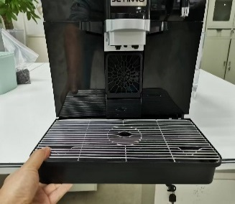
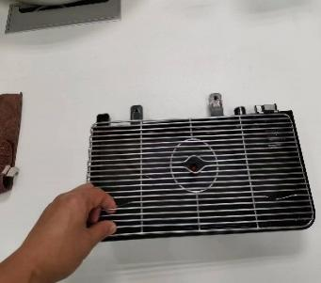
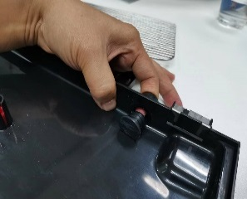
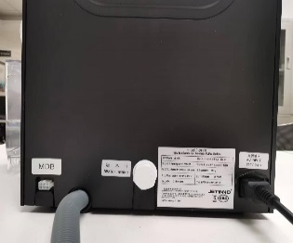
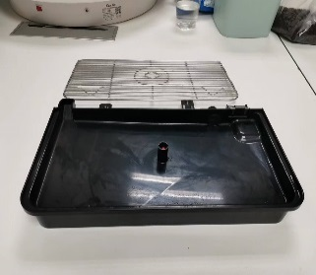
Connecting the external wastewater pipe

As shown in the above figure, pull out the water tray, remove the mesh grille, and remove the plug of the water tray; Insert the waste water pipe into the interface at the back of the machine.
Directly using a water tray can ignore this step.

Refrigerator connection
Insert one end of the coffee machine milk tube into the interface on the right side of the refrigerator, straighten the milk tube, and move the refrigerator to be level with the coffee machine cabinet.

Refrigerator power supply connection
Insert the female connector of the refrigerator power cord into the socket of the machine; Insert the other end of the power cord into the socket of the power supply; Press the refrigerator power switch.

Turning on

Coffee Machine
► Check the power connection of the machine.
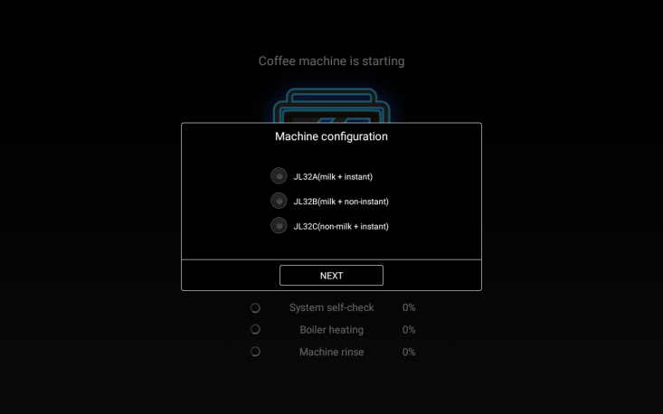
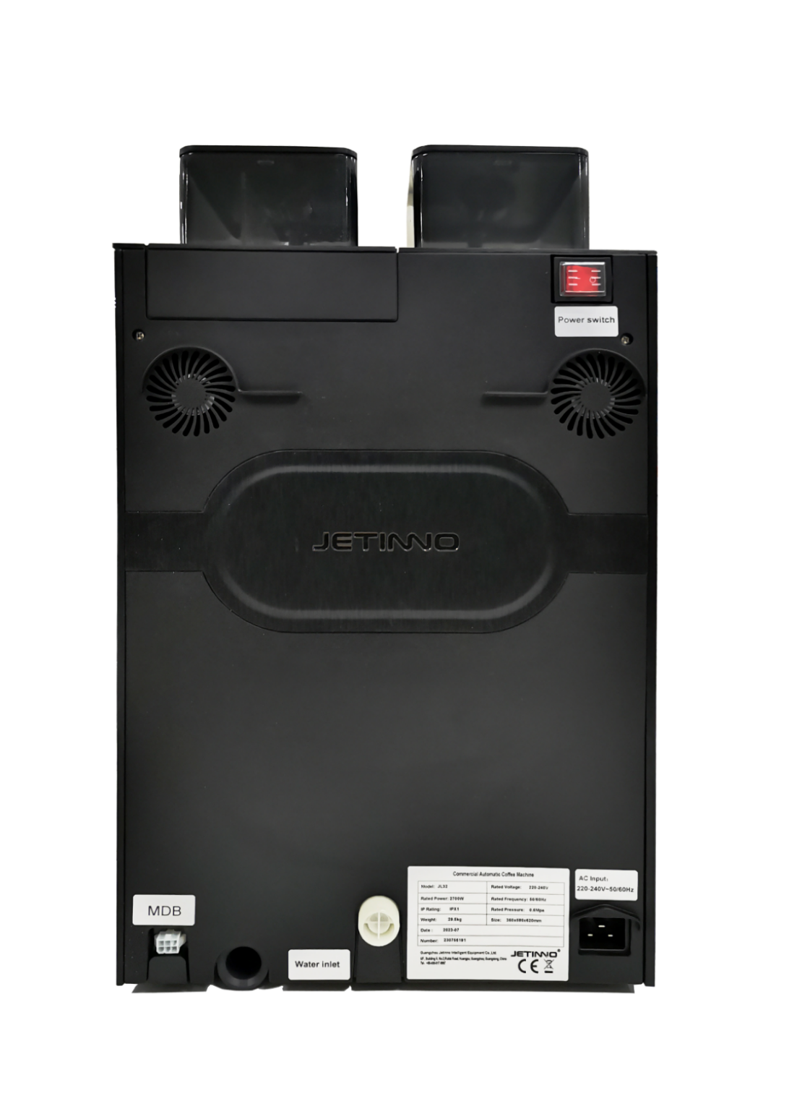

Machine startup, turn on the power switch；Select the corresponding machine configuration based on the nameplate on the back of the machine
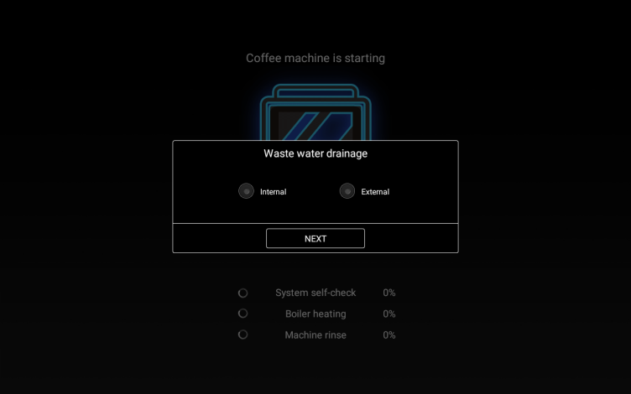
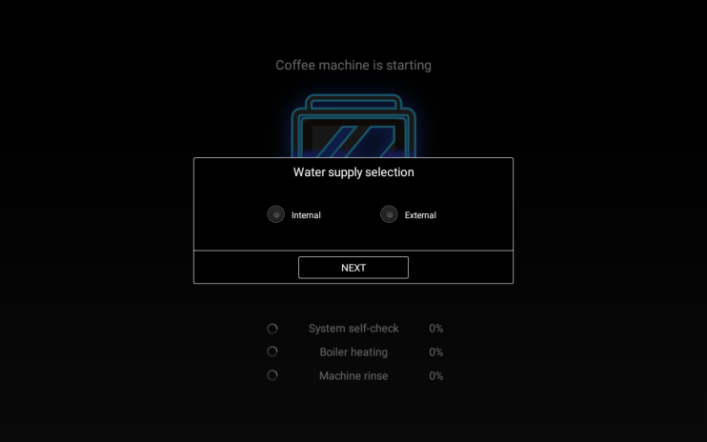

Choose wastewater drainage method Choose water supply method
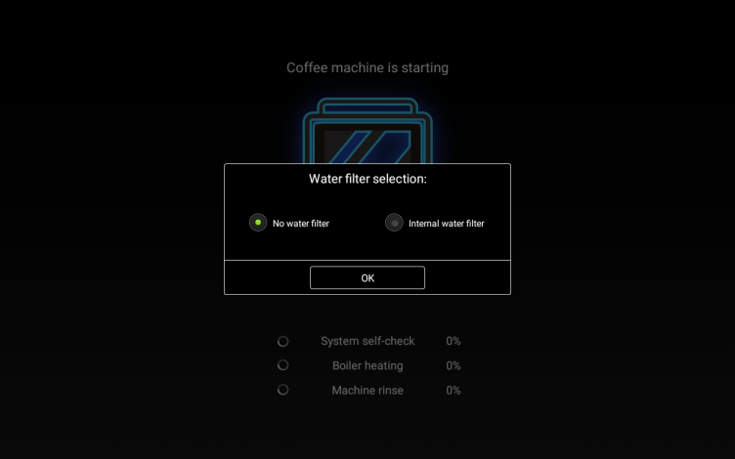
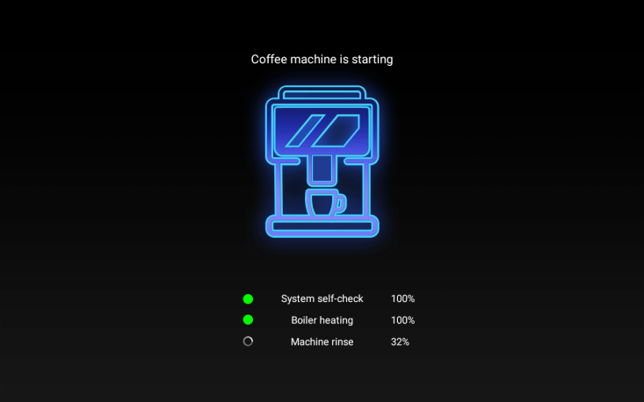

Water filter selection Display the main interface and start heating
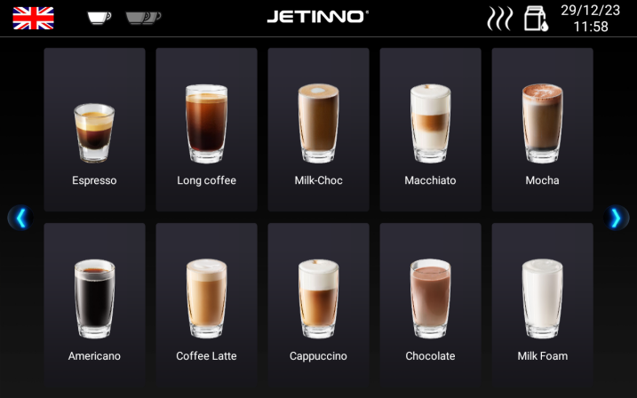
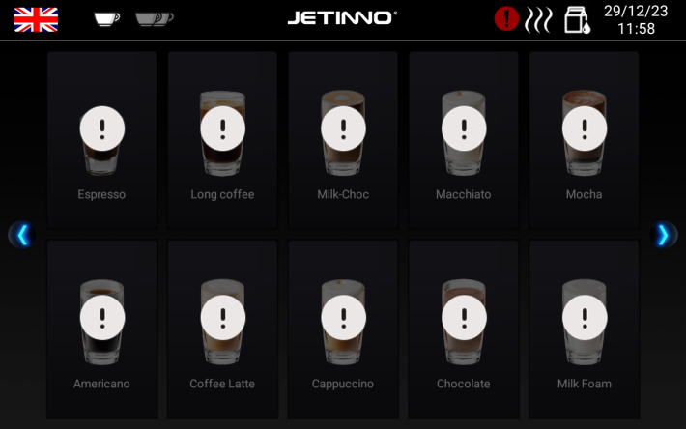

The boiler heats and boils water, and when the water temperature reaches the set temperature, the machine is ready.

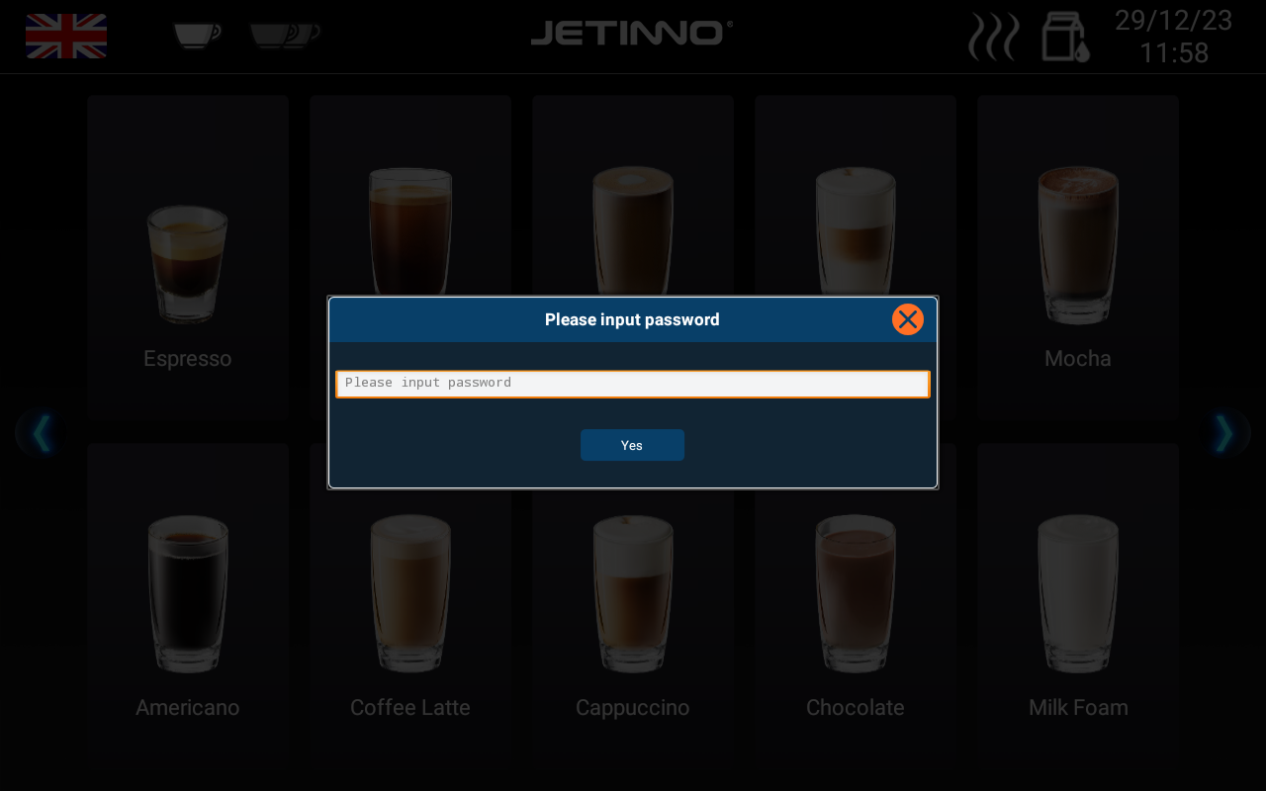
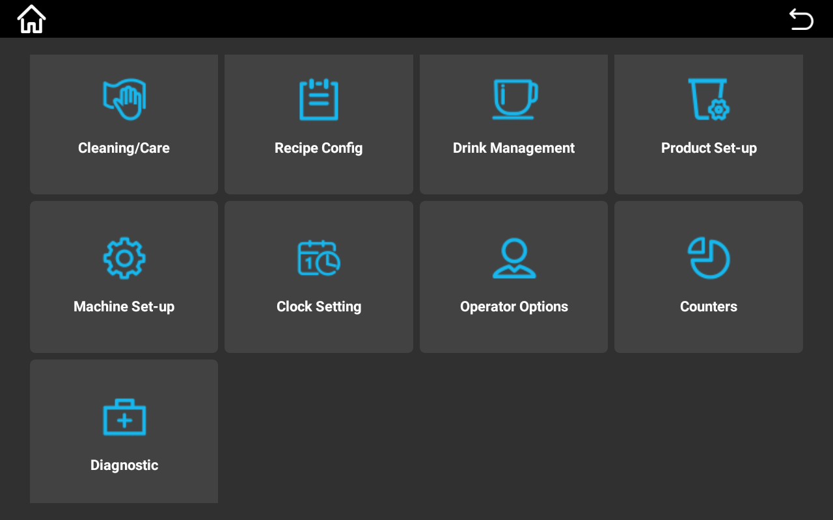
Network connection

Press upper left corner of the screen for a while, enter the password test9527 in the pop-up dialog box, enter the machine background, and click "Machine Set-up".
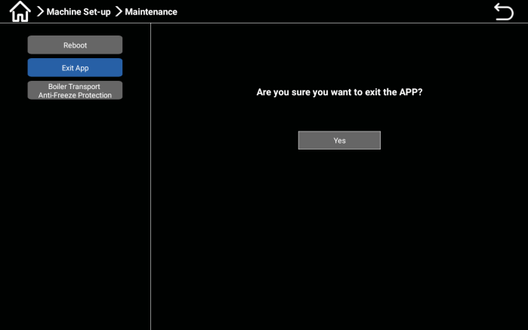
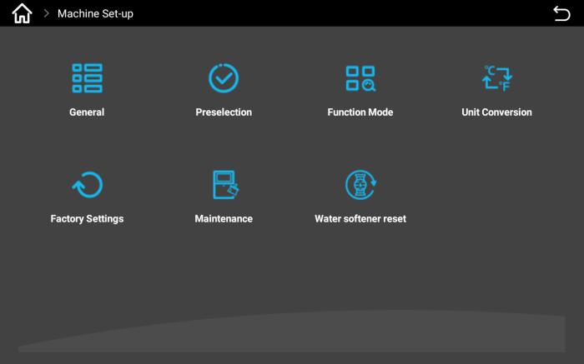

Select the "Maintenance" button and click "Exit APP" in the pop-up interface. The prompt is "Are you sure you want to exit the APP?" Click "Yes".
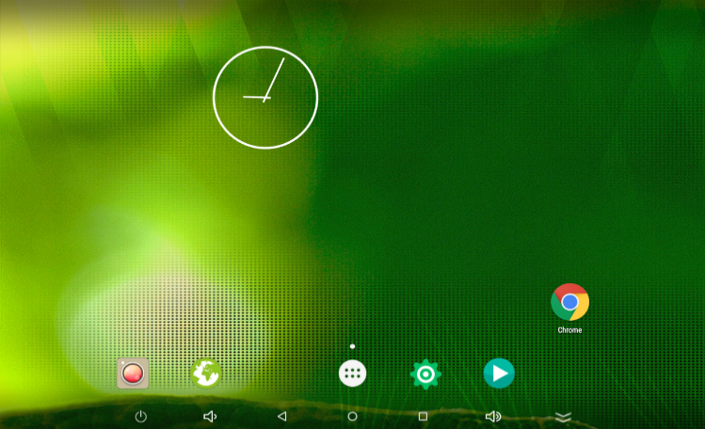
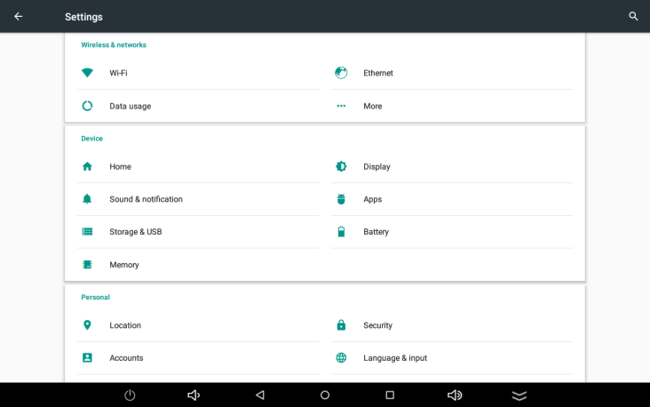

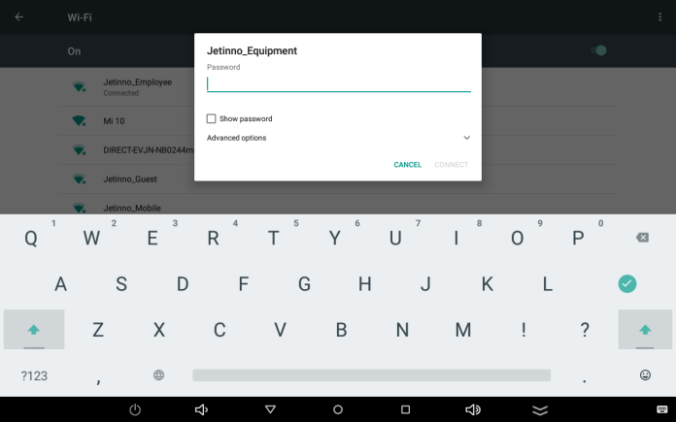
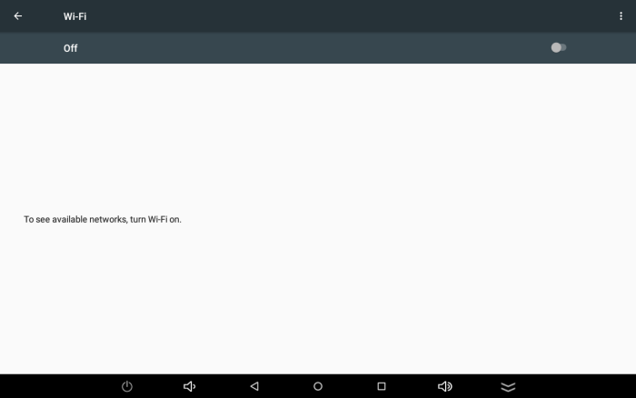
On the Android interface, click the "Settings" button and click "WIFI" in the pop-up window.

Turn on the switch, the machine will automatically search for WIFI, click on the name of the WIFI that needs to be connected, enter the password in the pop-up dialog box, and click "Connect".
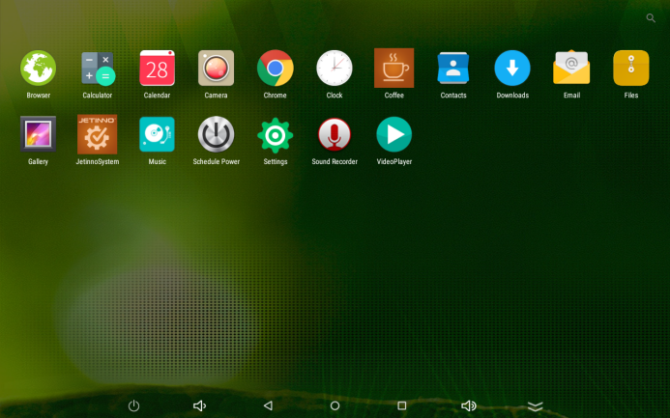
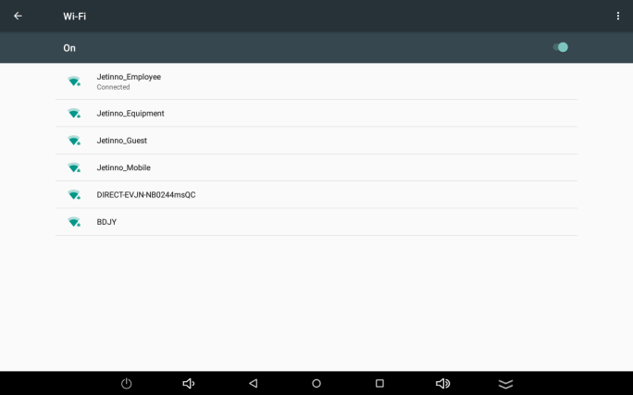

Click on the circle on the screen to enter the Android main interface, click on the "Coffee" icon to enter the coffee machine app.
Note: Under Offline model, there is no need to connect to the network and this step can be ignored.

Server connection

Press the upper left corner of the screen for a while, and click "OK". Enter the backend management interface and click "Diagnostic".

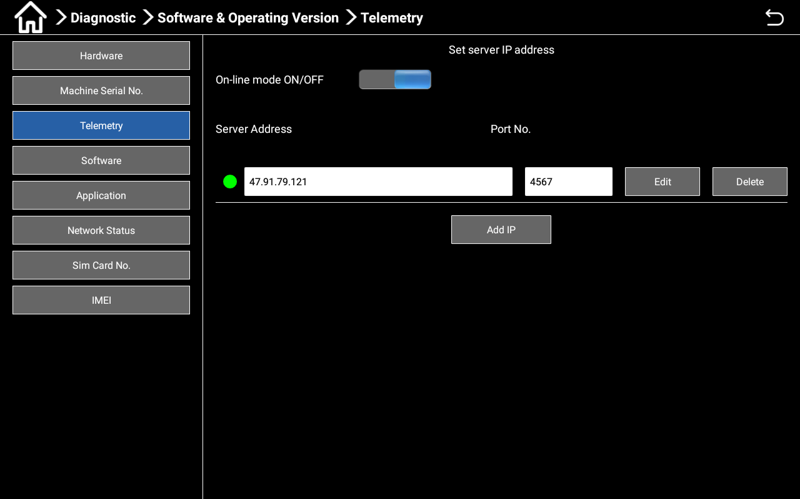
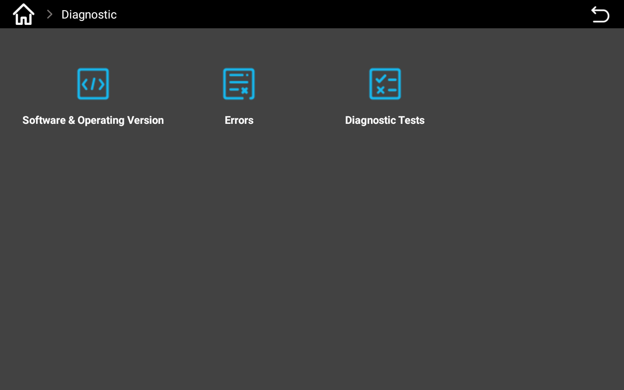

Click on "Software and Operation Version" ->"Telemetry" to turn on/off the online mode and open it. Click the return button in the upper right corner of the screen to return to the upper interface.
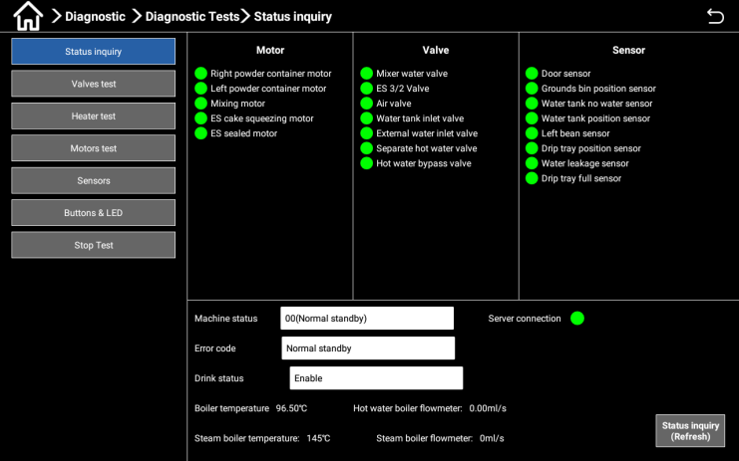



Click on "Diagnostic Tests" ->"Status Inquiry" to view: Service Connection Installation Status; Service Connection Status ，indicates successful connection to the server; Service Connection Status ，indicates a failure to connect to the server; If the connection to the server fails, please contact the local operator or agent to confirm whether the machine has been registered on the server.
Note: Under offline model, there is no need to connect to the server and this step can be ignored.

Setting Date/Time
When the user receives a machine connected to the network, the machine system time will be automatically updated and synchronized with the local time; when under offline model, the system time cannot be updated to synchronize with the local time, and the local time needs to be manually set. The specific methods are as follows:

Enter the machine background, click "Clock Setting ->Date & Time" in the pop-up interface, Use network-provided time to open it, and the system time will be automatically updated and synchronized with the local time;

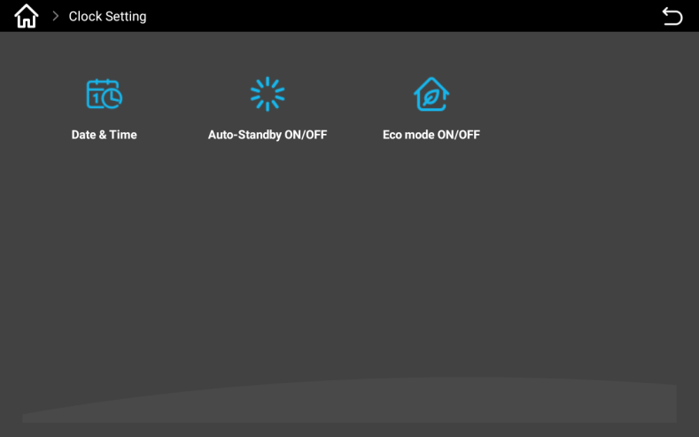
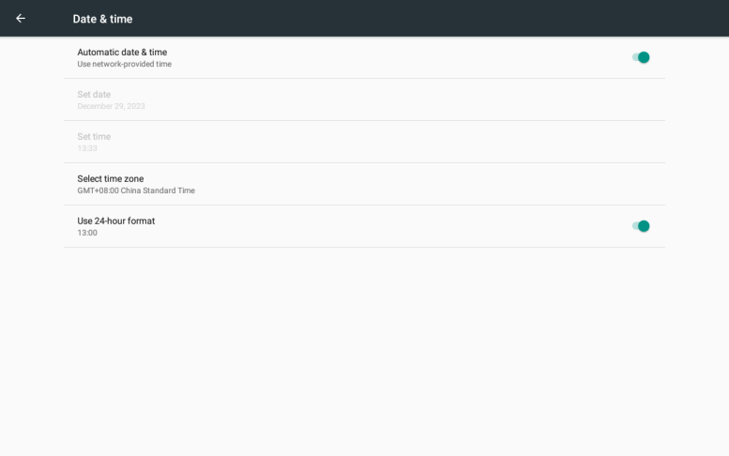

Under offline model, click "Use network-provided time" to turn it off, manually "Set date", "Set time",
and "Select time zone". Click on shortcut keys ， back to the main interface of Android, click on the "Coffee" icon, and re-enter the app.

Counters

Press the upper left corner of the screen for a while, enter the password in the pop-up dialog box, and click "OK". Enter the machine background and click on "Counters".
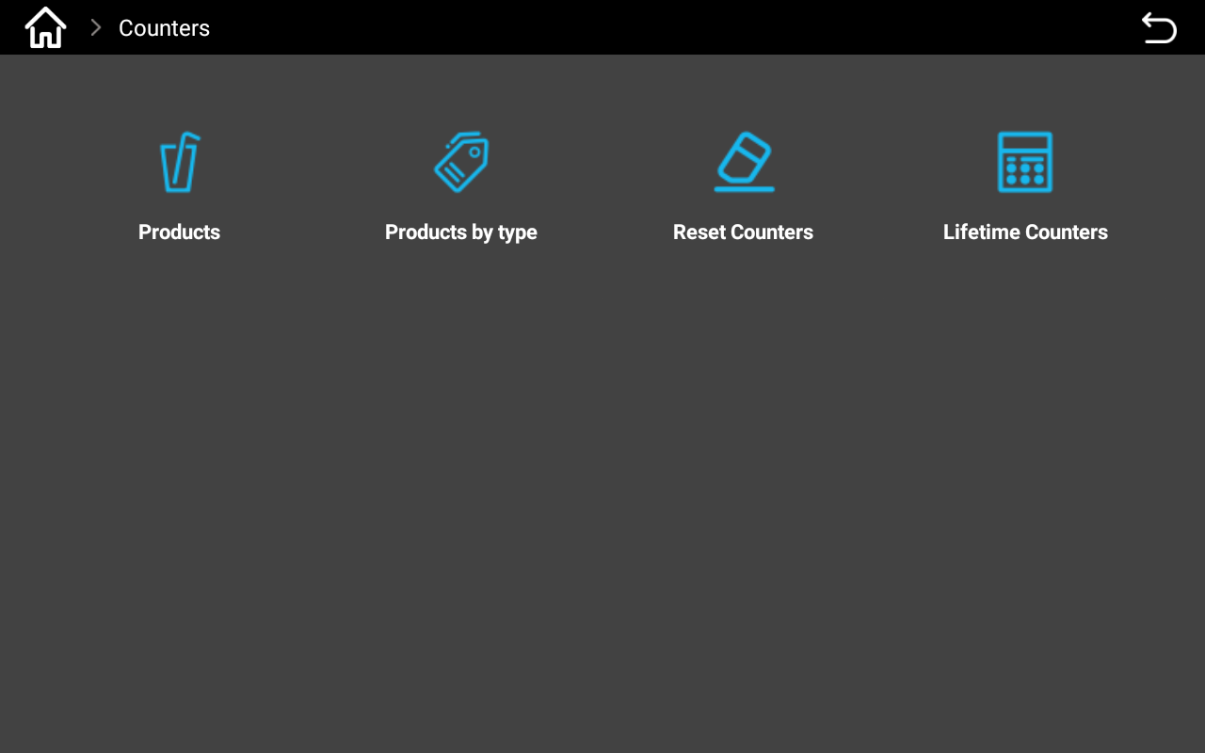
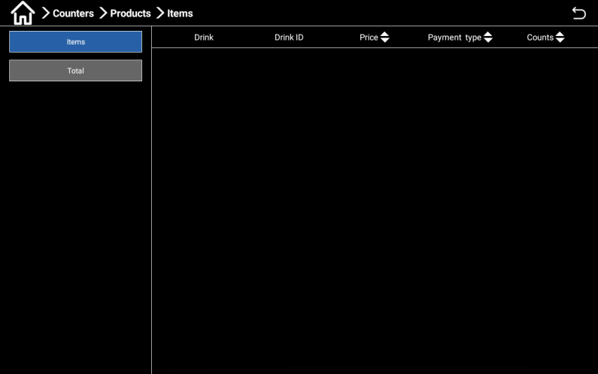

The pop-up dialog box includes functions such as Product, Products by type, Reset Counters, and Lifetime Counters. Click on "Product", there are counting methods for "Item" and "Total".

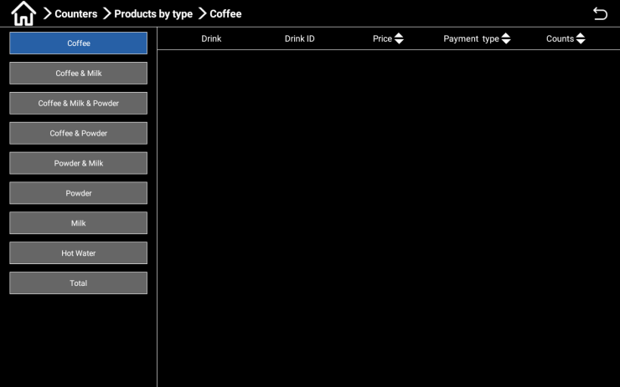
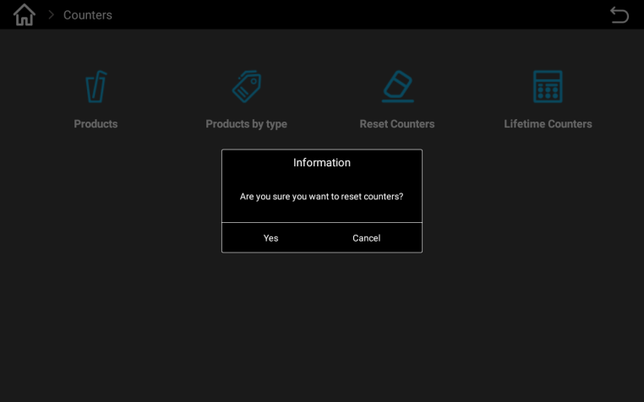

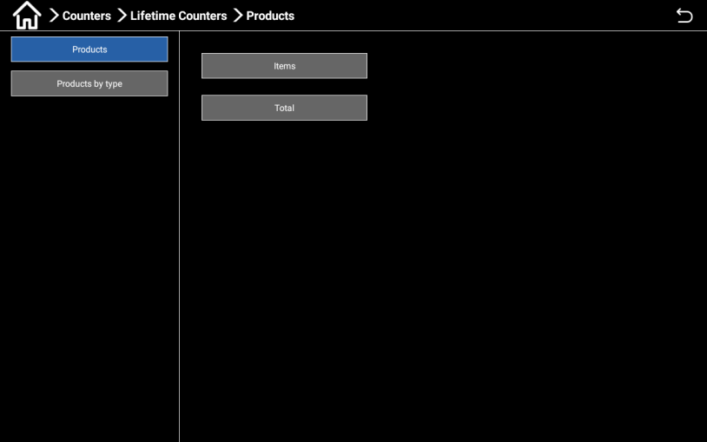
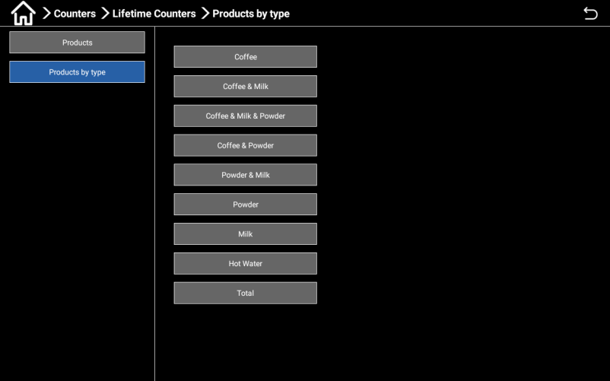
Products by type Reset Counters interface

Lifetime Counters interface by products.

Diagnostic
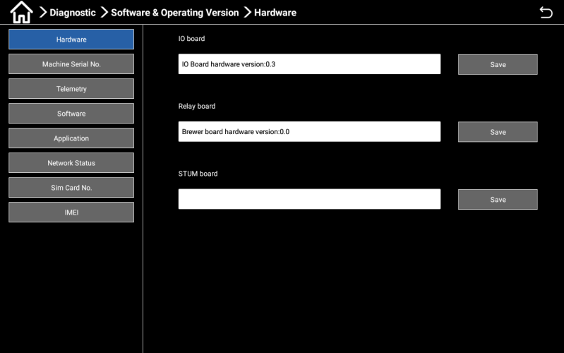
Press the upper left corner of the screen for a while, enter the password (tester: test9527) in the pop-up dialog box, and click "OK". Enter the backend management interface and click the "Diagnostic" button.

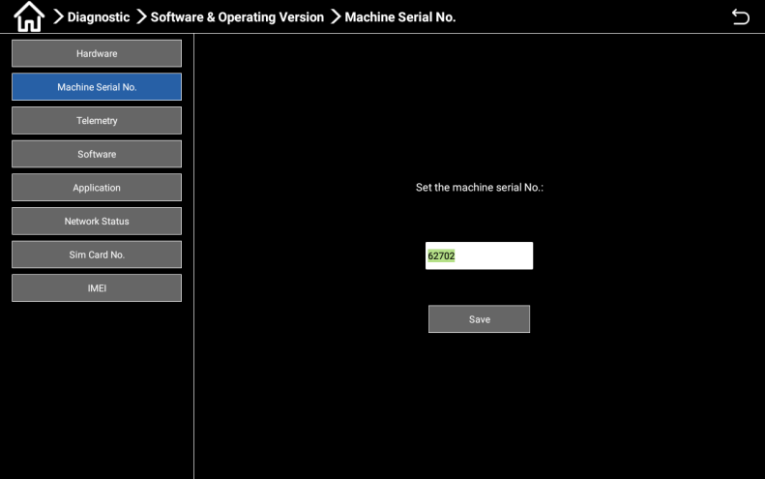
The diagnostic functions include software and operational versions, Errors, and Diagnostic Tests. Software and Operating Version - Hardware: Users can check the machine hardware version here;

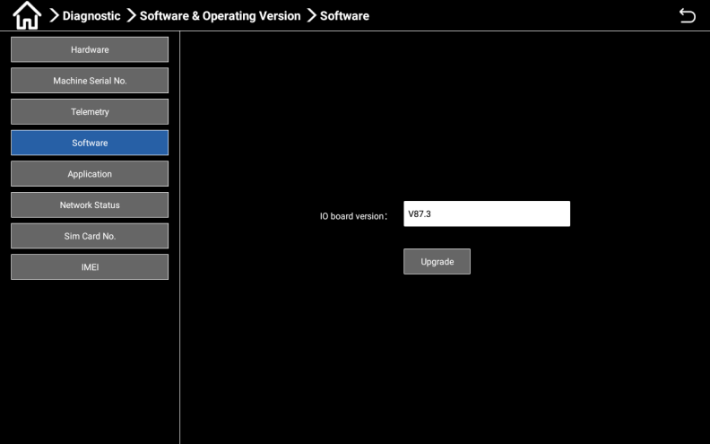
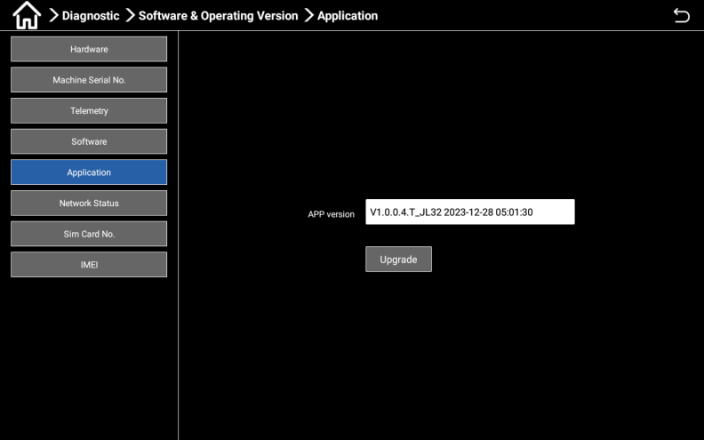
Software and Operation Version - Machine Series No.: Users can set the machine number here; Telemetry: Users can turn on/off "online mode on/off"

Users can check and update the firmware version of the I/O board here;
Users can check and update application versions here;
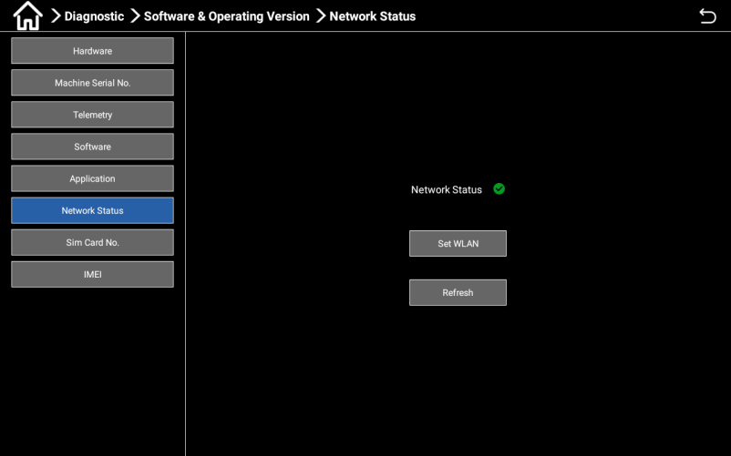
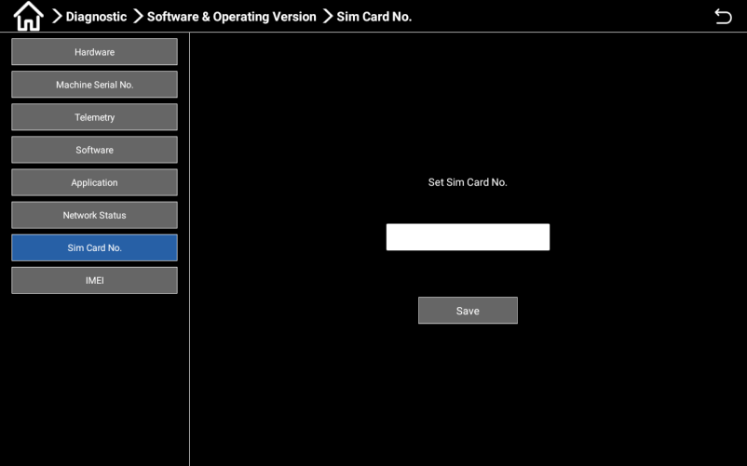

Software and Operation Version - Application: Software and Operation Version - Network Status: Users can check and set up the network here. Users can set their SIM card number here (hardware support required); Users can set up IMEI here (hardware support required);
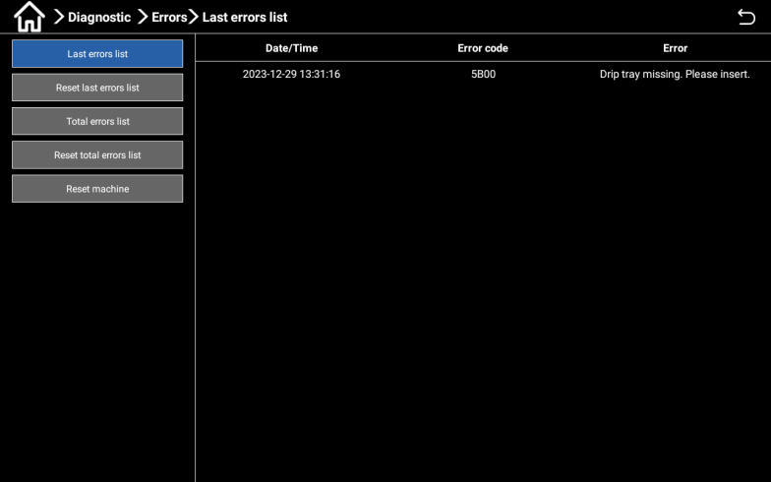
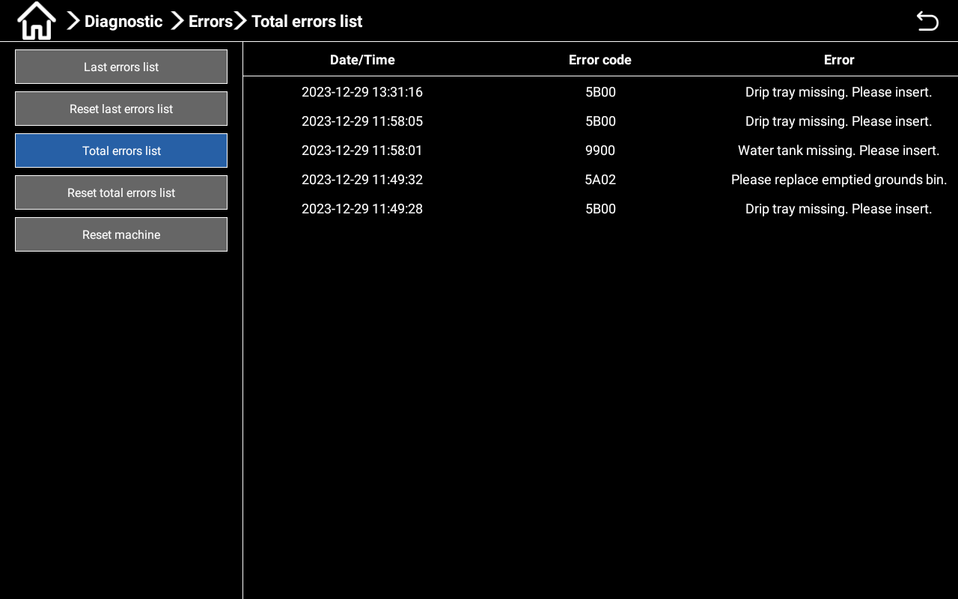

Errors - Current Error List: Users can query the current error; error - Total error List: Users can query all error information.

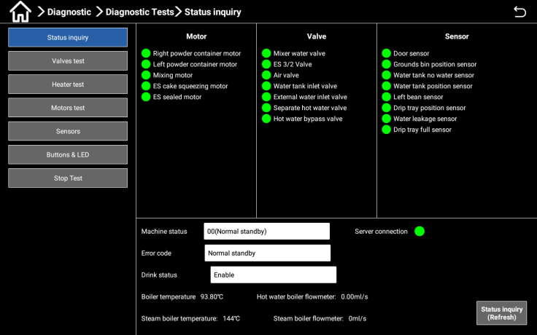
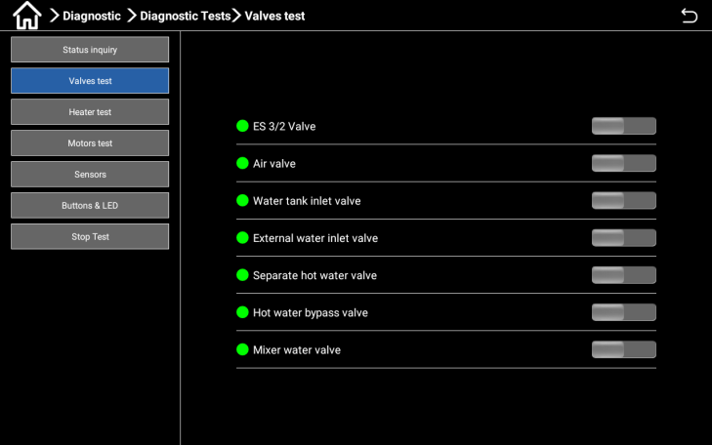

Diagnostic Tests - Status Inquiry: Users can check the status of all machine components here; Diagnostic Tests - Valves test: Users can test all valves inside the machine here.
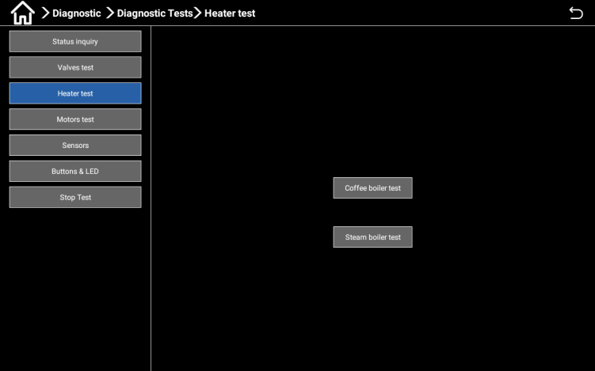
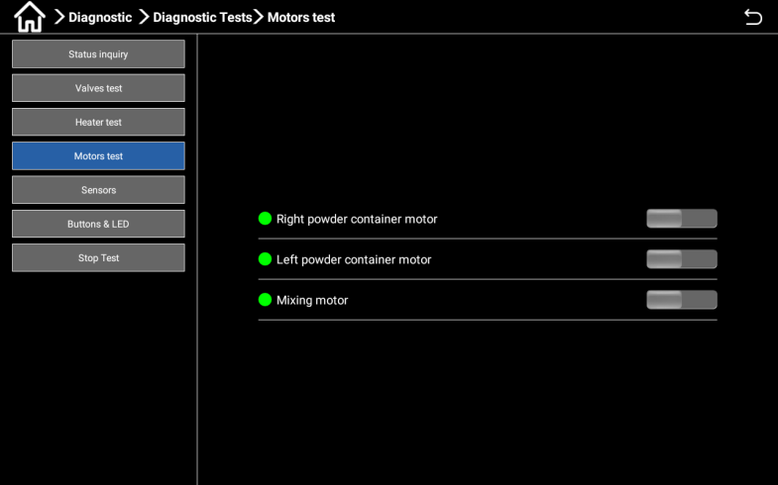

Heater test: Users can test all boilers inside the machine here;
Motors test: Users can test all sensors inside the machine here.

Machine Reset

Press the upper left corner of the screen for a while, enter the password test9527 in the pop-up dialog box, click "OK", enter the machine background, and click the "Diagnostic" button.

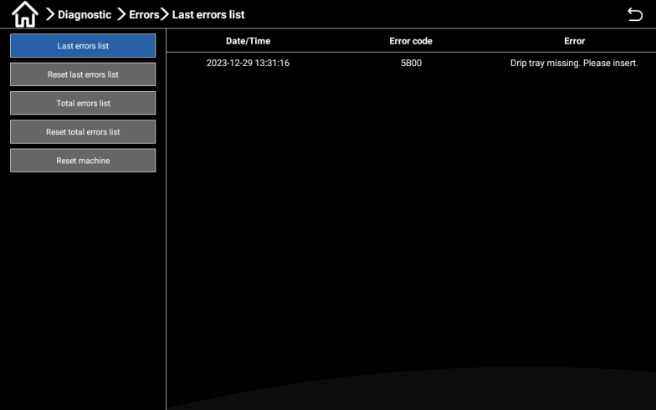

Select the "error" icon and follow the prompts on the machine for handling;
Click the "Reset total errors list" button, and the machine will automatically retest.

First use

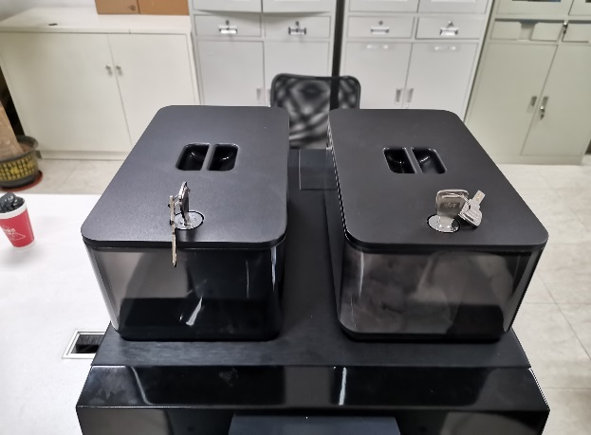
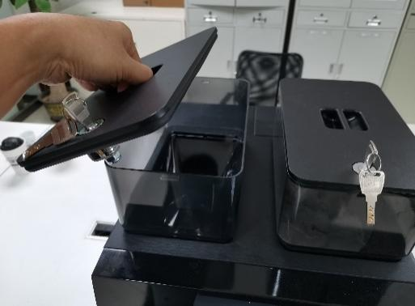
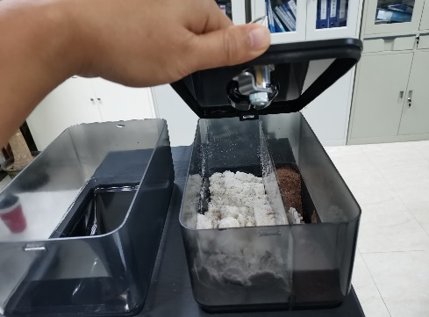
Filling canister

1) Wear a mask and disposable gloves;
2) Insert the key into the lock on the lid of the canister and rotate to unlock it;
3) After unlocking, remove the lid of the canister and add coffee beans and powder to the corresponding canister;
4) After adding coffee beans and powder, cover the lid, turn the key, lock the container, and remove the key.
Coffee beans

The rotating grinding disc of the grinder can cause injury to people.
Do not reach into the coffee bean container when the coffee machine is turned on

When covering the canister lid, tilt the back first to insert the buckle into the slot and then press down.
Adding foreign objects may cause blockage of the grinder or damage to the grinding equipment!
Do not put any items other than coffee beans into the coffee bean container.

Adding milk to the milk box in the refrigerator

Contamination of milk ducts may pose a threat to health.
After installation, debugging, or re operation, cleaning must be carried out.
Before the initial output of the drink, rinse according to the cleaning program guided by the display screen.
Insert the refrigerator door key and rotate it clockwise to open the refrigerator door;
Take out the milk box, pour the milk into the milk box, put the milk box into the refrigerator, and close the refrigerator door;
Determine the thermostat to be 3 to 5 degrees and adjust the thermostat Settings accordingly; If necessary, pour the pre-cooled milk into the milk pitcher, the height of the milk pitcher should be lower than the height of the coffee machine mouth, and finally close the refrigerator door. If necessary, pour pre cooled milk into the milk can and finally close the refrigerator door.
Ignoring this step without a fresh milk machine.

Debugging and calibration
Grinder calibration

Before adjusting the grinder, please prepare a (low value) electronic scale!

Grinder thickness adjustment
First calibration, please empty coffee beans (before adjusting the grinder, empty the remaining powder in the grinder)

Method for adjusting the thickness of coffee bean grinding powder
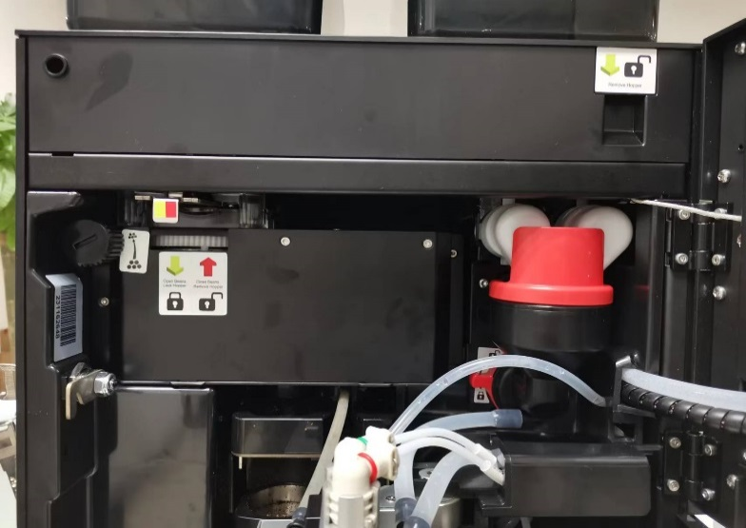
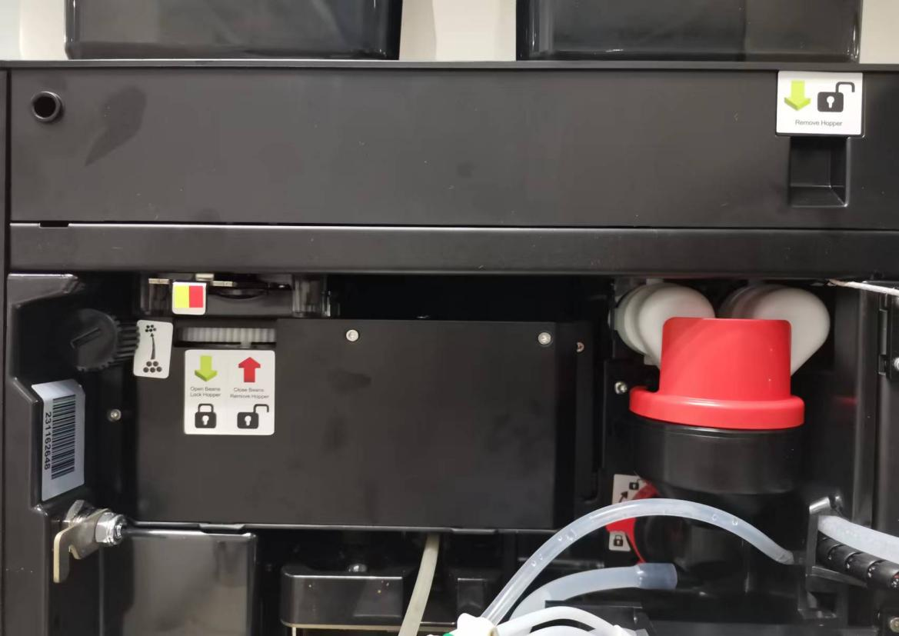

Adjustment knob for the thickness of coffee bean grinding powder, the clockwise direction is to adjust the thickness, the counterclockwise direction is to adjust the fine; Coffee bean box material stop plate, push inside to close, pull out to open; When it is necessary to remove the coffee bean box, the coffee bean box cutting plate should be pushed to the bottom, and the coffee bean box can be lifted up. Adjust the thickness of the grinding degree according to the label: It is recommended that in the absence of beans, first twist the knob counterclockwise to the position where the disc fits (can not be twisted under normal torque), and then rotate the knob clockwise 6 times, as a benchmark thickness position (the thickness of general espresso), and then fine-tune according to the thickness of the powder in the calibration process (clockwise is to adjust the thickness, counterclockwise is to adjust the fine). When fine-tuning, it is recommended to rotate the adjustment knob while grinding the beans. When it is necessary to empty the residual powder of the grinder, the coffee bean discharger plate is closed, click the "Drink Settings" button, select the "coffee" button and click, click the "Grinder calibration" option in the pop-up dialog box, and click the "Start" button several times until no coffee powder falls out of the grinder outlet.Hot milk and milk temperature regulation
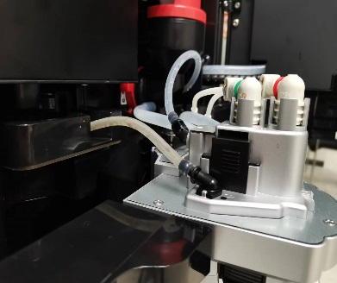
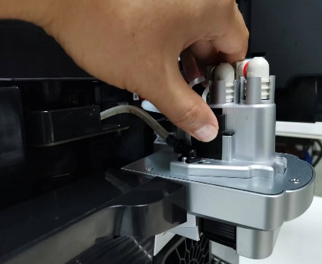
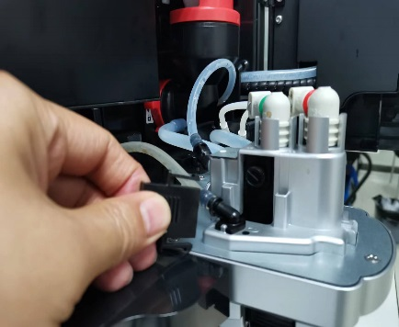
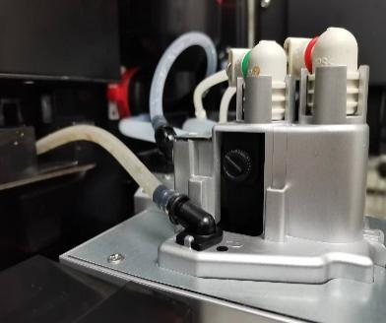
Warm milk and foam temperature regulation：

Open the door of the machine, pull out the protective button upward, you can see the adjustment knob, rotate clockwise by hand, the temperature of hot milk and milk foam will increase, and the flow rate of milk will slow down; On the contrary, rotating counterclockwise, the temperature of the hot milk and milk foam will be reduced, and the flow rate of milk will be faster. It is recommended to fine-tune, each adjustment amplitude is not too large.

Grinder calibration
Calibration is a software designed for the physical properties of instant canister, powders, and the degree of roasting of coffee beans. Prepare the electronic scale and cup before calibration.

Not doing calibration will cause abnormal powder production of the machine!
Before calibration, it is necessary to fill the grinder, milk tube, and canister with a full amount of material. Insufficient outlet may result in inaccurate calibration.

Because each component or powder has different physical properties, it is necessary to recalibrate every time the canister, motor, or coffee beans or powder from different manufacturers are replaced. During calibration, the amount of powder in the canister must be greater than one-third of the volume of the canister.
Grinder calibration steps:

Press the upper left corner of the screen for a while, enter the password in the pop-up dialog box, click OK, enter the machine background, and select the "Product Set-up" button.

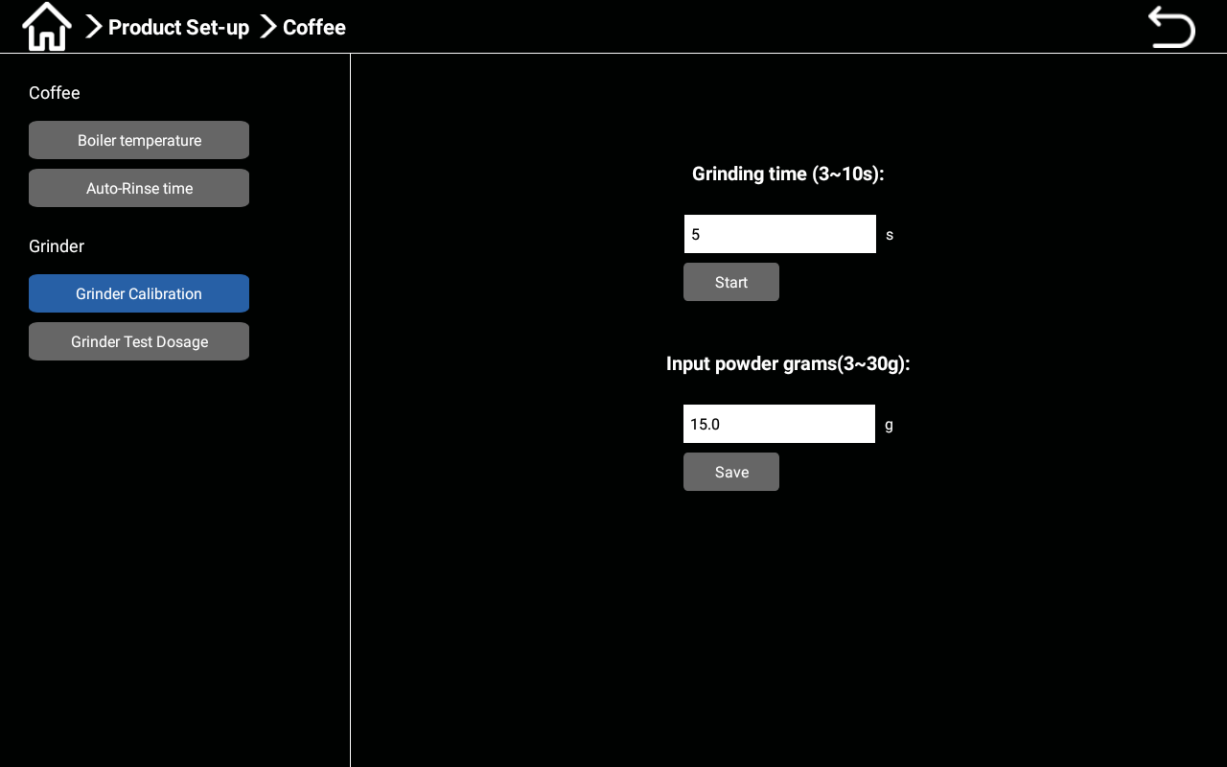

Select the "Coffee" button and click on it. In the pop-up dialog box, click on the "Grinder Calibration" option and click the "Start" button to grind the coffee powder once and discard it.
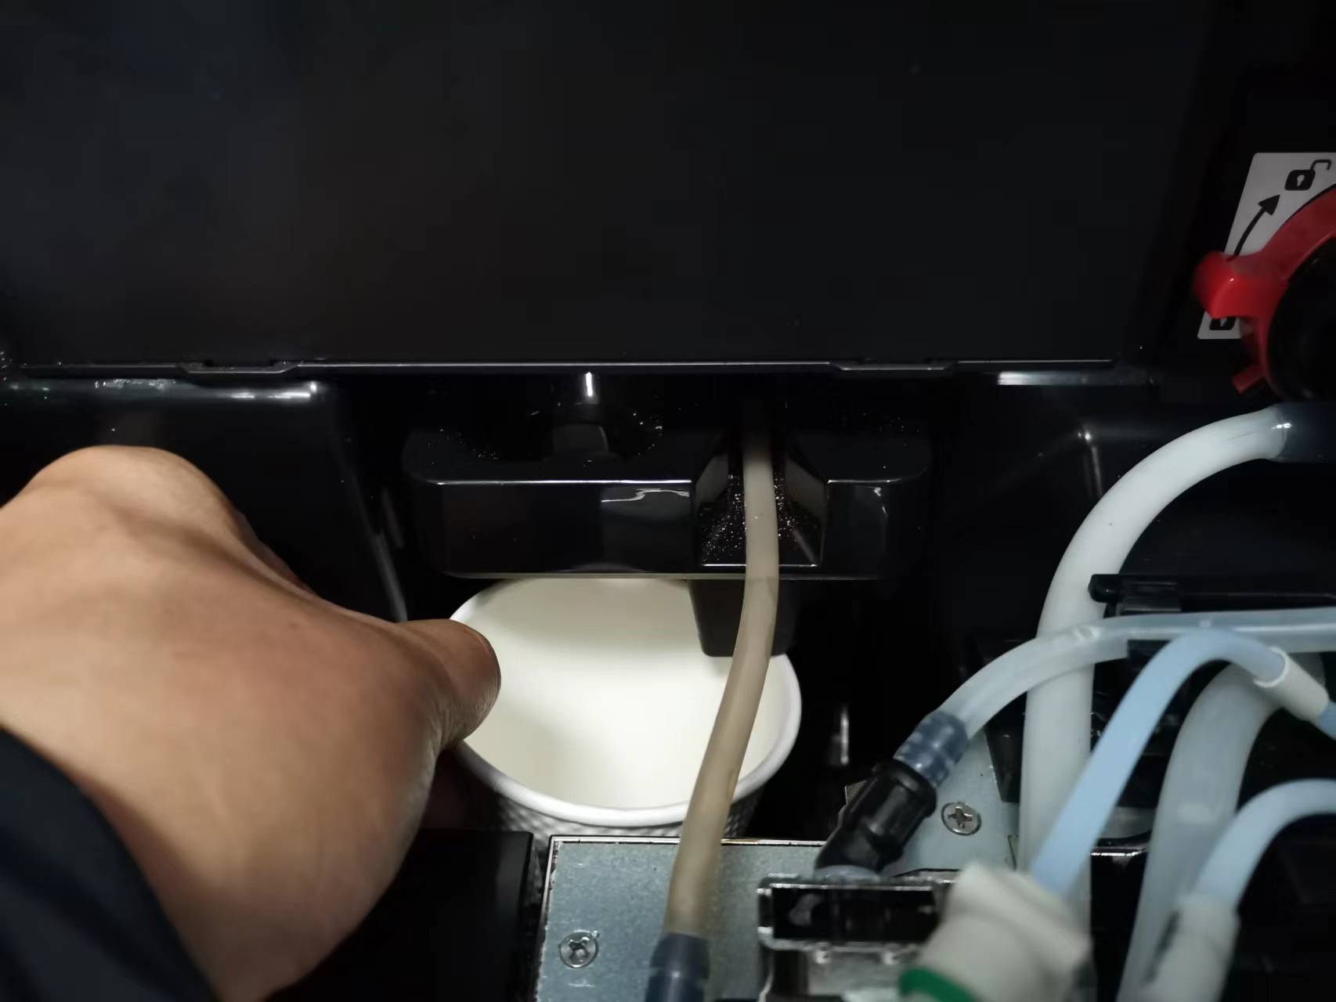

Place an empty cup on the electronic scale and reset it to zero, then place the cup at the powder outlet of the grinder; Click the start button again. Wait for the grinder to finish grinding. Remove the cup containing coffee powder and place it on an electronic scale for weighing. Enter the weight value in the blank field of [Input Powder Grams] and click "Save".

Fresh milk calibration
Different milk sources produce different concentrations, and fresh milk needs to be calibrated. Sufficient milk source needs to be ensured during calibration.
Calibration steps for fresh milk

Press the upper left corner of the screen for a while, enter the password in the pop-up dialog box, click OK, enter the machine background, and select the "Product Set-up" button.

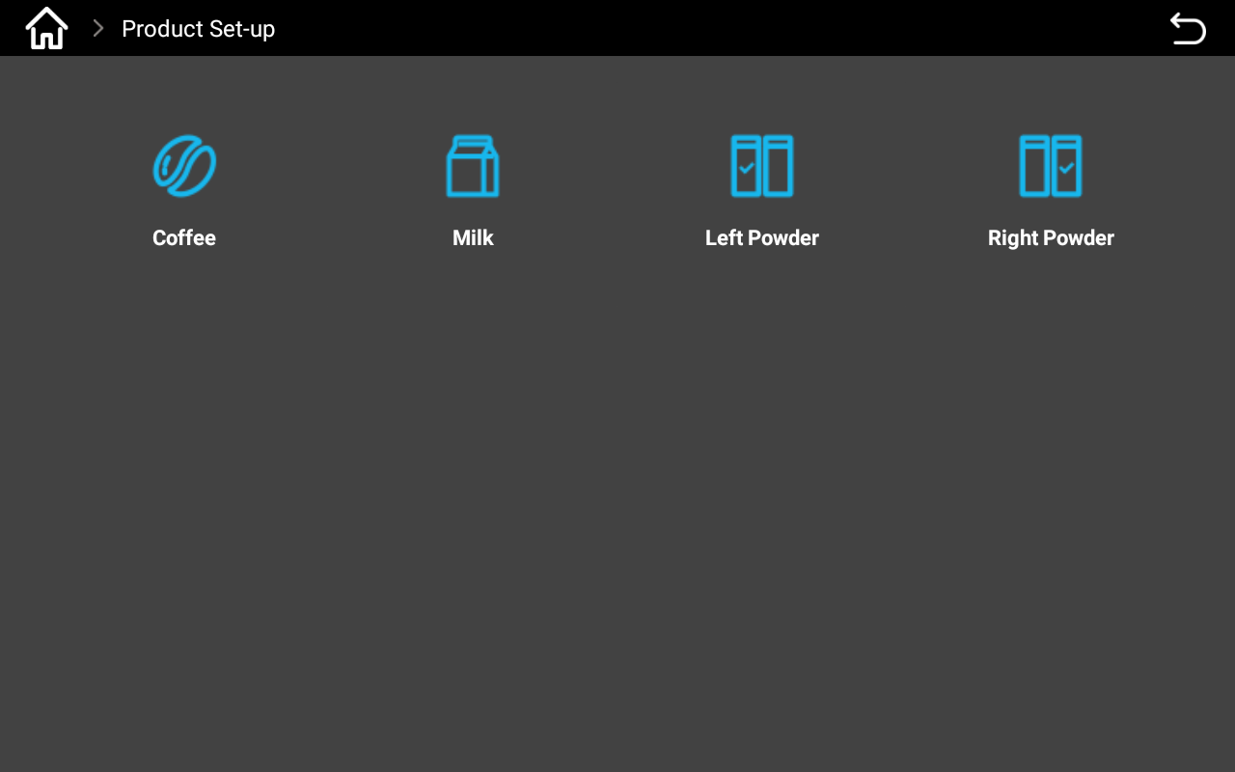
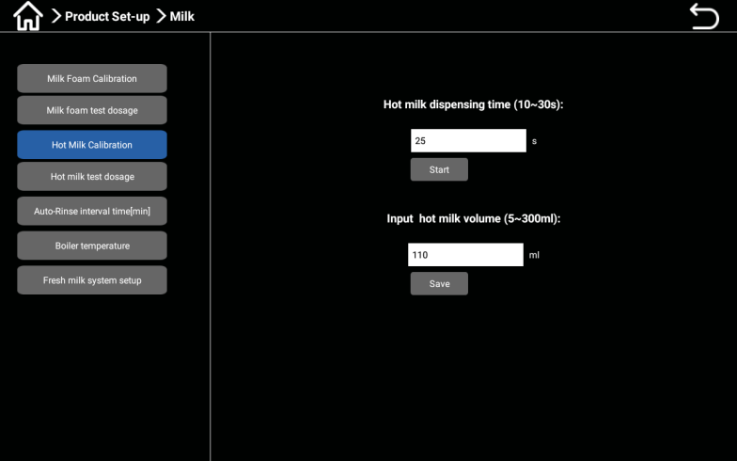

Select the "Milk" button and click to select "Milk Foam Calibration" or "Hot Milk Calibration" in the pop-up dialog
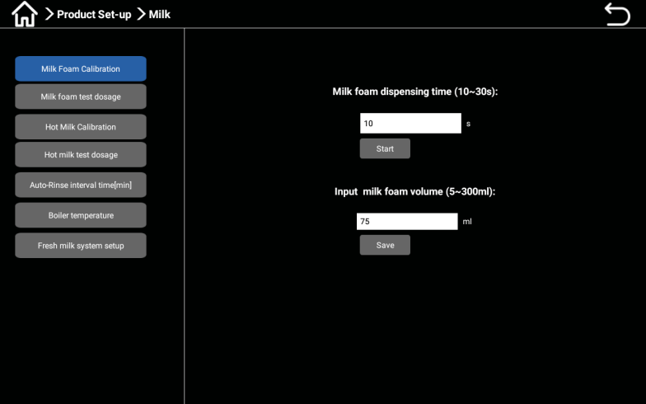
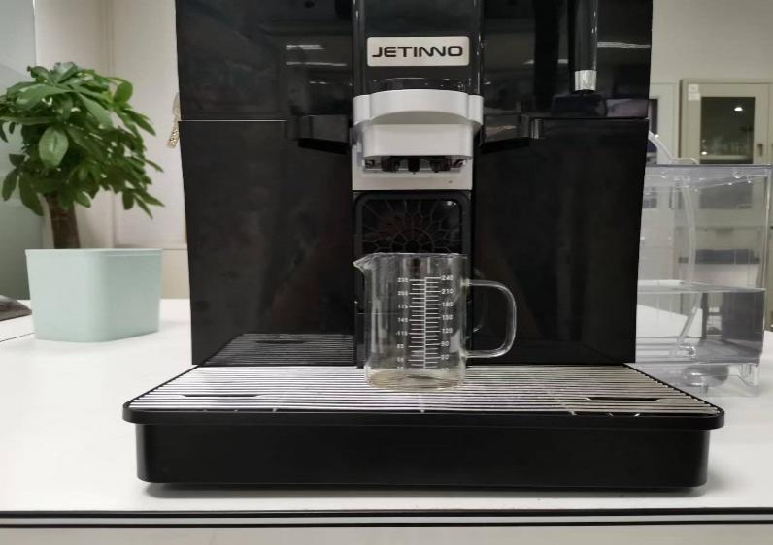
box.

Click the "Start" button. After the milk froth or hot milk is finished, remove the measuring cup containing the milk froth or hot milk, read the value of the milk froth or hot milk in the measuring cup with your eyes facing straight, input the read value into the blank space below [Input Milk Foam Volume]/[Input Hot Milk Volume], and click "Save".

Powder calibration
Because powders have physical properties, different densities, and different processes, calibration is required. During calibration, the amount of powder in the canister should be greater than one-third of the volume of the canister.
Powder canister calibration steps:

Enter the machine management backend. Click on "Product Set-up" and select "Left or Right canister".

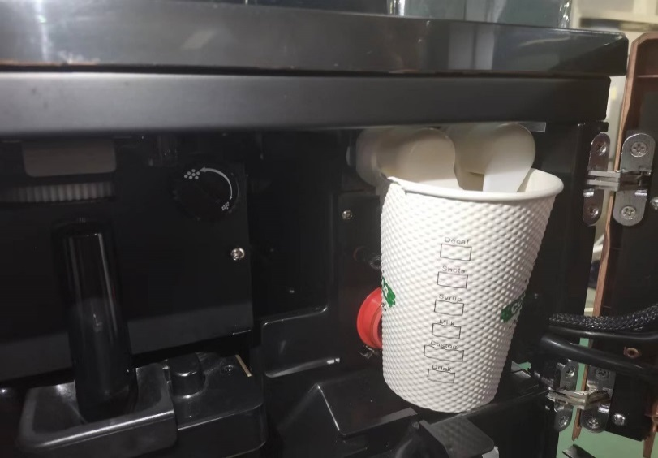
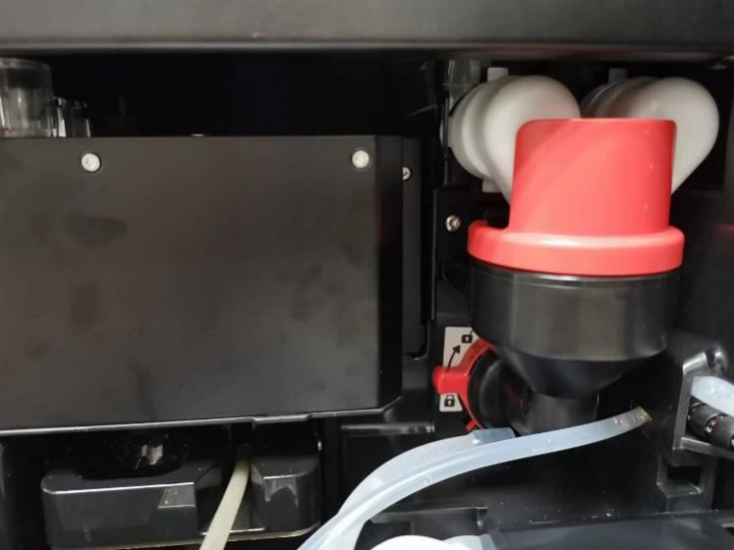

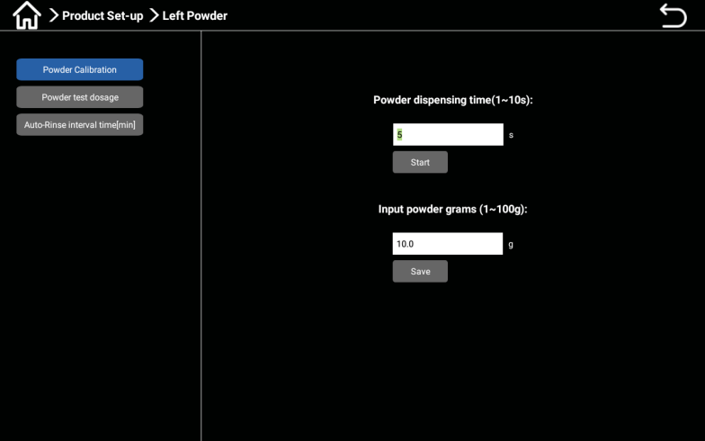
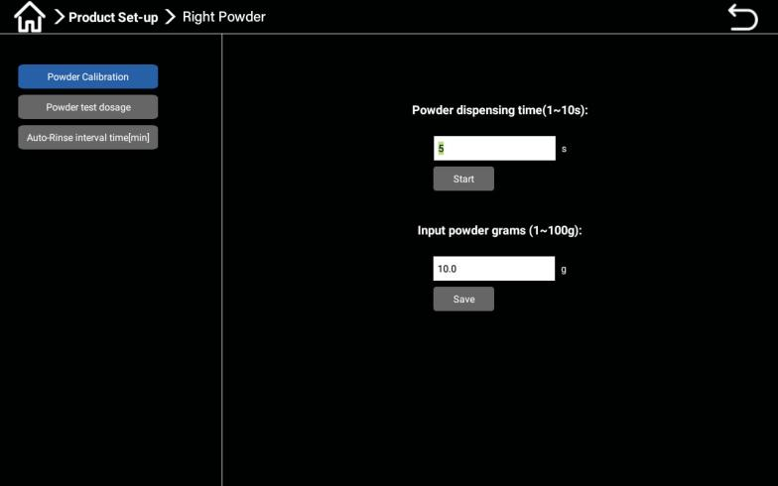
Open the machine door, rotate the mixer fixing ring clockwise, unlock, and pull out the mixer outward; Take an empty cup and place it at the canister outlet.

Click the "Start" button to discard the powder that falls into the cup. Place the cup on the electronic scale to reset or peel it, and then place the cup at the canister outlet. Click the "Start" button. After the powder box is finished, remove the cup containing the powder and place it on the electronic scale for weighing. Enter the weight value into the "Input powder grams" field and click "Save".

Product Testing and Adjustment
Click on [ Recipe Configuration ], and in the pop-up interface, there is a deerror factory recipe for the machine; Selecting the corresponding drink will pop up the corresponding recipe, and clicking [Test] can directly test the drink; The recipe interface has functions such as [Import Recipe], [Export Recipe], [Add Recipe], [Delete Recipe], [Edit], [Test], and [Delete]. Enter the recipe interface, select the product, click [Edit], and adjust the water volume, coffee bean powder, hot milk and foam discharge time of the product (the amount of milk is determined by the length of time). After modification, click [Save] and directly click [Test].
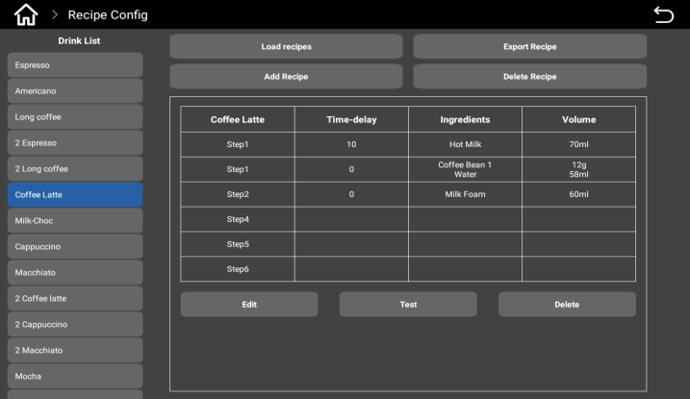
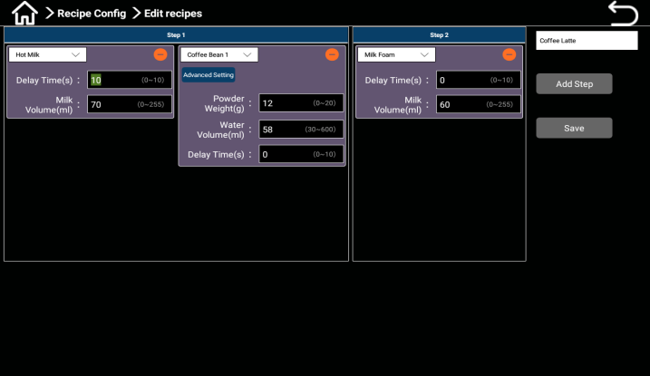

Recipe interface, select the product.
After selecting the product, click [Edit] to adjust the water and powder quantities.

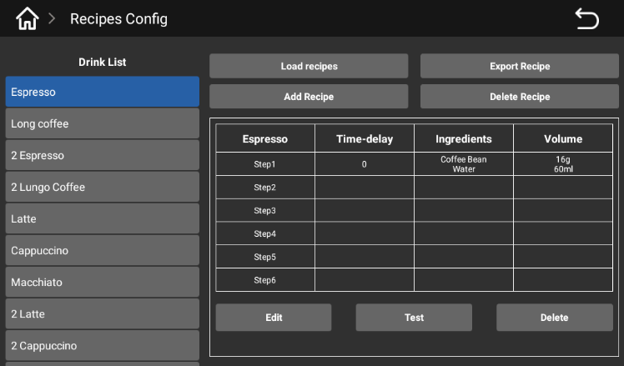
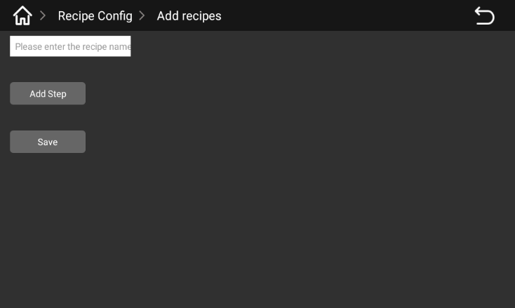
New Recipe

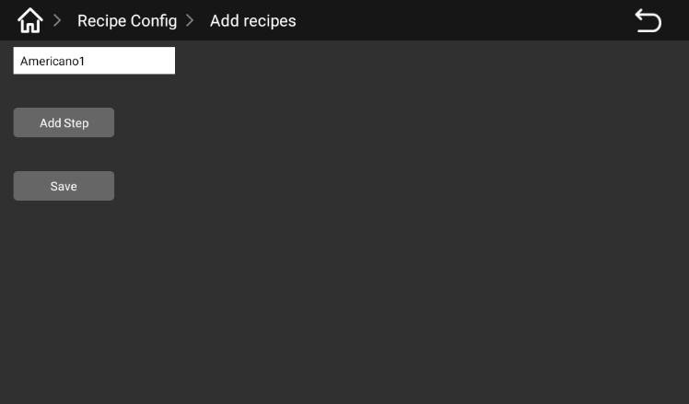
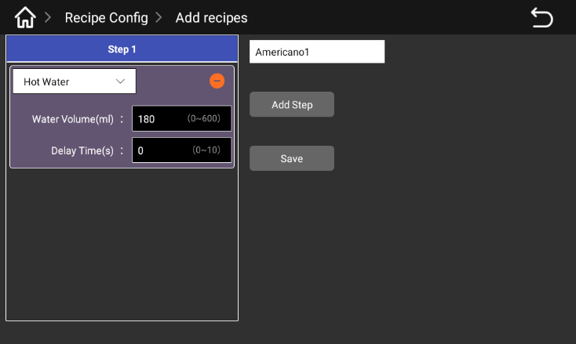
Go to the Recipe screen, click the "Add Recipe" button, and enter the recipe name in the pop-up dialog box.

Click "Add steps", enter the corresponding parameters in the pop-up dialog box, gouache ratio.
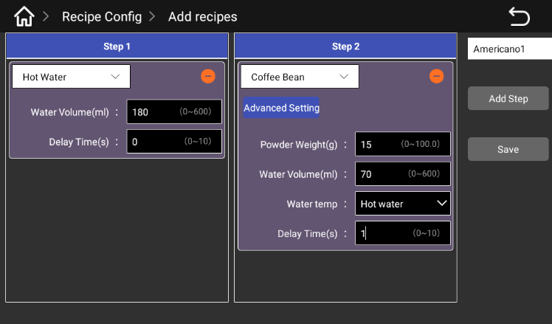
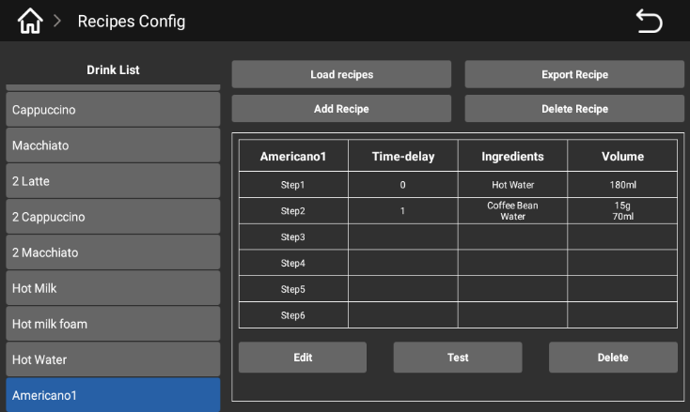

Continue to click "Add steps", enter the corresponding parameters in the pop-up dialog box, confirm the completion of the formula, click "Save" button, select the new formula in the formula interface, and then click "test", when the drink is finished, taste it, if it is OK, otherwise you can continue to modify the goureau ratio and continue to test until you get satisfactory coffee.

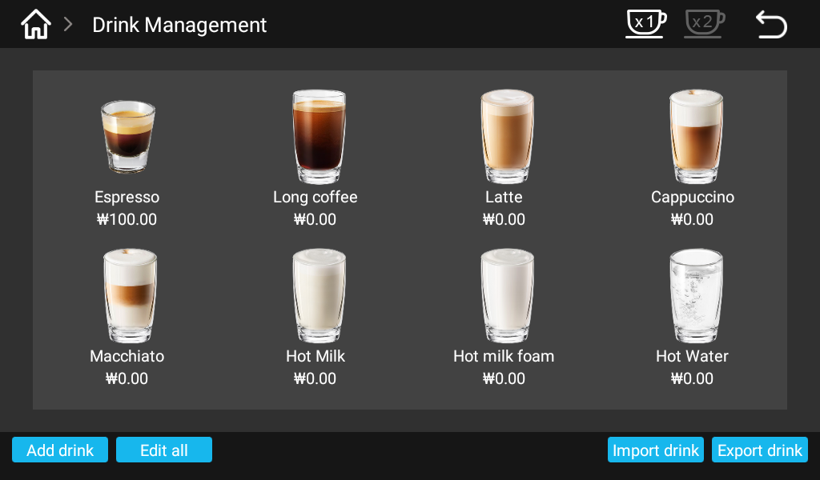
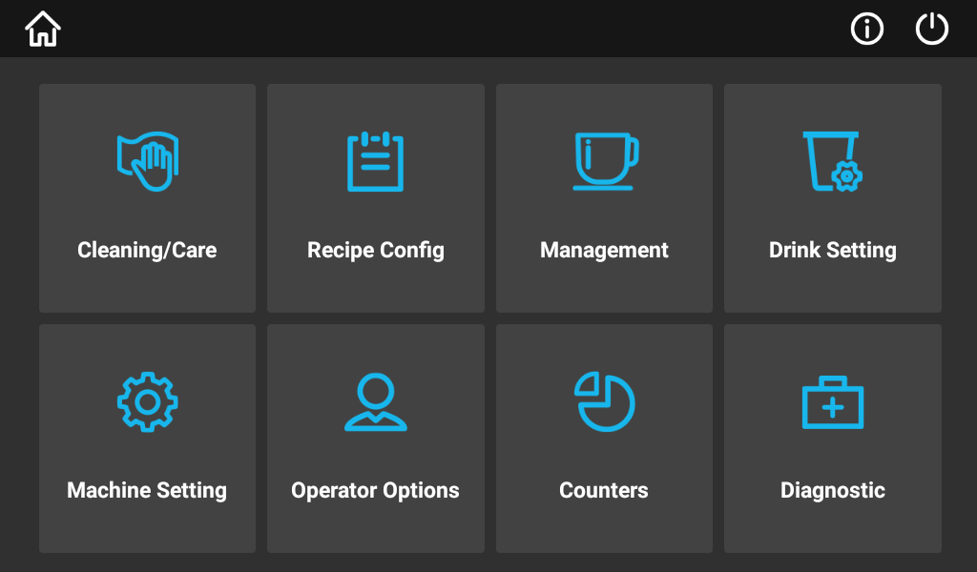
.New drink

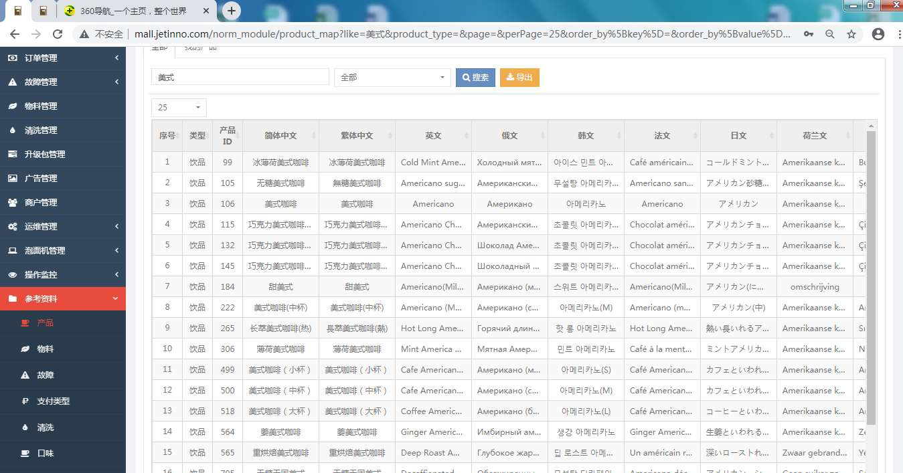
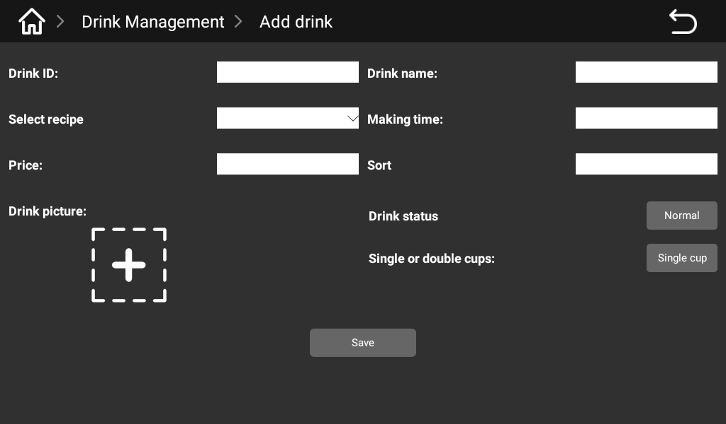
Select the "Drink Management" button and click, and click the "Add Drink" button in the pop-up interface.

Enter the drink ID and drink name in the pop-up interface (drink ID and name can be obtained through the network management background - Reference - search, when the use of a single machine, sales data are not counted, drink ID and name can be customized).
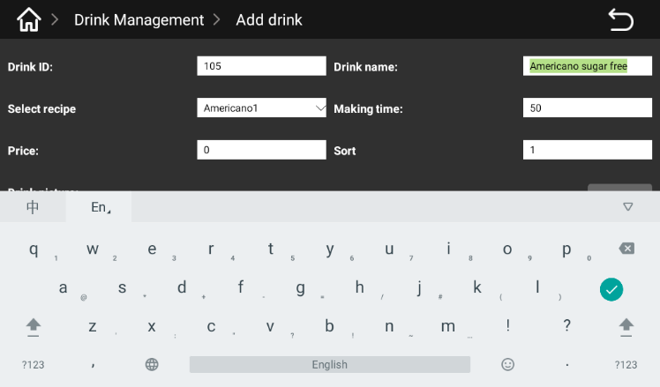
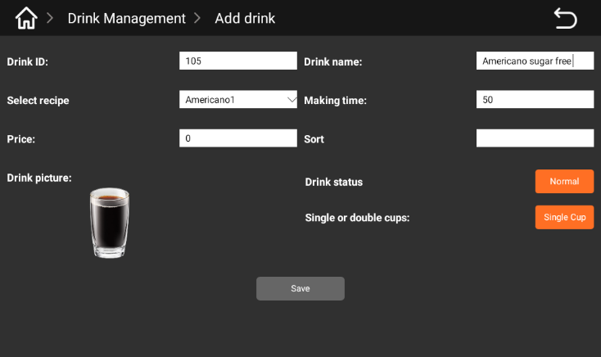

Select the recipe in the new drink interface (select the new recipe in the previous section - Americano 1), enter the drink production time, price, sort, select the drink picture, drink status, single or double drink, confirm and click the "Save" button.
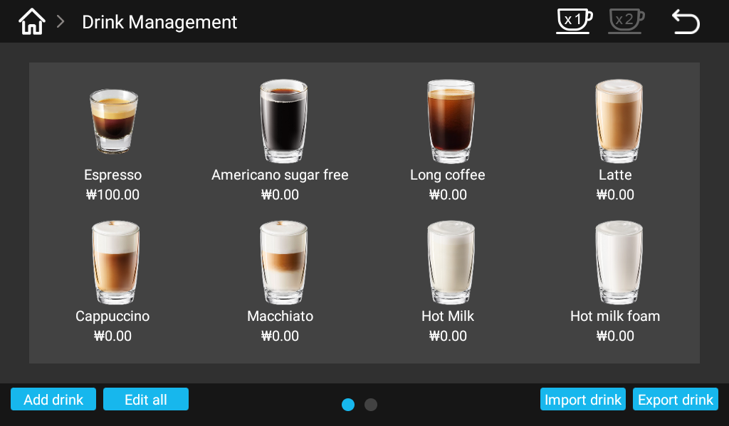
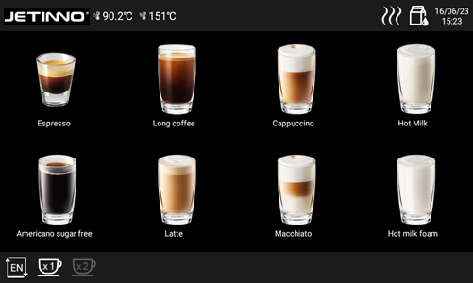

New drinks will be displayed in the beverage management interface, as shown in the figure above; Click the top left corner of the screen to return to the sales screen, which will display new drinks.

Drink management
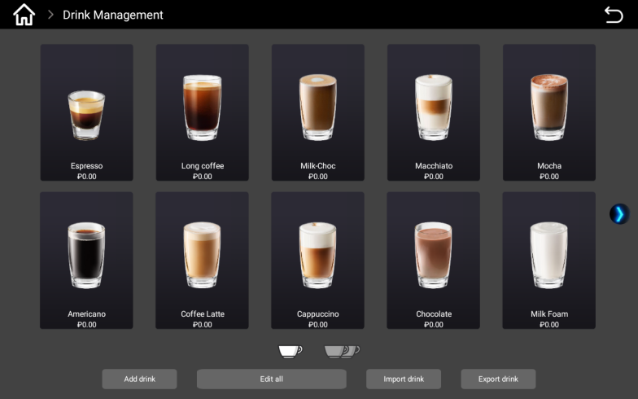
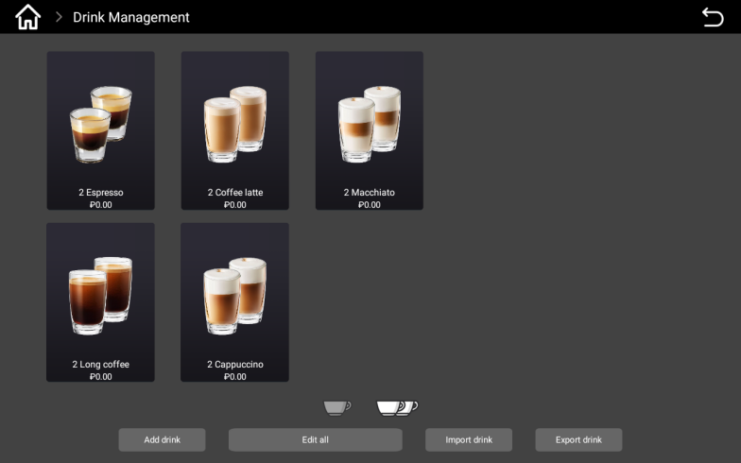

Single Cup drink Interface Double Cup drink Interface
The drink management interface can add drinks, edit all drinks, import drinks, and export drinks.
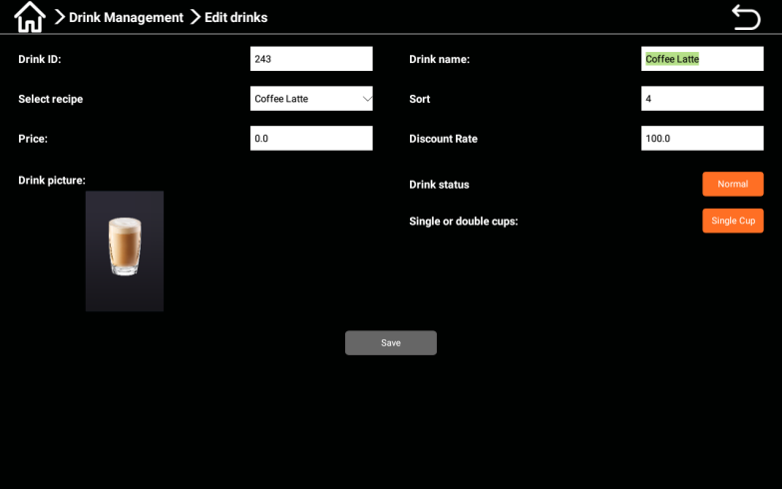

Click on the drink icon to edit the drink: drink ID (the entered ID needs to be consistent with the ID on the server), drink name, drink recipe, production time, price setting, sorting, normal display, delisting, single cup, double cup, and save function.
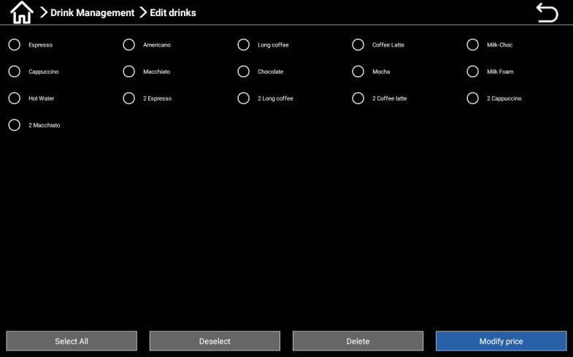
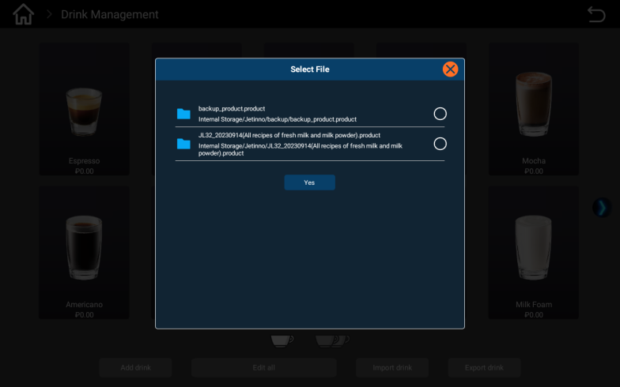

Click "Edit" to edit all drinks: you can select, reverse select, delete, and set prices. Selecting a drink can be checked individually. Click to set the price, enter the drink price in the pop-up dialog box, and click "OK" to confirm.

Drink production
- Under the user interface, select a drink;
- Adjust the taste in the touch screen, there are five levels, and then confirm; (This step can be cancelled in the factory settings according to customer needs);
- In free mode (set to 0 yuan), the machine can directly make drinks; In the payment mode, the machine will have several payment methods (such as paper currency, coins, and card payment);
- After successful payment, the machine automatically starts making drinks;
- After the drink production is completed, there will be a prompt message on the touch screen interface indicating the completion of the production;
- Customers can set the language of the user interface as needed.
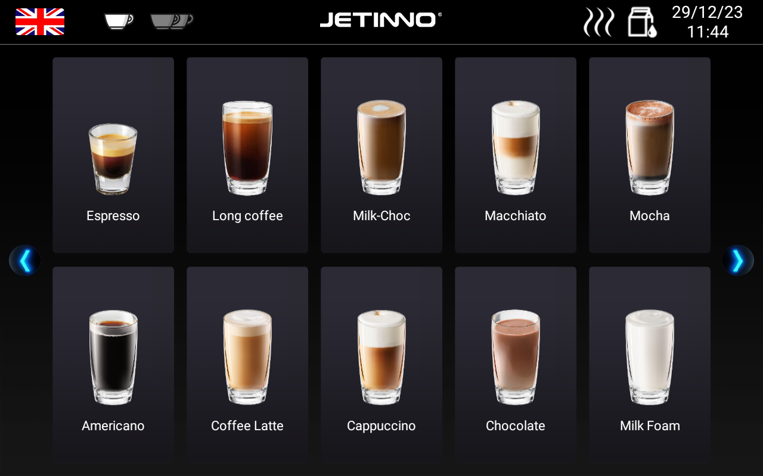
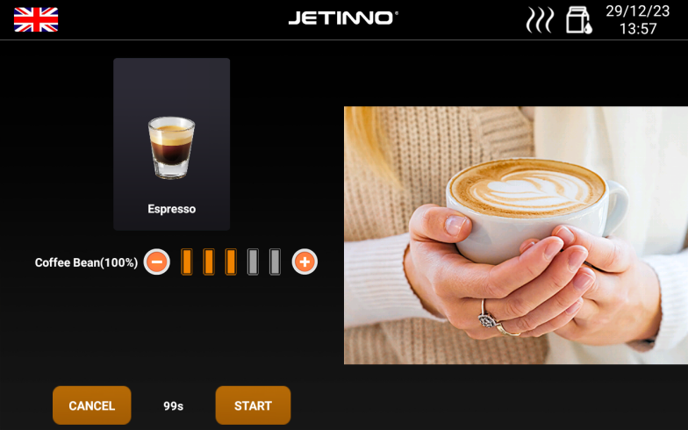

2. Concentration adjustment: coffee can be freely adjusted, and after adjustment, click OK.
1. Product List Page: Display all currently sold drinks; Language switching, sales mode, and left and right arrows are the up and down buttons.

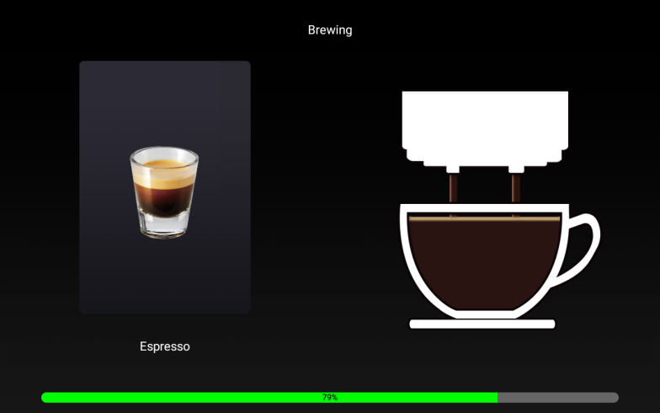
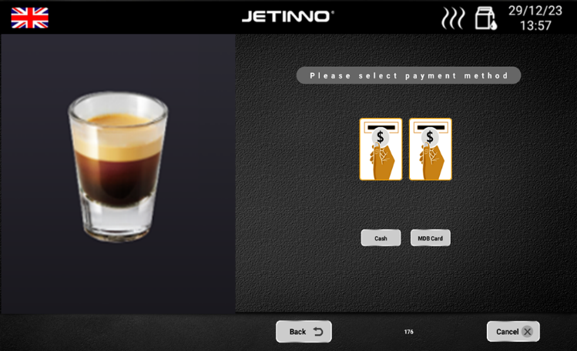

3. Payment page: WeChat, Alipay, MDB cash, MDB swipe card. (The interface will not pop up in free mode).
4. Product Production Completion Page: The product is completed, please take it away.

Operator Options
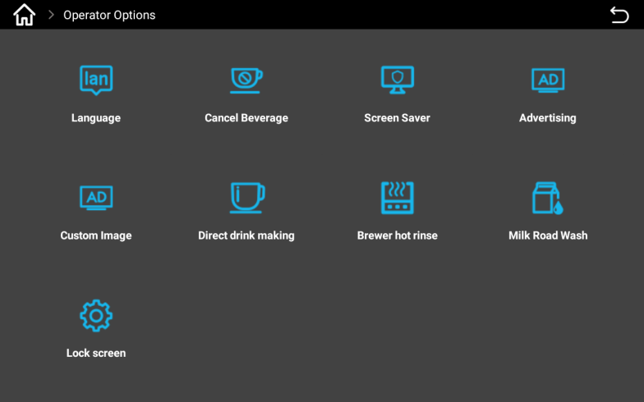

Operator options has the following functions and switches: language switching, stop production, screensaver, advertising, general picture, direct making production, brewer preheating, lock screen.

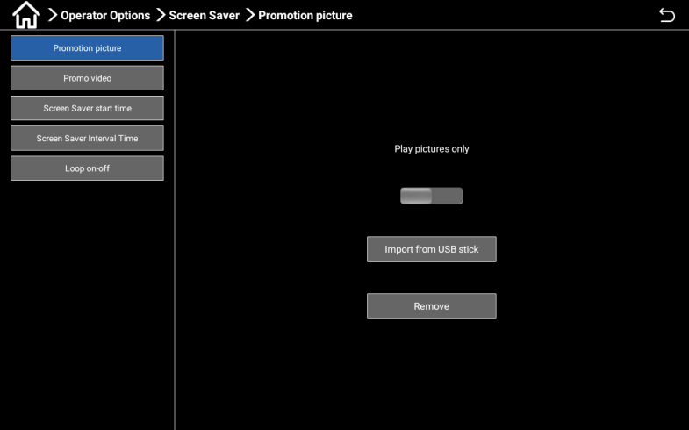
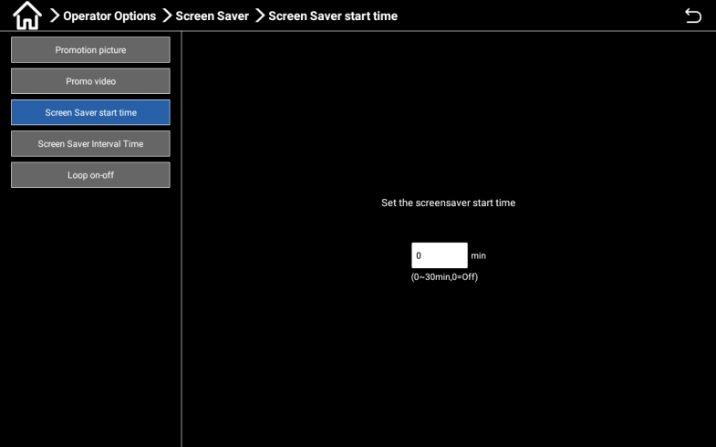

Screen saver: Turn on the picture playback switch, transfer the prepared pictures to a USB drive, insert the USB drive into the USB port (located at the bottom left of the display screen), and import the pictures from the USB drive; Set the screen saver to start within the range of 0-30 minutes.
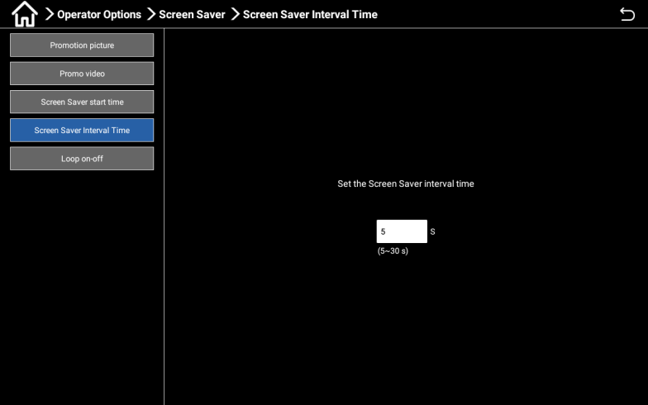
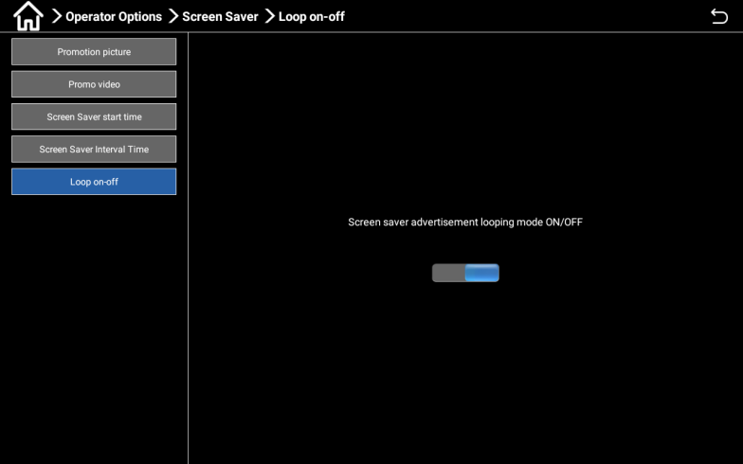

Set the screen saver interval time(5-30 seconds); Click on the carousel switch to enter the screensaver ad loop mode on/off, which allows for carousel.
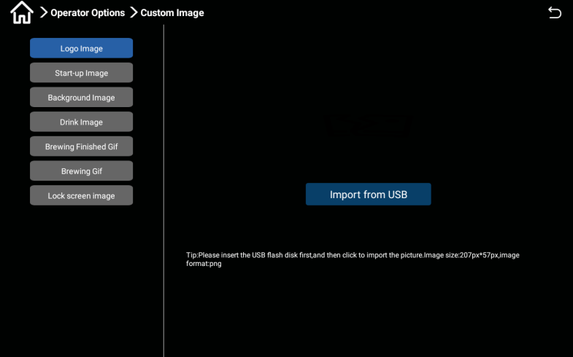
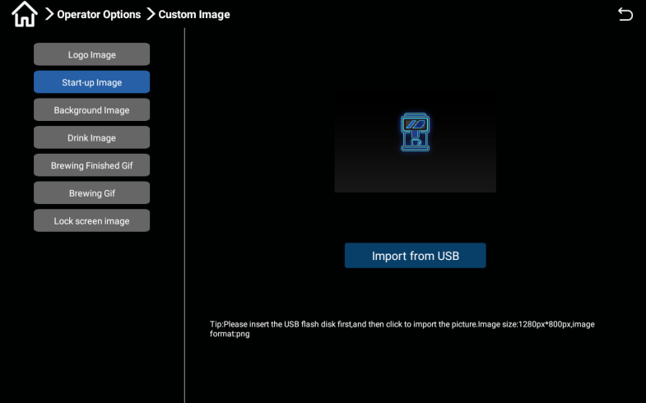

Custom image: Create a "logo, start-up image" on the computer according to the requirements (size and naming of the image), then transfer them to a USB drive, and then insert the USB drive into the USB port (the USB port is at the bottom left of the display screen) to import the image from the USB drive;

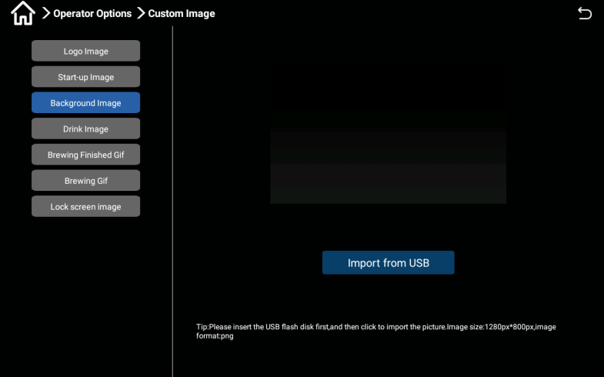
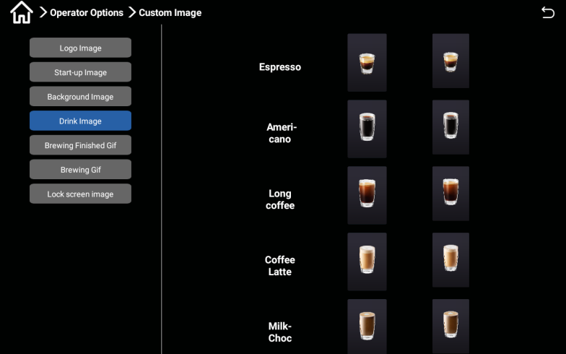

First, create "background images and drink images" on the computer according to the requirements (size and
naming of images), then transfer them to a USB drive. Then, insert the USB drive into the USB port (located at the bottom left of the display screen), and import the images from the USB drive;
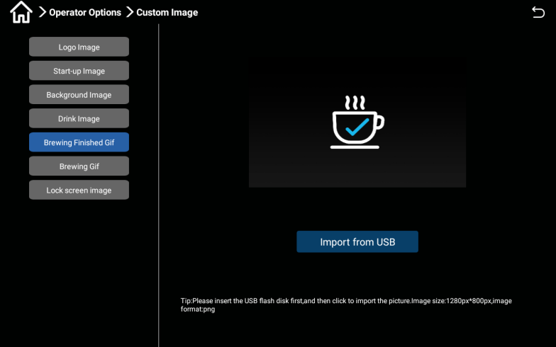
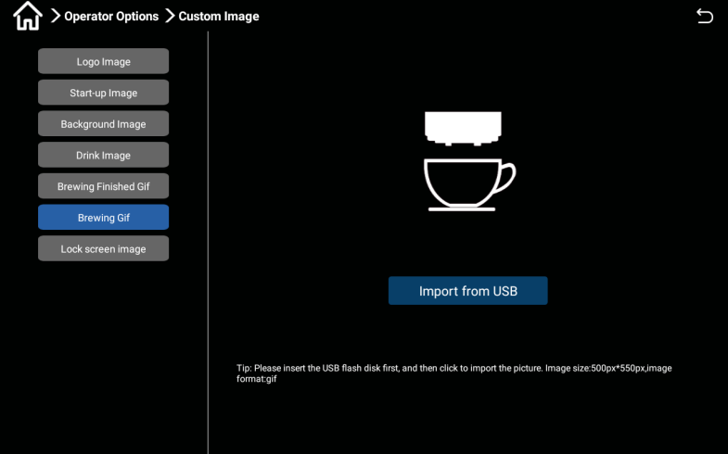

First, create "Brewing finished image" on the computer according to the requirements (size and naming of the image), then transfer them to a USB drive, and then insert the USB drive into the USB port (USB port at the bottom left of the display screen) to import the image from the USB drive;

Empty

Coffee grounds bin

- High temperatures may cause damage.
- Do not use the dishwasher to clean the coffee grounds bin.

First, pull out the water tray, then pull out the coffee grounds bin from the machine (refer to the following chapters for instructions).
Empty the coffee grounds bin and clean it.
Dry or wipe the powder box dry, then push the machine back into the innermost position.
The machine is ready for operation.

Water tray

- Pull out the water tray outward.
- Before disassembling the water tray, ensure that there is no drink output.
- When installing, ensure that the wastewater sensor is inside the wastewater tank.

Transportation conditions

Improper transportation of the coffee machine may result in injury.
Pay attention to general health and safety instructions.
- ► please make sure to disconnect the water and power sources before changing the position.
- ► please check the ground for obstacles and unevenness before changing position.

- Improper transportation may cause damage to the stacker transport machine.
- When using a handcart to change the position of the machine, the following points must be noted:
- For safety reasons, when changing positions, do not push or collide with the handcart, only drag it.
- Can only tow carts, cannot tow machine.
The manufacturer shall not be liable for any damage caused by misuse of the handcart or failure to comply with the instructions for use.

The waterway should be emptied before the machine is transported. Refer to Section 7.6 for the method of emptying the waterway.

- Pay attention to the risk of burns when emptying the boiler!
- There is a risk of freezing during outdoor transportation, as freezing at low temperatures can easily damage the machine. The operation of emptying the boiler is required!

Turning off

Operation end
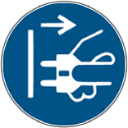
Standby mode

- In standby mode, the machine is still powered on.
- Do not disassemble the chassis.
- Before carrying out maintenance work, power off the machine.
If it has not yet started, start machine cleaning in the machine background management.
Cleaning will begin
Clean daily and weekly when necessary.
Empty and clean the waste box and water tray.
Please refer to the "Cleaning" section for specific data.
After the automatic cleaning is completed, close the machine door, turn off the power switch, and unplug the power plug.

Long downtime (over 1 week)
In case of prolonged downtime such as company holidays, the coffee machine and other ancillary equipment must be turned off.
- Empty the water tank or close the inlet valve.
- Unplug the power plug or turn off the main switch installed at the device to power off the machine.
If the ambient temperature of the coffee machine is below zero degrees, the boiler must be emptied beforehand;
- Execute the "Maintenance" section in the "Machine Set-up" section; Pre-freeze protection for boiler transportation.
- Please contact the machine manufacturer or operating agent.

- Frozen and swollen water may damage pipelines and water boilers.
- If the temperature in the room is likely to drop below freezing point, the water boiler must be emptied.
Before running and debugging again for the first time, a daily cleaning must be carried out.

Cleaning
Thorough cleaning and maintenance are the basic requirements for achieving food hygiene conditions. Only through regular maintenance (twice a week or increasing cleaning frequency based on specific usage), cleaning, and upkeep can the machine provide superior taste drinks and satisfy customers.

Cleaning interval
Cleaning interval
Daily | Weekly | Actual | Actual
Automatic cleaning
X |  |  |  | Hot water rinsing (system rinsing)
X |  |  |  | Regular cleaning (set time for cleaning)
Cleaning procedures
X |  |  | X | Waterway system rinsing
X |  |  | X | Coffee system rinsing
X |  |  | X | Milk system rinsing
X |  |  | X | Mixer rinsing
Manual cleaning
X |  |  |  | Cleaning waste bin
X |  |  |  | Clean the water tray
X |  |  |  | Clean the cup holder
X |  |  |  | Clean the mixer module
X |  |  |  | Clean the touch screen
X |  |  |  | Clean the drink spout
X |  |  |  | Cleaning milk container
 | X |  |  | Cleaning coffee bean container
 | X |  |  | Cleaning waste bins
 | X |  |  | Clean the exterior of the coffee machine and refrigerator
 |  | X |  | Clean the small water tank
 |  | X |  | Clean Brewer
Illustration
Daily |  |  |  | Execute at least once a day and increase the frequency if necessary.
Weekly |  |  |  | At least once a week, increase the frequency if necessary.
Actual |  |  |  | According to demand (when contamination occurs).
Actual |  |  |  | According to demand (when contamination occurs).

Cleaning plan
The following two cleaning plans are available for technical service personnel to configure:
The cleaning plan of "Jetinno Intelligent Deerror" (standard).
A "manual" cleaning plan.

The cleaning intervals described in this chapter comply with the cleaning plan of "Jetinno Intelligent Deerror". These settings comply with the Hygiene Management Standards for Ready made and Sold Autovending Machines. When the cleaning level is set to "none", the operator is responsible for carrying out necessary cleaning work.

Refer to the "JL series coffee machine cleaning and maintenance manual" - "Hygiene management standards for on-site vending machines".

The screen displays pending or executed cleaning messages, depending on the selected configuration in the cleaning plan.

Daily rinsing

Brewer rinsing

At the top of the screen, click the rinse button on the brewer and select the "OK" button in the pop-up dialog box.
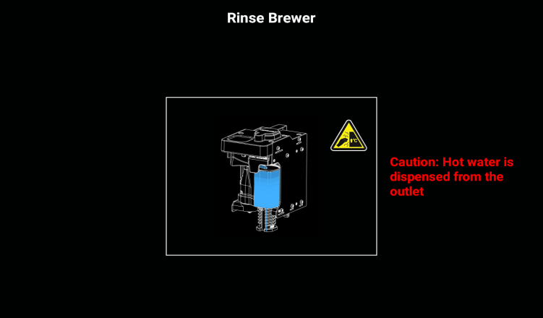
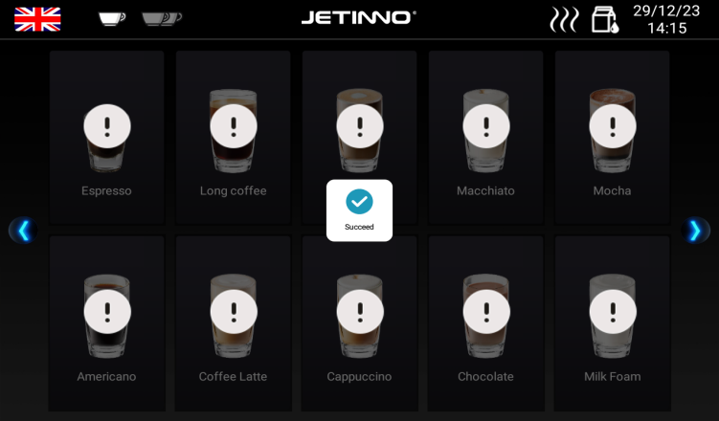

The interface for rinsing the brewer pops up, and the machine executes the rinsing program. After the program ends, it automatically returns to the ordering interface, displaying "Operation successful".

Milk system rinsing
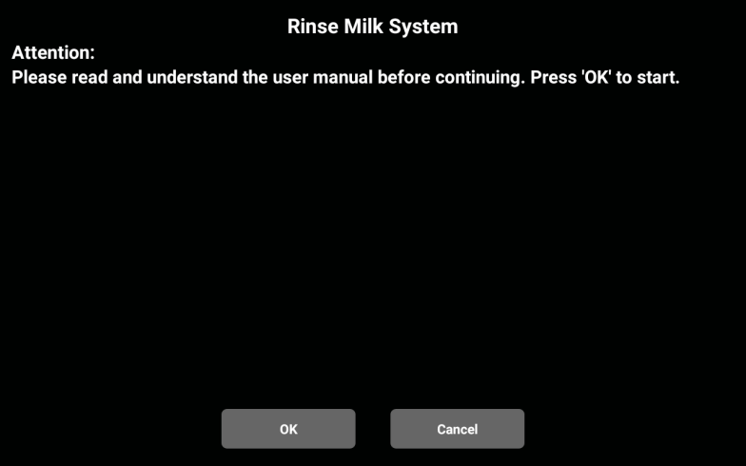

At the top of the screen, click the Milk system rinsing button and select the "OK" button in the pop-up dialog box.
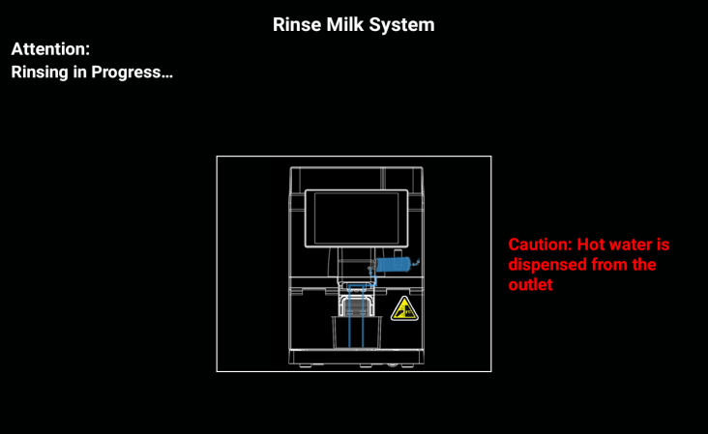
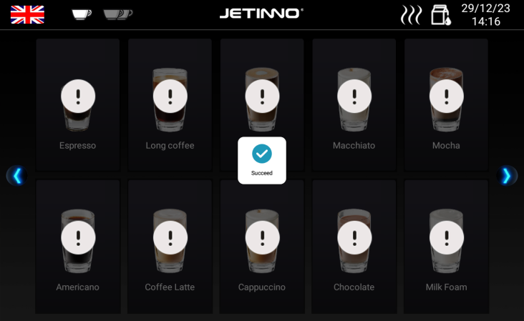

The rinsing milk system interface pops up, and the machine executes the rinsing program. After the program ends, it automatically returns to the ordering interface, displaying "Operation successful".

Mixer rinsing
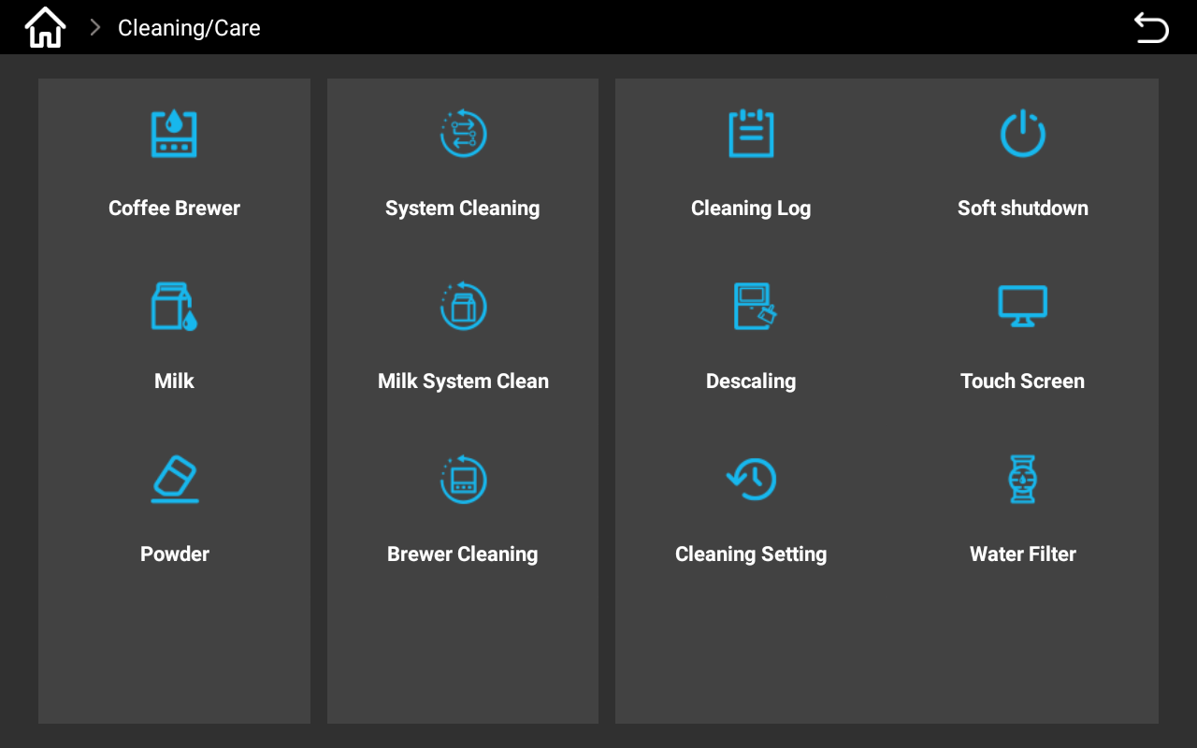

Enter the machine background, click "Cleaning and Maintenance", select "Powder", and click the button; Click "OK" in the pop-up dialog box until the cleaning program ends.

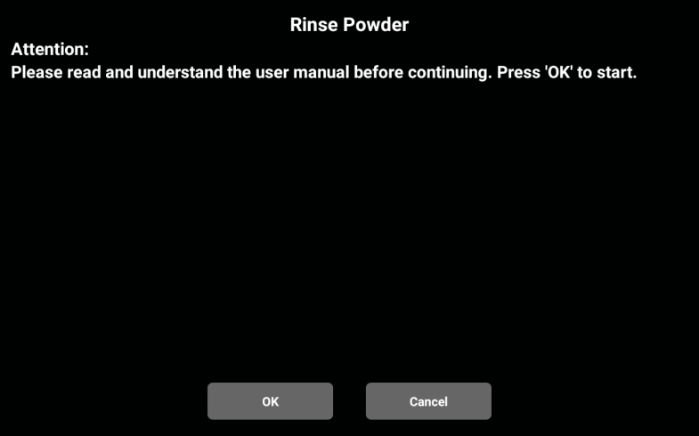
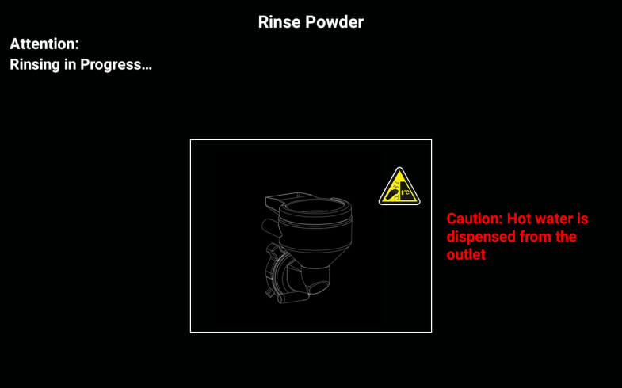

Click "OK" in the pop-up dialog box until the cleaning program ends.

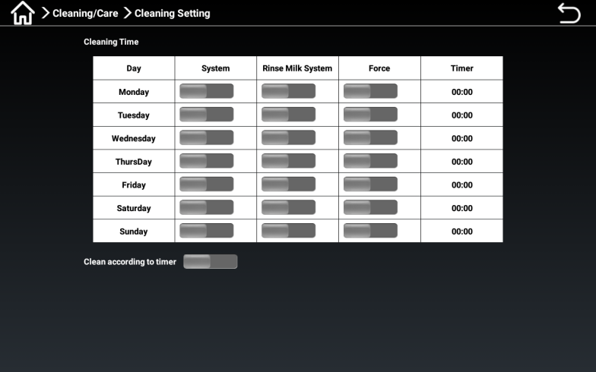
Automatic rinsing settings

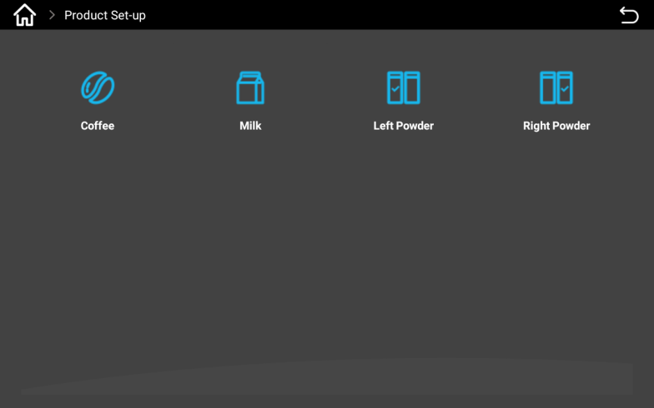
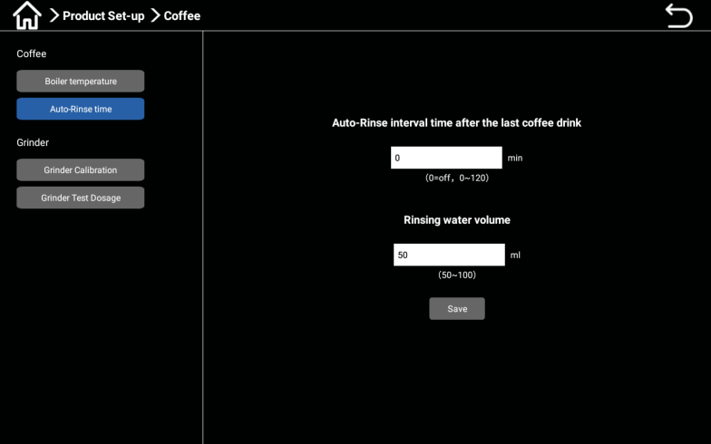
Timed rinsing: Enter the machine background, Cleaning/Care, set cleaning settings, and set automatic cleaning time from Monday to Sunday at a certain time every day.

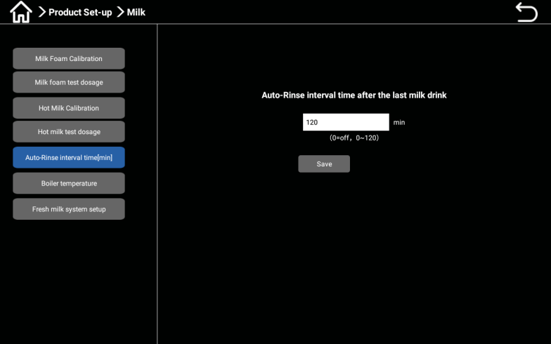
Interval Rinsing Brewer: Go to "Product Set-up", select Coffee ->Auto-rinse time, and you can set the brewing machine's rinsing interval time and rinsing water volume.

Auto-rinse interval time[min]: Go to "Product Set-up", select "Fresh Milk ->Auto-rinse time", and you can set the interval time for milk system rinsing.

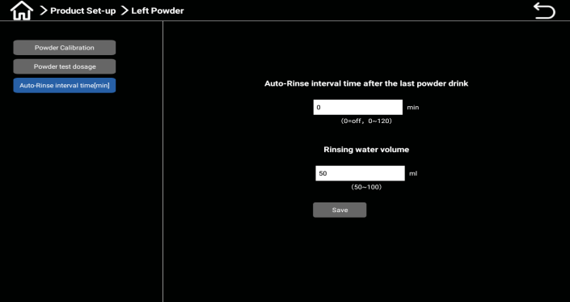
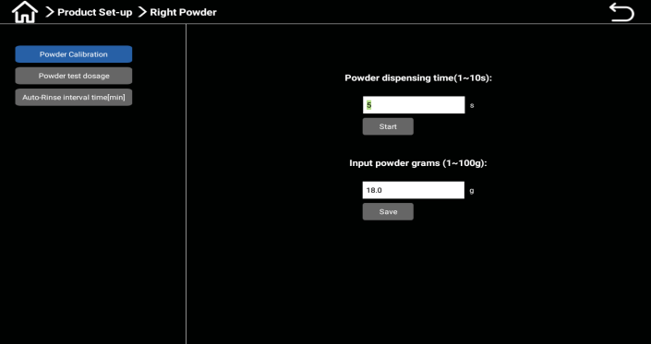
Interval rinsing mixer: Enter "Product Set-up" and select "Left Powder and Right Powder" respectively;

Select "Auto-rinse interval time[min]" to set the interval time and rinsing water volume of the mixer.

Cleaning of water tray


Sediments and bacteria can contaminate the water tray.
Rinse and clean the water tray daily.
Please wear gloves when cleaning.
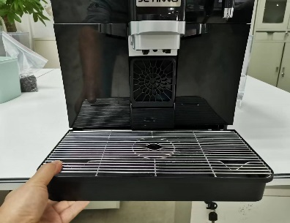
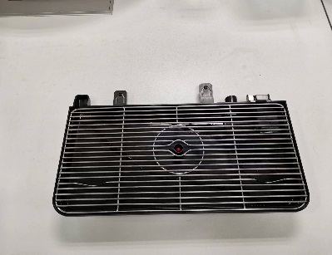
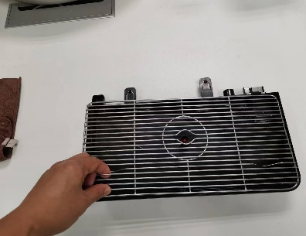
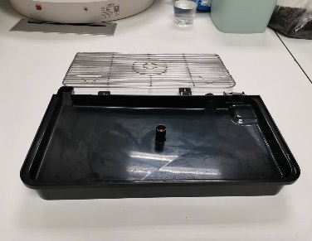

- Cleaning method for water tray: Pull the water tray out of the machine.
- Thoroughly brush the water collection tray with clean water, household cleaning agents, and a brush.
- Rinse with water and dry with a clean towel.
- Reinstall the dried water tray into the machine and check to ensure it is pushed to the bottom.

Cleaning of waste bin

- The coffee grounds in the waste bin are prone to mold formation. If the plaque spreads to the machine, coffee may be contaminated.
- Therefore, it is necessary to clean the waste bin every day.

- High temperatures may cause damage.
- Do not use dishwasher to clean waste bins
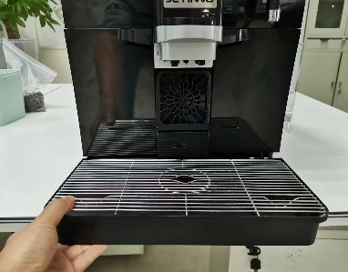
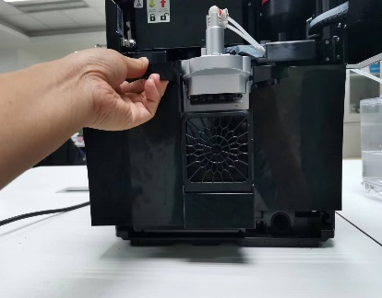
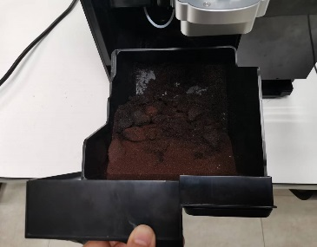
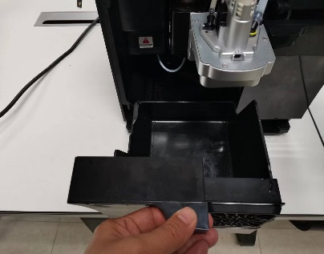

Cleaning method for waste bin:
First, remove the water tray from the machine; Then take out the waste box from the machine and pour out the coffee grounds.
Thoroughly clean the waste bin with clean water and household cleaning agents.
Rinse with water and dry with a clean towel or air dry.
Reinstall the waste bin into the machine.

Disassembling and cleaning the milk frother
In order to ensure the proper operation of the milk frother, and for hygiene reasons, if you have made milk before, be sure to disassemble and rinse the milk frother on the same day. The coffee machine does not prompt you to disassemble and rinse the frother.
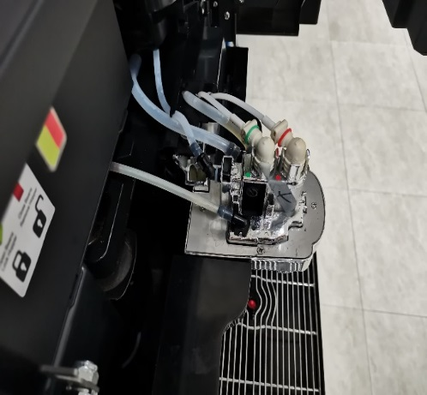
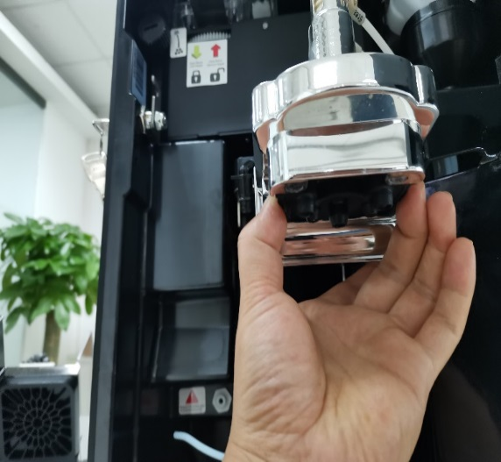
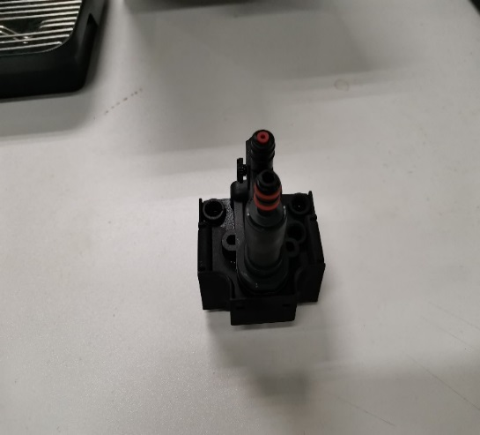
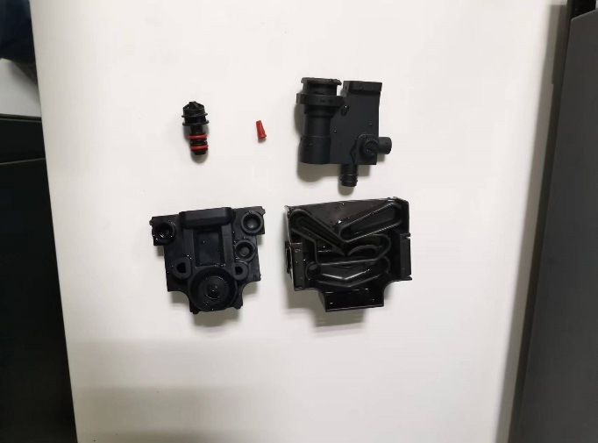

The specific methods are as follows:
Pull out the coffee discharge tube upward, pull out the milk tube backward, remove the milk tube and wash it thoroughly under the flowing water;
Hold down the buckle on both sides of the beverage outlet mouth, pull down hard, remove the outlet mouth, disassemble the milk frother into a single component, and rinse each component thoroughly under flowing water. If there is a serious dry milk stain, please soak each part in 250ml (water + milk cleaner 1 tablet) milk system cleaning solution, and then wash each part thoroughly.
Reassemble the frother: In order to ensure optimal use of the frother, ensure that all components are properly and securely connected.
Install the foam firmly back into the outlet mouth.
Put the discharge nozzle back into the bottom, and finally put the coffee discharge tube and milk tube back in.
Note: The duckbill check valve is small, be careful to be washed away or lost when washing with water.

Regular cleaning

Cleaning agents



- Cleaning agents can cause poisoning!
- Only cleaning agents recommended by the equipment manufacturer are allowed to be used.
- Cleaners should be kept away from children.
- Do not consume or directly touch the cleaning agent with your hands.
Before using cleaning agents, it is necessary to carefully read the instructions and safety data sheet on the packaging. If no safety data sheet is provided, please request it from the dealer.

- Using the wrong cleaning agent may damage the machine!
- Use only the manufacturer's recommended cleaning agents for daily and weekly cleaning.

Brewer Cleaninging tablets
Information
 | Usage | Cleaning of coffee machine system
 | Cleaning purpose | Remove oil residues from the coffee system
 | Interval | Daily
Milk system cleaning tablets：

- RINZA's innovative product for cleaning milk stains: milk stain tablets.
- Tablets can dissolve quickly in warm or cold water.
- Containing cationic surfactants to improve cleaning safety and strength.
- Safe, easy to clean, improve transportation efficiency, and reduce transportation costs.
- Ratio: Mix 1 tablet with 250 milliliters of water.
- Product specifications: 4g/tablet, 120 pieces/bottle, 12 bottles/box


- There is a risk of burns. When washing the machine, the drink outlet outputs hot water.
- Do not reach your hands below the drink outlet during machine rinsing.

Display screen guided cleaning program
Preparation - necessary tools for cleaning.
Coffee system cleaning tablet [1 tablet].
Household washing aid.
Clean kitchen cleaning towels [2 pieces]
Collect containers
Start cleaning program



- Cleaning agents can cause poisoning.
- When cleaned machine components are contaminated with cleaning agents, it can cause harm to the body
- Harm to physical health.
- Please wear gloves during the cleaning procedure.



- During the operation of the cleaning program, high-temperature liquid will be output. During cleaning, do not extend your hands to the outlet position
- Below, otherwise there is a risk of burns.

- Obstruction of wastewater drainage will cause the drip tray to overflow.
- Check the wastewater discharge outlet of the drip tray before starting the cleaning program.
The cleaning process can be interrupted at any time. After the cleaning is interrupted, the coffee machine is not in a state of operational readiness. The cleaning program forcibly shuts down. Restart the interrupted cleaning program as soon as possible.
Start the cleaning program in the maintenance menu. The touch screen will guide the user through all the necessary operations.

System cleaning

Enter the background of the machine - click Cleaning/Care, select System Cleaning, and click the System Cleaning button;
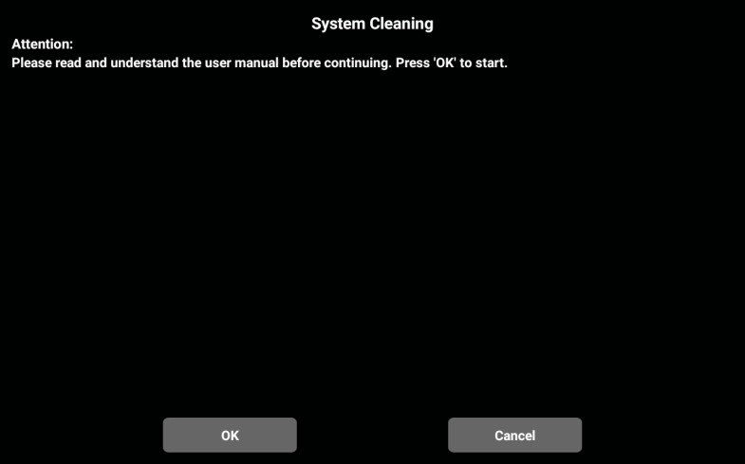
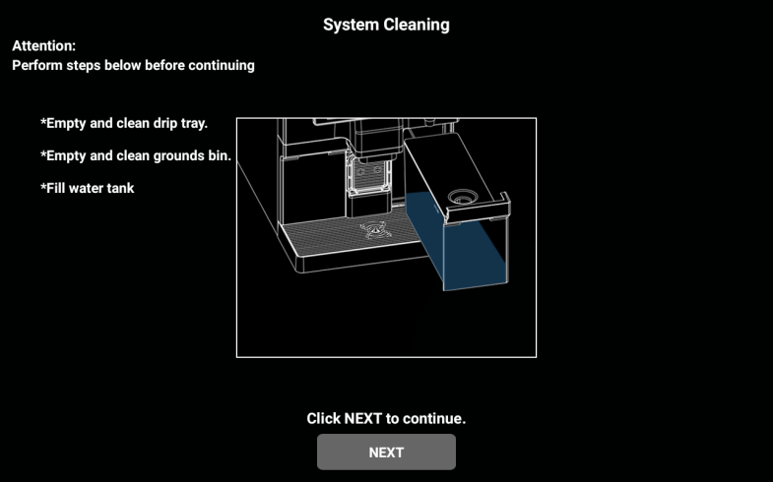

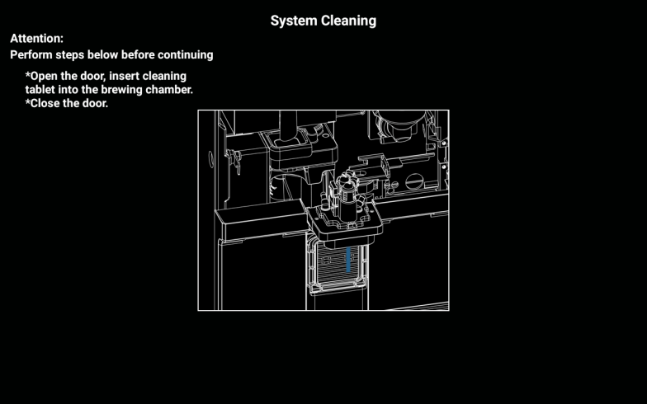
Click "OK" in the pop-up dialog box to enter the next interface, according to the interface prompt: empty the water tray, waste residue box, water tank, and then click "Next".

Please operate according to the display interface: take out the milk hose and insert the cleaning container with 500ml water and 30ml milk cleaning solution. Put the empty container of 2L under the outlet (the one with the drainage function outside the water tray can not put the 2L container). Click “Next” and follow the prompts: open the door and place the cleaning tablets into the brewing chamber, then close the door.
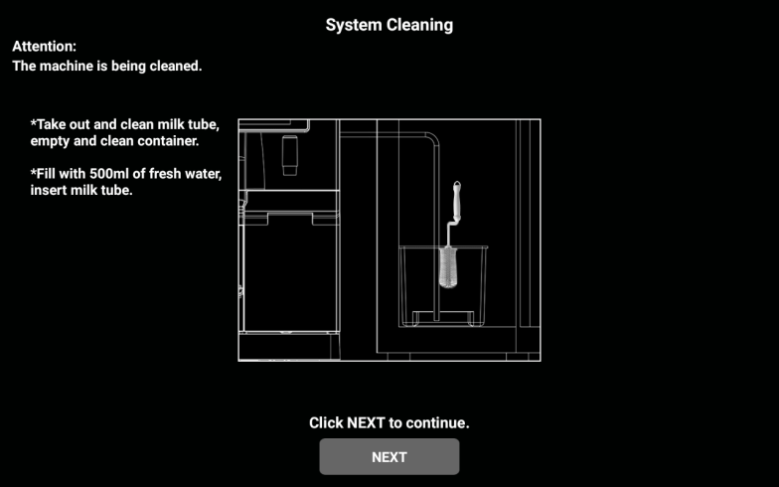
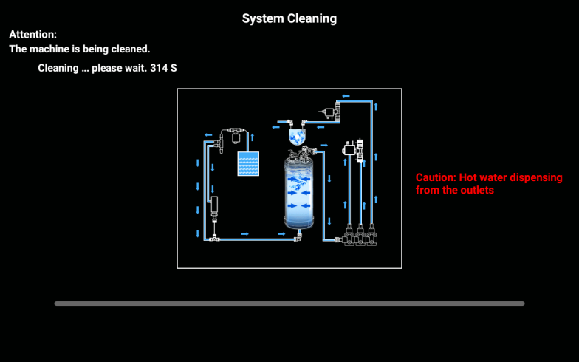

The machine is performing cleaning, cleaning... Please wait, when the progress is completed, the next interface will pop up, follow the prompts: take out and clean the milk tube, empty and clean the container, pour 500ml of water, insert the milk tube, click "Next" to continue.

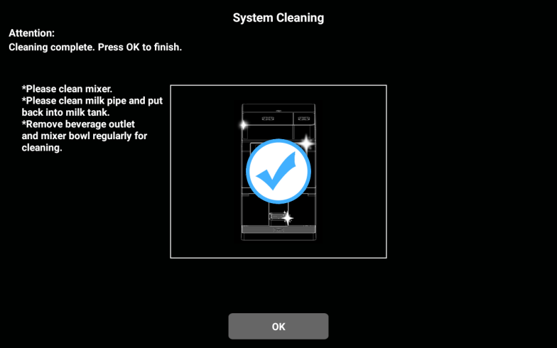
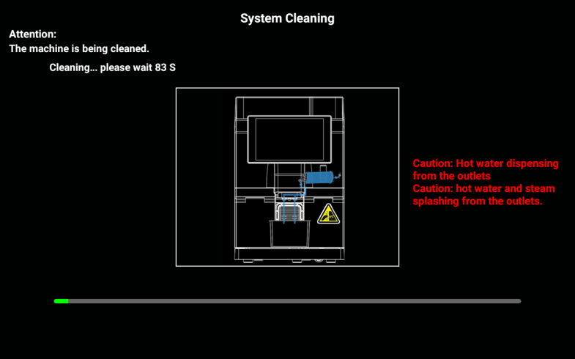

The machine is performing cleaning, cleaning...... Please wait, when the progress is completed, the next interface will pop up, follow the prompts: Please clean the blender, please clean the milk tube and put back in the milk tank. Disassemble the drink mouth and blender regularly for cleaning, and click "OK".

Milk system cleaning
Daily cleaning, put the fresh milk system cleaning agent into the cleaning box, the recommended cleaning frequency is once per day. According to the amount of cleaning agent and water, the proportion of the corresponding solution, the milk tube into the cleaning box.
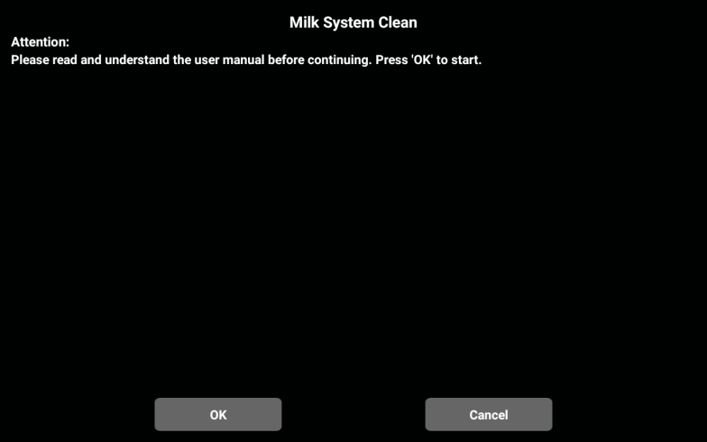

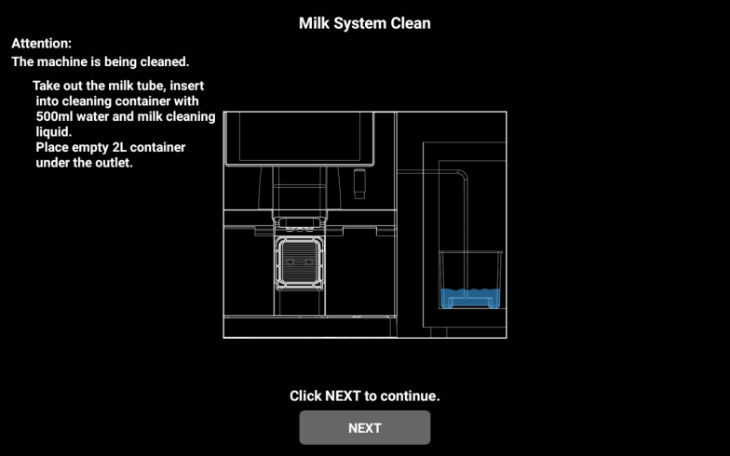
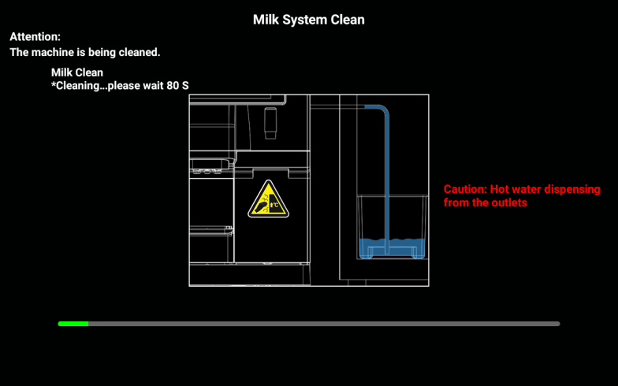
Enter the background of the machine - click "Cleaning/Care" - "Fresh milk cleaning"; In the pop-up dialog box, select [OK] to go to the next step, select [Cancel] to return to the menu of the previous layer; Click [OK] to go to the next step.

Please operate according to the display interface: Take out the milk tube and insert the cleaning container with 500ml water and 30ml milk cleaning solution. Put the empty container of 2L under the outlet (the one with the drainage function outside the water tray can not put the 2L container). Click “Next”, the machine is performing cleaning. Milk path cleaning, please wait...
When the progress is complete, the next interface will pop up.

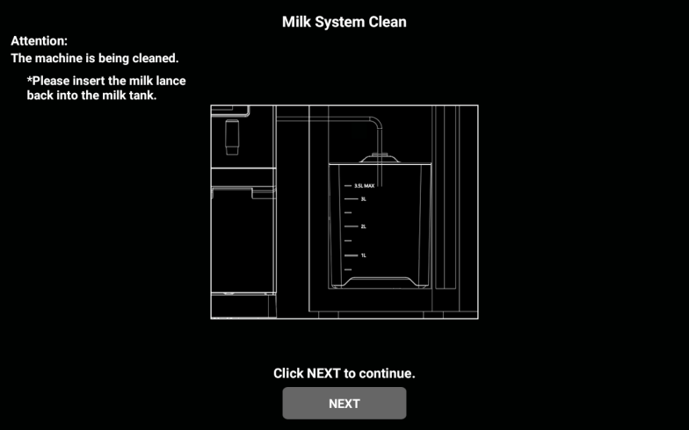
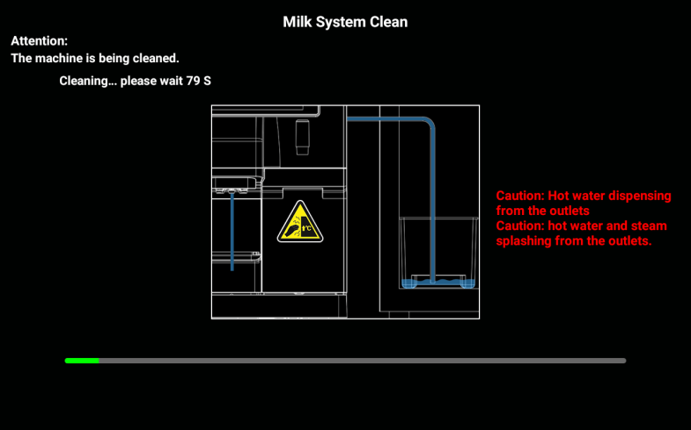

Follow the prompts: remove and clean the milk tube, empty and clean the container, pour 500ml of clean water, insert the milk tube and click "Next" to continue. When the progress is complete, the next interface will pop .
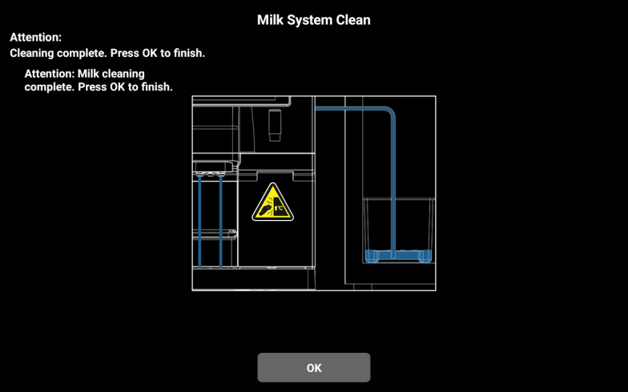
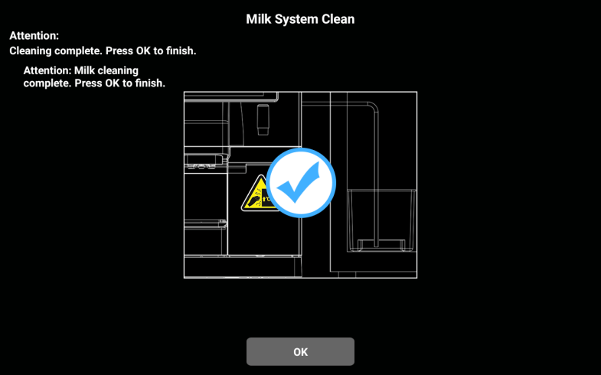

Follow the prompts: Please return the milk tube to the milk crate. Click "Next" to proceed. When the next interface pops up, the screen will prompt: Milk road cleaning is finished, click "OK" to finish.

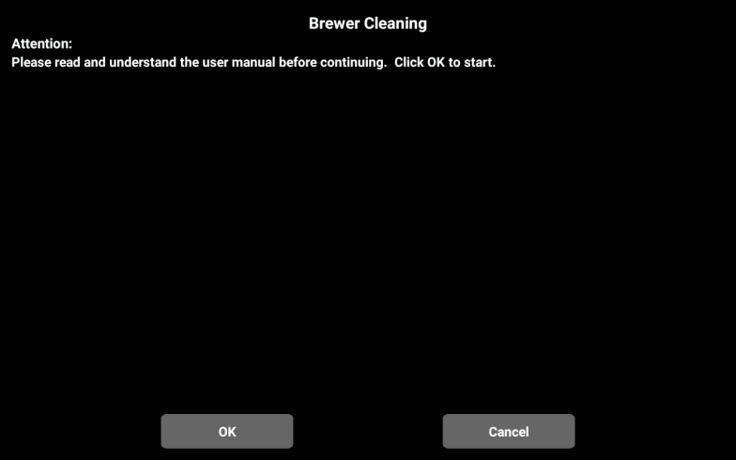
Brewer Cleaning

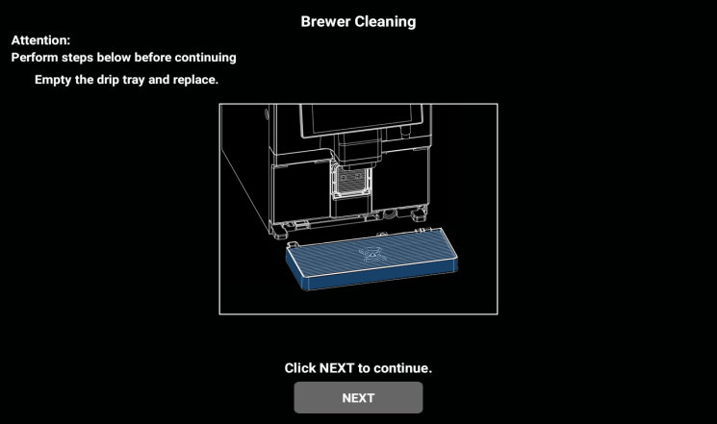
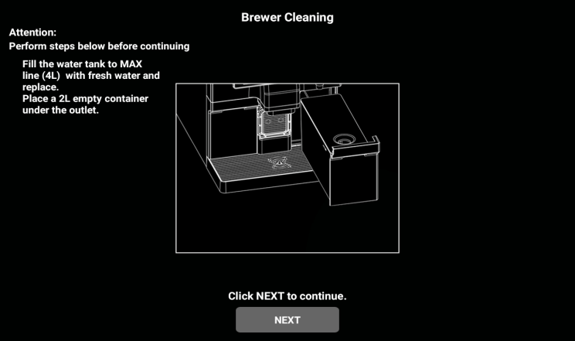
Enter the background of the machine and select "Cleaning/Care -> Brewer Cleaning". Click "OK" in the dialog box that pops up. Go to the next interface.

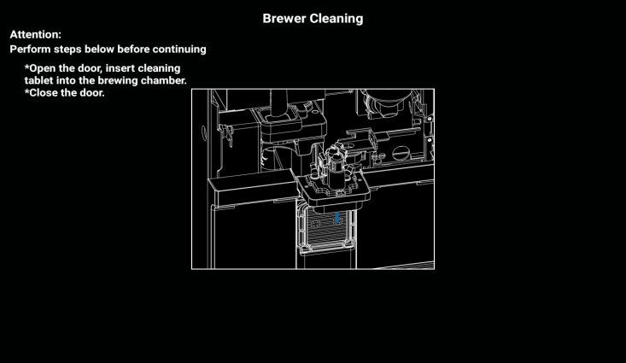
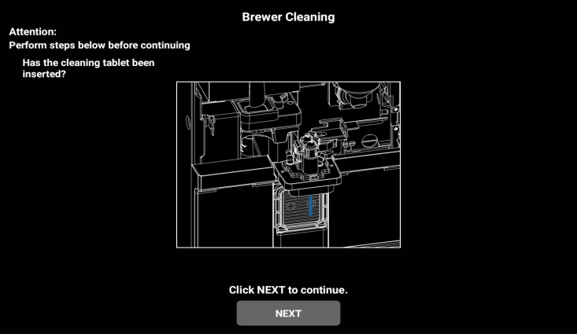
Please operate according to the screen prompt: whether the water tray is empty and installed back (the water tray with drainage function outside the belt can be ignored). Click "Next" to continue. Follow the prompts in the next interface: Please fill the tank to the maximum water level (4L). Place a 2L container at the outlet port (the one with the drainage function outside the water tray can be ignored). Click "Next" to continue.

Follow the prompts: Open the door and place the cleaning tablets into the brewing chamber, then close the door. Confirm that the cleaning tablets have been put in? Click "Continue Next".
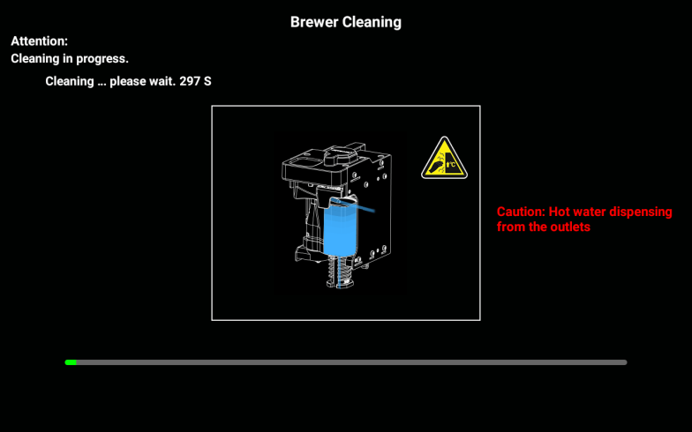
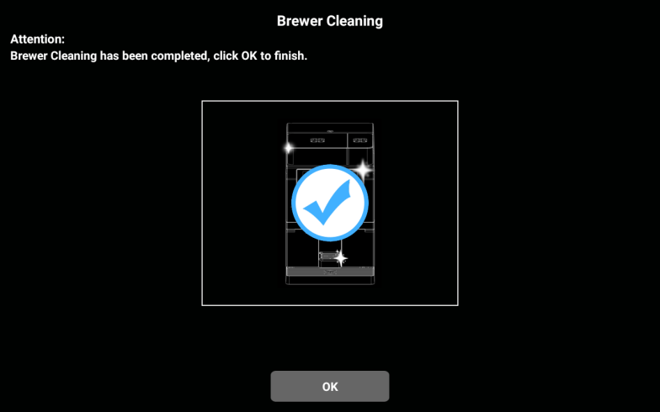

Cleaning, please wait... When the progress is complete, the next interface will pop up and the Brewer Cleaning is complete, click "OK" to return to the order interface.

Deep cleaning mixer
Recommended cleaning time: the top cover of the agitator is cleaned 2-3 times a week, the upper and lower cover of the agitator body and the steam inlet of the agitator is cleaned once a week, the V-shaped sealing ring, the gland and the mixing impeller are checked once for damage.
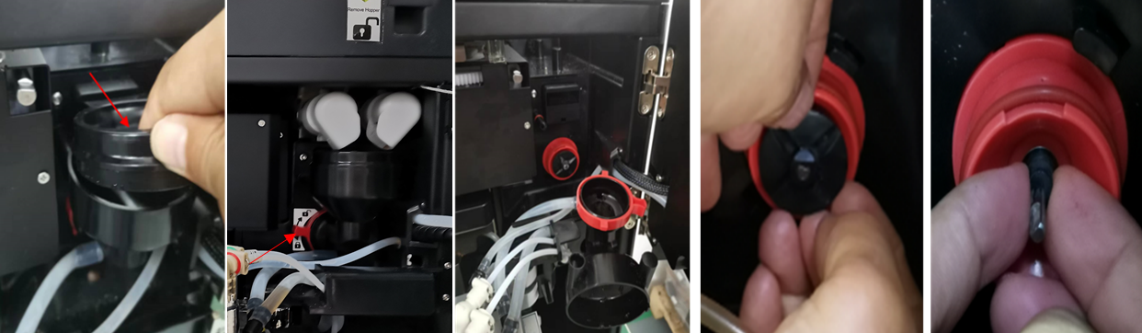

Open the machine door; Draw the upper cover of the lower agitator upward; Turn the handle on the fixed seat clockwise to unlock the lock; Pull out the agitator body, and be careful that the O sealing ring on the outlet mouth is removed when taking the agitator body (arrow in the figure below); Draw the steam cover outward; Pull out the mixing impeller with both index fingers; Take out the V-seal ring;

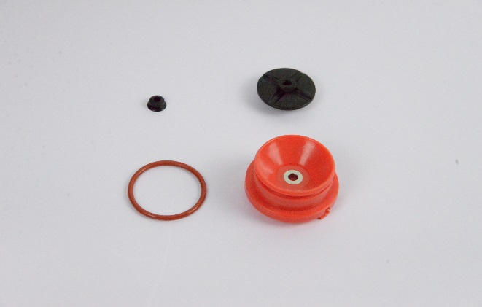
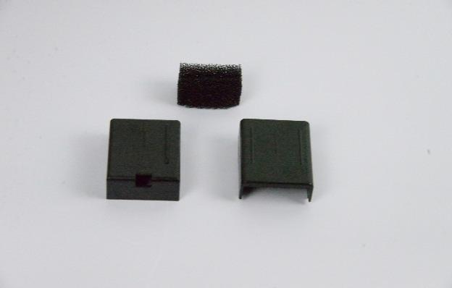
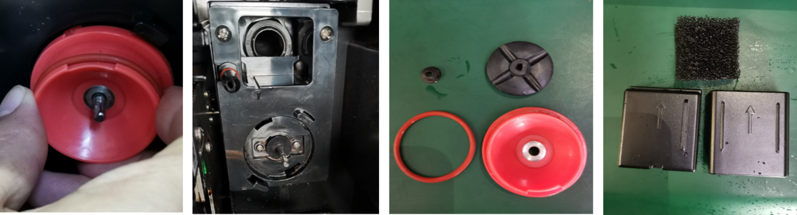

Pull out after turning the gland clockwise; Wipe the mixer holder with a towel or 75% alcohol wipes; Clean the mixer body, gland, V, O seal ring, mixing seal, mixer steam inlet upper and lower cover; V, O seal ring check regularly whether damaged, damaged to replace in time. The mixer is restored after cleaning, and the installation method is contrary to the disassembly, no longer described.

Cleaning touch screen
Wipe the touch screen with a clean towel

- Unintentionally exporting a drink while cleaning can cause burns.
- Turn off the machine before cleaning by locking the screen or cleaning the operating panel.

- Damage to the touch screen during cleaning.
- The stain cannot be removed by grinding. Do not press the display with brute force, high pressure, or sharp objects.

Clean the coffee bean container weekly



- The rotary grinding blade of the grinder and the coffee bean slot opener blade are sharp and pose a risk of injury.
- Do not put your hand into the coffee bean slot while the coffee machine is on. Wear gloves when cleaning.

- Coffee bean grooves scratched.
- Do not use the abrasive type of stain remover.

Empty waterway
Waterways must be emptied when long distances transportation below zero degrees Celsius, as follows:

Press the top left corner of the screen for a while, enter the password test9527 in the dialog box that pops up, go to the background of the machine, and click "Machine Set-up".
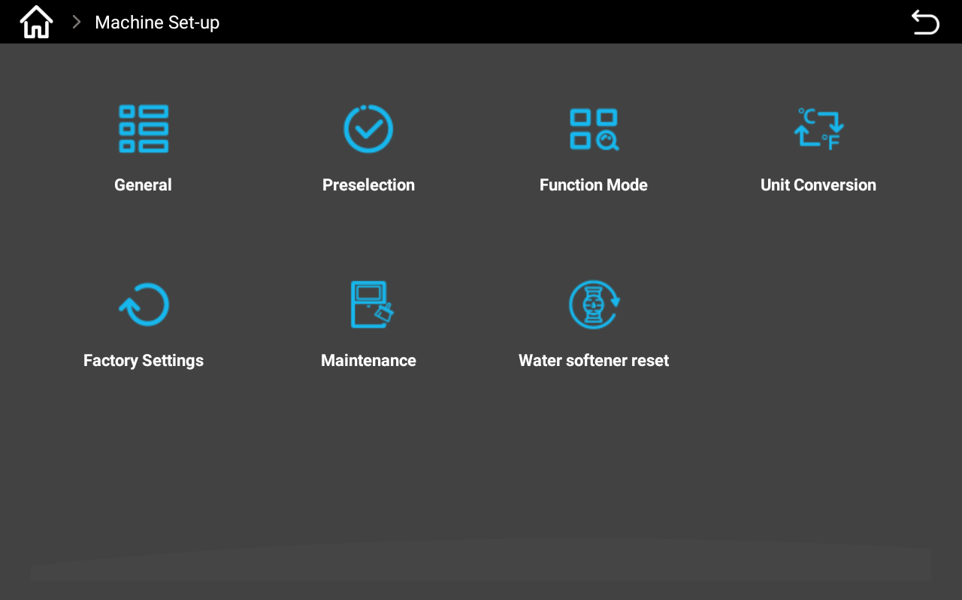
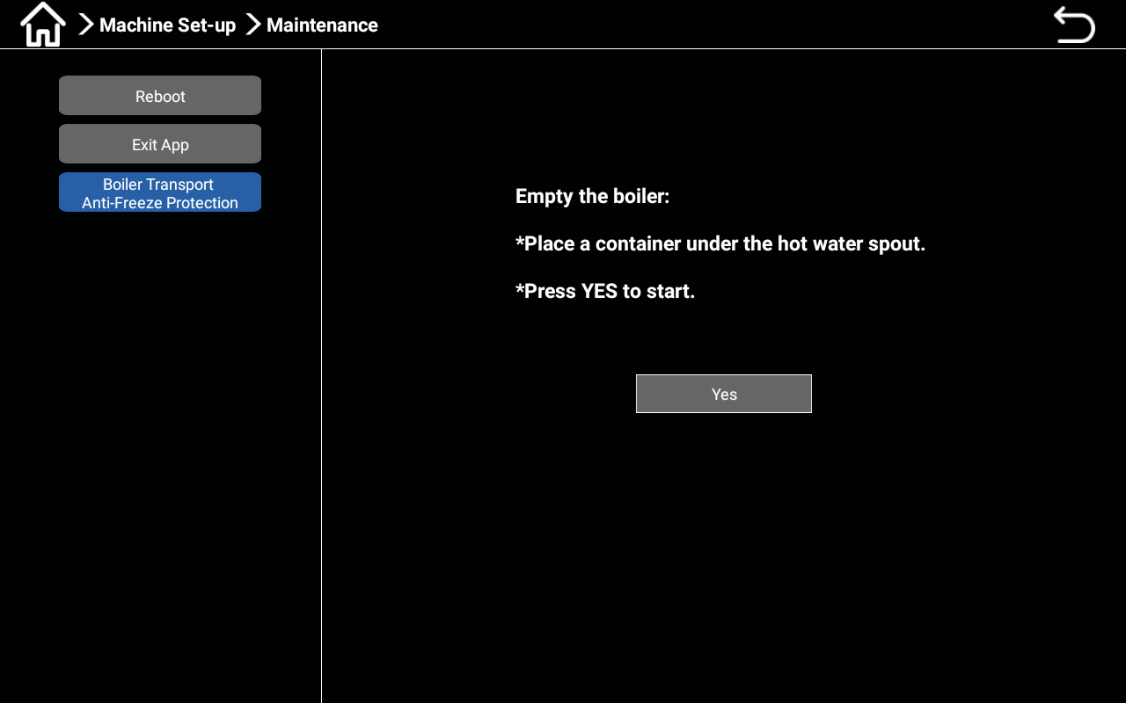

Select the "Maintenance" button, click the "Boiler transport antifreeze protection" button in the pop-up interface, and operate according to the interface prompt: place a water receiving container under the water outlet. Click “YES” to begin emptying the boiler.

Descaling

Enter the background of the machine, click the "Cleaning/Care" button, and select "Descaling" in the dialog box that pops up.

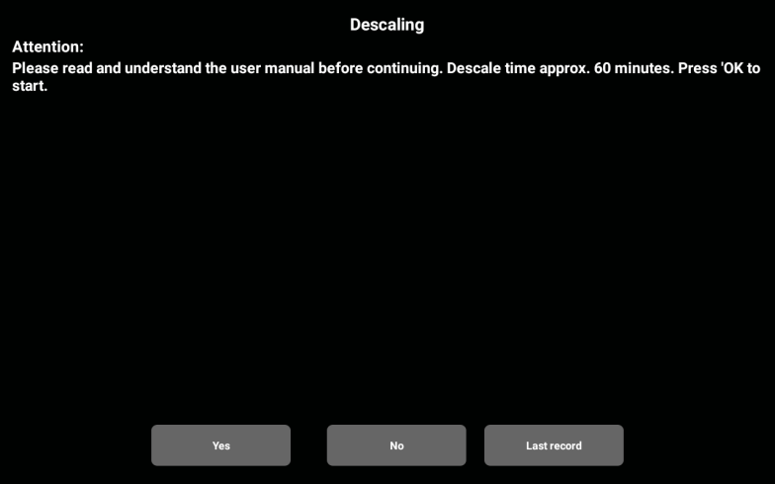
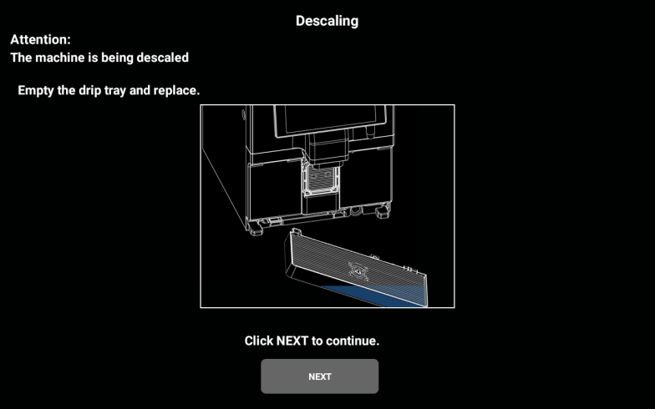

The descaling time is about 60 minutes. Press "OK" to start descaling and click "No" to cancel descaling. Click "OK" to enter the next interface, and follow the prompts to "empty the drip tray and put it back"; Follow the prompts and click "Next" to go to the next interface.
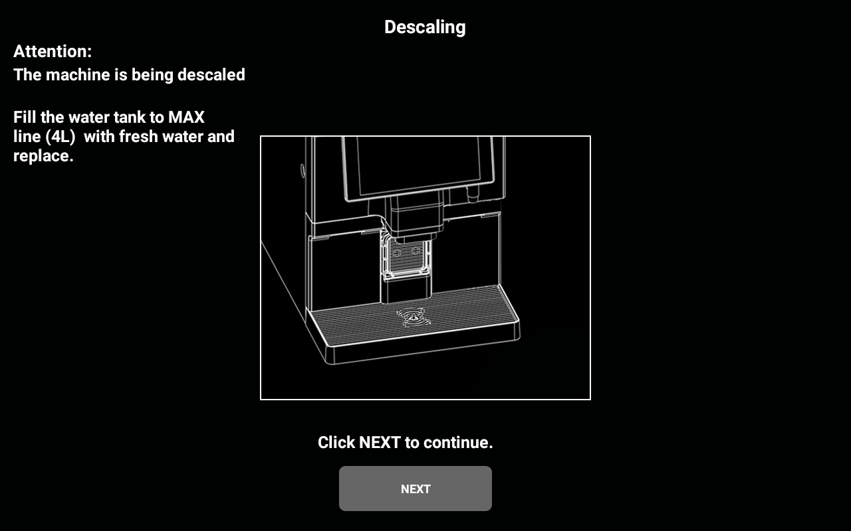

Follow the screen prompts to operate: Fill the tank to the maximum water level (4L) and then put it back. Click "Next" to continue; Follow the prompts in the pop-up interface: Place an empty 2L container under the outlet. Click "Next" to continue.
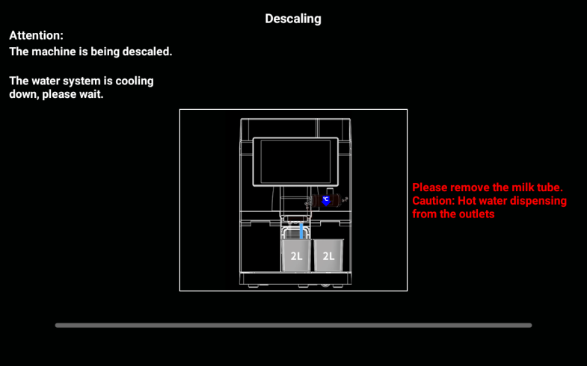
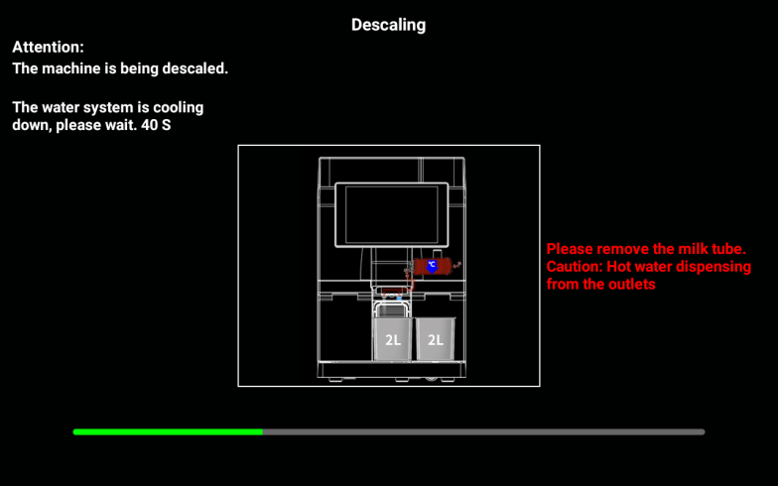

Screen notice: pay attention to hot water and steam splashing from the outlet. Click on "Next"; The interface that pops up shows: "Water system is cooling, please wait" (issue an instruction to lower boiler temperature to 60 degrees), and a progress bar appears at the bottom of the screen. When the progress is complete, the next interface pops up.

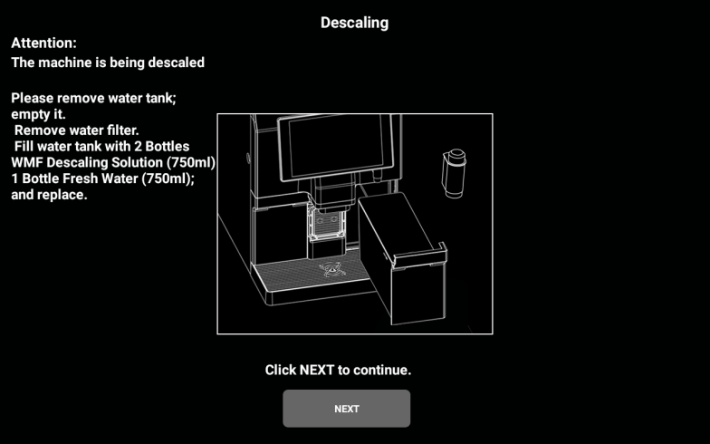
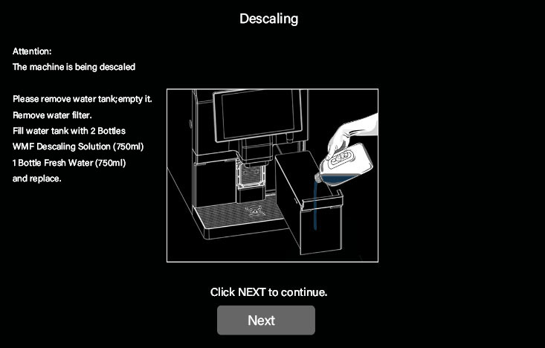

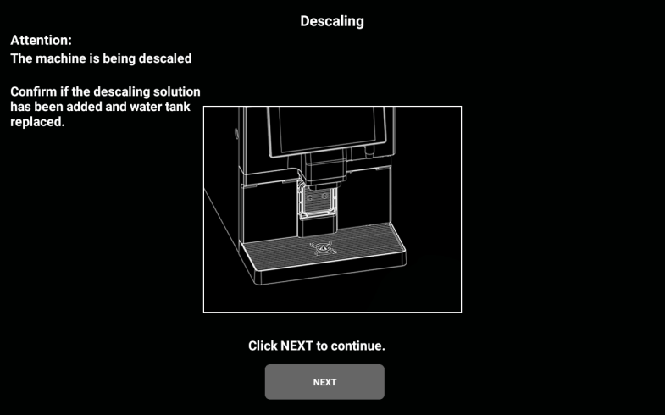
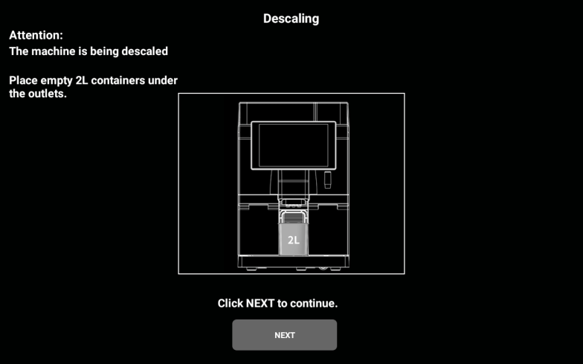
Follow the on-screen prompts: "Please remove the tank and empty it, remove the water filter; Pour 2 bottles (750ml each) of WMF descaling solution and 750ml of clean water into the tank and fill* it back "and click" Next "to go to the next interface.

The interface prompts "Confirm whether the descaling solution has been added and the tank has been replaced". After confirmation, click "Next" to go to the next interface;
The screen prompts "Place a 2L empty container under the outlet", after confirming, click "Next" to enter the next interface.
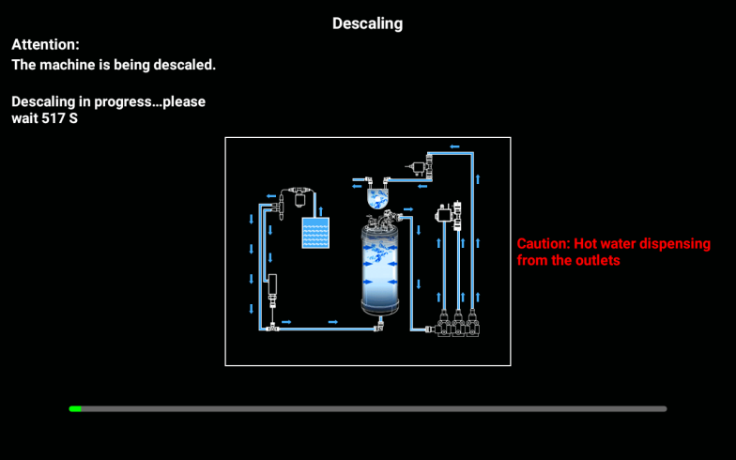
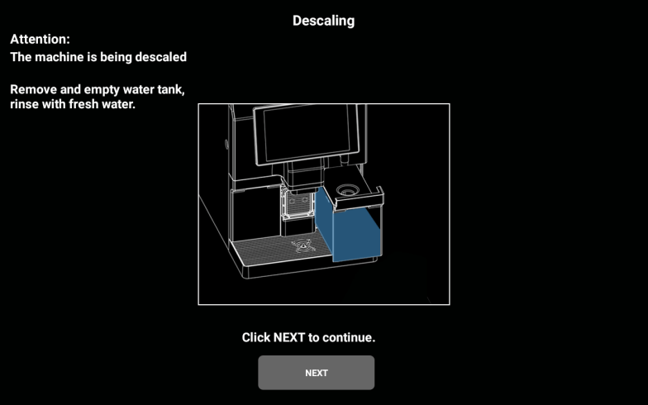

The screen shows "The machine is descaling, please wait..." ", the progress bar appears at the bottom of the screen, when the progress is completed, it automatically jumps to the next interface, the screen displays "take out and empty the tank, rinse the tank with water", operate according to the screen prompt, take out the tank and empty it, rinse the tank with water, click "Next" to go to the next interface.

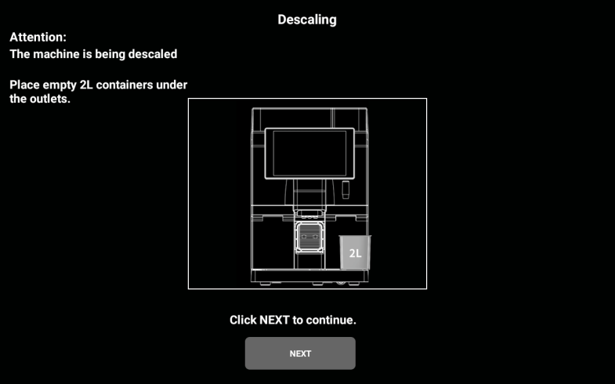

Follow the prompt on the screen: "Fill the water tank to the maximum water level (4L), then put it back", click "Next", go to the next interface. The screen prompts "Place a 2L empty container under the outlet", operate according to the prompt, confirm and click "Next" to go to the next interface.
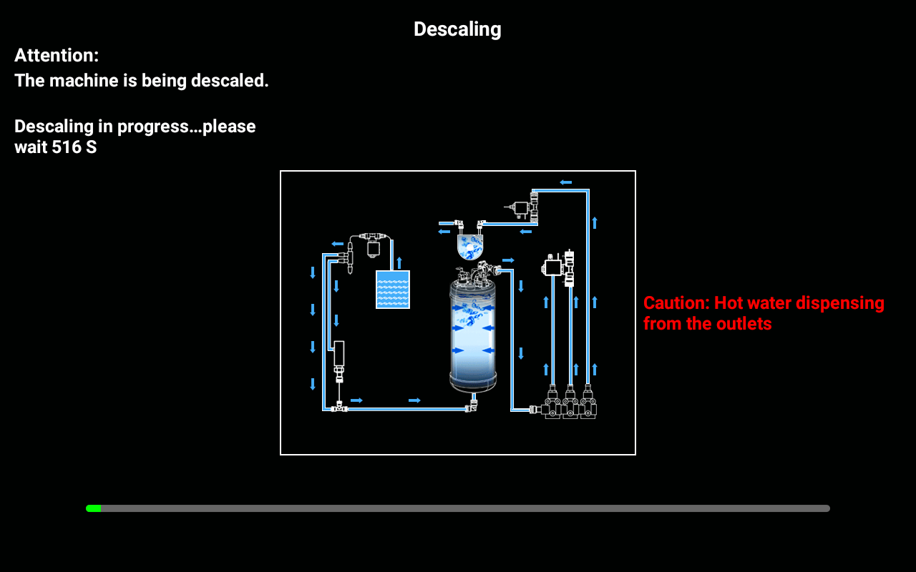
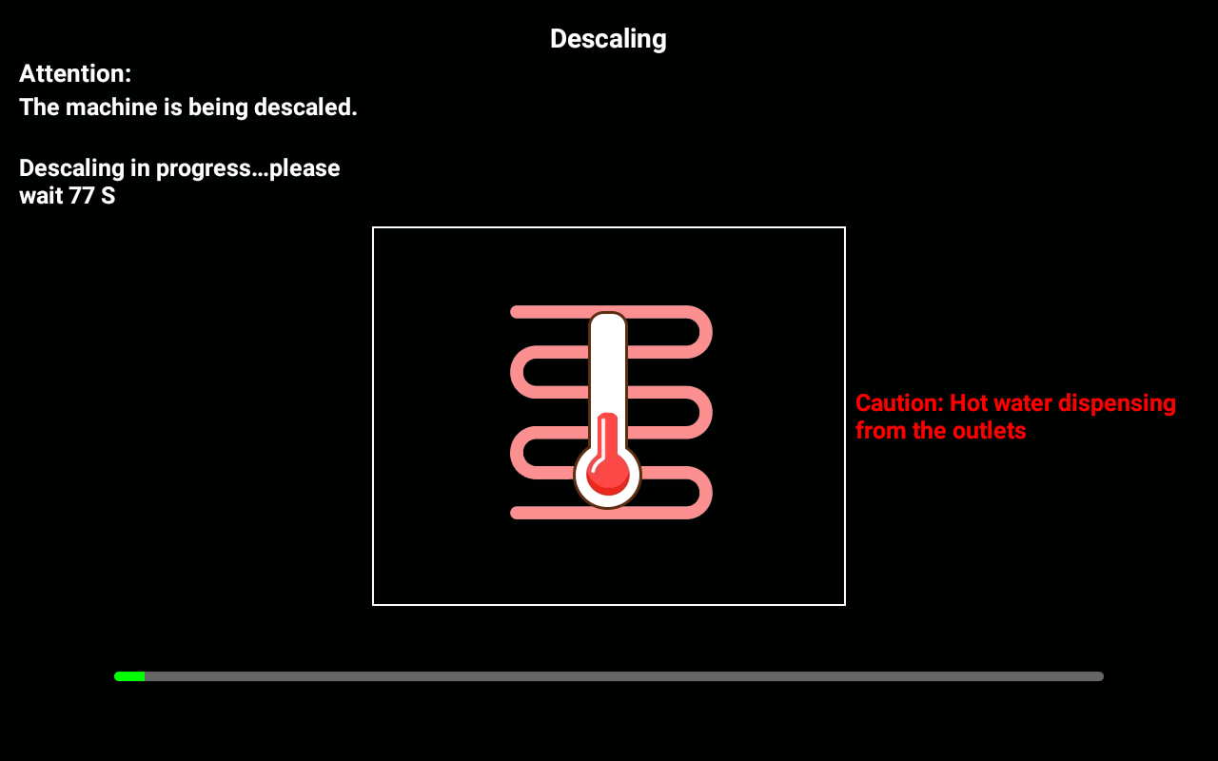

The screen shows "Descaling, please wait a moment..." , a progress bar appears at the bottom of the screen. When the progress is complete, go to the next interface.
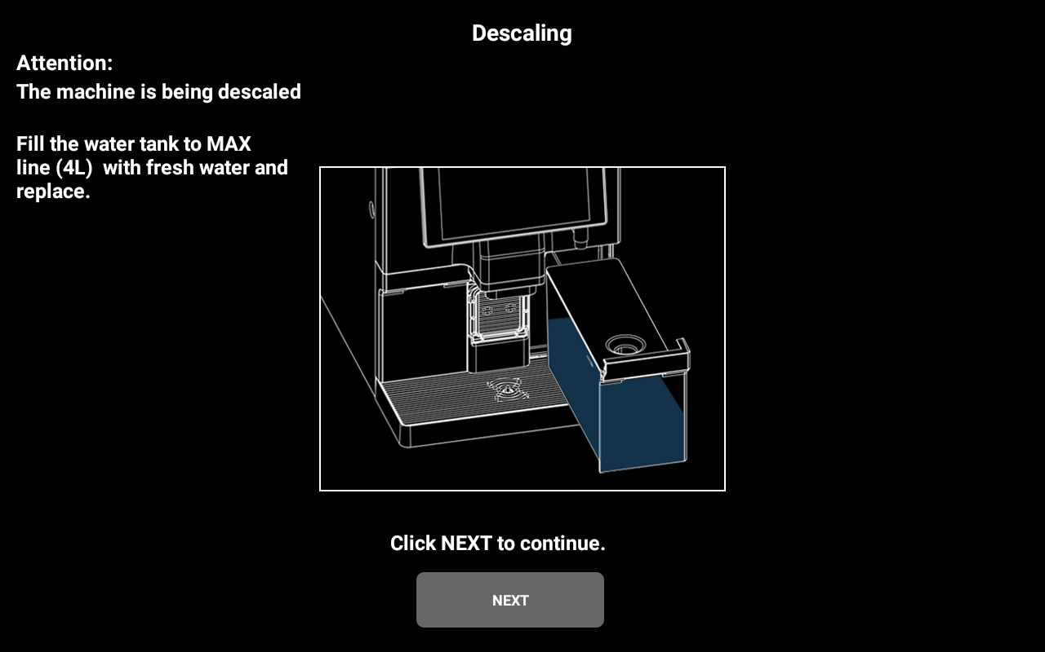
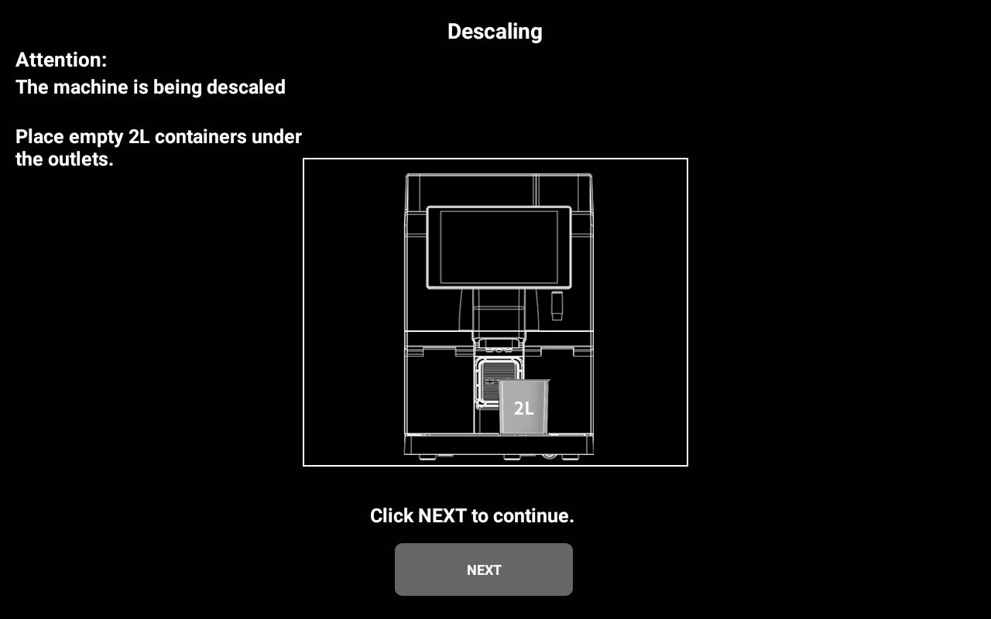

Follow the prompt on the screen: "Fill the tank to the maximum water level (4L) and put it back" and click "Next" to go to the next interface. The screen prompts "Place a 2L empty container under the outlet", operate according to the prompt, confirm and click "Next" to go to the next interface.

The screen displays "Descaling, please wait a moment..." (The two boilers are heated to 94 degrees, opening the separate hot water valve and the holding valve during the heating process), and a progress bar appears at the bottom of the screen. When the progress is complete, go to the next interface.

Follow the prompt on the screen: "Fill the tank to the maximum water level (4L) and put it back" and click "Next" to go to the next interface. The screen prompts "Place a 2L empty container under the outlet", operate according to the prompt, confirm and click "Next" to go to the next interface.
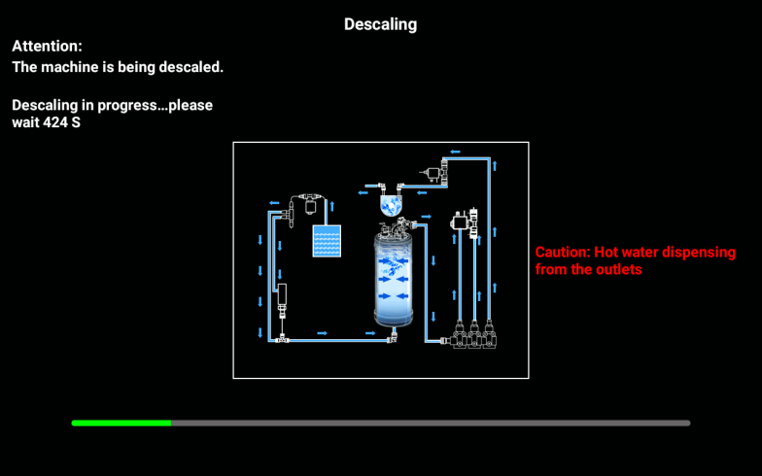
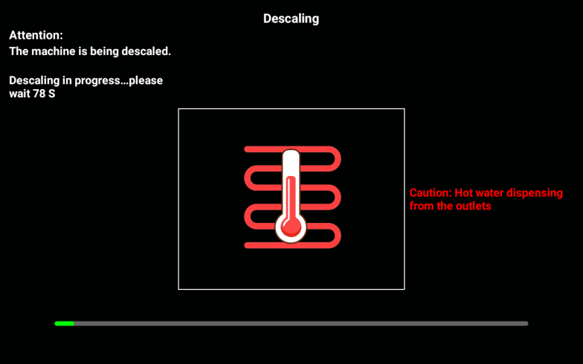

The screen displays "Descaling..., please wait" (Perform 1 rinse of the whole machine, about 0.75L water; Heat two boilers to standby temperature; 3S steam from the steam nozzle), a progress bar appears at the bottom of the screen;
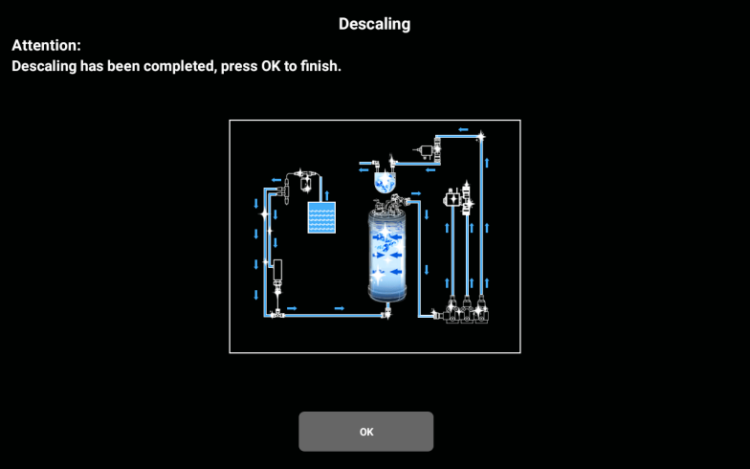

When the progress is completed, the screen jumps to the completion interface, the screen displays "descaling successfully", click to confirm completion, go to the standby state.
Special note
(1) There is no cancel button in the middle of descaling, and it must be completed in accordance with the process.
(2) If the descaling is stopped in the middle due to human or other reasons such as power failure, the next restart will prompt you to finish descaling or restart descaling, otherwise the machine cannot be locked to make any drink; Because the boiler is full of agents during descaling, drinks can not be made.

List of Common Problems
Problems(Questions) | Possible causes | Solution
Coffee flow rate is too slow | The coffee is ground too fine | Adjust the grinder and rotate to the side with the larger number
 | The dose is much larger than expected | Recalibrate the grinder
 | Strainer blocking | Pills to clean the brewer or replace the strainer
 | Leaks (lower plunger damaged) | Replace the plunger or brewer
 | Brewer O-ring leak | Replace the seal ring
Contaminated water tray | No cleaning for a long time | Clean the water tray
 | The outlet spout is not installed correctly | Check and reinstall
Coffee flows too fast | The coffee is ground too coarse | Adjusting grinder
 | The dose is not nearly as good as expected | Recalibrate or check the recipe Settings
The waste bin is full | The cumulative count of coffee ground cakes since the last empty has reached 10 | Pull out the water tray, remove the coffee grounds box, and empty the grounds box
Boiler filling fails | Prolonged machine shutdown and deactivation (water valve not open) | Turn on the water valve to restart the machine
 | The first time the machine is used, there is air in the waterway system | Power off and try again to vent
Lack of coffee beans | The coffee beans in the container have been used up | Add the appropriate amount of coffee beans to the coffee bean container
 | Too much fat sticks to the coffee beans | Stir the coffee beans in the container
The water tray is not installed | The water tray is not installed properly | Reinstall the water tray
 | The water tray sensor is damaged \ magnet is missing or damaged | Replace the sensor \ magnet
Water tray full | The water tray is full | Pull out the water tray and empty the waste water
 | The water level monitoring metal plate of the water tray is dirty | Clean and dry the monitoring metal strip
Unable to suck milk | Milk crate is empty | Check that the milk carton is filled with milk
 | Clogged steam line or steam outlet | Use potions for deep cleaning of the milk system
 | Broken steam line | Disassemble steam line or outlet, check and replace
 | The temperature adjustment knob of the milk frother is too tight | Loosen the temperature adjustment knob of the milk dispenser to the proper position
 | The frother is blocked | Remove the milk frother to check all holes and clean; Replace the foam with a new one
The coffee maker needs descaling | The cumulative production of the coffee machine reaches the set amount of water or cup, indicating the need for descaling; The threshold value of the prompt can be modified in the background menu of the machine. | Click the prompt button to remove the scale, the specific operation method refer to the manual

Preventive measure

Cleanser

Use


Danger of poisoning from ingesting detergent.
- Be sure to observe the following:
- Cleaning agent storage should be kept away from children and unauthorized persons.
- Do not ingest cleaning agents.
- Do not mix cleaning agents with other chemicals or acids.
- Do not add cleaning agent to the cup.
- Do not add cleaning agent to drinking tank (inside/outside).
- Cleaning agents and descaling agents should only be used for their stated purpose (see label).
- Do not eat or drink while using the cleaning agent.
- Good ventilation and venting must be ensured when using the cleaning agent.
- Protective gloves should be worn when using the cleaning agent.
- Safety goggles should be worn when using detergent.
- Wash your hands thoroughly immediately after applying the detergent.
Read the package instructions carefully before using the cleaner. If a safety data sheet is not provided, you can ask the distributor for it (see Packaging of the cleaner)

Storage
Be sure to observe the following:
- Keep out of reach of children and unauthorized persons.
- Keep away from heat, light and moisture.
- Store separately from acidic substances.
- Store in original packaging only.
- Store the cleaner separately.
- Do not store with food or drinks.
- Comply with local laws regarding the storage of chemicals (detergents).

Disposal of waste
If recycling is not possible, the cleaner and its storage must be disposed of in accordance with local laws.

Health Regulations

Water

The possible health hazards of not using water properly!
The water source should meet the GB5479 sanitary standard for drinking water.
Be sure to comply with the following points:
The water must be clean and pollution-free.
- Do not add seepage water or other corrosive water to the coffee maker.
- The carbonate hardness should not exceed 5-6 °DKH (German carbonate hardness) or 8.9-10.7°FKH (French carbonate hardness).
- The total hardness value must always be higher than the carbonate hardness.
- The minimum carbonate hardness is 5 °DKH or 8.9 °FKH.
- The maximum chlorine content is 50 mg per litre.
- PH 6.5-7 (pH neutral).
- Equipped with filters (internal & external)

Coffee

Not using coffee properly could be taking a toll on your health!
Be sure to follow the following:
- Check the bag for damage before filling.
- Close the coffee bean tank top immediately after adding coffee beans.
- Coffee should be stored in a dry, cool and dark place.
- Coffee should be stored separately from cleansers.
- The earliest purchased product should be used first (" early in, early out ").
- The package should be sealed properly after opening to keep the product in the package fresh and prevent it from becoming contaminated.

Finished drink powder

The wrong use of drink powder can cause damage to your health!
Be sure to follow the following:
- Inspect the package for damage before opening it.
- Store finished drink powder in a dry, cool place.
- The finished drink powder must be stored separately from the cleaning agent.
- The earliest purchased product should be used first (" early in, early out ").
- Please use it within the shelf life.
- The package should be sealed properly after opening to keep the product in the package fresh and prevent its contamination.

Safety and Quality Assurance
The manufacturer does not accept any responsibility for damage that may occur to the coffee machine if the user does not follow the instructions for the use and installation of the machine.
Take care to follow the instructions.
The installation site should be kept dry and waterproof; It is strictly forbidden to use the machine in the open air; The machine can only be used for the specified raw material package; Other raw materials are regarded as abnormal use, resulting in damage, the manufacturer does not assume any responsibility.
Whether the Buyer is entitled to warranty rights, and what specific warranty rights the buyer may be entitled to, depends on the agreement between the buyer and the seller. Failure to comply with the operating instructions forfeits warranty rights.
The warranty will not be fulfilled if:
1.Natural wear and tear that occurs in all parts.
2.3. Machine defects caused by non-compliance with the operation, cleaning and maintenance regulations of the machine (such as operating instructions and cleaning and maintenance).
3.Defects caused by not using the original parts of the manufacturer or by a third party's wrong installation or careless use of the machine.
4.Machine defects caused by improper modification or repair of the machine by the user or a third party without our permission.
5.Machine defects due to improper or incorrect use.

