JL15&30 series coffee machine
Instruction Manual
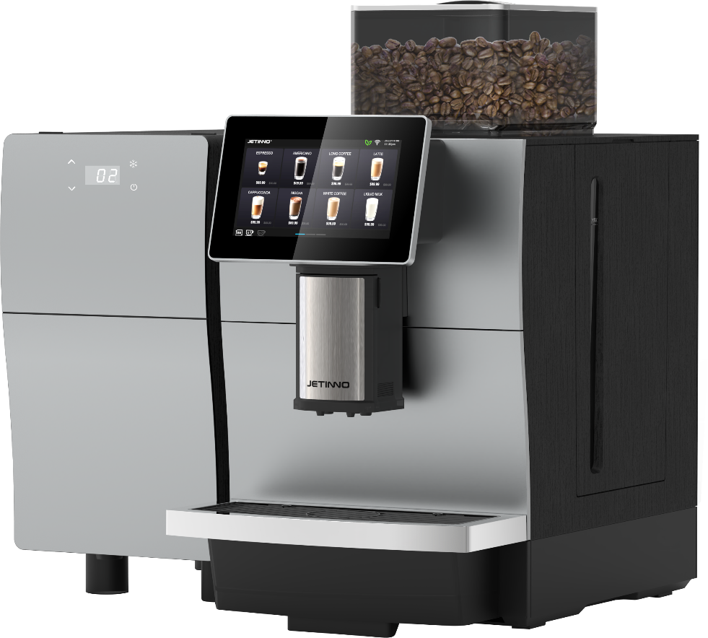

Read the manual carefully before use and keep it safe
Please read this operation manual carefully before use and keep it safe
Please read this operation manual carefully before use and keep it safe
Please read this operation manual carefully before use and keep it safe

Guangzhou Jetinno Intelligent Equipment Co., LTD
Guangzhou Jetinno Intelligent Equipment Co.,Ltd.
www.jetinno.com
(86) 20-32038721
(86) 400-017-9997
Add: 4F, A Building, Creator Park, No.2,Tairui Rd, Science Park, Huangpu District, GZ, GD, PRC. 510663Add: 4F, Building A, Creator Park, No.2 Ruitai Road, High-tech Industrial Development Zone, Huangpu District, Guangzhou

Contents
1 Introduction 4
1.1 Welcome to Use 4
1.2 Labels and symbols 4
2 General safety tips 6
2.1 Danger to users 6
2.2 Hazard to the machine 8
3 Product Description 9
3.1 Welcome to Use 9
3.2 Technical Data 10
3.3 Installation and commissioning 11
3.4 Installation 11
3.4.1 Place 11
3.5 Power Supply 12
3.5.1 Conditions 12
3.5.2 Connecting the Power Cable 12
3.6 Water interface/Drainage 13
3.6.1 Conditions 13
3.6.2 Water Inlet Conditions 13
3.7 Installation 13
3.7.1 Unpack the machine 13
3.8 Disassemble and dispose of scrap 13
4 Operation 14
4.1 Device Description 15
4.1.1 External operation unit of the machine 15
4.1.2 Technical parameters 16
4.1.3 Accessories 17
4.2 Check before starting 18
4.3 Add and connect 18
4.3.1 Connect water sources 18
4.3.2 Connecting the wastewater pipe 19
4.3.3 Connecting the refrigerator 19
4.3.4 Connecting the power supply to the refrigerator 19
4.4 Turn on the power, 20
4.4.1 Coffee maker 20
4.4.2 Confirming the Water Source Mode 20
4.4.3 Counting 21
4.4.4 Diagnosis 22
4.4.5 Machine Status 24
5 First Run 25
5.1 Set up the machine configuration - model number 25
5.2 Connecting to the Network 26
5.3 Connecting to a Server 27
5.4 Fill the box 28
5.5 Fill the milk box in the refrigerator with milk 29
5.6 Commissioning and calibration 29
5.6.1 Adjustment method of grinder thickness 30
5.6.2 Adjusting the temperature of hot milk and milk foam 31
5.6.3 Calibration of grinder 31
5.6.4 Fresh Milk Calibration 33
5.7 Product testing and adjustment 35
5.8 Beverage Management 35
5.9 Setting the sales mode 36
5.10 Beverage making 37
5.11 Set the date/time 38
5.12 Operator Options 38
5.13 Empty 40
5.13.1 Coffee grounds Box 40
5.13.2 Water tray 40
5.14 Transport conditions 40
5.15 Shutdown 41
5.15.1 End of running 41
5.15.2 Long downtime (more than 1 week) 41
6 Cleaning 41
6.1 Cleaning Intervals 42
6.2 Cleaning Schedule 42
6.3 Daily Rinse 43
6.3.1 Brewer flushing 43
6.3.2 Milk Road rinse 43
6.3.3 Automatic flushing Settings 44
6.4 Cleaner 44
6.5 Daily machine cleaning 45
6.5.1 Display guided cleaning program 45
6.5.2 System Cleaning 46
6.5.3 Brewer cleaning 48
6.5.4 Milk path cleaning 49
6.5.5 Clean the coffee grounds box 51
6.5.6 Clean the water tray 52
6.5.7 Clean the drink out of the mouth 52
6.5.8 Clean the touch screen 52
6.6 Weekly Cleaning 53
6.6.1 Clean the coffee bean trough 53
6.7 Emptying the Waterway 53
7 Preventive Measures 54
7.1 Cleaners 54
7.1.1 Use 54
7.1.2 Storage 55
7.1.3 Disposal of waste 55
7.2 Health Regulations 55
7.2.1 Water 55
7.2.2 Coffee 56
8 Safety and quality assurance 56
9 List of frequently asked questions 57
10 Certification 58

1 Introduction

Welcome to use
This instruction manual gives you the information of JL15&30 and other products and how to use them. If you do not use the coffee machine according to the relevant instructions in this manual, we do not assume any responsibility for the loss caused by this. However, all intended uses may not be included in the instruction manual! For more information, please contact our customer service.
Equipment performance depends on proper maintenance and use. Please read the instruction manual carefully before the first commissioning and keep the instruction manual for easy access.
This manual is applicable to: JL08, JL09, JL10, JL15, JL29A, JL29B, JL30, JL31A, JL31B.
Wish you a happy use!

Logos and symbols
 See also the "General Safety Tips" section.
The following signs and symbols are used in the instruction manual to indicate hazards and special matters:
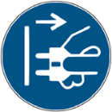


- Immediate danger situations, which may result in serious injury or death due to electric shock.
- Be sure to follow precautions to prevent such hazards.



- A general hazardous situation that can cause serious injury.
- Be sure to follow precautions to prevent such hazards.

- General hazardous conditions that can cause minor injuries.
- Be sure to follow precautions to prevent such hazards.



- Conditions exist that could cause damage to the machine.
- Be sure to follow the precautions to prevent such hazards.

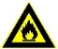

- Fire hazard/combustible materials.
- Watch out for fire.


- Hot liquids. A dangerous condition that may cause burns. A hazard exists at the flow outlet location. Only symbols are used for identification below.
- Be sure to follow the precautions to prevent such hazards.


- Hot steam. Dangerous condition that may cause burns. The location of the water outlet creates this hazard. Only symbols are used in the following.
- Be sure to follow the precautions to prevent such hazards




- Hot surfaces. Dangerous conditions that can cause burns. Stream exit location.
- Location (optional) to create this hazard. Only symbols are used in the following.
- Be sure to follow the precautions to prevent such hazards.



- Crush hazard. Dangerous conditions that can cause splint injuries. Only symbols are used for identification below.
- Be sure to follow the precautions to prevent such hazards


- Poisoning hazard. A general hazardous condition that may result in injury from poisoning. In the following
Identification by symbol only.
- Be sure to follow precautions to prevent such hazards.

General Safety Tips

Danger to users


Improper use of a coffee machine can result in minor injuries.
Be sure to follow the following:
Read the instructions carefully before use.
- Only allow technical service personnel to enter the maintenance area of the machine.
- Do not use the coffee machine if it is not working properly or is damaged.
- Do not change the built-in safety device.
- Do not touch hot machine parts.
- Children over 8 years of age and persons with physical, sensory, or intellectual impairments or who lack experience and cognition should only use equipment under constant supervision after learning how to operate it safely and understanding the risks associated with it.
- Do not allow children to tamper with machinery. Cleaning and user maintenance tasks must not be performed by children. Only persons familiar with and experienced with the equipment are allowed to perform such work, especially as it relates to safety and hygiene.
- Install the coffee machine in a place where it can be looked after and maintained at all times.
- Self-use and operation should be supervised by trained personnel to ensure compliance with maintenance regulations and to resolve usage issues at all times.
- Only coffee beans should be filled in the coffee bean tank, and only ground coffee beans should be added to the manual addition port (or cleaning tablets should be added during cleaning).

Electric shock hazard. Incorrect use of electrical equipment can result in an electric shock.
Be sure to observe the following:
- Work on electrical equipment should only be performed by electrical professionals.
- This machine must be connected to a circuit with a fuse protection (it is recommended to lay the wiring through a leakage protector).
- Please comply with the relevant low voltage directives and national or local safety regulations.
- Connections must be grounded in accordance with regulations to prevent electric shock.
- The voltage must be consistent with the instructions on the device nameplate.
- Do not touch live parts.
- Be sure to turn off the main switch and disconnect the device from the power supply before performing maintenance.
- All connectors of the device must be able to disconnect from the power grid. Disconnected connections must be visible at all times at the point of operation of the equipment, or power must be secured by locking.
- Only professional technical support personnel can replace the power cable.



If the safety tips are not followed, there may be negligence in normal use, which will cause harm to personnel and the surrounding environment!
- Ventilation should be maintained around the machine or in the embedded structure without obstructions.
- There should be no inflammables around the machine.
- Do not use mechanical devices or other means to accelerate defrosting other than those recommended by the manufacturer.
- Do not damage the refrigeration circuit.


Drinks with additives or residues may cause allergies.
Be sure to follow the following:
- In the self-service application, express the possible use of allergenic additives through the coffee machine prompt board.
- In the case of a service person application, a trained person should inform you of possible allergenic additives



Danger of poisoning from ingestion of cleaning agents.
Be sure to observe the following:
- Cleaning agent storage should be kept away from children and unauthorized persons.
- Do not ingest cleaning agents.
- Do not mix cleaning agents with other chemicals or acidic substances.
- Do not add cleaning agent to the cup.
- Do not add cleaning agent to drinking tank (inside/outside).
- Cleaning agents and descaling agents should only be used for their stated purpose (see label).
- Do not eat or drink while using the cleaning agent.
- Good ventilation and venting must be ensured when using the cleaning agent.
- Protective gloves should be worn when using the cleaning agent.
- Safety goggles should be worn when using detergent.
- Wash your hands thoroughly immediately after applying the detergent.

Read the package instructions carefully before using the cleaner. If a safety data sheet is not provided, you can ask the distributor for it (see Packaging of the cleaner)


High temperature liquid. Risk of burns in the exit area of beverages, hot water and steam. During export or cleaning
Do not extend your hand below the flow outlet position


Hot surface. High temperature exists in the flow outlet position, ES brewer and boiler.
- Only allow contact with handles pre-designed for output.
- Clean the ES brewer only after the coffee machine has cooled.

Squeeze \ scratch hazard. There is a risk of being crushed by touching any moving part.
- Only handles pre-designed for output are allowed to be touched.
- Do not reach into the opening of the coffee bean trough, powder trough, or brewer after starting the coffee machine.
- The blades on the grinder disk and the coffee trough opener blades are sharp and should be taken care of during cleaning.

Hazard to the machine

Improper use of the coffee machine can cause damage or contamination.
Be sure to follow the following:
- If the carbonate contained in the water is harder than 5°DKH, install a scale filter, otherwise it will damage the coffee due to calcification.
- For safety reasons, please note that the main water valve (coffee machine with tap water interface) should be turned off after shutdown, and the main switch should be turned off or the plug should be unplugged.
- Please comply with the relevant low voltage directives and/or national and local safety rules and regulations.
- If water injection is not possible, do not turn on the device. Otherwise you will not be able to refill the water boil and the pump will run "dry".
- It is recommended to install a ball valve in the water pipe when connecting to the direct drinking water to avoid water seepage hazards when the hose breaks.
- After a long shutdown (such as a corporate holiday), the coffee machine must first be cleaned and then turned back on for use.
- Protect the coffee machine from weather - empty the tank (frost, moisture, etc.).
- Troubleshooting should only be done by a technical service person.
- Use original parts for repairs.
- For visible external damage or leakage, contact your service partner immediately for replacement or repair.
- Do not rinse the machine with water or clean it with steam cleaner.

- Do not place the machine where it may be sprayed with water.

- Protect the ground.
- If you do not use the machine for a long time, it is recommended to use up all the coffee beans in the bean bin, otherwise the residual coffee beans will absorb moisture in the air, and it is easy to cause the grinder to block when grinding again;
- If the boiler is not regularly descaled, it will have the following effects: the heating speed slows down and the temperature is not enough; Abnormal coffee taste, resulting in boiler damage.


Proper use of the coffee machine can cause damage or contamination.
Be sure to follow the following points:
- Only coffee beans can be filled in the coffee bean tank, only finished beverage powder can be filled in the powder tank, and only ground coffee beans can be added to the manual addition port (or cleaning tablets can be added when cleaning).
- Do not use freeze-dried coffee, otherwise it will cause the ES brewer to stick.
- If the coffee machine and its additional equipment are transported at a temperature below 10 ° C, the coffee machine and its additional equipment must be placed at room temperature for three hours after transportation, and then connected to the power supply and started. Failure to comply with this regulation may result in a short circuit hazard or damage to electrical components due to condensation.
- Use a hose kit (drinking water/wastewater hose) that is new or comes with the machine. An old hose kit must not be used.


Improper use of the coffee machine can result in injury;
Climbing on top of the machine is strictly prohibited.

Product Description

Welcome to use
The JL15&30 is used to make and output various types of coffee drinks and milk drinks with syrup. The equipment is suitable for commercial use in hospitality, catering or similar establishments. The equipment is self-serving and unattended, and can be operated by non-professionals or by guests themselves. User maintenance should only be carried out by trained outside operators. If installation conditions can always be met, the device can also be used in a train station, gas station shop, or similar public place. The machine is not designed for outdoor installation or use.
Children over 8 years of age and persons with physical, sensory or intellectual impairments or who lack experience and cognition should only use the equipment under constant supervision after learning how to operate it safely and understanding the risks associated with it. Do not allow children to tamper with machinery. Cleaning and user maintenance tasks must not be performed by children. Only persons familiar with and experienced with the equipment are allowed to perform such work, especially as it relates to safety and hygiene.
In addition, refer to the terms and conditions of the manufacturer of the equipment and this instruction manual when using the coffee machine. Any other use or use beyond the limits is considered unreasonable use. The manufacturer shall not be liable for any loss arising therefrom

- Hazard to machinery.
- Incorrect operation of the coffee machine may cause damage to the equipment, use the original formula, do not use other formulas.

Technical Data
Name parameters
Model number | JL15, JL30
JL15 Dimensions/weight | 300 (W)* 440 (H)*490 (D)mm, 14Kg
JL30 Dimensions/weight | 300 (W)* 540 (H)*490 (D)mm, 15Kg
Rated voltage/frequency | AC220V-240V/50Hz; AC110-120V/60Hz
Rated power Total power | 1550W\2850W（Refer to nameplate）
Rated current | 10A\16A（Refer to nameplates）
Exposed length of power cord | Greater than 1.5m
Coffee machine operating  temperature/humidity | Temperature 5℃-35℃, relative humidity is less than 80%
Rated pressure | 0.6 MPa
Communication interface | USB; WIFI; 4G
Device display | 7 ", 10.1 "display
Coffee bean box capacity | JL15, 500 g; JL30, 1200 g
Wastewater volume | 1.2L/ Optional effluents
Coffee grounds box capacity | JL15,20 coffee grounds cakes; JL30,40 coffee grounds cakes
Hot water boiler, steam boiler | Thermal block, 1400W*2
High water adjustment range | 80mm-160mm
Fresh milk module | Yes
Fresh milk refrigerator | Optional
Water supply mode | Standard: 2L built-in tank, barreled water; Optional: 8L built-in water tank; Direct drinking water;
Payment system | Optional payment functions: wechat, Alipay; Or optionally connect to other MDB devices
Operating system | Android
Waterproof rating IP | IPX1

Installation and commissioning
Machines should be installed in accordance with the electrical and hygiene regulations in force in each country or locality. These include taking adequate backflow protection measures.


Sharp edges of packaging materials can lead to injury. Cutting nylon cable ties may make
Eye injury. Wear gloves when unpacking the machine and keep safety goggles on.


Contaminated water inlet pipes may pose a health hazard. It must be cleaned after installation, commissioning or commissioning again.
Before the initial output of drinks, clean according to the cleaning program guided by the display screen.
See "Cleaning" - "Daily Machine Cleaning" - "Screen Guided Cleaning Program".

Set Up

Locations

Hazard to machinery. The following conditions are suitable for placing a coffee machine. Failure to guarantee these conditions may damage the machine.
- Do not put the machine upside down, horizontally or vibrate the machine when handling, and do not move the machine at an Angle greater than 45°.
- Before the machine is installed, ensure that the refrigerator with fresh milk has been placed forward for at least 24 hours.
- The mounting surface must be stable and flat, and will not deform under the weight of the coffee machine.
- The distance between the necessary energy interface set according to the site installation drawings and the machine position must not exceed 1 m.
4.1.2 Climatic conditions
Hazards to machinery. The following climatic conditions are suitable for placing coffee machines. If these conditions are not guaranteed, the machine may be damaged. Be sure to observe the following conditions:
- The ambient temperature should be maintained at 5 ° C - 40 ° C.
- The maximum relative air humidity is 10%RH-90%RH.
- Coffee makers are designed for indoor use only. It must not be used outdoors to protect it from the weather (rain, snow and frost)!

Power supply

Conditions
Electrical connections must be made according to the relevant regulations of the host country. The voltage at the installation site must be consistent with the voltage given on the nameplate.
Electric shock hazard! An immediate danger situation that can result in serious injury or death due to electrocution.
Be sure to observe the following:
- All power supply circuits must be turned off before touching the terminal!
- Leakage protection devices must be protected by fuses with amperage values indicated on the nameplate!
- All connectors of the device must be able to disconnect from the power grid.
- The JL15&30 series models can only be connected to a power supply with a system impedance of 0.293 ohms or less. Consult the authority of your system impedance information provider if necessary.
- Do not run the machine when the power cord is damaged. Replace the damaged power cord or plug immediately by a professional technical service person.
- It is recommended not to use an extension cable! If you must use an extension cable (minimum cross section: 1.5 mm²), follow the manufacturer's data (instruction manual) for the cord and local regulations.
- When laying out the power cables, make sure that the power cables will not trip people. Do not drag the cable at sharp or sharp corners, and do not clip the cable or leave it hanging in the air. In addition, cables should not be placed over hot objects and should be oil and corrosive cleaners resistant.
- Do not lift or pull the device through the power cord. Do not pull the plug out of the socket by pulling on the power cord. Never touch the power cord or plug with wet hands! Do not plug wet plugs into sockets!

Power connection cable

Danger to the user. There is a risk of electric shock and fire if the power connection cable is damaged or non-original!
Use an original power connection cable.
- Be sure to follow precautions against such hazards:
Country-specific original power connection cables can be purchased through service partners.
Power connection cables with fixed connections should be replaced by technical service personnel.

Water interface/drain

Conditions
Poor quality raw materials and poor water quality can damage the machine. Be sure to follow the precautions against such hazards.
Be sure to observe the following:
- The water used must be clean and pollution-free, with no more than 50 mg of chlorine per litre of water.
- Do not add reverse osmosis water or other corrosive water to the coffee maker.
- Carbonate hardness should not exceed 5-6°DKH (German carbonate hardness) or 8.9-10.7°FKH (French carbonate hardness).
- The minimum carbonate hardness is 5 °DKH or 8.9 °FKH. The PH is between 6.5-7.
- Use the new hose kit (clean water/waste water hose) that comes with the machine.
- The water source must be connected in accordance with current regulations as well as the regulations of the country in which it is located. If the machine is connected to a newly installed water pipe, the water pipe and water inlet hose must be thoroughly rinsed to prevent stains from entering the machine.
- The machine is connected directly to an external drinking water tank or waste water tank. Corresponding level monitoring is available.

Water intake conditions
Water Pressure | 0.1-0.6 MPa (1-6 bar) recommended
Inlet temperature | Minimum | Greater than 0°C
Inlet temperature | Maximum value | 30°C

Mount


Unwrap the machine
Read the "Set Up" and "Power Supply" sections carefully before starting the installation!
Pay attention to the installation instructions that come with it!
- Unwrap the machine.
- Check the package to see if any accessories are left in it.
- Remove the accessories provided with the package.
Auto Debugger Run debugger automatically the first time you turn it on. All installation items will be explained in it. Technical service personnel can start the debugging program at any time.

Disassembly and disposal of scrap
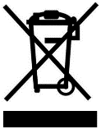
Proper disposal of coffee machines must be done in accordance with local regulations.
► Contact a service partner agency.


Operations

Hot liquid. Drinks made with this machine are hot drinks.
Do not put your hand under the outlet of the drink or into the machine during discharge.


High temperature steam. Risk of burns in the steam nozzle exit area.
Do not put your hand under the steam nozzle during output.


High temperature surface. Dangerous conditions that can cause burns. Drink outlets and water brewers present this hazard.
Do not grip the outlet of the drink or touch the surface of the boiling device while it is heating.

Hazard to the machine. Wrong operation may damage the touch screen.
Do not press the display with brute force, high pressure, or sharp objects.

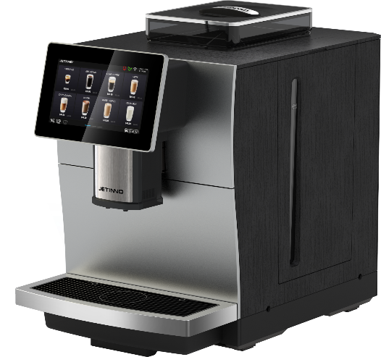
Equipment introduction
3.
1.

Machine external operating unit
JL15 coffee maker (front)
2.
(4)
5.

① coffee bean box, ② drink mouth, ③ built-in water tank, ④ touch + display screen, ⑤ water tray.
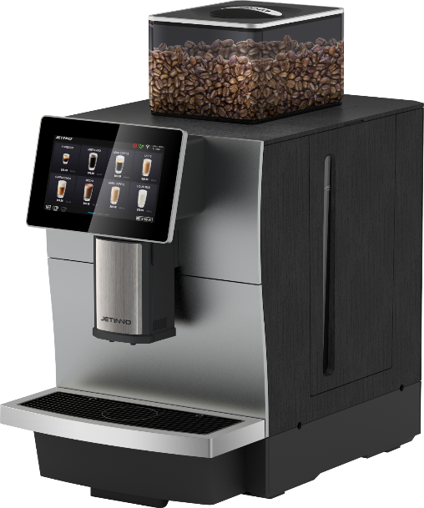
3.
1.
(4)
JL30 coffee maker (front)

2.

5.

① coffee bean box, ② drink mouth, ③ built-in water tank, ④ touch + display screen, ⑤ water tray.
Coffee machine (back)

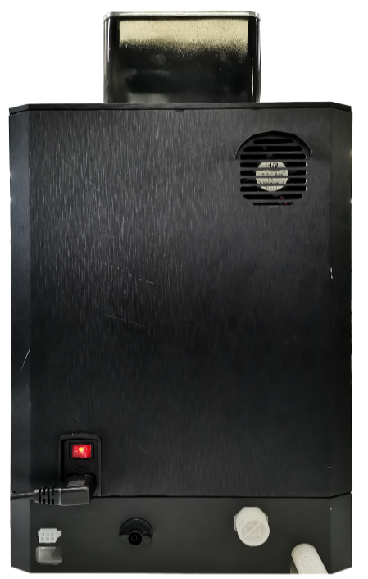
5.
1.

6.
2.
3.
All landowners
(4)

① barreled water and built-in water tank switch knob, but also barreled water inlet, ② power switch, ③ power cable connector, ④MDB device interface,
⑤ machine heat dissipation, ⑥ direct drinking water inlet interface, ⑦ water tray waste water exhaust pipe.
Product interface
Company LOGO
Time/date
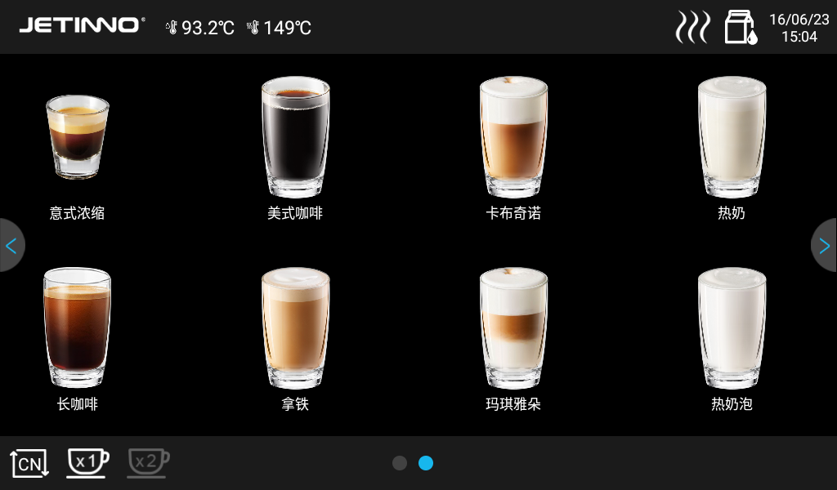
Hot water boiler temperature degree
Steam boiler temperature
Milk road flush button
Brewer flush button
Page turn button
Single/double cup toggle button
Product buttons
Product name
Language switch button

Technical parameters
JL08 |  |  | JL29
Drinks | The recommended daily serving size | Cup capacity per hour | drink | The recommended daily serving size | Cup capacity per hour
Italian | 30 | 90 | Italian | 100 | 90
American style | 30 | 65 | American Style | 100 | 65
Long coffee | 30 | 65 | Long coffee | 100 | 65
Hot Water | 30 | 120 | Hot Water | 100 | 120
JL09 |  |  | JL30
Drinks | The recommended daily serving size | Cup capacity per hour | drink | The recommended daily serving size | Cup capacity per hour
Italian | 30 | 90 | Italian | 100 | 90
American style | 30 | 65 | American Style | 100 | 65
Long coffee | 30 | 65 | Long coffee | 100 | 65
Milk coffee | / | / | Milk coffee | 100 | 90
Hot Water | 30 | 120 | Hot Water | 100 | 120
JL10 |  |  | JL31A
Drinks | The recommended daily serving size | Cup capacity per hour | Drinks | The recommended daily serving size | Cup capacity per hour
Italian | 30 | 90 | Italian | 100 | 90
American style | 30 | 65 | American Style | 100 | 65
Long coffee | 30 | 65 | Long coffee | 100 | 65
Milk coffee | 30 | 60 | Milk coffee | 100 | 90
Hot Water | 30 | 120 | Hot Water | 100 | 120
JL15 |  |  | JL31B
Drinks | The recommended daily serving size | Cup capacity per hour | Drinks | The recommended daily serving size | Cup capacity per hour
Italian | 60 | 90 | Italian | 100 | 90
American style | 30 | 65 | American Style | 100 | 65
Long coffee | 60 | 65 | Long coffee | 100 | 65
Milk coffee | 60 | 65 | Milk coffee | 100 | 90
Hot Water | 60 | 120 | Hot Water | 100 | 120

Accessories
Random accessories
Fully automatic coffee makers come with the following accessories when supplied:
Graphical representation | Item name | Functional specifications | Product parameters
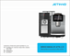 | Instruction manual | For coffee machine use reference | 210mmx291mm
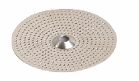 | Coffee maker, pack of consumable materials (seals, strainers, etc.) | For daily consumable replacement of coffee machine | Regular
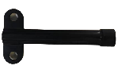 | Coffee maker debugging tool (grinder adjustment key) | A tool for adjusting the coffee machine | Routine
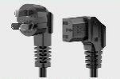 | Power cord | For coffee machine special function installation use | Three plug (10A)/Pin tail (left bend)
Optional accessories
ICONS | Item name | Functional specifications | Product parameters
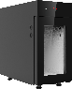 | Milk cold bin | For refrigeration and fresh use | 220 (W) x400(H)x403(D)mm/ 220 (W) x430(H)x403(D)mm, capacity 9L
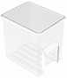 | Fresh Granny box | Container for holding fresh milk | Food grade, 5L
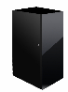 | Bottom cabinet (can be customized) | A bottom cabinet for your coffee maker | Can be customized
 | Coffee system cleaning pills | Used to clean coffee machine ES brewer | 2 g/tablet, 100 tablets/can, 12 cans/box
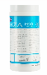 | Coffee maker milk system clean tablets | For cleaning the milk system | 4g/ tablet, 120 tablets/bottle, 12 bottles/case
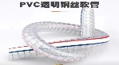 | Coffee machine mounting accessories (connect the outer row tube of the water pan) | For coffee machine special function installation | Inner diameter 12, outer diameter 21

Check before turning on
Check that the following prerequisites are met before turning on the coffee machine.
- The main water valve has been opened or the tank has been filled with water.
- The waste water outlet is properly set/the water tray is properly placed.
- Bean boxes are filled.
- Coffee grounds box emptied and properly inserted.
- The power cord is connected to the power supply.

Add and connect

Special care must be taken when replenishing that the maximum amount of filling must not cause the container lid to come into contact with the contents.

Connecting water source

Water quality affects human health! Water sources must meet the sanitary standards for drinking water
- Pay attention to the sanitary condition of water pipes.
- Wash the relevant parts.
- The water source to which the machine is connected should be easy to operate.
- Tighten the joint for direct drinking water to avoid water leakage.
- External water source
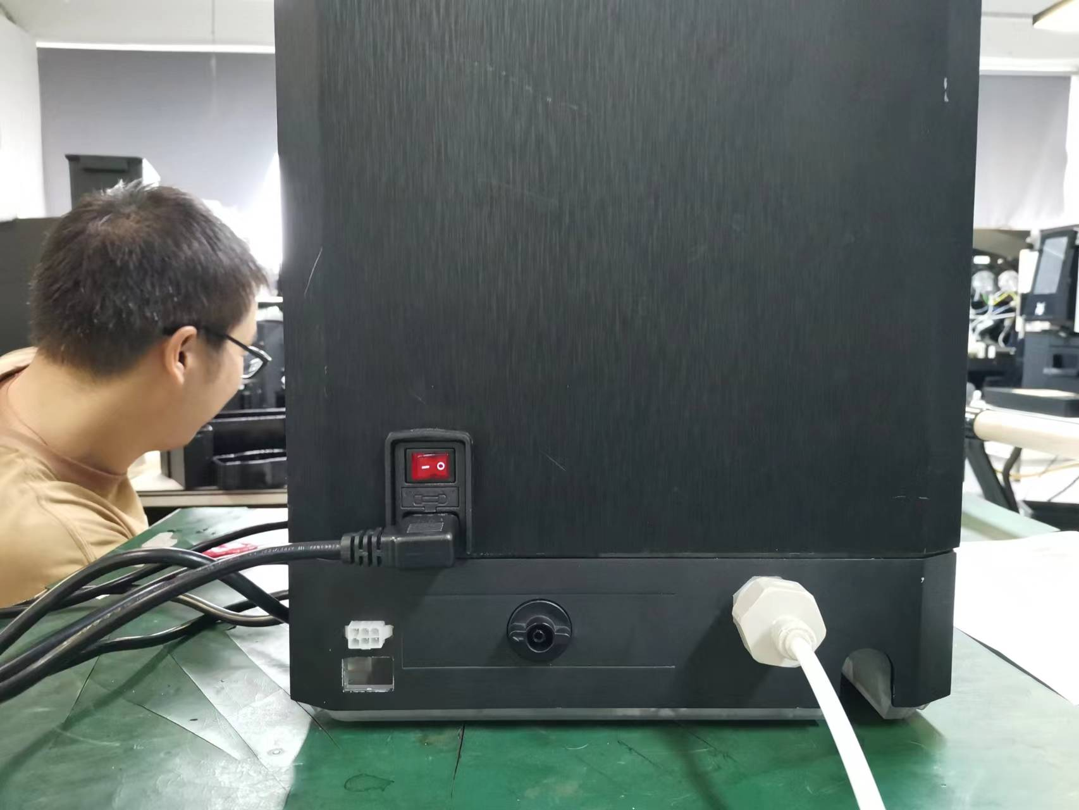
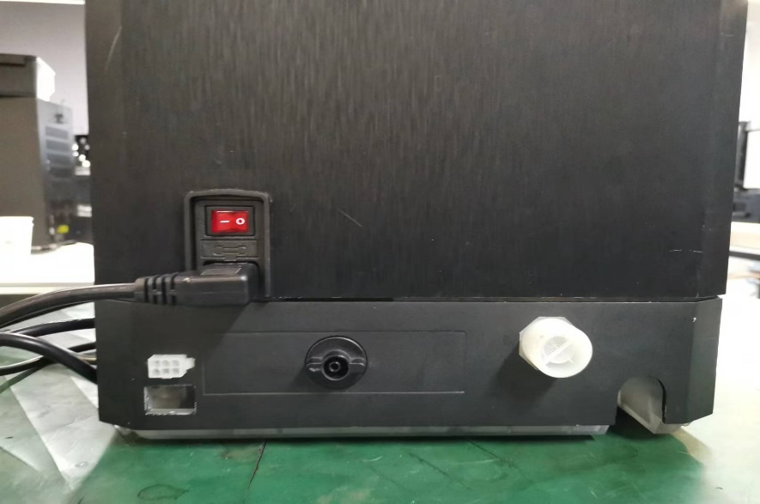

At the red circle in the figure above, take off the cover, take out the connector inside the machine, rotate clockwise to install the inlet valve interface, and insert the water inlet pipe into the interface.
Direct drinking water interface
A pump running without water can damage the machine.
Make sure the main water valve is open before turning it on.
When stopping, make sure the main water valve is closed.
- Internal water source
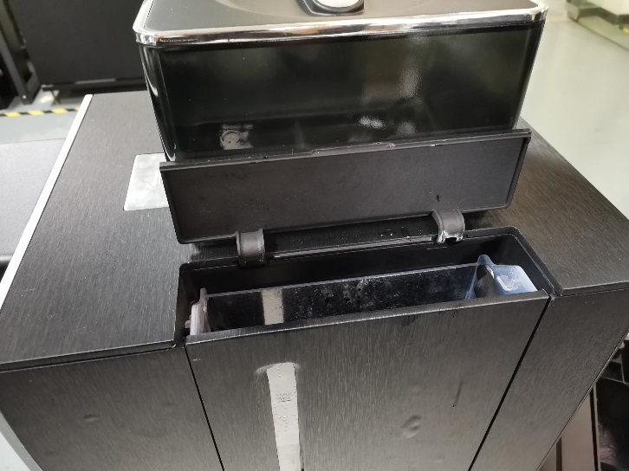
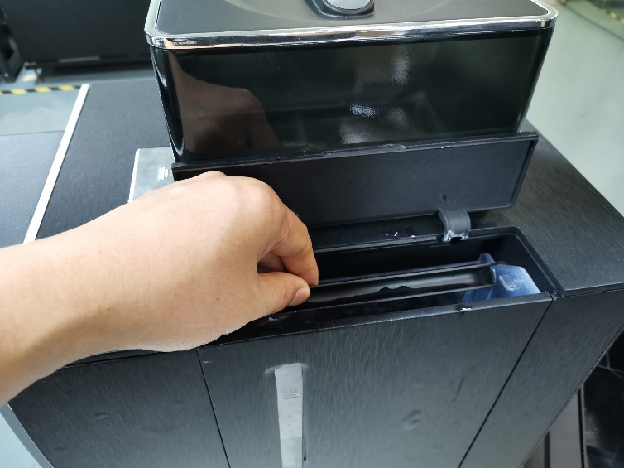

Open the lid of the tank, raise the tank upward, fill the tank with clean water, and load the tank back into the machine. The water level of the tank is detected, and the water shortage interface is prompted.
C. bottled water
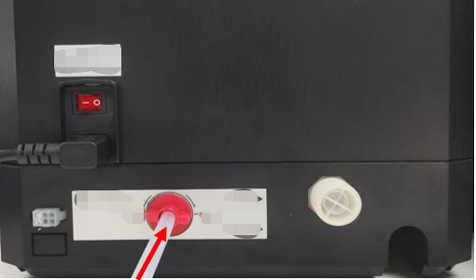
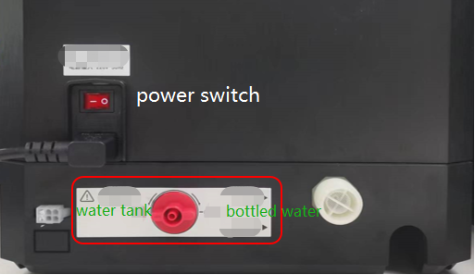
Open the switch knob between the bottled water and the built-in tank -> Arrow points to the bottled water, take out the white tube from the machine, and insert the tube into the interface until it is inserted to the bottom. Put the other end into the barreled water.

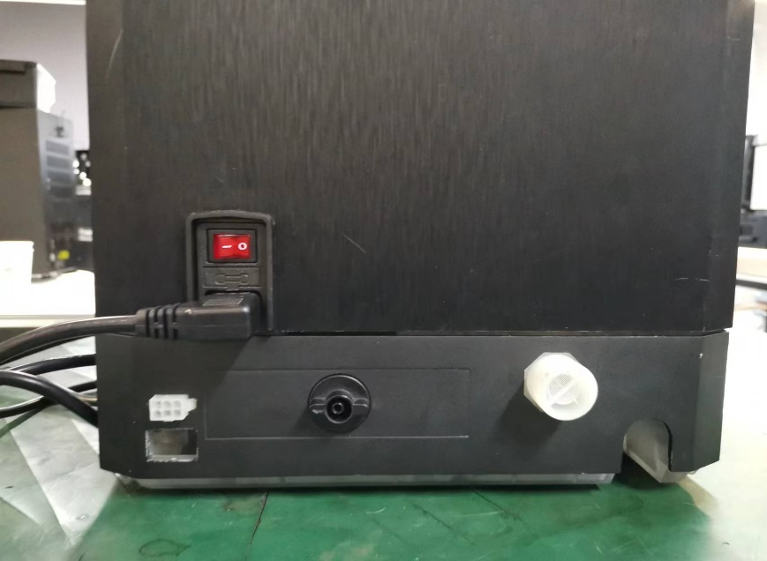
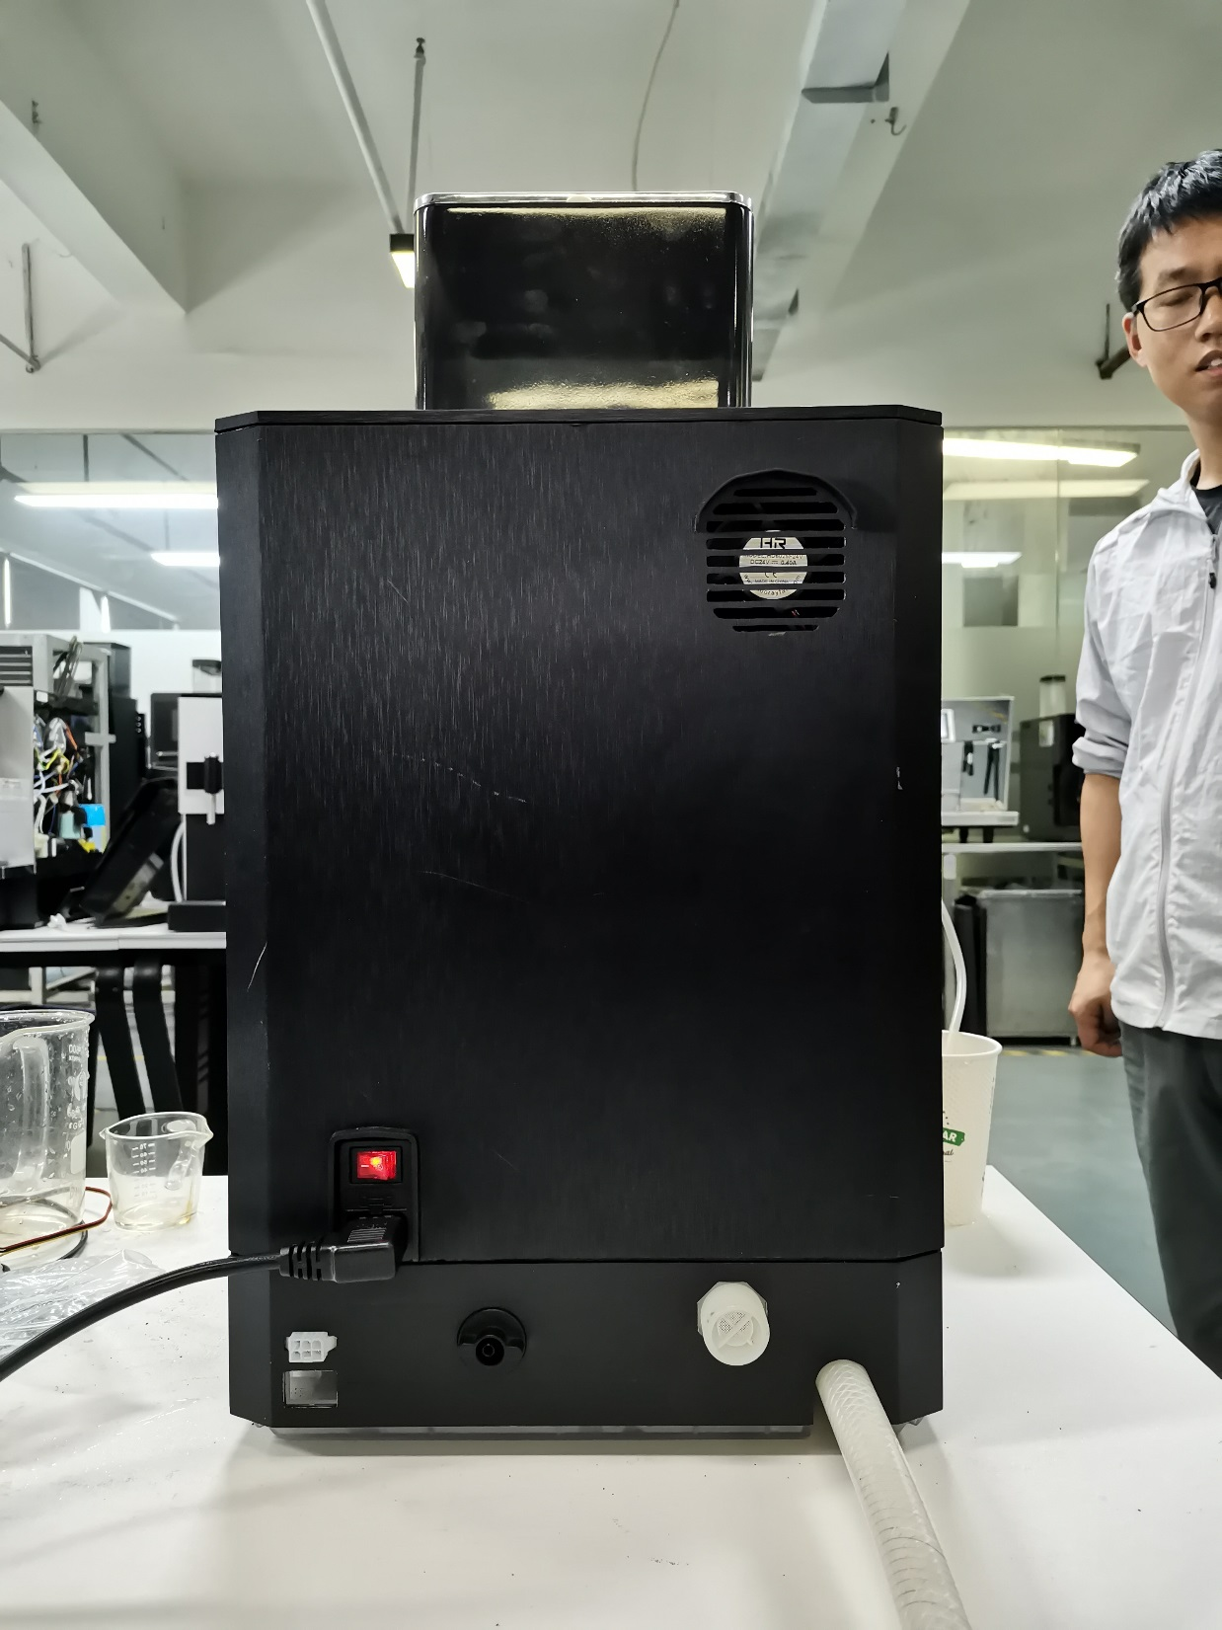
Connecting waste pipe

The drainage function outside the water tray needs to connect the waste water pipe, take out the water pipe, insert it into the interface at the bottom of the machine, and lock the fixed ring.

Connect the refrigerator
Insert one end of the milk tube into the port on the left side of the refrigerator, straighten the milk tube, and move the refrigerator flush with the coffeemaker cabinet.

Connect the power supply to the refrigerator
Insert the refrigerator power cord, female head, into the socket of the machine; Insert the other end of the power cable into the socket of the power supply; Press, refrigerator power switch.

Turn it on,

Coffee maker
► Insert the machine power cord, female head, into the socket of the machine; Insert the other end of the power cable into the socket of the power supply;
► Check the power connection of the machine and turn on the power switch.
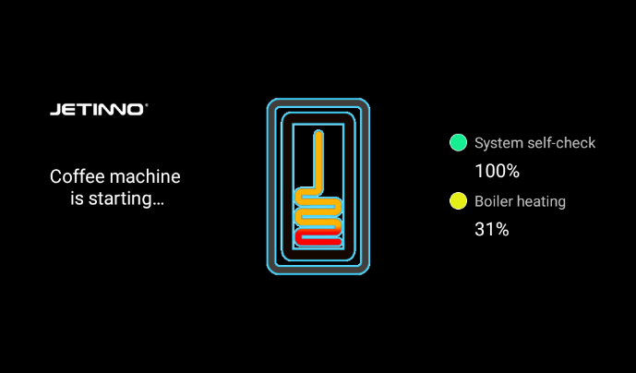
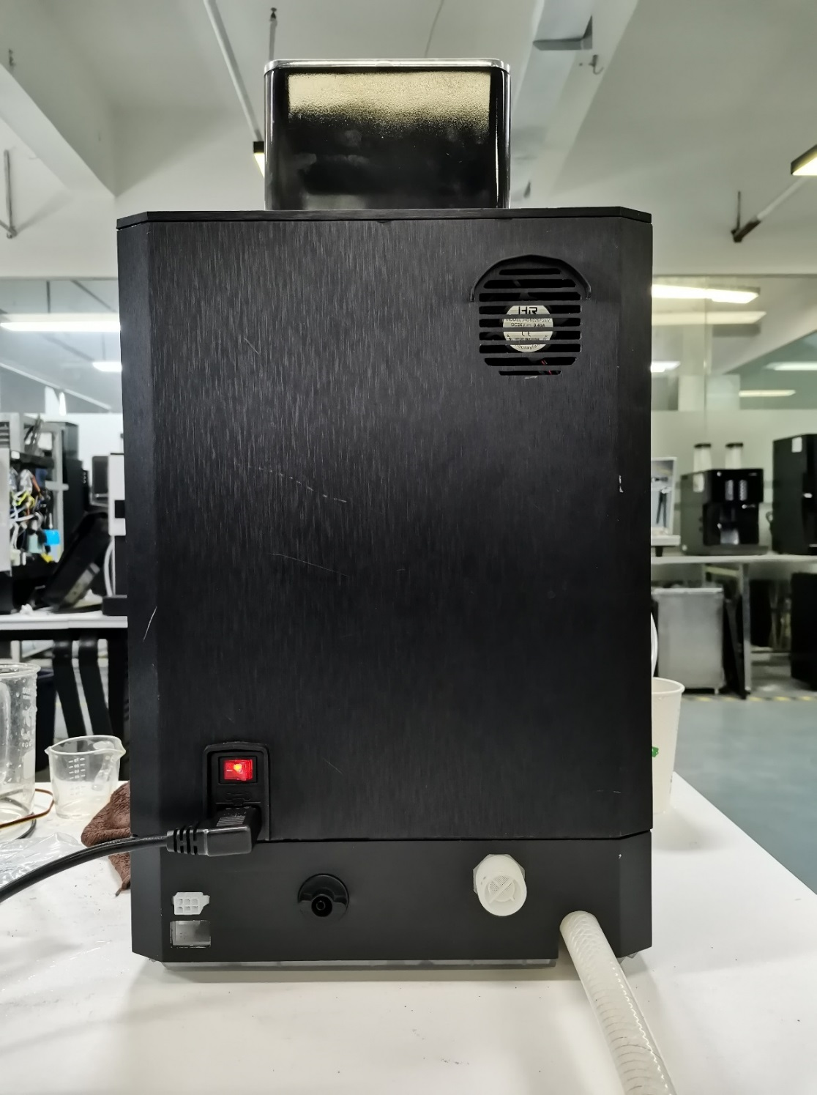

The machine starts, displays the main interface, and starts heating. When the desired temperature is reached, the machine is ready.

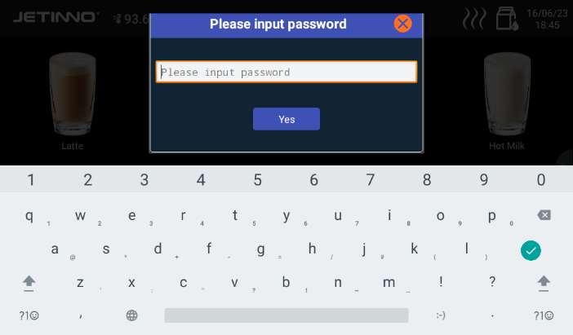
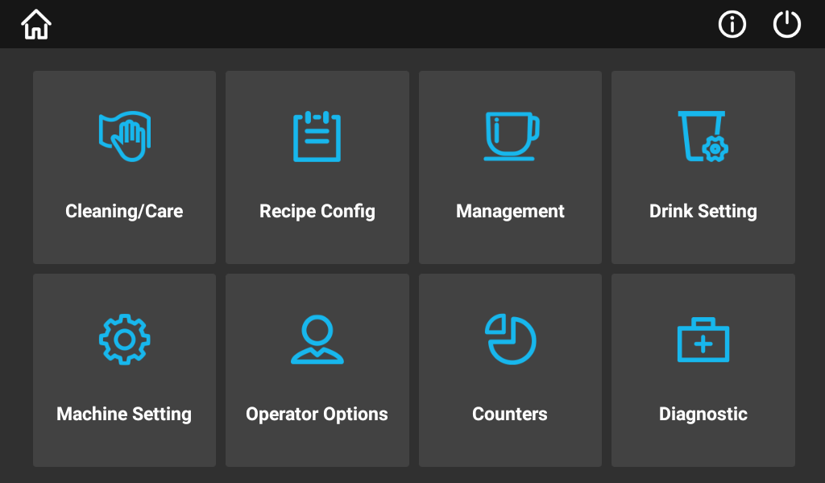
Method of confirming water source

Press and hold, the top left corner of the screen, enter your password (Tester: test9527) in the dialog box that pops up, and click "OK". Select "Machine Settings" and click.
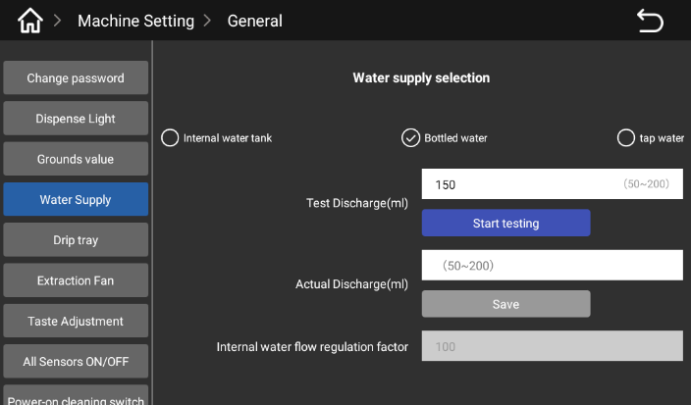
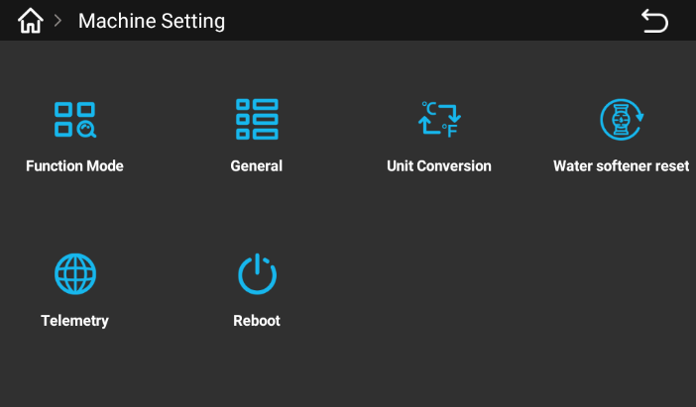

In the interface that pops up, click "General -> Water Supply" and select the correct water supply method (corresponding to the way you actually connect your water source).
Take the empty measuring cup and put it under the outlet mouth, click "Start test" when the water is finished, read the value on the measuring cup, and click "Save" in the place of "Input real material discharge (ml)".

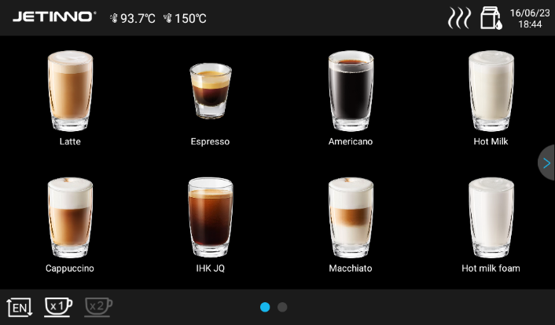
Counting

Long press, in the upper left corner of the screen, enter the password (administrator: jn9527, operation and maintenance personnel: 9527) in the pop-up dialog box, and click "OK".
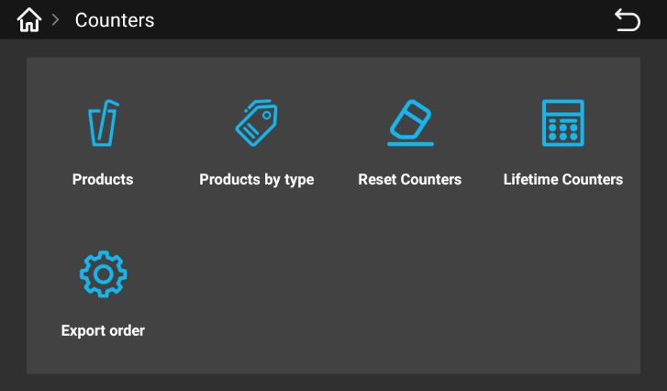
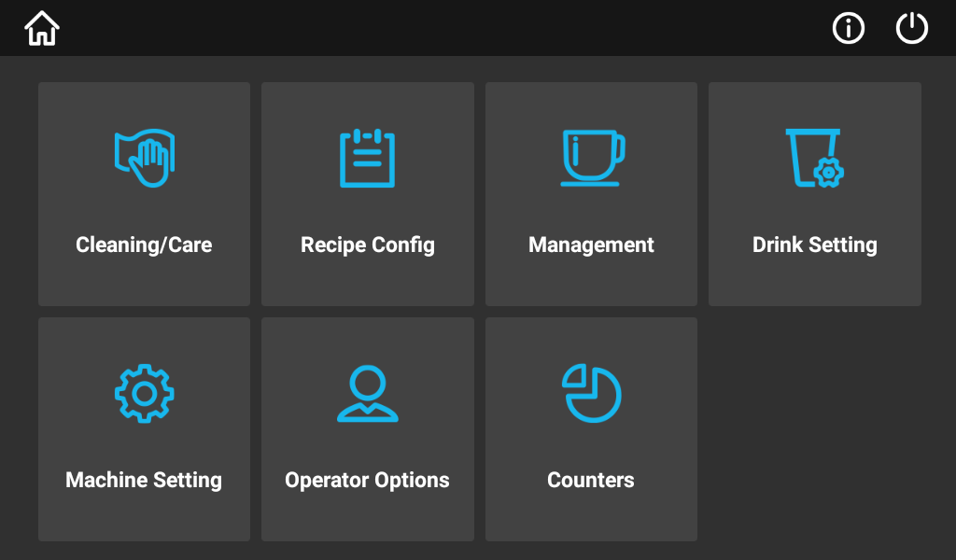

Enter the background of the machine, click "counter", the pop-up dialog box has, drink count, count by drink type, reset counter, life counter, order export function.
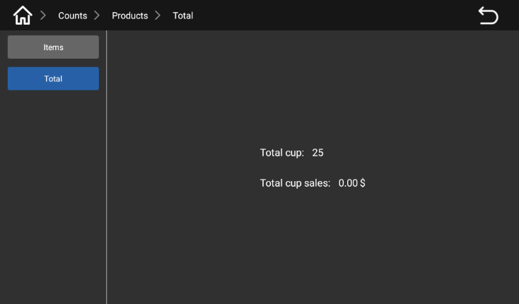
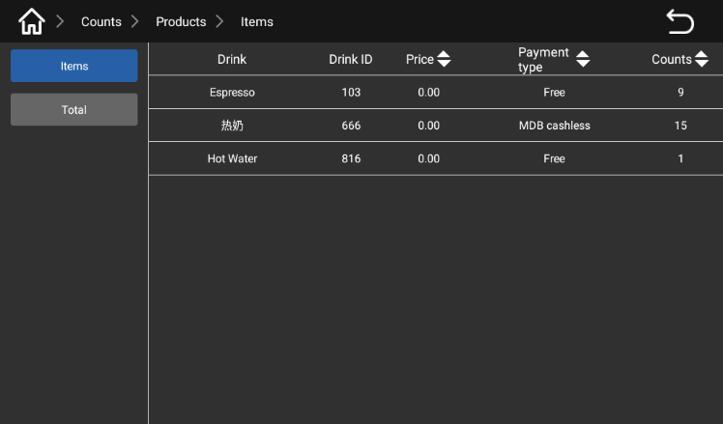

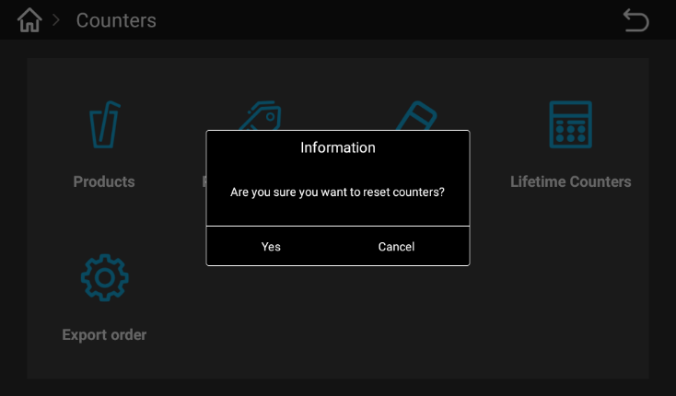
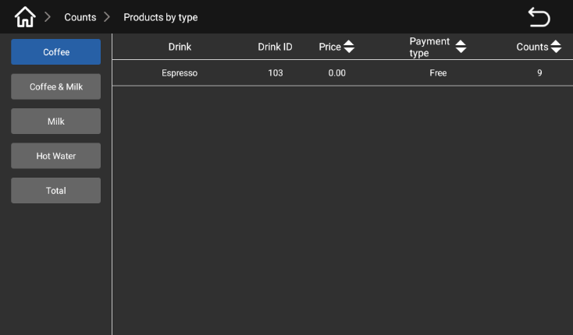
Click "Drinks", [item] Counting mode interface [All] Counting mode interface

Counting by Drink type screen Reset the counter screen
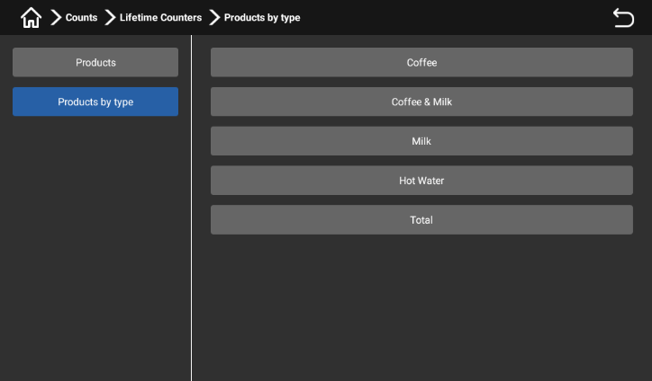
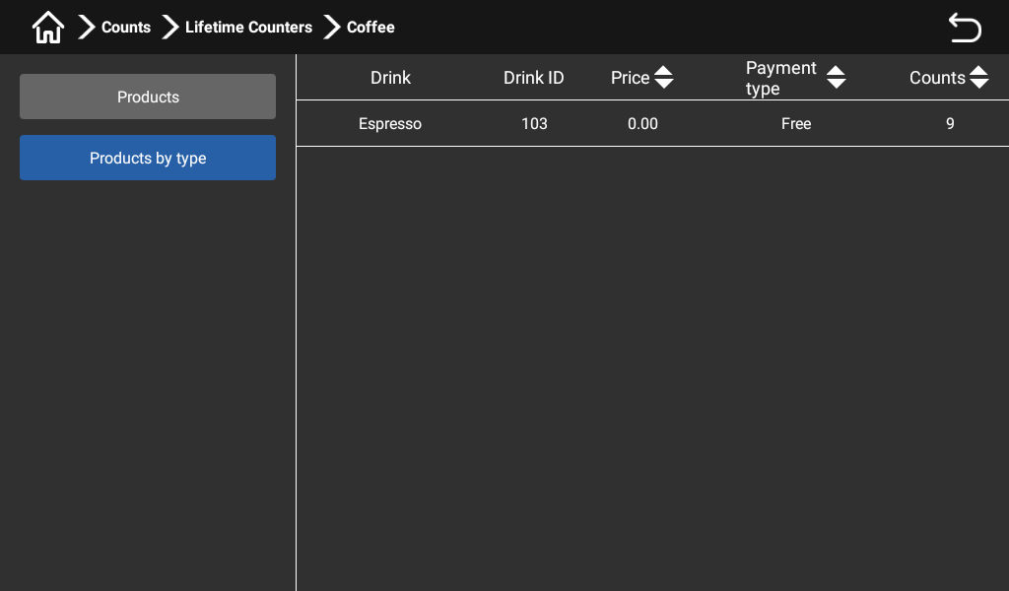

Life Counter Counts by drink type interface

diagnosis

Press and hold, the top left corner of the screen, enter your password (Tester: test9527) in the dialog box that pops up, and click "OK".
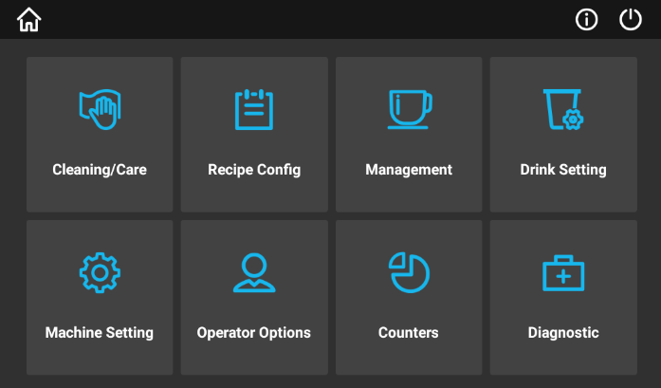
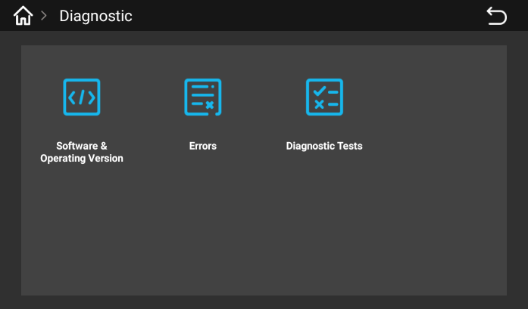

Enter the background management interface and click on "Diagnosis", the diagnostic functions include "software and operating version, fault, diagnostic test".
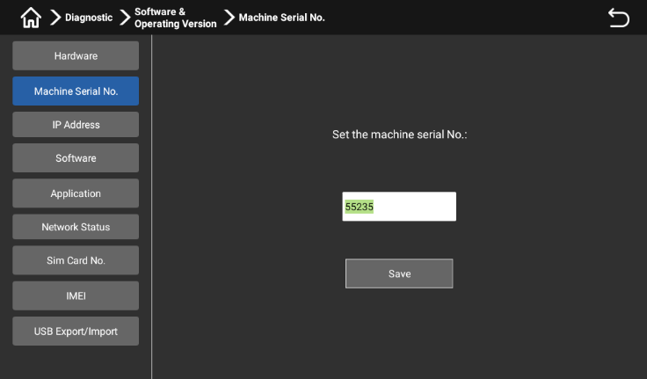
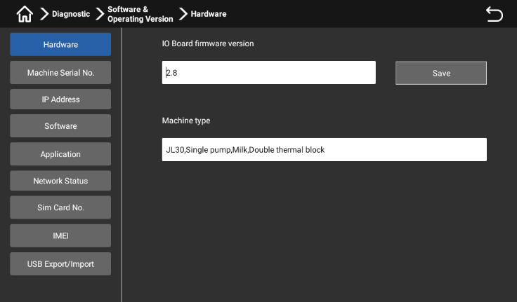

Software and operating version - Hardware: users check the hardware version of the machine here; Software and operating version - Machine Number: The user can set the machine number here.
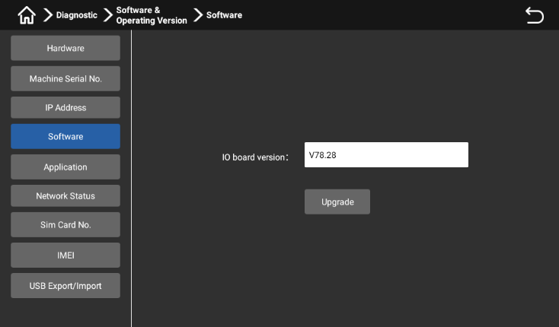
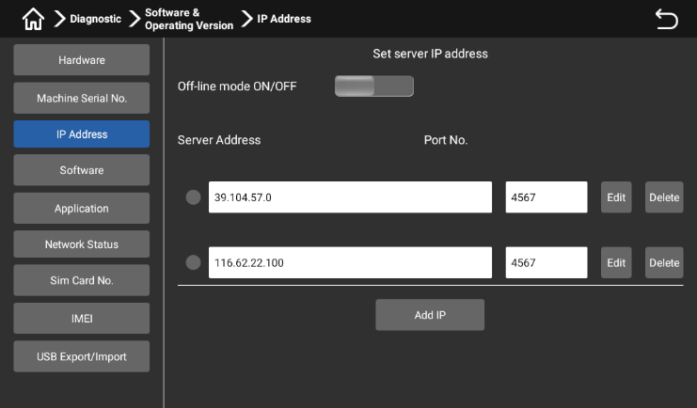

Software and operating version -IP Address: Users can turn on/off offline mode and set IP address here; Software and Operation version - Software: Users can check and update the IO board firmware version here.
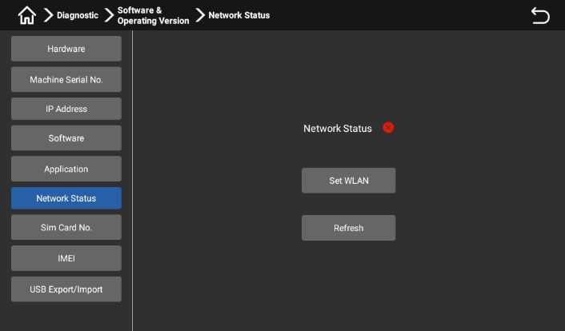
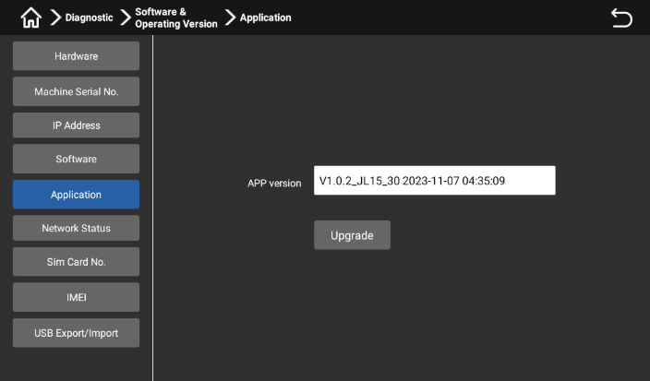

Software and Operating Versions - Applications: Users can check and update application versions here; Software and Operational version - Network Status: Users can check and set up networks here.

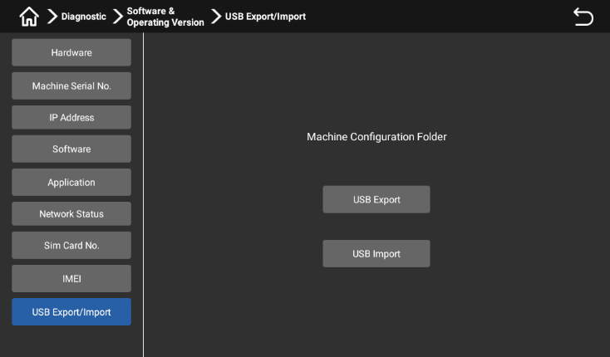
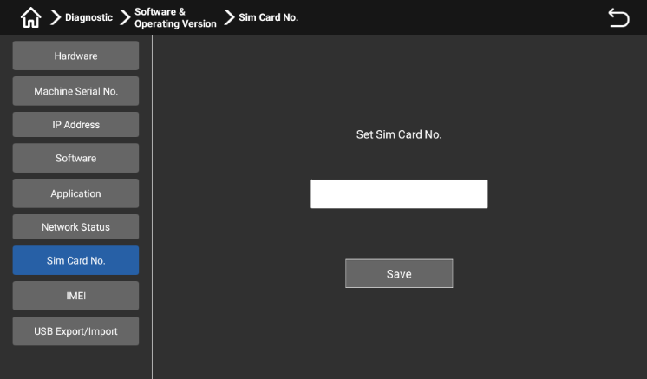

Software and operating version -SIM Card Number: Users can set the SIM card number here (hardware support required); Software and operating version -IMEI: Users can set their IMEI here (hardware support required); Software and operational version -USB Export/Import: Users can export/import machine configurations via USB for analysis or updating applications.

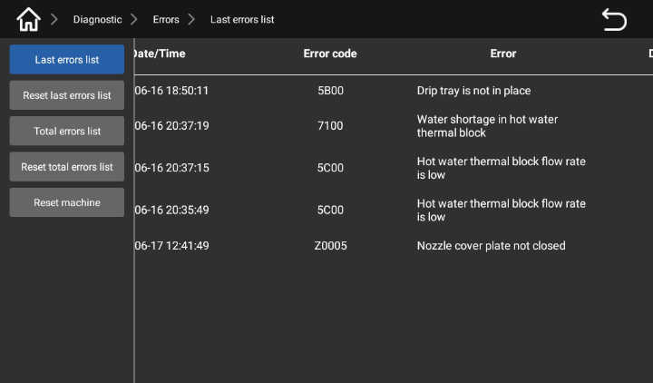
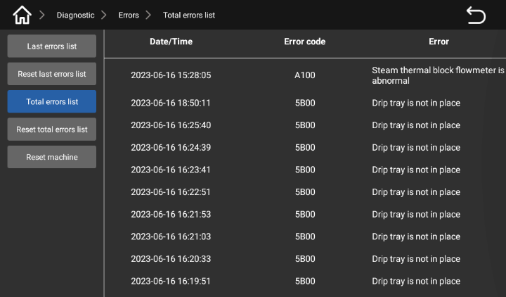

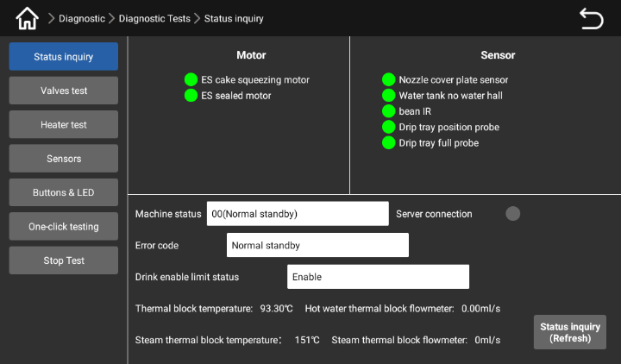
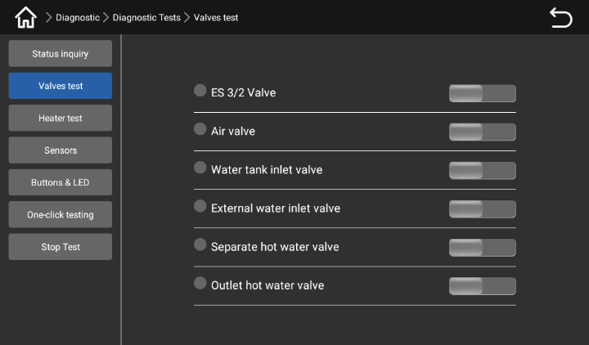
Faults - Current faults list: Users can query the current faults; Fault - Total fault list: users can query all the fault information.

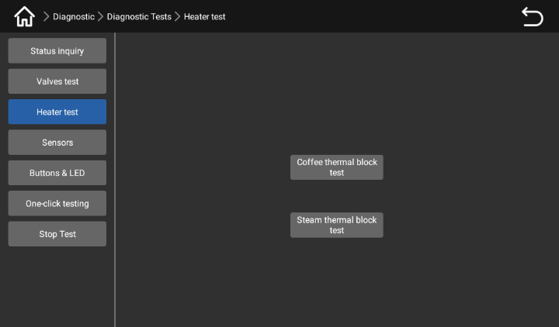
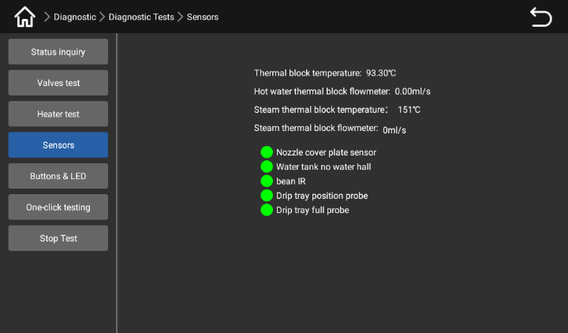
Diagnostic test - Status query: Users can check the status of all parts of the machine here; Diagnostic test - Valve test: Here the user can test all the valves within the machine.

Diagnostic Test - Heater test: Users can test all boilers in the machine here; Diagnostic test - Sensor: The user can test all the sensors inside the machine here.

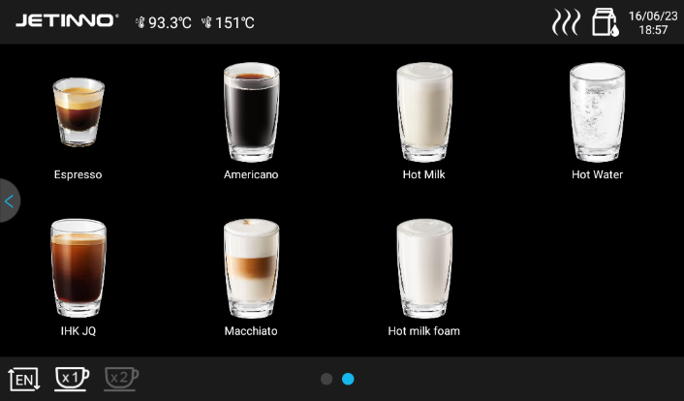
Machine status

Press and hold, the top left corner of the screen, enter the password (Administrator: jn9527) in the dialog box that pops up, and click "OK" to enter the background of the machine.
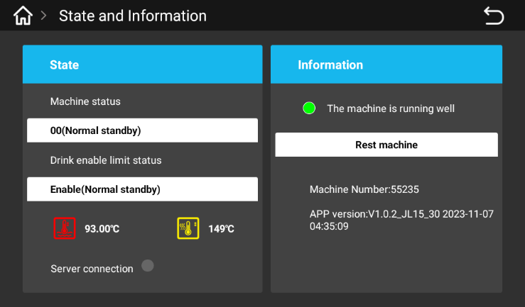

Click the icon to enter the "Status Details", press the prompt on the machine, and proceed with processing; Click the "machine reset" button, the machine will automatically redetect.

First run

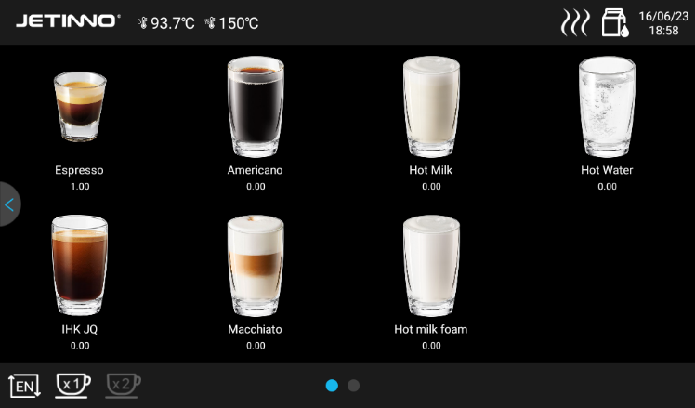
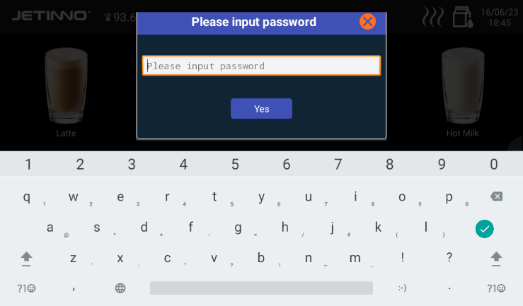
Set up machine configuration - model number

Press and hold, in the upper left corner of the screen, enter the password (Administrator: jn9527, Operation and maintenance personnel: 9527) in the dialog box that pops up, and click "OK".
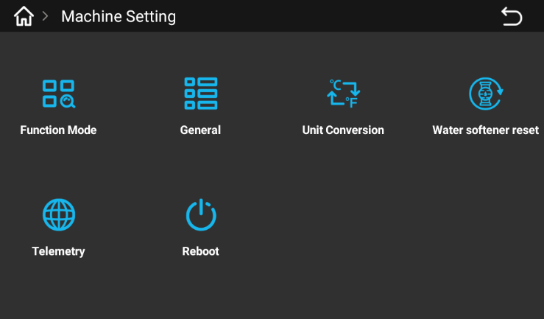

Select [Machine Set -- up] - In the interface that pops up, click [Function Mode].

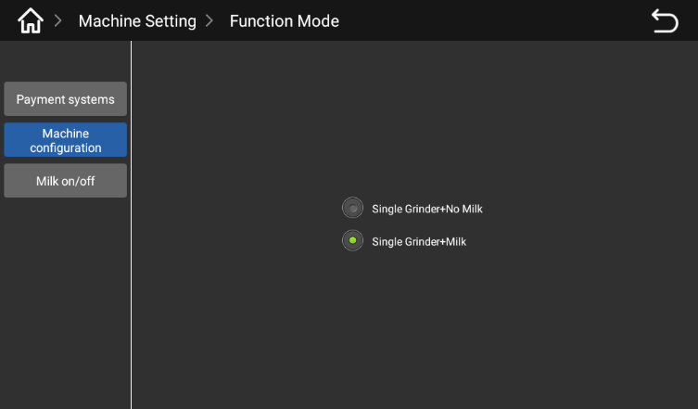
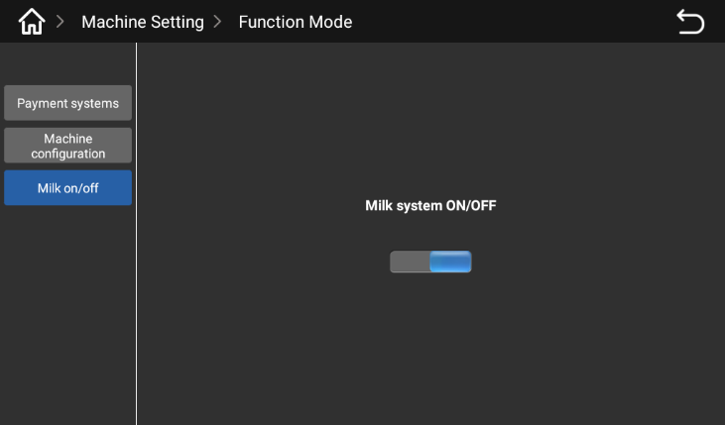

Select the corresponding machine model in the pop-up interface; With fresh milk model, click "fresh milk function on/off" to open the button in the pop-up interface.

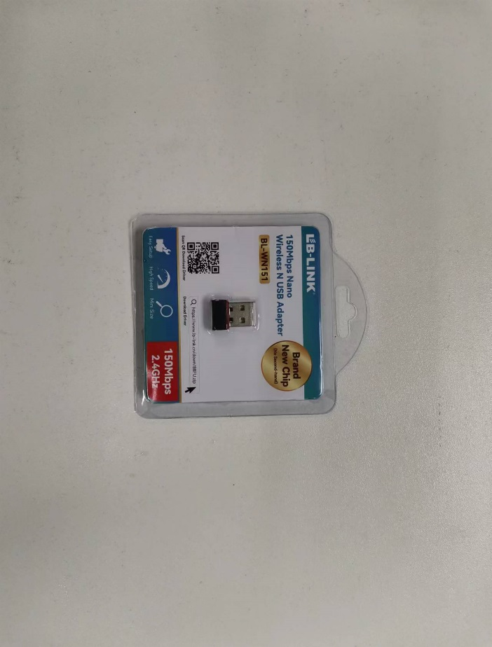
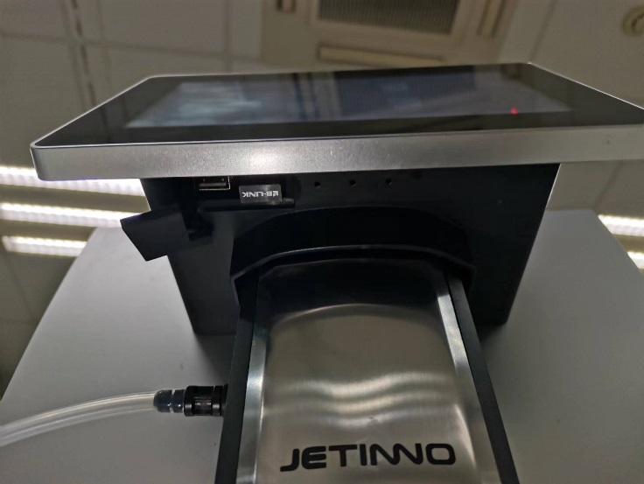
Connect to the Internet

Inside the machine, take out the signal receiver. Open the glue plug under the display, insert the signal receiver into the USB port on the right, and the machine will automatically restart. When the machine restarts, long press, the top left corner of the screen, enter the password: jn9527 in the pop-up dialog box, and click "OK".
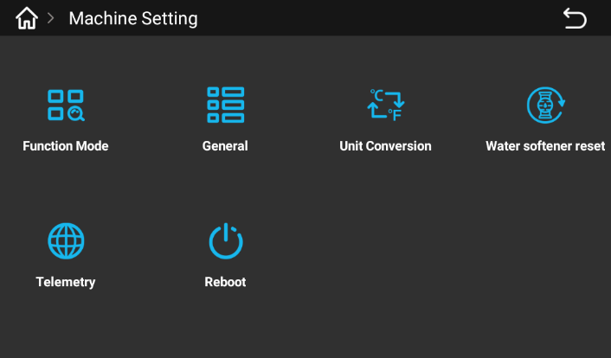
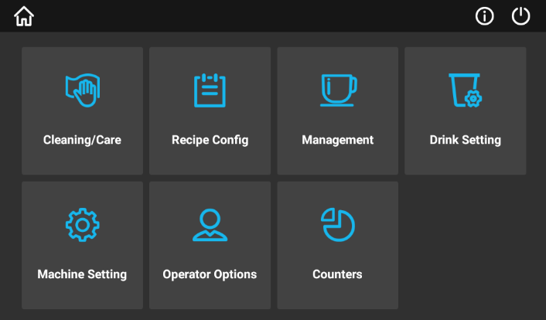

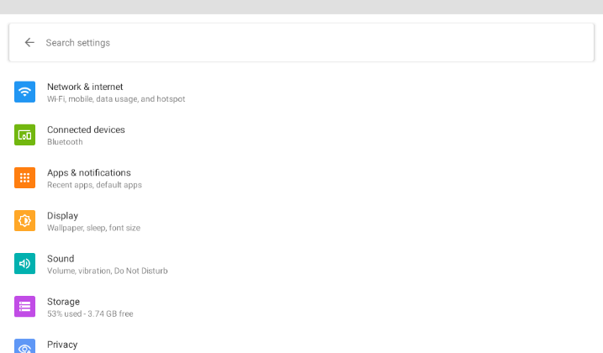
Enter the background of the machine, click "Machine Settings", select [Remote detection] in the pop-up interface, and click the icon of "Remote detection".
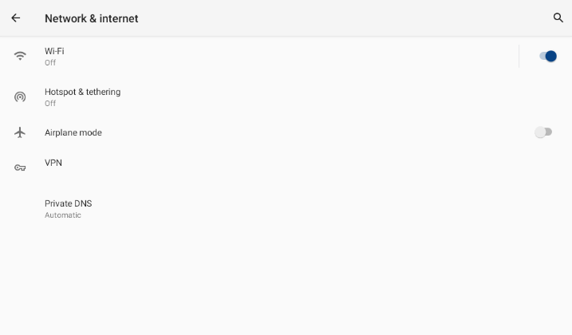

Click "Network and Internet", select "WLAN" in the pop-up interface, turn on the switch, the machine will automatically search for WIFI.

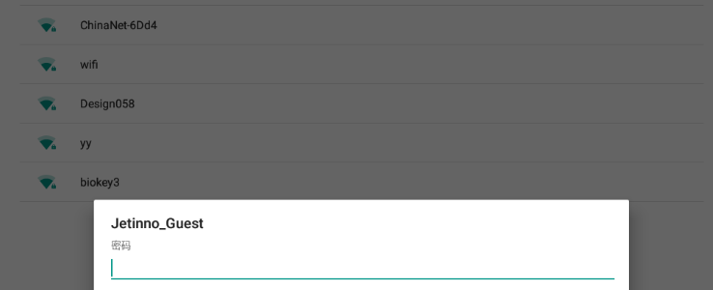
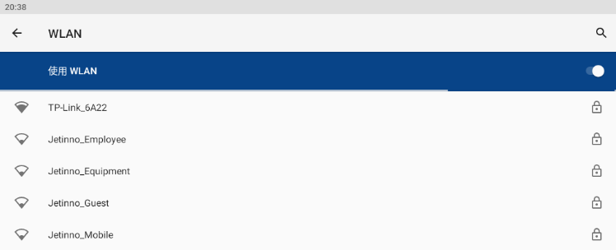

Click the name of the WIFI you want to connect to, enter your password in the pop-up dialog box, and tap "Connect".
Note: When using a single machine, you do not need to connect to the network, you can ignore this step.

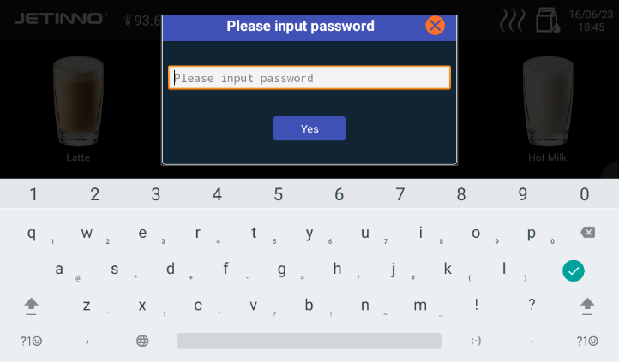
Connect to the server

Long press, top left corner of screen, enter password (Tester: test9527) and click "OK". Go to the admin screen in the background and click on "Diagnose".
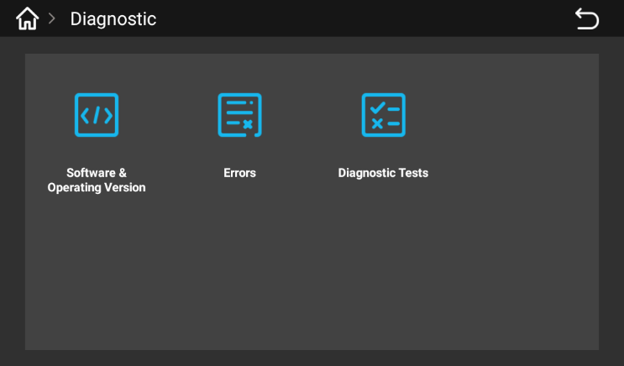
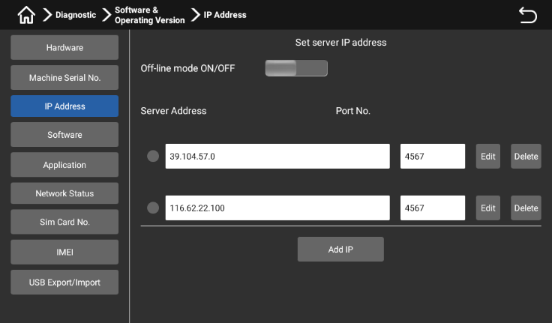

Click "Software and Operating Version" -> "IP Address" to turn off offline mode. Click the Back button in the top right corner of the screen to return to the upper level interface.

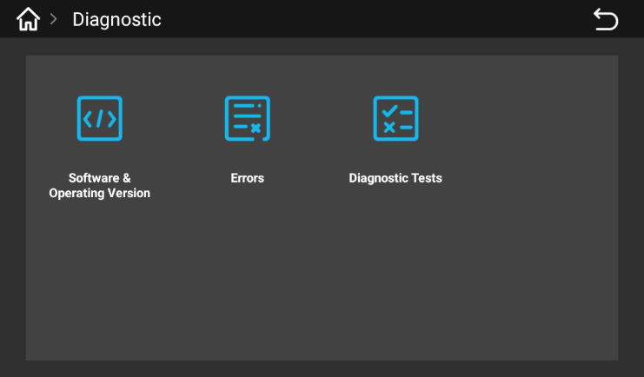
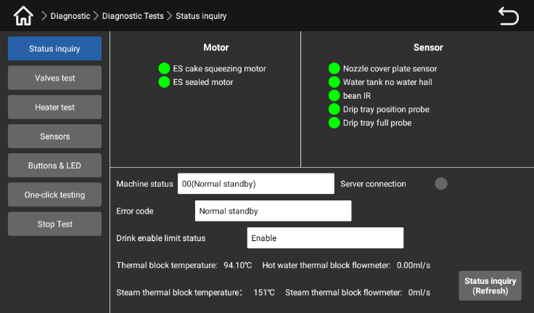



Click "Diagnostic Test" -> "Status Query" to view: Service connection configuration; Service connection status, indicating successful connection to the server; Service connection status: failed to connect to the server; If the server fails to be connected, contact your local carrier or agent to check whether the server is registered.
Note: If you use a single machine, you do not need to connect to the server. You can skip this step.

Fill the material box
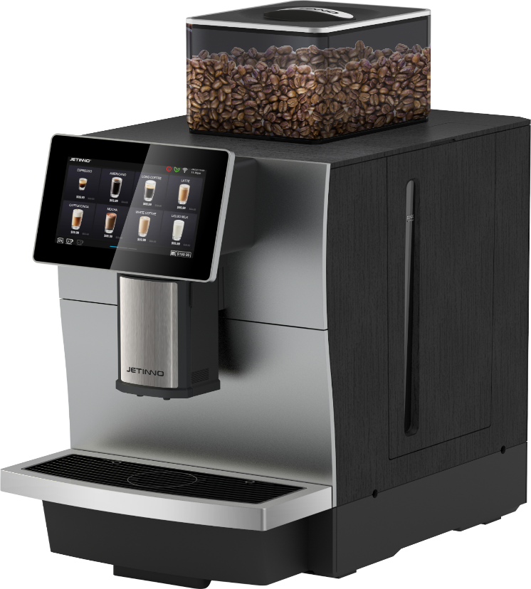
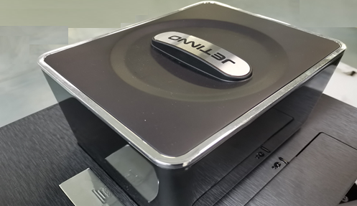

- Wear a mask and disposable edible gloves;
- Remove the lid of the coffee bean box and add coffee beans; After adding coffee beans, put the lid on the coffee bean box;
Coffee bean Coffee bean

The grinder's spinning disk can cause injury.
Do not put your hand into the coffee bean trough while the coffee machine is turned on.

Adding foreign objects may cause the grinder to clog or damage the grinding equipment!
Do not load any items other than coffee beans into the coffee bean trough.

Fill the milk carton in the refrigerator with milk
It is Important to:
Contaminated milk tubes can be a health hazard. It must be cleaned after installation, commissioning, or running again. Follow the cleaning procedure guided by the display screen before the initial output of the drink.
Insert the refrigerator door key and turn it clockwise to open the refrigerator door;
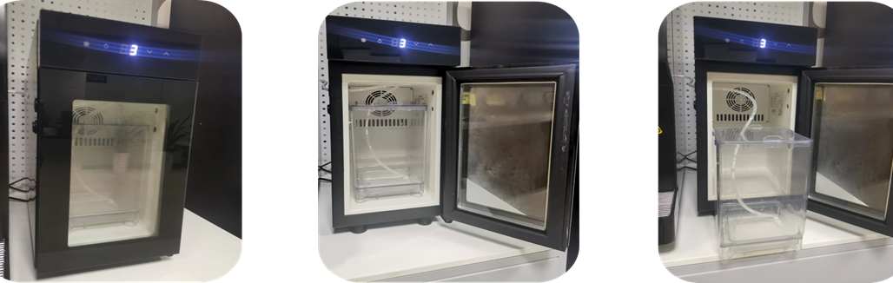

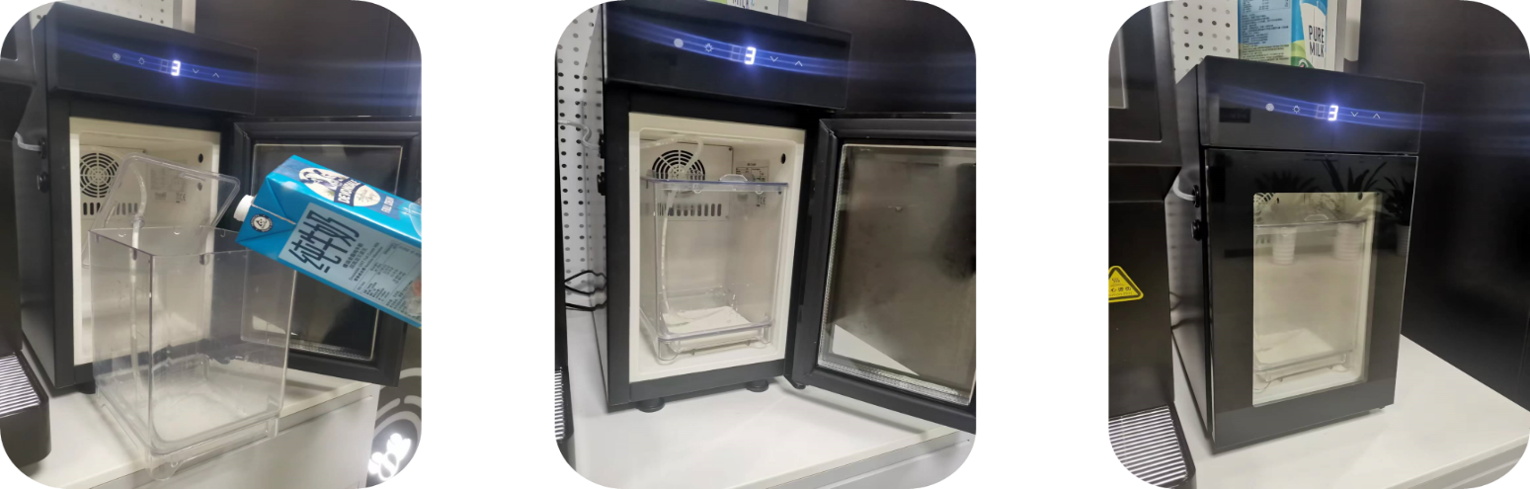

Remove the milk carton, pour the milk into the carton, place the carton in the refrigerator and close the refrigerator door;
Determine that the thermostat is 3 to 5 degrees and adjust the thermostat Settings accordingly; Fill the milk jug with pre-cooled milk if necessary, and finally close the freezer door.
Skip this step without fresh milk.

Debugging and Calibration
Calibrate Grinder calibration

Before adjusting the grinder, prepare the (low magnitude) electronic scale!
Grinder thickness adjustment
First calibration Empty coffee beans (empty grinder residue before adjusting grinder)

Grinder thickness adjustment method
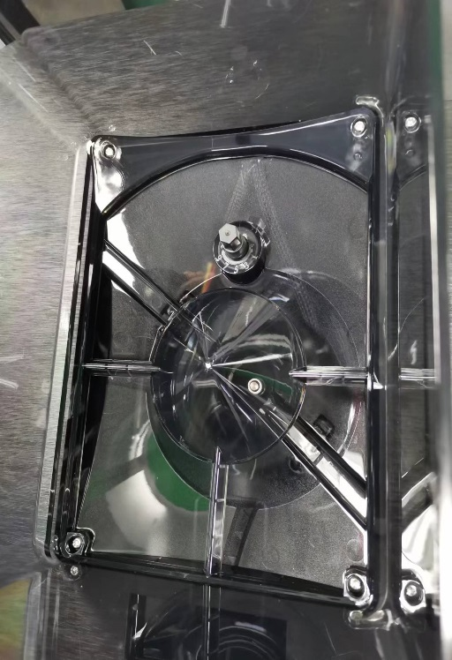

- Open the coffee bean box and find the grinder coarseness adjustment knob.
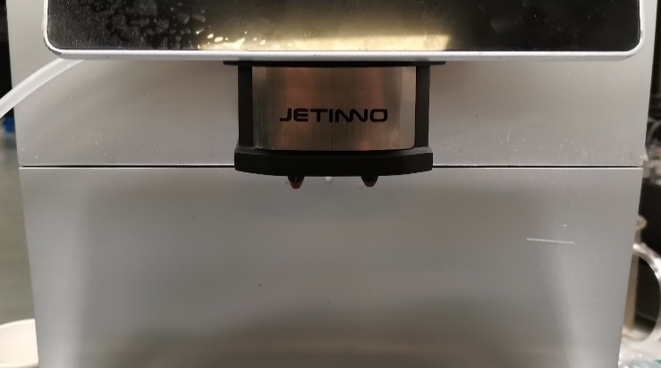
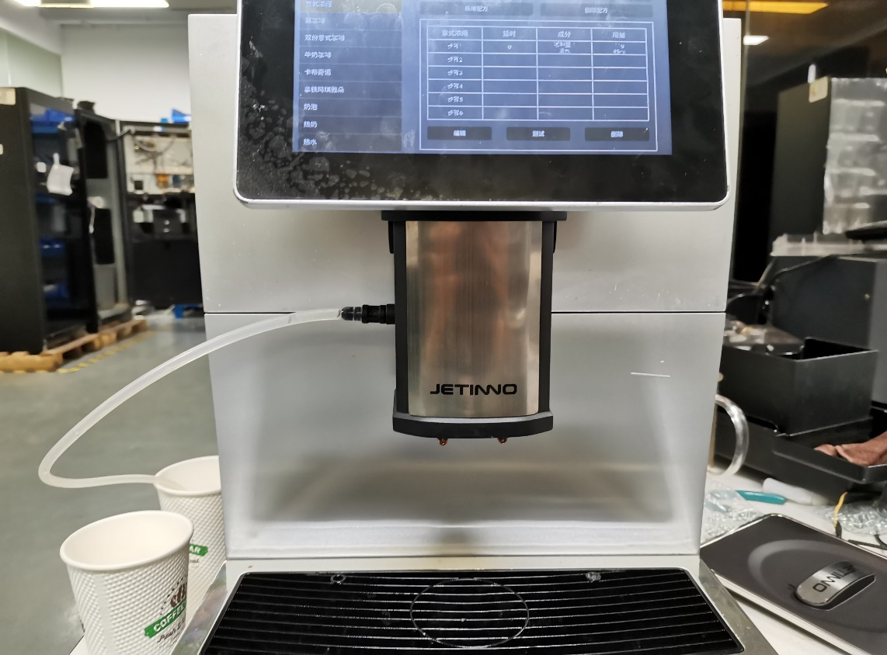

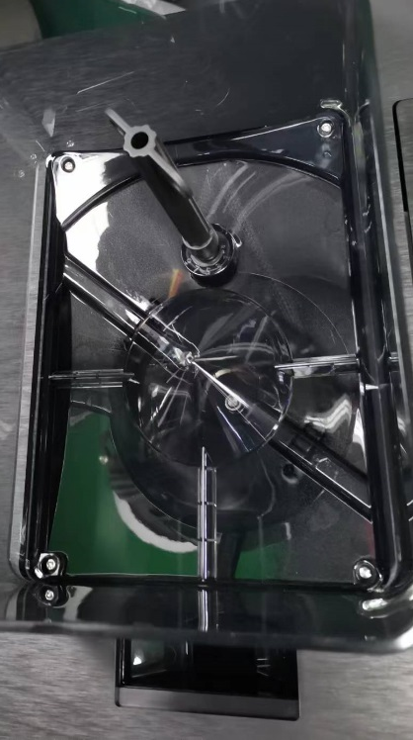
- Lift the coffee out of the mouth to the highest position and pull the water tray outwards to remove the water tray.
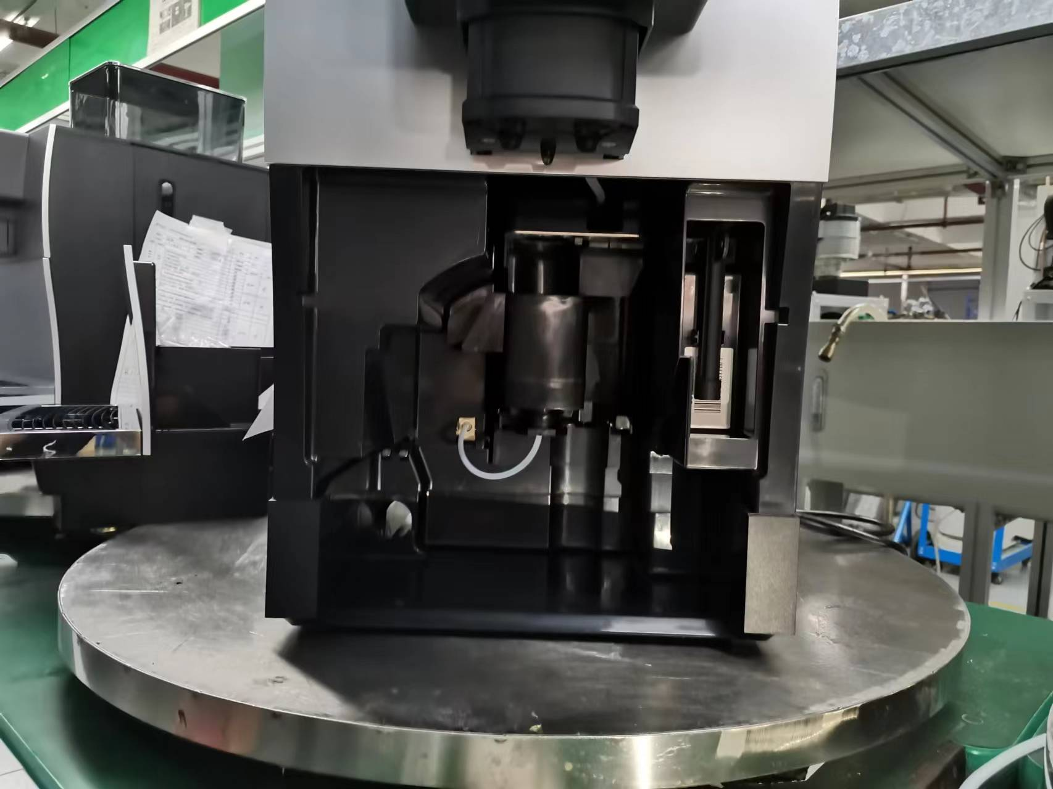

- Take out the coffee grinder grinding powder thickness adjustment tool (grinder adjustment key), insert the tool into the adjustment knob, press down to the end to rotate. In the absence of beans, first turn the knob counterclockwise to the disc fit position (can not be twisted under normal torque until), then turn the knob clockwise to between 5-6, as a reference thickness position (the thickness of the general espresso), and then fine-tune according to the thickness of the powder during the calibration process (clockwise is to adjust the thickness, counterclockwise is to adjust the fine).

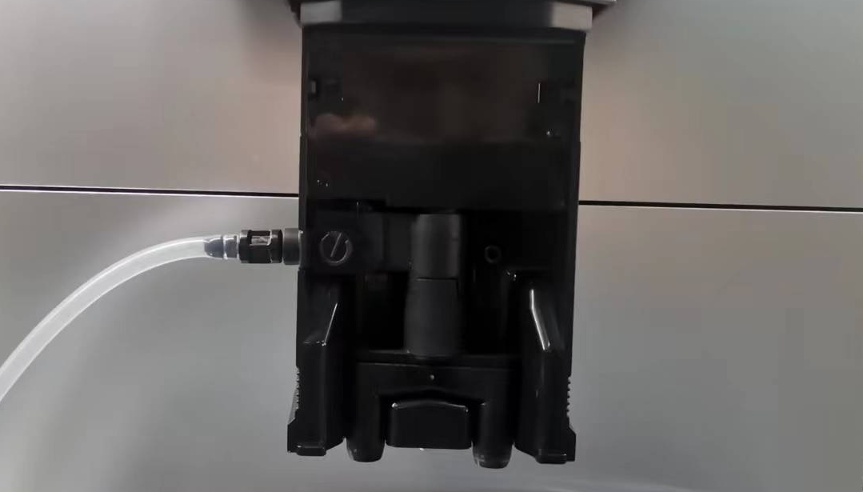
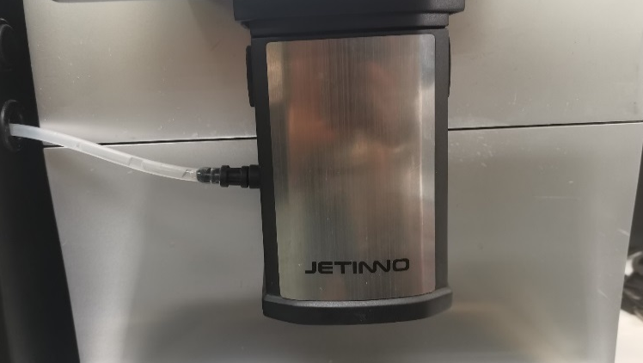
Warm milk and foam temperature regulation

Press and hold the latches on both sides of the outlet mouth and remove the outlet mouth so that you can see the adjustment knob, turn it clockwise by hand and the warm milk and foam temperature will increase, and turn it counterclockwise to decrease. It is recommended to fine tune and not adjust the amount too much.

Grinder Calibration
Calibration is the software for the physical characteristics of the instant box and the physical characteristics of the powder, the degree of roasting of the coffee beans, etc. Electronic scales and cups need to be prepared before calibration.
It is Important to:
No calibration will cause the machine powder abnormal!
Before calibration, it is necessary to discharge the material once, fill the grinder, milk tube, and the outlet is not satisfied, which will lead to inaccurate calibration.

Note Note:
Because each part or powder has different physical characteristics, it is necessary to recalibrate each time the cartridge, motor or coffee beans from different manufacturers, and the amount of material in the cartridge should be greater than 1/3 of the volume of the cartridge when calibrated.
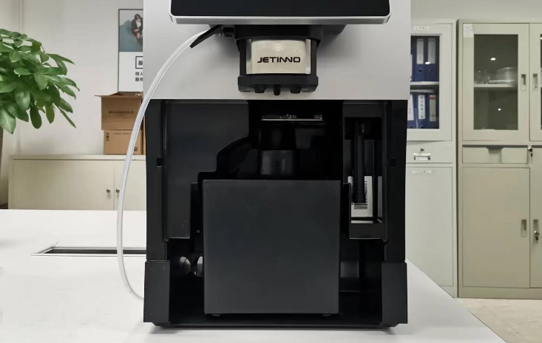
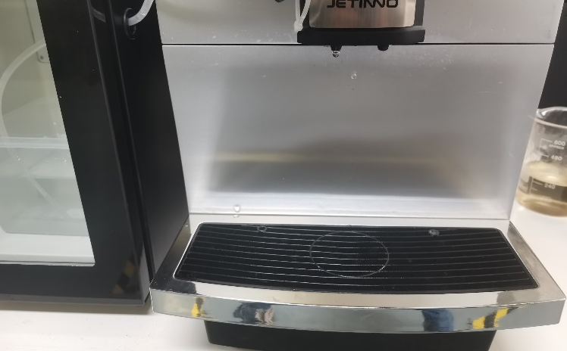
Grinder calibration steps:

- Lift the coffee nozzle up to the highest position, pull the water tray outwards, and remove the water tray; Remove the coffee grounds box from the water tray and place it inside the machine.

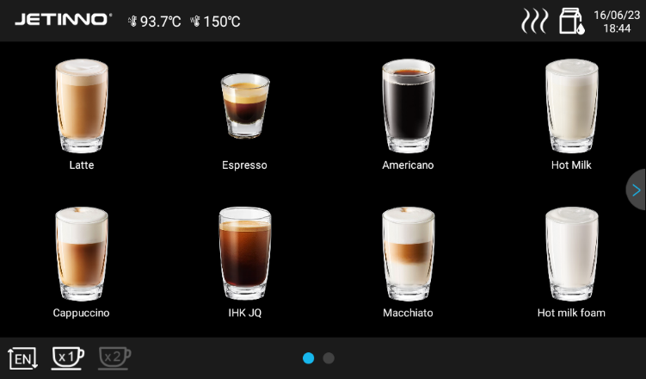
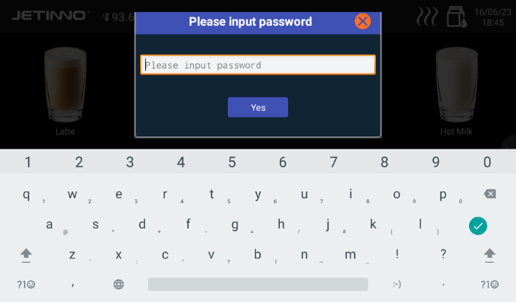

2, Long press, the top left corner of the screen, enter the password (administrator: jn9527) in the dialog box that pops up, and click "OK".
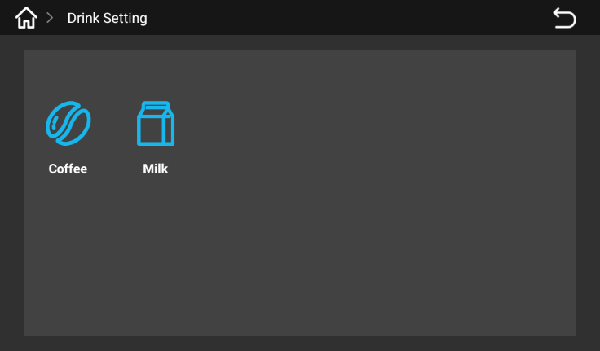

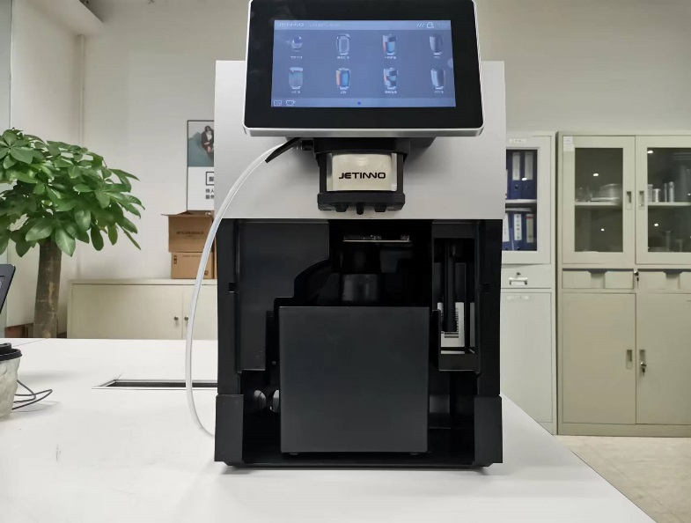
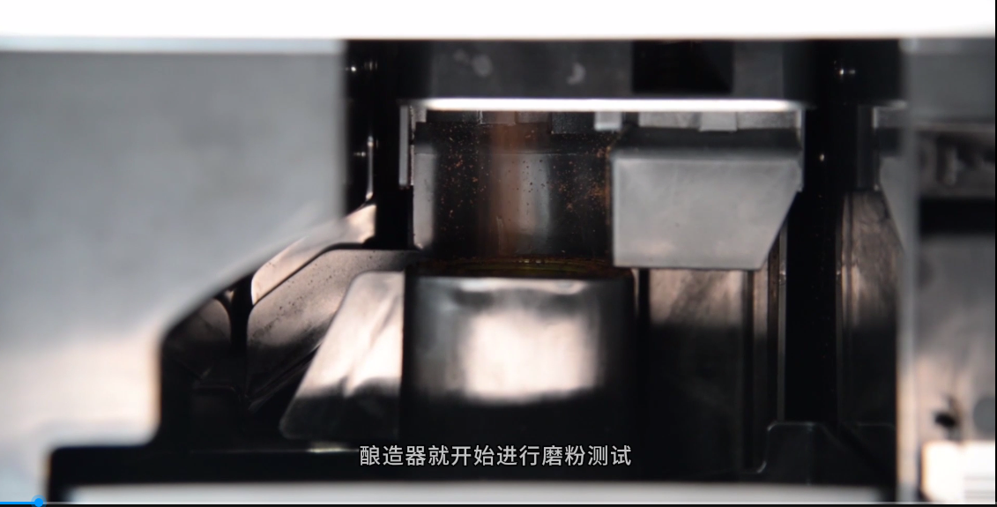
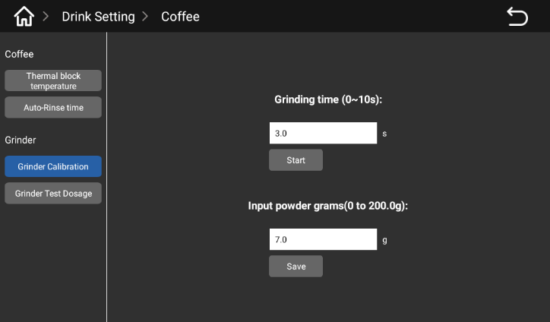

- Click the "Grinder Calibration" option, -> "Start" button, the grinder starts to work, the grinder out of the powder mouth, will produce coffee powder, and finally drop into the coffee grounds box.

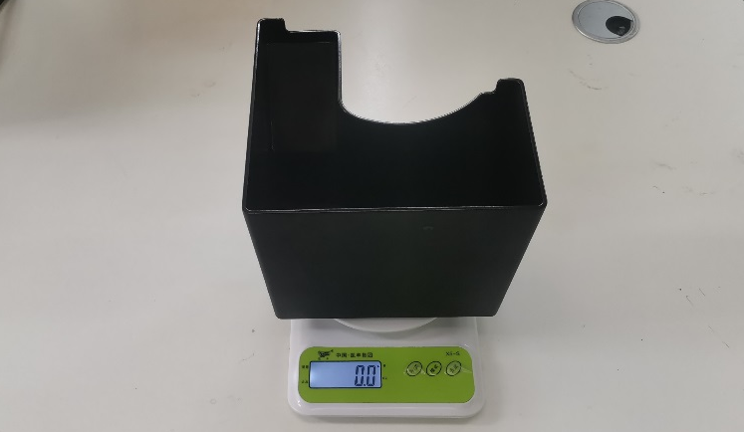
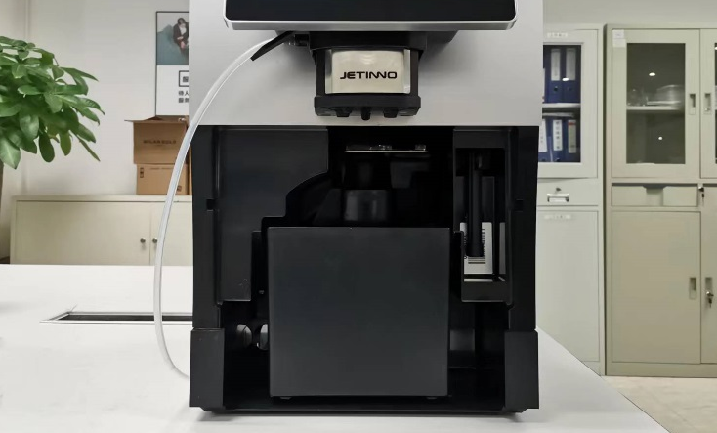

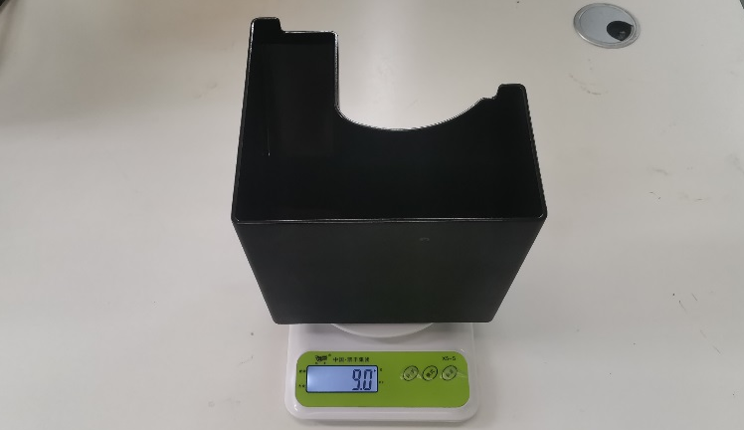
5, take out the coffee grounds box in the machine, put it on the electronic scale "zero/peel", put the coffee grounds box "zero/peel" back inside the machine, and then click the "Start" button on the screen. Wait for the end of the grinding process of the grinder -- the ground coffee is weighed.
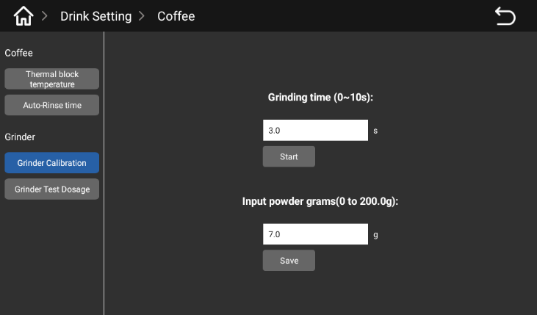

- Take out the coffee ground box and weigh it on the electronic scale. Fill in the weight value in the space below "Enter the amount of ground coffee (0 to 200.0g)" and click "Save".

Fresh milk calibration
Different milk sources produce different concentrations, and fresh milk needs to be calibrated. The calibration should ensure that the milk source is sufficient.

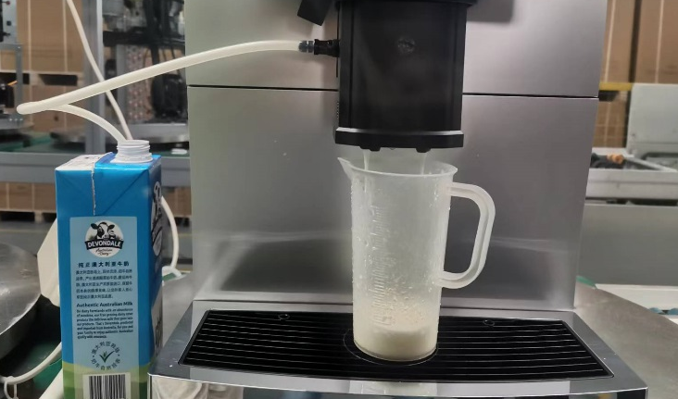
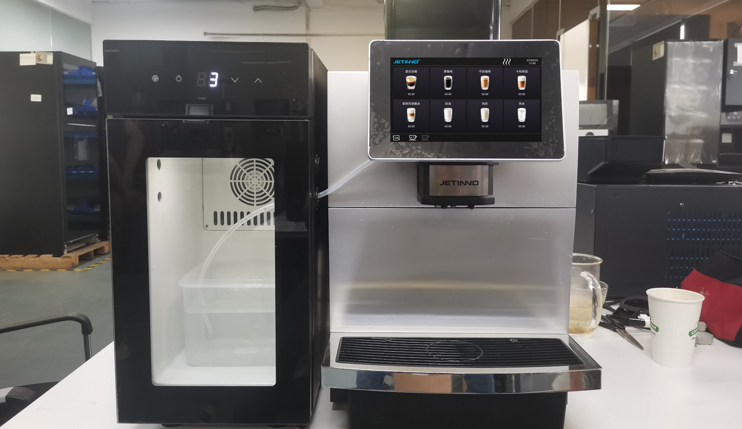
Calibration steps for fresh milk:

- Place the empty measuring cup under the outlet mouth and move the outlet mouth down to the lowest to lowest position.
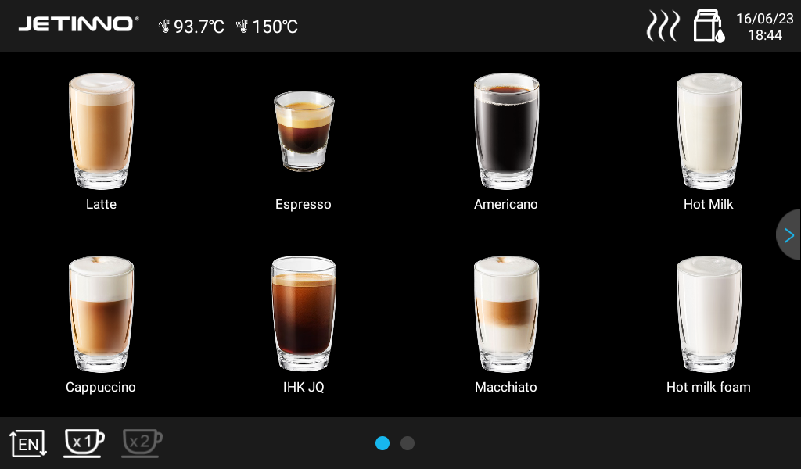
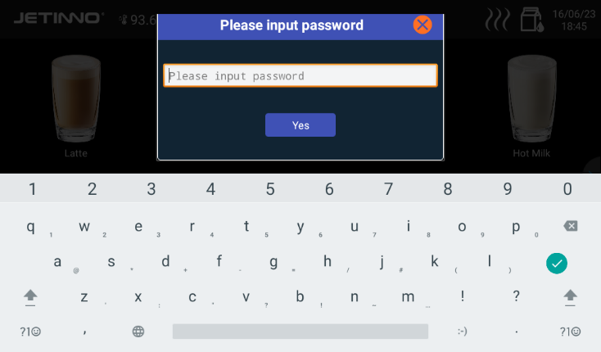

2, Long press, in the upper left corner of the screen, enter the password (administrator: jn9527) in the pop-up dialog box, and click "OK".
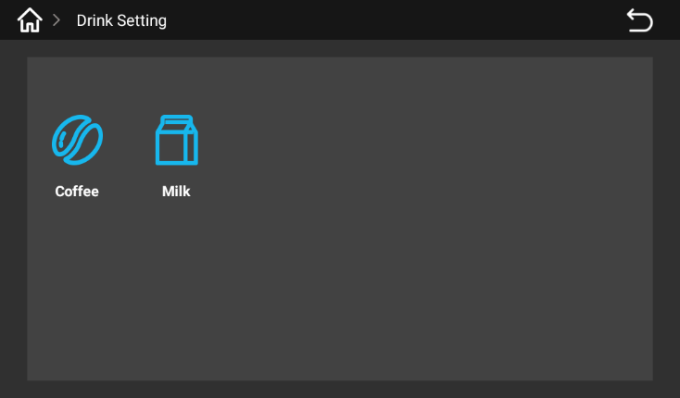

3, machine management background. Click on "Beverage Management" and select "Fresh Milk".
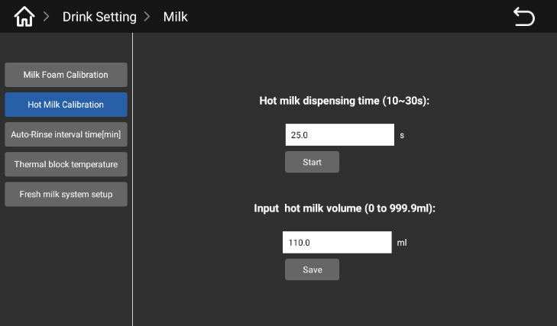
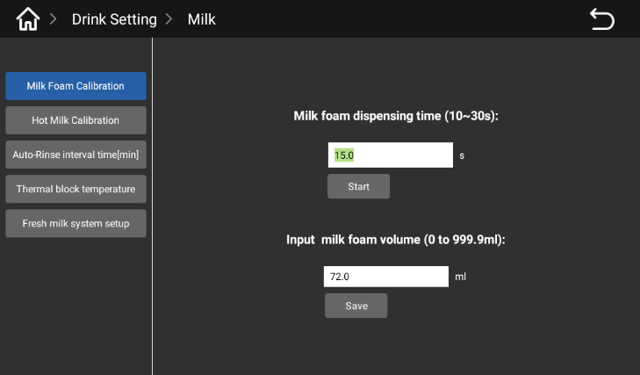

4. Click the "Foam Calibration or Hot Milk Calibration" option and -> click the "Start" button to discard the foam or hot milk. Replace with an empty measuring cup and place it under the outlet mouth; Click the "Start" button again. When the milk foam or hot milk is finished, take off the measuring cup with the milk foam or hot milk, read the value of the milk foam or hot milk in the measuring cup with eye level, input the read value in the blank under [Input milk foam capacity] / [Input hot milk amount], and click "Save".

Product testing and adjustment
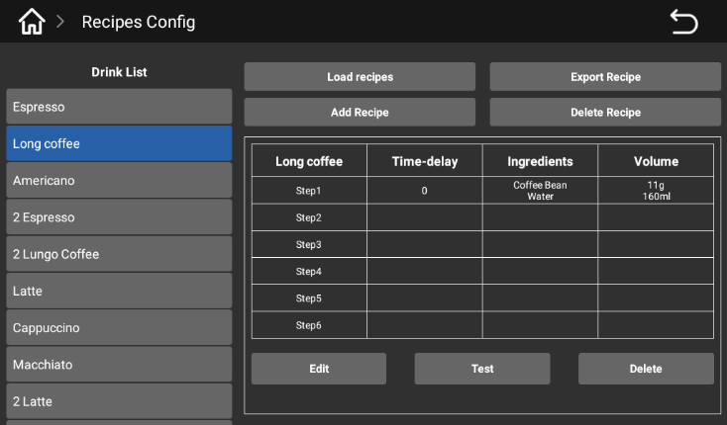
Click [Formula configuration], there is the machine factory default formula in the pop-up interface; Select the corresponding drink and the corresponding formula will pop up. Click [Test] to test the drink directly; The formula interface has the functions of [import recipe], [Export recipe], [Add recipe], [Delete recipe], [Edit], [Test] and [Delete]. Enter the formula interface, select the product, click [Edit], you can adjust the product's water, feed amount, hot milk and milk foam discharge time (determine the amount of milk by the length of time). After modification [save], you can directly click [Test].

Formula interface, select the product. After selecting the product, click [Edit] to adjust the amount of water and material

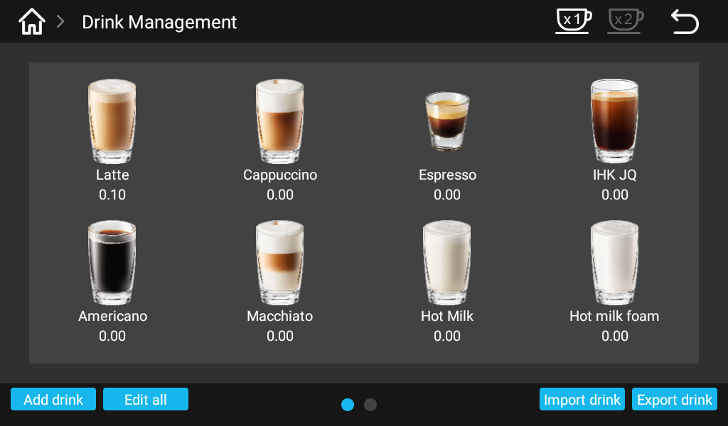
Drink Management

Enter the background of the machine, click "Beverage management", enter the beverage management interface, you can choose single/double cups of drinks, add products, batch operation, import products, export products.
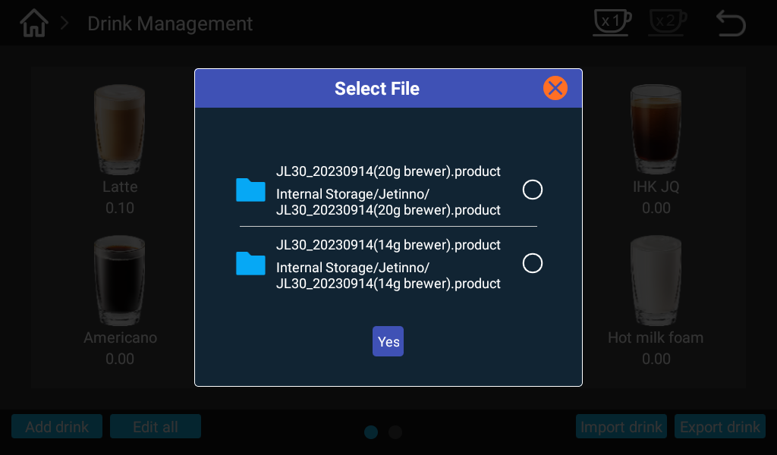
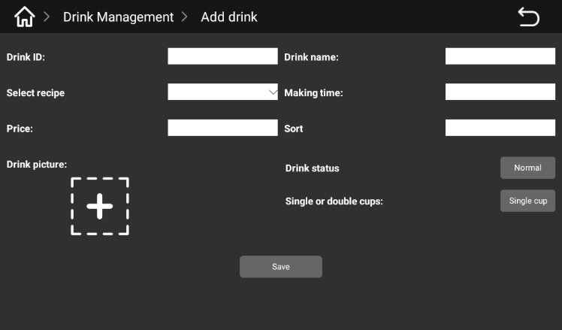

Click to add a drink or product picture, you can edit the product: product ID (the entered ID needs to be consistent with the ID on the server), product name, product recipe, production time, price setting, sorting, normal display, removal, single cup, double cup, save function;
Click Import drink, select the corresponding file in the pop-up dialog box, and click "OK"; The operation is displayed successfully, indicating that the drink has been imported; Click Export drinks, select all drinks or a drink in the pop-up interface, click "OK". Note: The exported drink file is named after the point in time. The exported drink file is located on this site, under the File Manager.
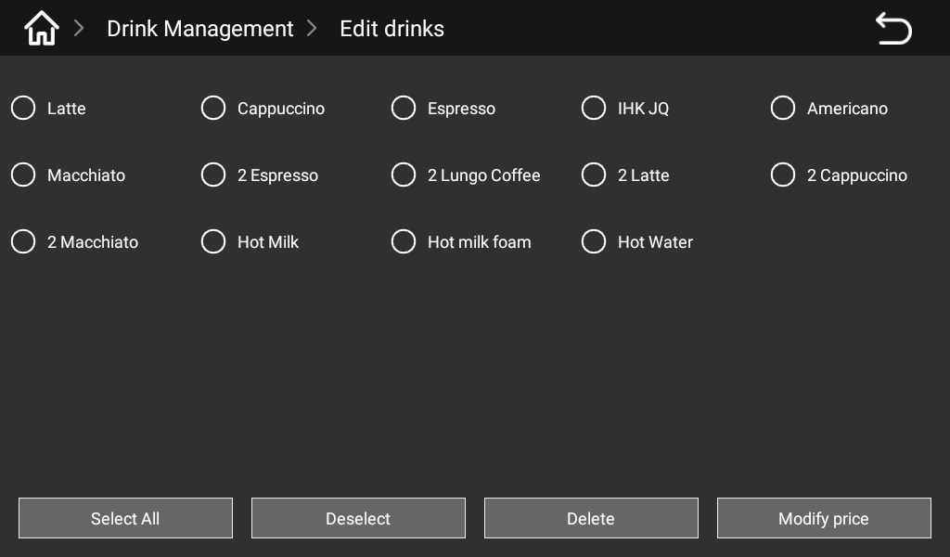
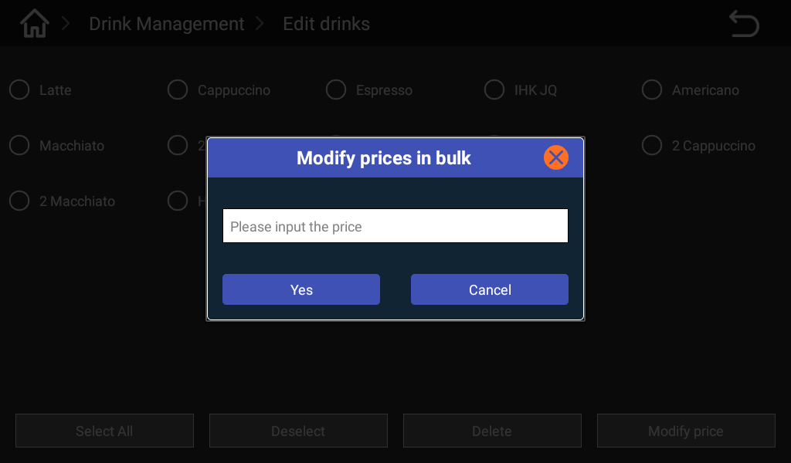

Click "Batch operation" to edit all products: you can select, reverse select, delete, set the price, select a product can be single tick. Click set price, enter the product price in the pop-up dialog box, click "OK" to confirm.

Set the selling mode
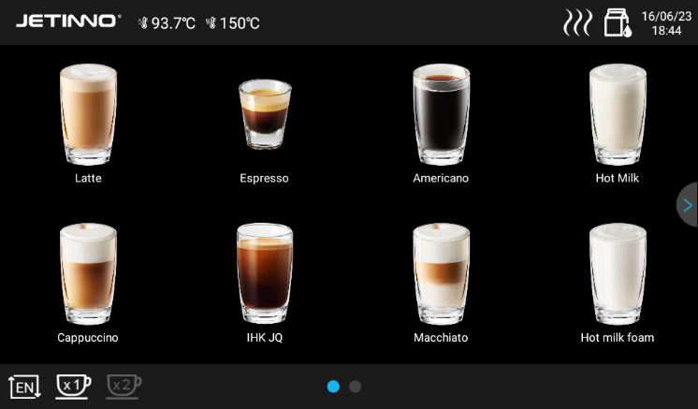
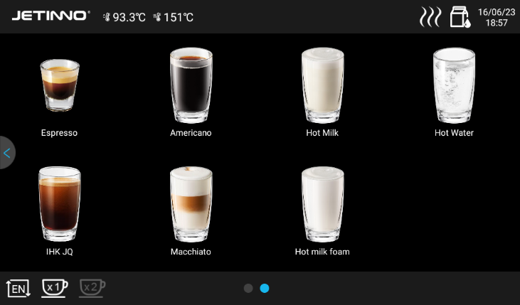

Free mode sales interface - no product price payment mode sales interface - product price
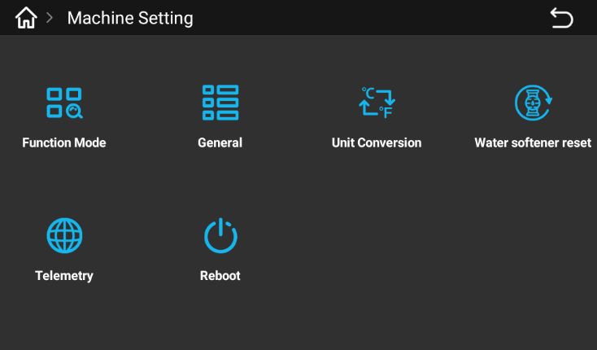

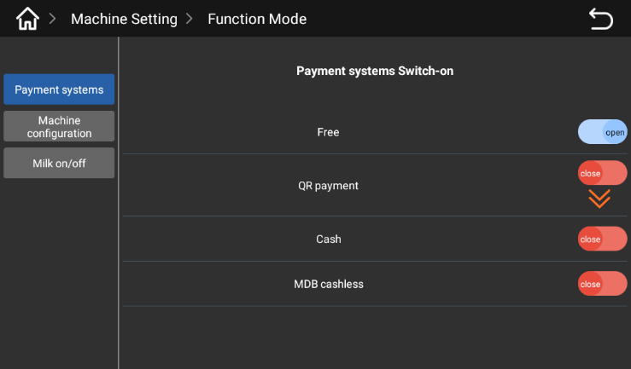
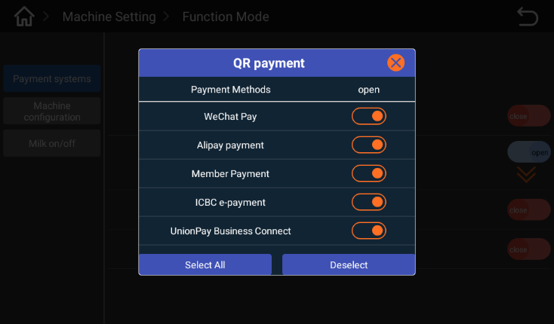
Enter the background of the machine, click "Machine Settings", select [function mode] in the pop-up interface, and click the icon of "function mode".

Click the "Payment System" button to set the payment method in the pop-up interface; 【 Free 】 switch is enabled, which means free mode is open, no payment is required; Yes, when scanning code to pay, [free] switch off, click [QR code], select the payment method in the pop-up dialog box (enable wechat Pay and Alipay Pay). The MDB cash and MDB card switch is enabled, which means that the payment mode is on. The machine can produce products only after the payment is successful.

Offline mode switch: in free mode, the offline mode should be turned on; In the payment mode, the offline mode should be turned off to ensure the normal network. Refer to the previous section 5.3 to connect to the server.

Drink Making
Place the cup under the mouth and select a drink from the display;
Adjust the taste in the touch screen, there are five levels, and then confirm;
Free mode or set to 0 yuan, the machine directly make drinks, will not pop up, scan the code payment interface; In payment mode, the machine will appear several payment methods (paper money, coins, credit card payment);
After the payment is successful, the machine automatically starts to make drinks; .
After the beverage is finished, the touch screen interface will have a reminder that the beverage is finished;
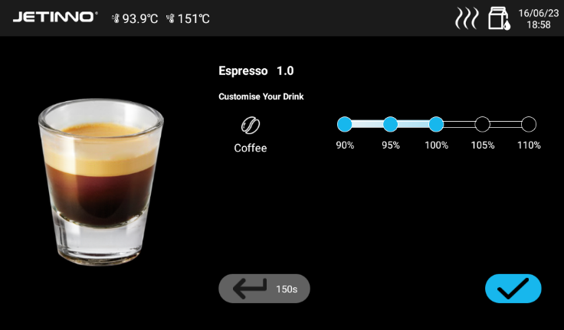

Set the date/time
When the user receives that the machine is connected to the network, the machine system time is automatically updated to sync with the local time; When a single machine is used and not connected to the network, the system time cannot be updated and synchronized with the local time, and the local time needs to be manually set. The specific method is as follows:
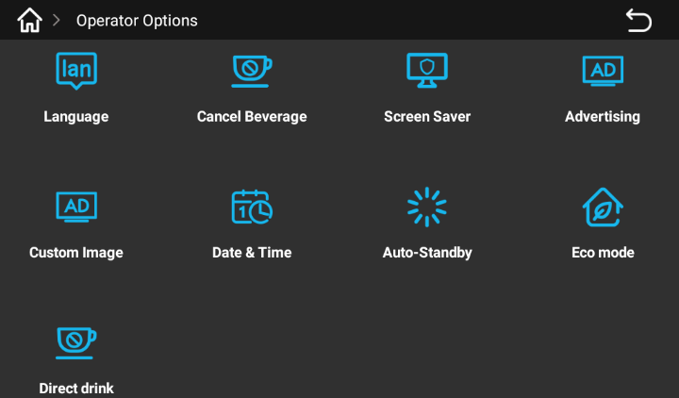
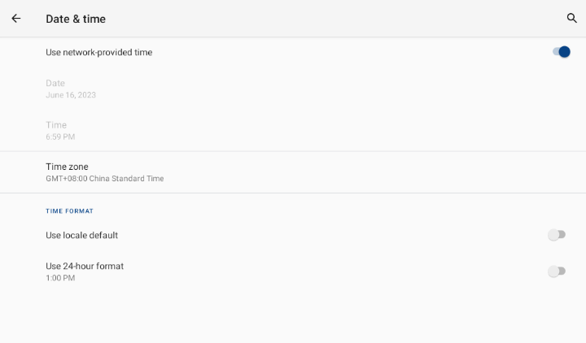

Enter the background of the machine, click "Operator Options - > Date and time" in the pop-up interface, use the time switch provided by the network to open, the system time will automatically update and synchronize with the local time;
When the machine is used in a single machine and the network is not connected, click "Use the time switch provided by the network" to close, and manually "Set date", "set time" and "select time zone". Click the shortcut key to return to the main interface of Android, and click the "Coffee" icon to enter the APP again.

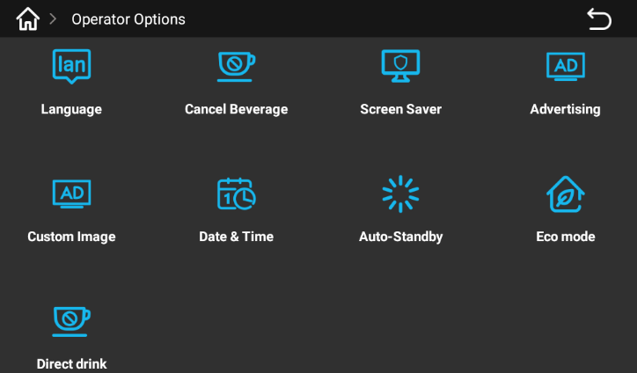
Operator option

The operator option has the following functions: language switch, Stop Drink Making, Screensaver, AD, General picture Down, Date Time, Auto, etc., Eco Mode, Direct Drink Making.
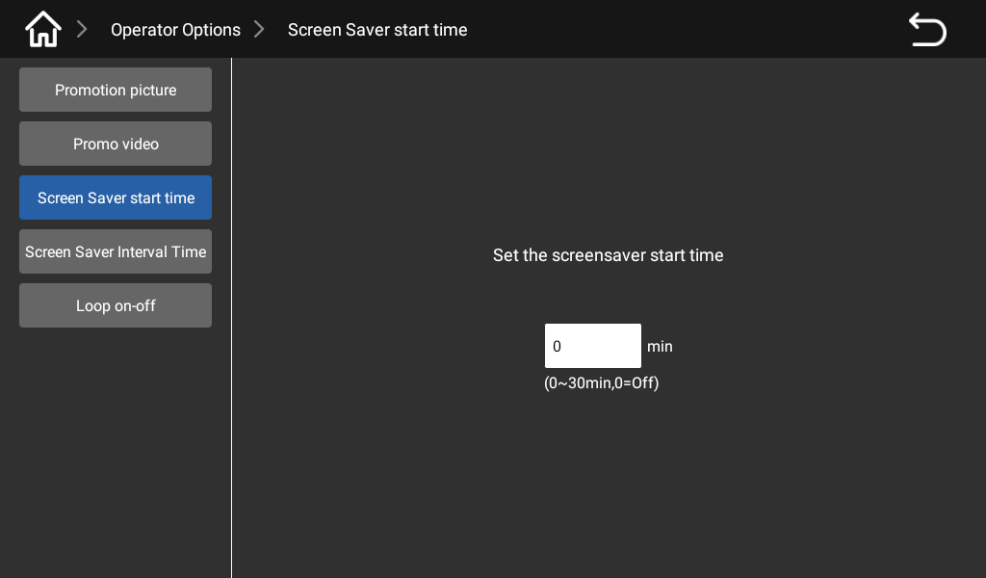
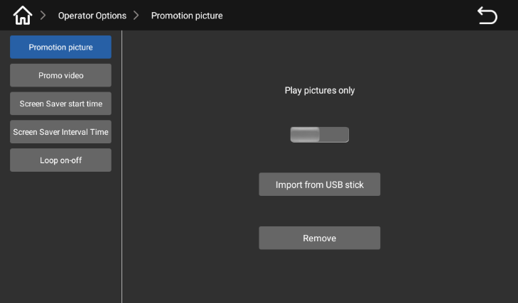

Play the picture switch on, the prepared picture to the U disk, the U disk into the USB port (USB port at the bottom left bottom of the display), import the picture from the U disk; Set the screen saver startup time range to 0-30 minutes.
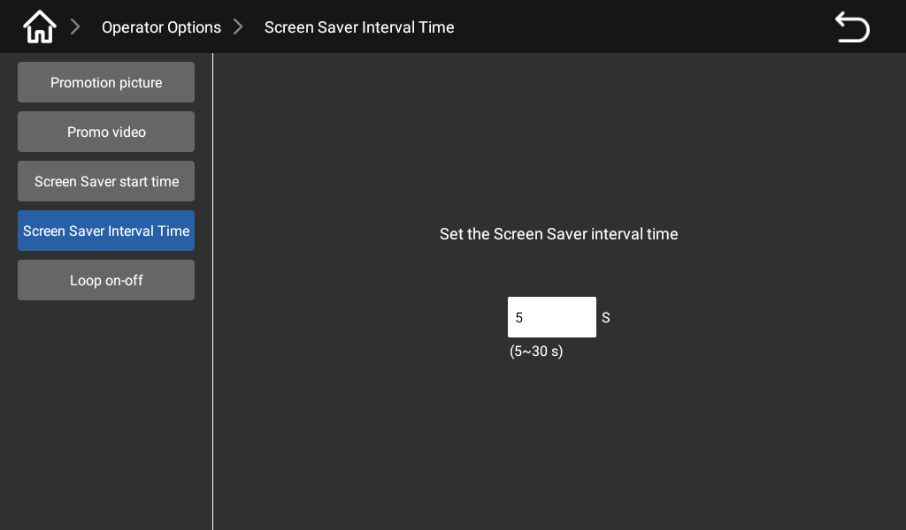
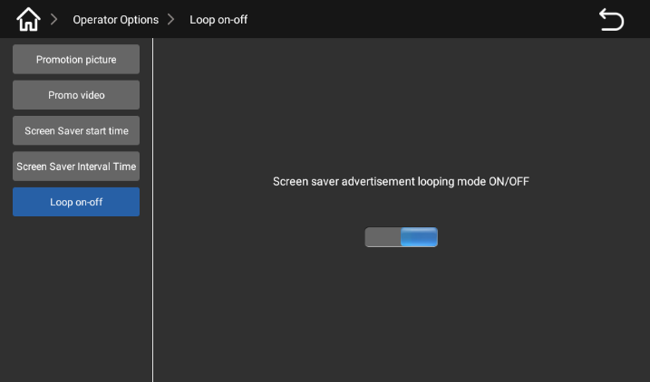

Set, screen saver wheel insertion interval (5-30 seconds); Click, wheel casting switch, enter the screen saver advertising cycle mode on/off, open can wheel casting.
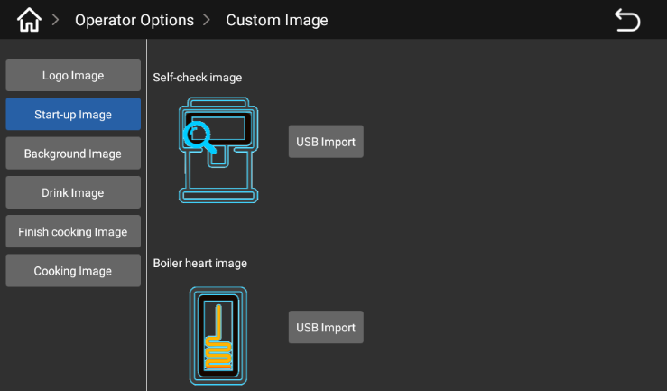
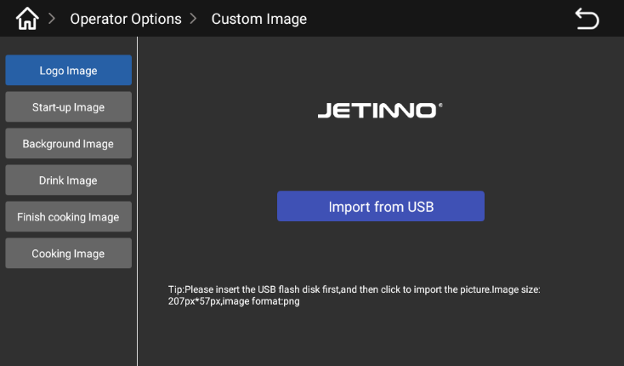

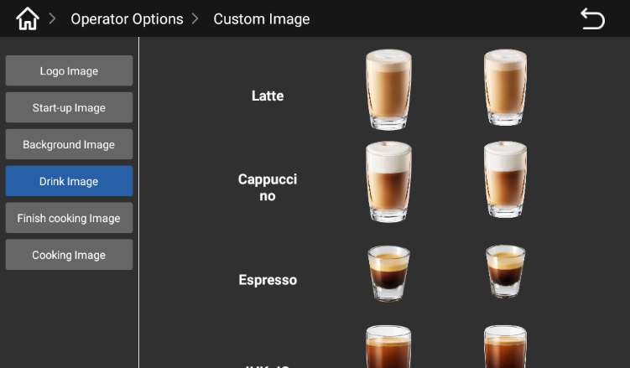
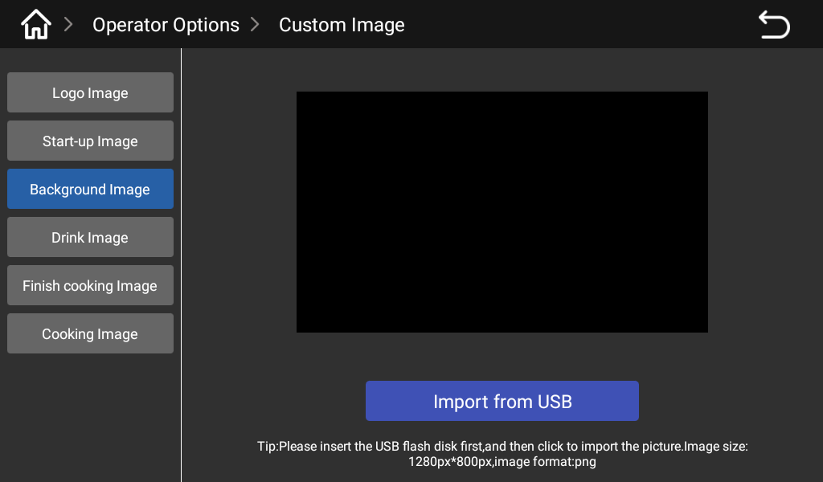
According to the requirements (picture size, name) on the computer to make "logo, start the picture", and then test them to the U disk, and then the U disk into the USB port (USB port at the bottom left bottom of the display), import the picture from the U disk;

First according to the requirements (picture size, naming) in the computer to make "background picture, drink picture", and then put them into the U disk, and then the U disk into the USB port (USB port at the bottom left bottom of the display), import pictures from the U disk;
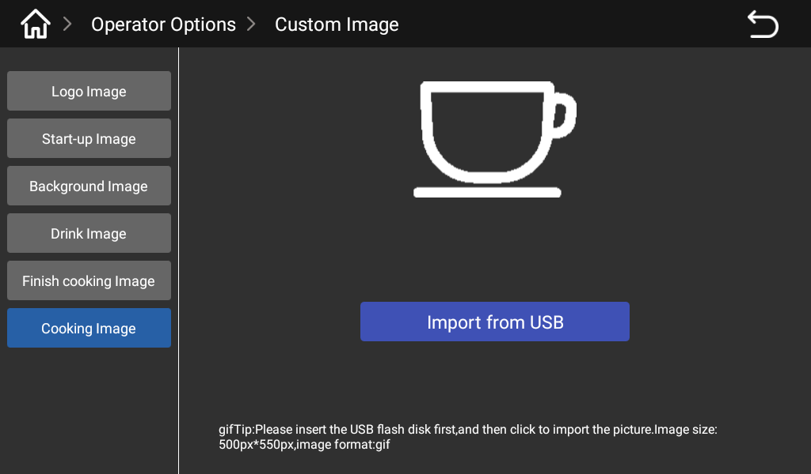
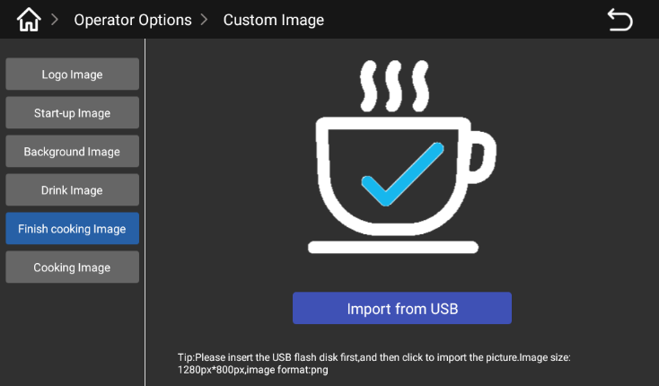

First according to the requirements (picture size, naming) in the computer to make the "end of the production picture, production picture", and then put them into the U disk, and then the U disk into the USB port (USB port at the bottom left bottom of the display), from the U disk into the picture;

Clear Pictures

Coffee grounds box

Heat may cause damage.
Do not use the dishwasher to clean the powder residue box.
► Remove the coffee grounds box from the machine.
► Empty the coffee grounds box and clean it.
► Dry or wipe the powder grounds box and push it back into the machine until it reaches the innermost position.
The machine is ready for operation.

Water tray

Push the mouth up to the highest position
Pull out the catch pan outwards.
Make sure no drink output occurs before removing the water tray.


Transport conditions

Improper transportation of a coffee machine can result in injury.
Pay attention to general health and safety instructions.
► Be sure to disconnect the drinking water source and power supply and empty the built-in water tank before changing location; To empty the water, refer to section 6.7.
► Check the ground for obstructions and bumps before changing position.

When using a stacking machine, improper transportation can cause damage to the machine.
The following points must be noted when using a trolley to change the position of the machine:
• For safety reasons, you must not push the trolley when changing its position, only drag it.
• Only drag the trolley, not the machine.
The manufacturer is not liable for damage caused by misuse of the trolley or failure to follow the instructions.

Power Off

End of run
Standby mode
In standby mode, the machine is still powered on.
Do not disassemble the case.
Power off the machine before performing repair work.
► If it has not yet started, start the machine cleaning in the background management of the machine (cleaning will start).
► Daily and weekly cleaning as needed.
► Empty and clean the water catch dish.
See the "Cleaning" section for specific data.
After the automatic cleaning is completed, close the door and small door of the machine and unplug the power plug.

Long downtime (more than 1 week)
In case of extended downtime, such as corporate holidays, the coffee machine and other ancillary equipment must be turned off.
► Perform "Fresh Milk Cleaning" in the "Cleaning" section;
► Power off the machine by unplugging the power or turning off the main switch installed at the device.

Cleaning
Thorough cleaning and maintenance are essential requirements for achieving food hygiene conditions. Only by regular maintenance, cleaning and maintenance (twice a week or increasing the frequency of cleaning according to the specific use) can the machine provide superior tasting drinks and satisfy customers.
All relevant standards have been taken into account in the design of the machine to reduce maintenance costs and improve operational efficiency.

Cleaning interval
Cleaning interval
Daily | Weekly | As needed | On demand
Automatic cleaning |  |  |  |  | Chapter Number
X |  |  |  | Hot water rinse (system rinse)
X |  |  |  | Timed cleaning (set time to clean)
Cleaning routine
X |  |  | X | System flushing
X |  |  | X | Coffee system Rinse
X |  |  | X | Milk system flushing
Manual cleaning make
X |  |  |  | Clean the coffee grounds box
X |  |  |  | Clean the water catch dish
X |  |  |  | Clean the cup holder
X |  |  |  | Clean touch screen
X |  |  |  | Clean drink out of mouth
X |  |  |  | Clean milk carton
 | X |  |  | Clean coffee bean trough
 | X |  |  | Clean the coffee grounds bucket
 | X |  |  | Clean the outside of the coffee maker and refrigerator
 |  | X |  | Clean the tank
 |  | X |  | Clean Brewer
Legend
Daily: |  |  |  | Perform this at least once a day, increasing the number as necessary.
Each week: |  |  |  | Perform at least once a week, more often if necessary.
As needed: |  |  |  | According to demand (when contamination occurs).
On demand: |  |  |  | According to demand (when contamination occurs).

Cleaning plan
The following two cleaning plans are available for technical service personnel to configure:
• The cleaning plan for "TechnoSmart Default" (standard).
• A "manual" cleaning schedule.

The cleaning intervals described in this chapter comply with the cleaning schedule of "TechnoSmart Default". These Settings are in accordance with the "Hygiene Management Code of Make and Sell Automatic Vending Machines".
When the cleaning level is set to "none", the operator is responsible for performing the necessary cleaning work.
See "JL Series Coffee Machine Cleaning and Maintenance Manual" - "Hygiene Management Code for Made and Sold Vending Machines".
The screen displays messages about pending or performed cleaning, which vary according to the configuration selected in the cleaning plan.

Daily Rinse

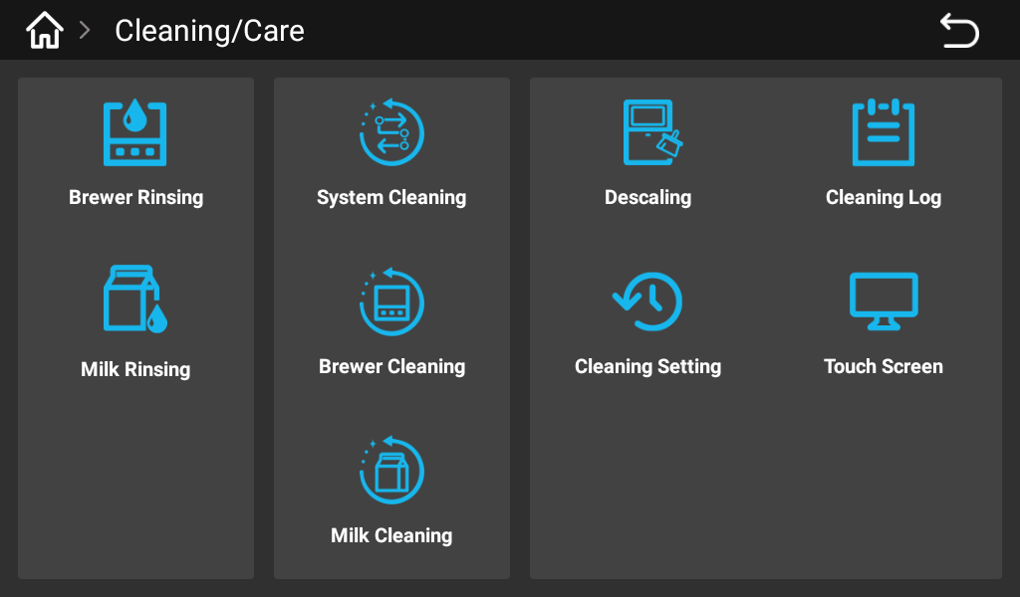
ES brewer flushing

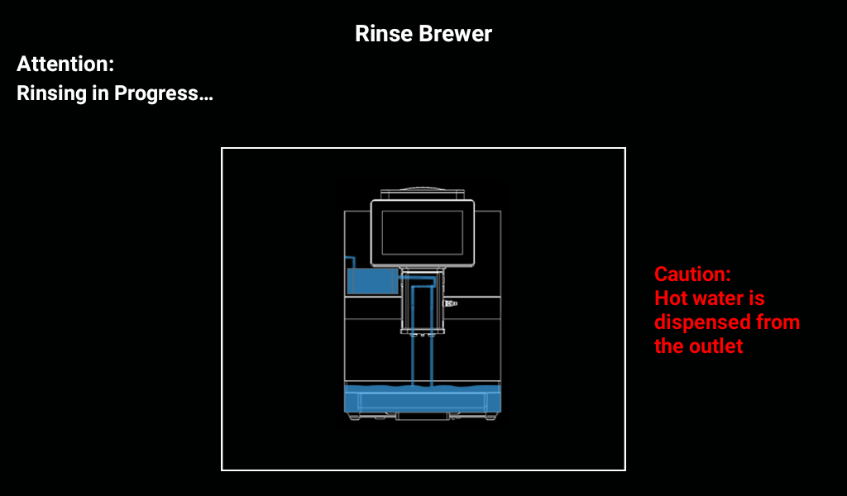
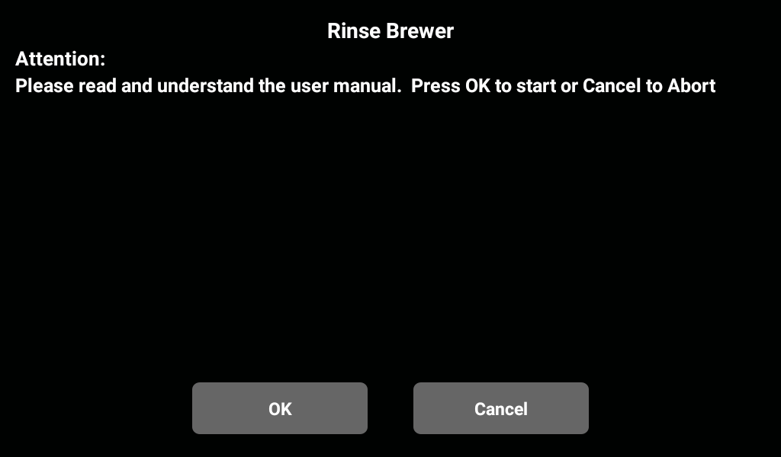
Enter the background of the machine, click the "Cleaning and maintenance" button, and select "ES brewer rinse" in the pop-up interface.

In the pop-up box there are two keys "confirm or cancel", click "confirm" to execute the first program, click "cancel" to return to the menu bar of the previous layer; Select the "OK" button until the ES brewer flush procedure is complete.

Milk Route Rinse

Enter the background of the machine, click the "cleaning and maintenance" button, in the pop-up interface, select "milk road flushing".
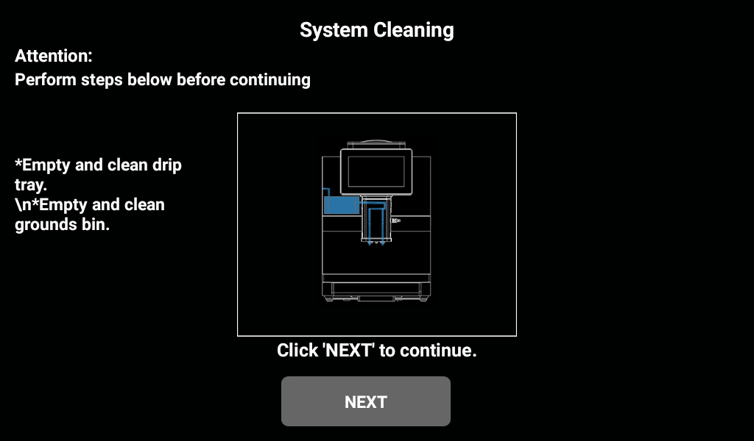
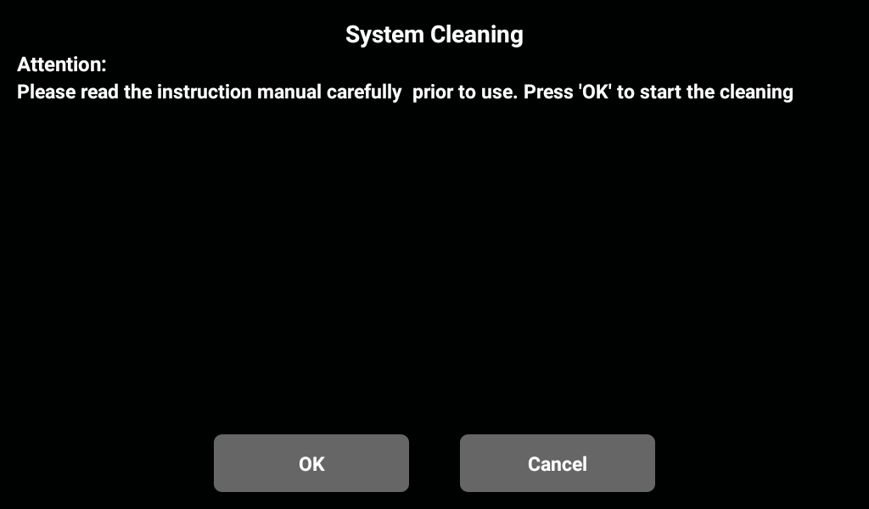

There are two keys of "Confirm or cancel" in the pop-up matching box. Click "Confirm" to execute the flushing program, and click "Cancel" to return to the menu bar of the previous layer; Select the "OK" button until the milk circuit system flushing program is finished.

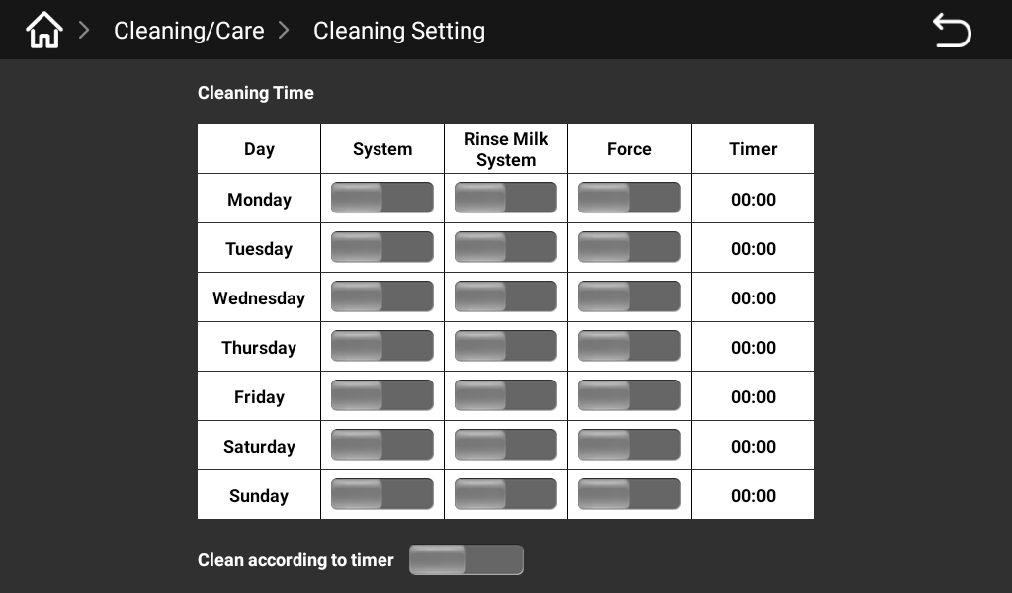
Automatic flushing Settings
.

Go to the background of the machine, clean/maintain, set the automatic Cleaning Settings, Monday to Sunday, set the automatic cleaning time at a certain time every day.

Cleaning Agent
Cleaning agents can cause poisoning!
Only use cleaners recommended by the manufacturer of the device.
The cleaner should be kept away from children.
Do not eat or touch the detergent with your hands.
Read the instructions and safety data sheet on the package carefully before using the detergent. If a safety data sheet is not provided, ask the distributor for it.

Using the wrong cleaner can damage the machine!
Use only manufacturer's recommended cleaners for daily and weekly cleaning.

Cleaning tablets "URNEX"
Messages
 | use | Coffee machine system cleaning
 |   Purpose of cleaning | Remove grease residue from the coffee system
 | Use spacers | Daily
There is a risk of burns. When the machine is rinsing, hot water is discharged from the mouth of the drink.
Do not reach under the outlet while the machine is rinsing.

Daily machine cleaning

Display to guide the cleaning routine
Preparation - Utensils needed for cleaning.
Coffee system cleaning tablet [1 tablet].
Household detergent.
Clean kitchen cleaning towel [2 pieces]
Collection container
Start a cleaning program
Cleaning agents can cause poisoning. Cleaning machine parts can cause poisoning when contaminated with cleaning agents
May cause harm to physical health.
Please wear gloves during the cleaning procedure.

High temperature liquid will be output during the cleaning procedure. Do not extend your hand to the stream outlet position during cleaning
Below, or there is a risk of burns.

Obstructed drainage of waste water will result in overflow of the water tray.
Check the waste water outlet of the catchment pan before the cleaning procedure begins.
The cleaning procedure can be interrupted at any time. After the cleaning is interrupted, the coffee machine is not in a state of operational readiness. The cleaning program forcibly shuts down. Restart the interrupted cleaning program as soon as possible.
Start the cleaning program in the maintenance menu. The touch screen will guide the user through all the necessary operations.

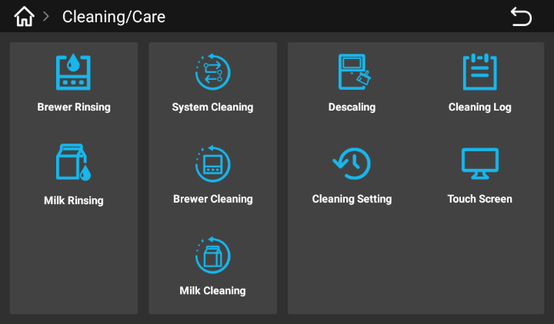
System cleaning

Enter the machine background - click "Cleaning/Maintenance" - "System cleaning"; In the pop-up dialog box, select [OK] to go to the next step, select [Cancel] to return to the menu of the previous layer; Click [OK] to go to the next step.

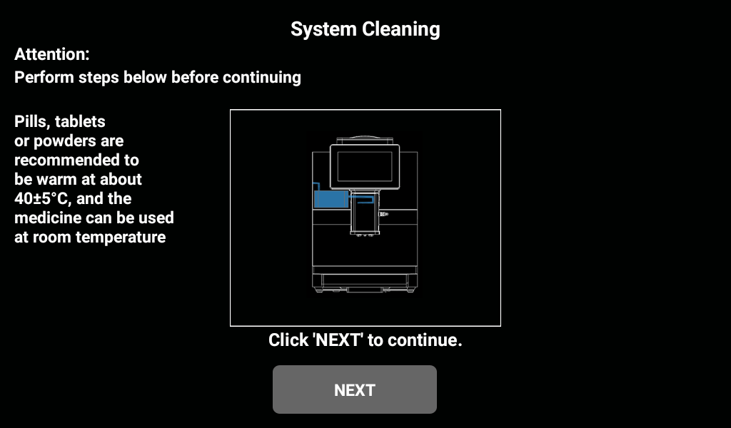

Draw out the water tray and empty the water in the tray; Pull out the coffee grounds pail and empty the coffee grounds pail. Remove the tank and fill it with water;
Take out the milk tube, put it into a clean box (milk road cleaning box), add 500ml water, and put in the cleaning tablet; Put a water container under the mouth of the drink and click [Next].


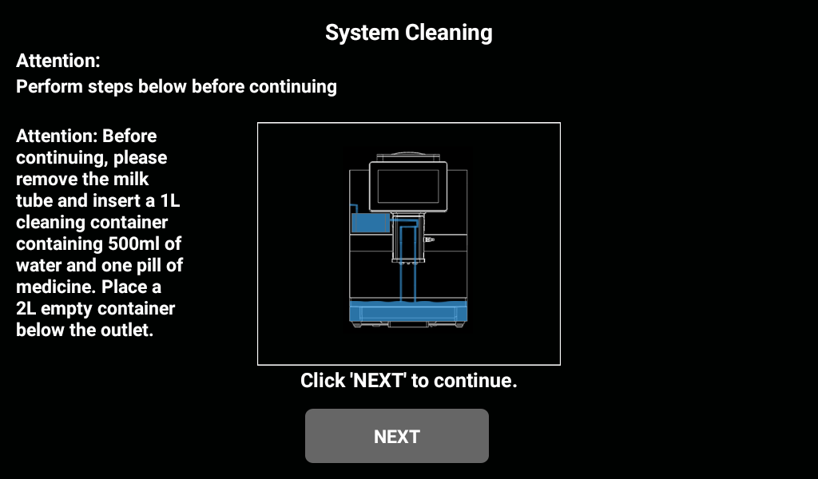

Put the ES brewer cleaning tablet - top of the machine, open the door, put the cleaning tablet in the brewing chamber, close the door and click "Next"

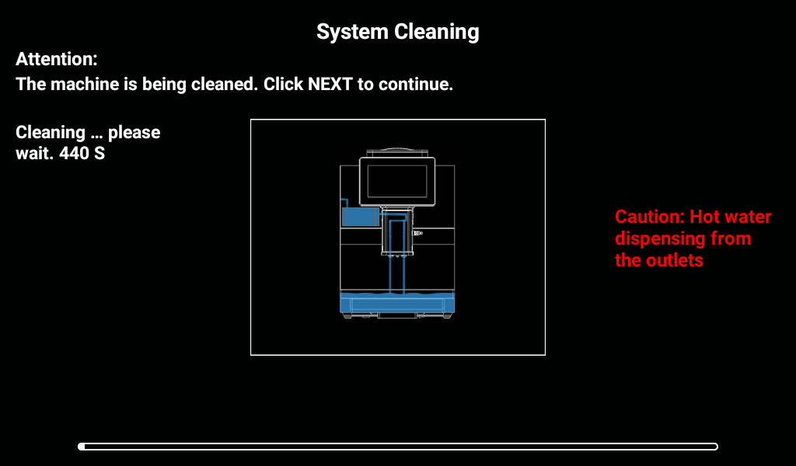

The cleaning tablet is dissolving the water, please wait... ; Tablet dissolve time to program automatic execution cleaning, cleaning in... Please wait a moment.

Empty clean pill box and clean Add 500ml warm water and click [NEXT]

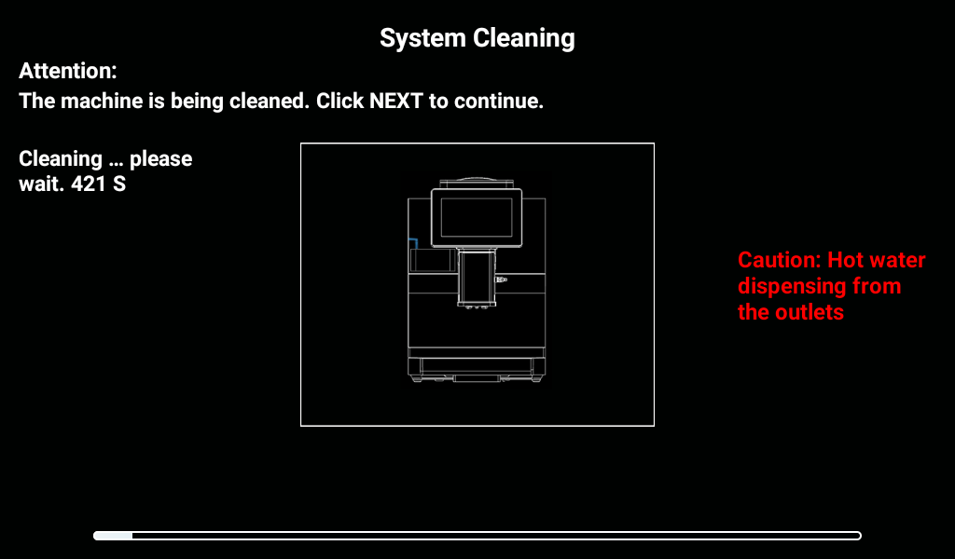

The machine is cleaning automatically, please wait... When the water runs out and the time is up, take out the cleaning box and put the milk carton in the refrigerator. Insert the milk tube into the carton and close the refrigerator door. Click "OK".

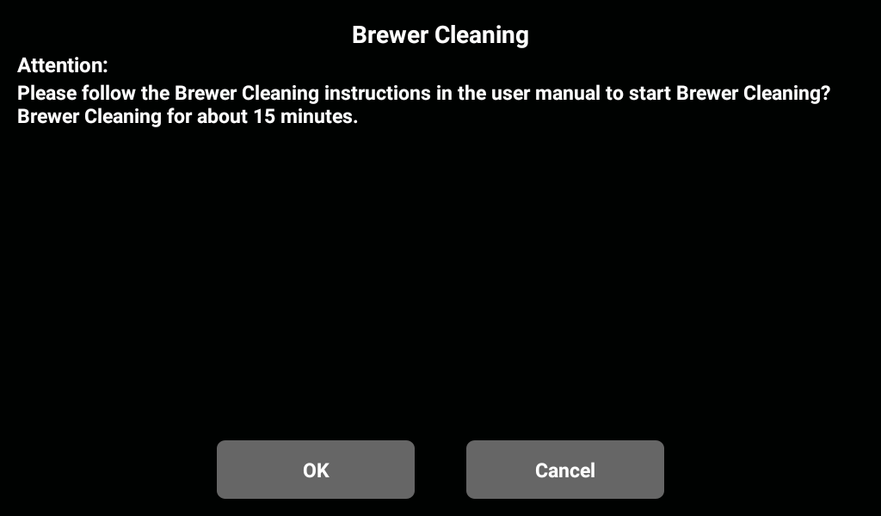
ES brewer cleaning

Enter the machine background - click "Clean/Maintain" - "ES brewer Clean"; In the pop-up dialog box, select [OK] to proceed to the next step, select [Cancel] to return to the menu of the previous layer; Click [OK] to go to the next step.
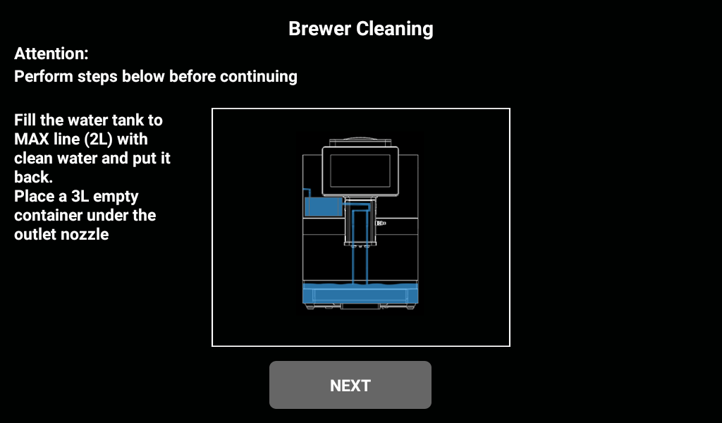
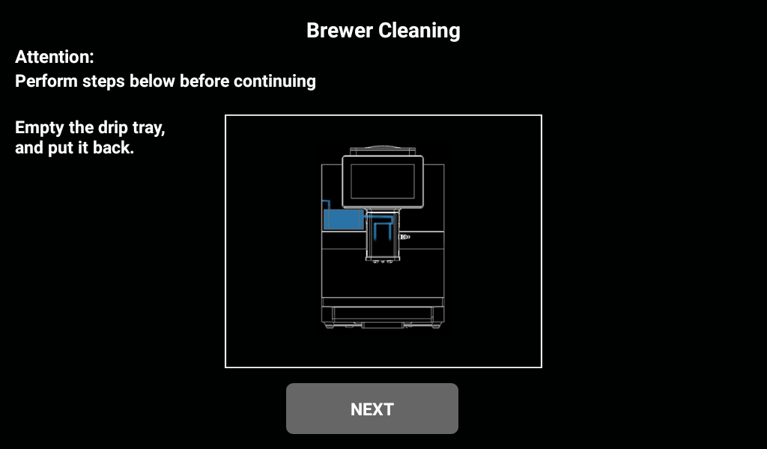

Take out the water tray, empty the water tray, if the water tray has waste water discharge function, empty the waste water bucket; Fill the tank to the maximum water level and place a 2L container under the outlet. Click "Next".
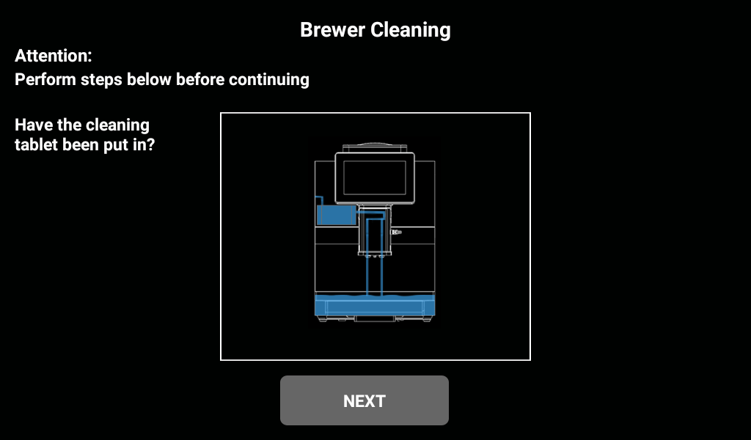
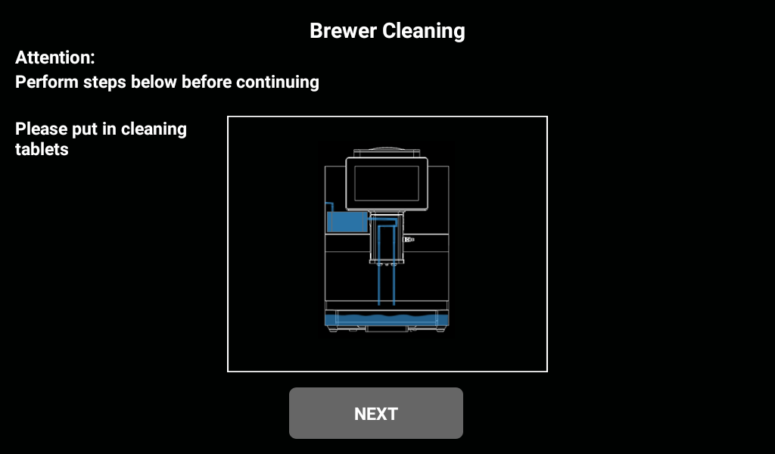
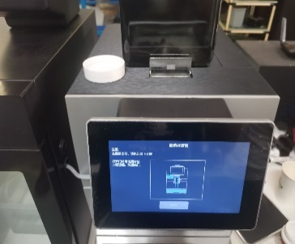

Top of the machine, open the door, put the coffee cleaner in the brewing bin, close the door; Confirm whether the cleaning tablets have been put in, after putting in, click "NEXT".
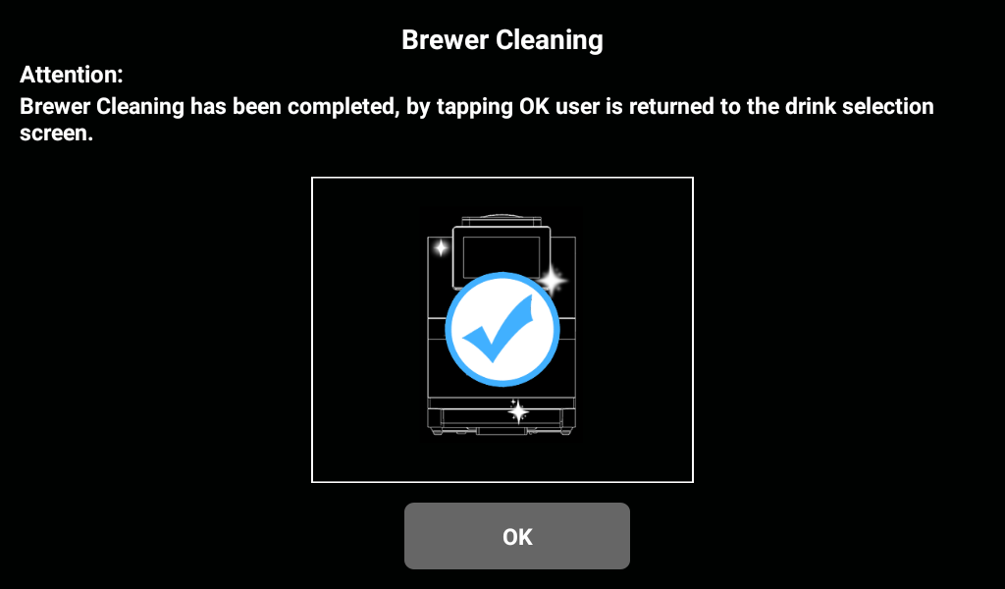
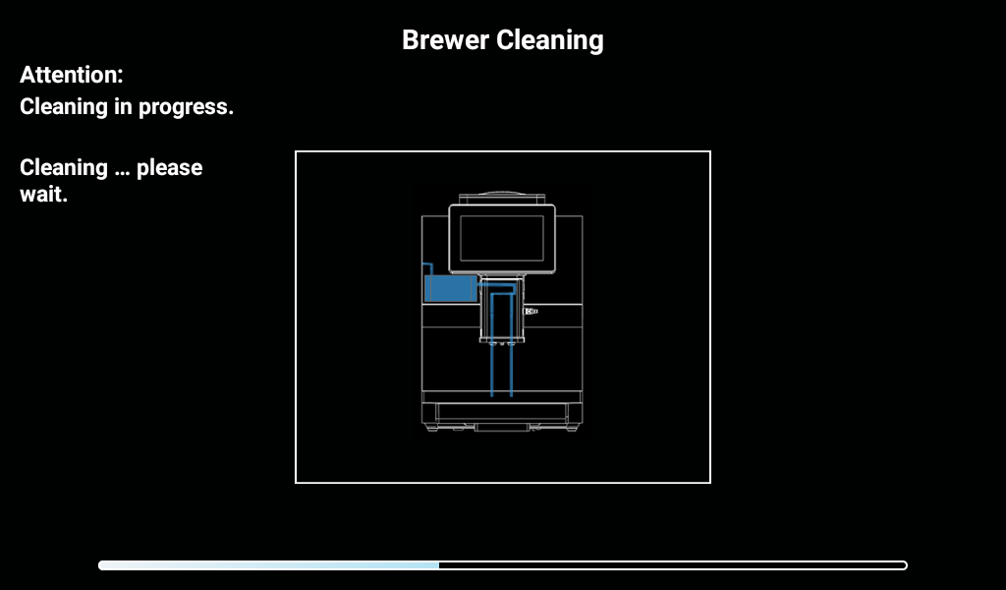

The machine performs ES brewer cleaning procedures. The ES brewer cleaning time takes about 15 minutes to complete, wait patiently until the program is over, the interface prompts: "ES brewer cleaning is completed, click OK to return the user to the beverage selection screen"; Click "OK" to return to the drink screen.

Milk Path Cleaning
Clean daily, put the fresh milk system cleaning agent into the cleaning box, the recommended cleaning frequency is once a day. According to the amount of cleaning agent and water, the proportion of the corresponding solution, the milk tube into the cleaning box.
Pills
RINZA® M61 TABLETS Milk stain cleaning tablets

- RINZA's innovative product for milk cleaning: Milk stain tablets.
- The tablets dissolve quickly in warm or cold water.
- Contains cationic surfactants to improve the safety and strength of cleaning.
- Safe, simple cleaning, improve transportation efficiency, reduce transportation costs.
- Ratio: 1 tablet to 250ml water.
- Product specification: 4g/ tablet 120 tablets/bottle 12 bottles/case

Enter the background of the machine - click "Cleaning/maintenance" - "Milk Road Cleaning"; In the pop-up dialog box, select [OK] to go to the next step, select [Cancel] to return to the menu of the previous layer; Click [OK] to go to the next step.

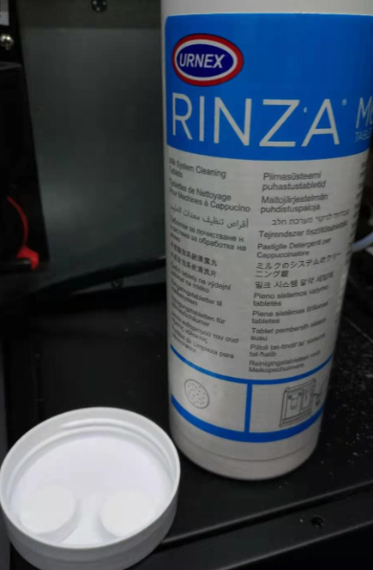
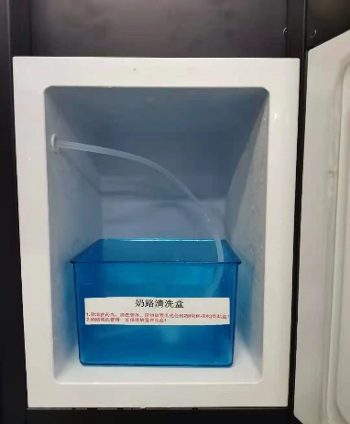

Get 1 or 2 Rinza milk cleaning tablets; Drop the tablets into the cleaning box and fill with the appropriate amount of water; Open the refrigerator door, put the cleaning box in the refrigerator, take out the milk tube, insert it into the cleaning box, close the refrigerator door; Place the 1 lift container under the outlet mouth. Click "Next".

Machine is performing cleaning, detergent is dissolving, please wait... Machine is being cleaned, milk cleaning, please wait a moment......

Open the refrigerator door, take out the milk tube, empty the water in the cleaning box, and clean it, after cleaning, inject 500ml of water into the milk tube, and close the refrigerator door. Click on "Next". The machine is performing cleaning. The milk line is cleaning automatically, please wait...

When the screen prompts: "Please put the milk tube back in the milk crate", open the refrigerator door, put the milk tube back in the milk crate, and close the refrigerator door; Then click "Next" on the screen; The next interface shows, "milk road cleaning is finished, click OK to finish"; Click "OK" to return to the drink screen.

Clean the coffee grounds box
Coffee grounds in a coffee grounds box can easily lead to mold formation. If the plaque spreads to the machine, the coffee may become contaminated.
Therefore, the coffee grounds box must be cleaned daily.

High temperatures may cause damage.
Do not use the dishwasher to clean the coffee grounds box

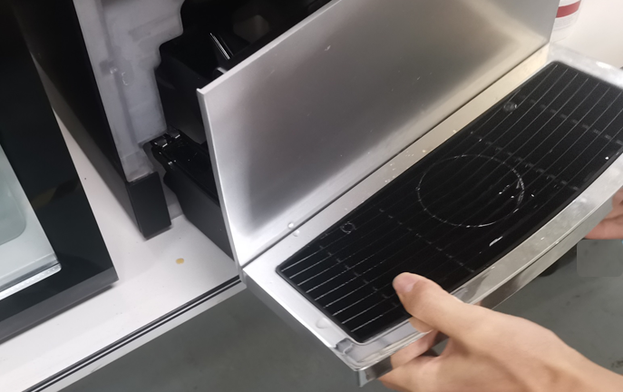
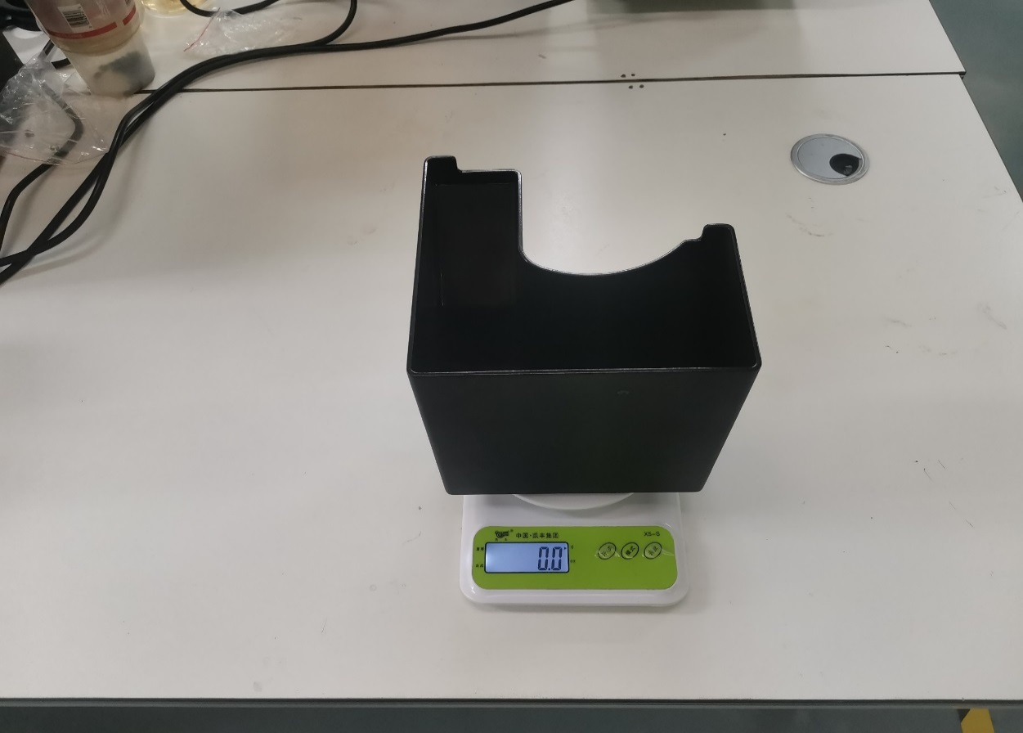

Coffee grounds box cleaning method:
- Pull the water tray out of the machine, remove the coffee grounds box, and dump the coffee grounds.
- Use clean water and household cleaner to thoroughly clean the coffee grounds box.
- Rinse with clean water and dry with a clean towel, load the coffee grounds box, and reload the machine.

Clean the water catch tray
Sediment and bacteria can contaminate the waste water tray.
Rinse and clean the waste water box daily.
Wear gloves when cleaning.
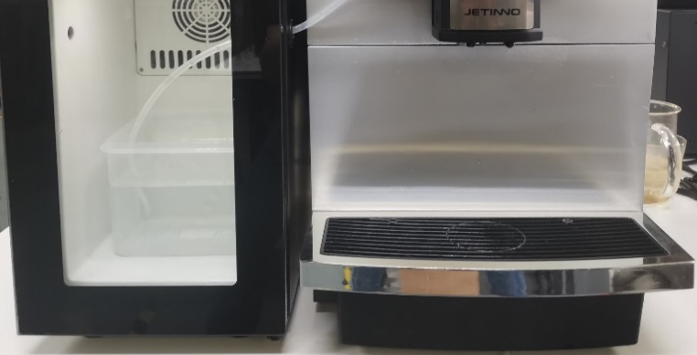 | Method of cleaning the water tray: Pull the water tray out of the machine.  - Use clean water and household cleaner and brush to thoroughly connect the water dish.  - Rinse with clean water and towel dry.  - Reinstall the dried catch pan into the machine and check to make sure it is pushed to the bottom.

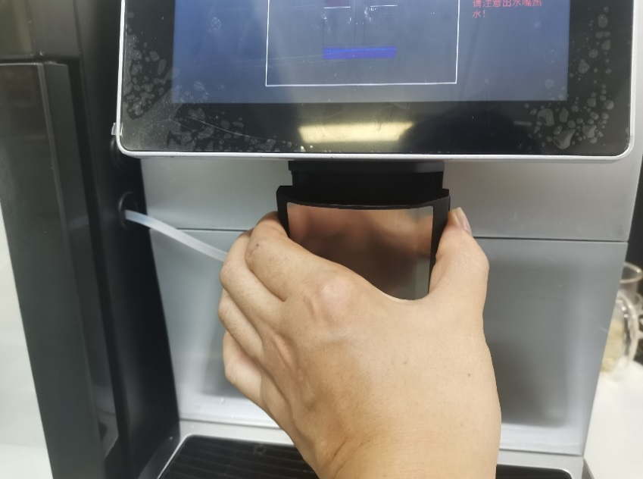
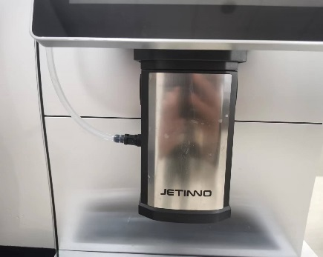
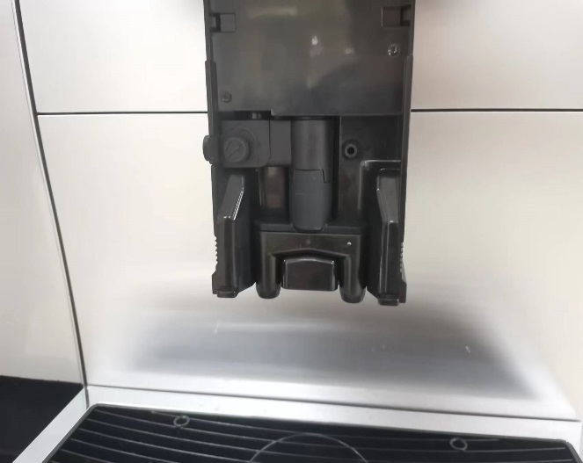
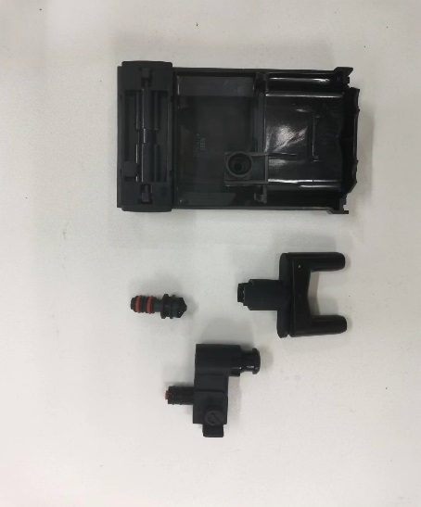
Clean the drink out of the mouth

First pull out the milk tube, hold down the buckle on both sides of the beverage outlet mouth, pull down hard, take off the steam nozzle, fresh milk heating chamber, fresh milk outlet mouth seal cover, fresh milk outlet mouth, coffee outlet mouth, rinse with water. Put back into the discharge nozzle to press to the bottom, and finally put the milk tube back.

Clean the touch screen
Unintentionally exporting drinks while cleaning can cause burns.
Lock the screen before cleaning; Turn off the machine before cleaning the operation panel.
Damage to the touch screen during cleaning.
The stain cannot be removed by grinding. Do not press the display with brute force, high pressure, or sharp objects.

Clean weekly

Clean coffee bean trough
The grinder's rotating grinding blade, the coffee bean groove opener blade, is sharp and poses an injury hazard
Do not put your hand into the coffee bean slot while the coffee machine is on. Wear gloves when cleaning.
Coffee bean grooves scratched.
Do not use the abrasive type of stain remover.

Empty waterways
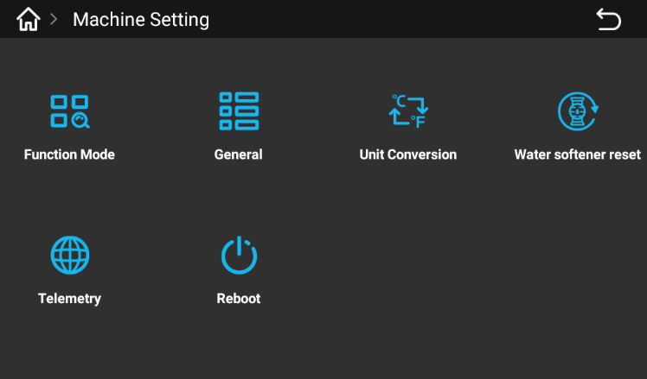

Enter the background of the machine, click "machine Settings", and click "Restart" in the pop-up interface. The next dialog box will pop up.
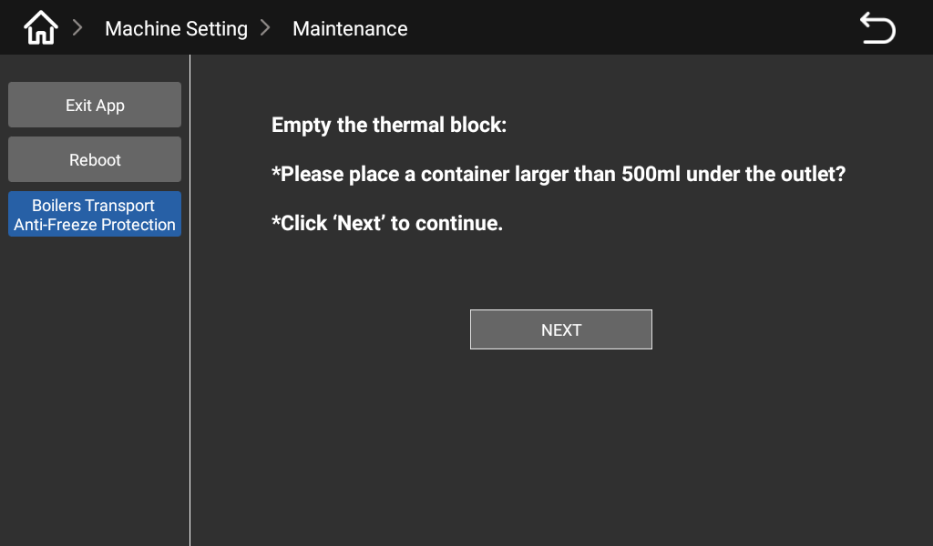
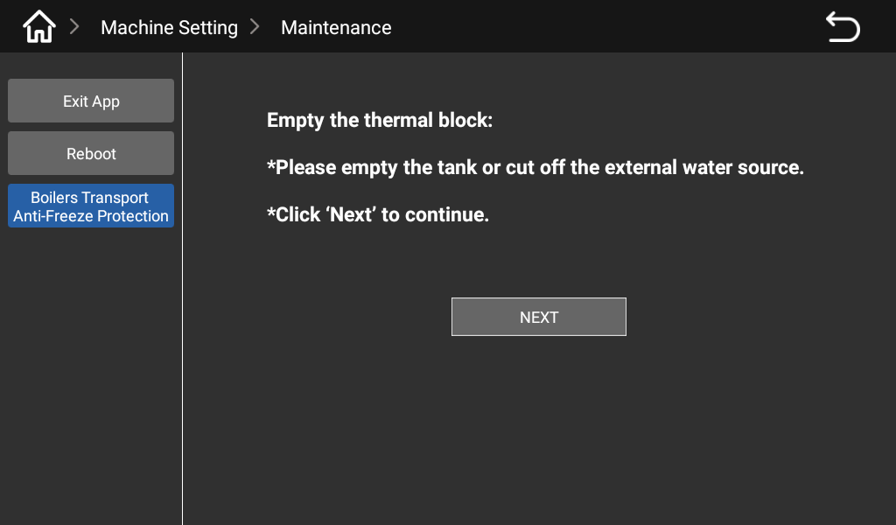

First click the "Boiler transport Antifreeze protection" button in the interface, follow the interface prompts to operate (empty the tank or cut off the external water source), and then click "Next" to pop up the next interface. According to the prompt, empty the drip tray and put it back, click "Next" to continue.
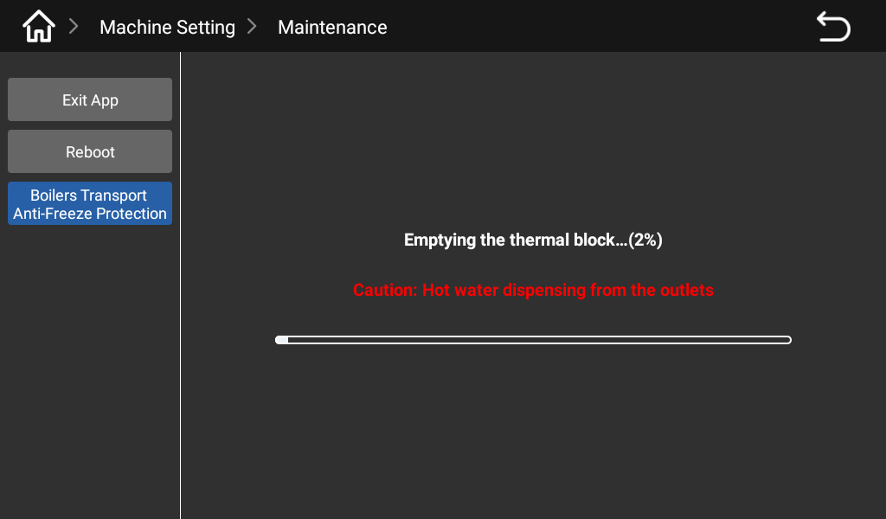

According to the prompts in the interface (place an empty container larger than 1L under the outlet), click "Next", the water drain starts, there is a progress bar in the interface, when the progress is completed, the interface will prompt: "Boiler empty is 100% complete", click the return button.

preventive measure

Cleanser

Use

Danger of poisoning from ingesting detergent.
Be sure to observe the following:
- Cleaning agent storage should be kept away from children and unauthorized persons.
- Do not ingest cleaning agents.
- Do not mix cleaning agents with other chemicals or acids.
- Do not add cleaning agent to the cup.
- Do not add cleaning agent to drinking tank (inside/outside).
- Cleaning agents and descaling agents should only be used for their stated purpose (see label).
- Do not eat or drink while using the cleaning agent.
- Good ventilation and venting must be ensured when using the cleaning agent.
- Protective gloves should be worn when using the cleaning agent.
- Safety goggles should be worn when using detergent.
- Wash your hands thoroughly immediately after applying the detergent.
Read the package instructions carefully before using the cleaner. If a safety data sheet is not provided, you can ask the distributor for it (see Packaging of the cleaner)

Storage
Be sure to observe the following:
- Keep out of reach of children and unauthorized persons.
- Keep away from heat, light and moisture.
- Store separately from acidic substances.
- Store in original packaging only.
- Store the cleaner separately.
- Do not store it with food or drinks.
- Comply with local laws regarding the storage of chemicals (detergents).

Disposal of waste
If recycling is not possible, the cleaner and its storage must be disposed of in accordance with local laws.

Health Regulations

water
The possible health hazards of not using water properly!
The water source must meet the sanitary standards for drinking water.
Be sure to observe the following points:
The water must be clean and pollution-free.
- Do not add seepage water or other corrosive water to the coffee maker.
- The carbonate hardness should not exceed 5-6 °DKH (German carbonate hardness) or 8.9-10.7°FKH (French carbonate hardness).
- The total hardness value must always be higher than the carbonate hardness.
- The minimum carbonate hardness is 5 °DKH or 8.9 °FKH.
- The maximum chlorine content is 50 mg per litre.
- PH 6.5-7 (pH neutral).
- Equipped with filters (internal & external) :

Coffee
Not using coffee properly could be taking a toll on your health!
Be sure to follow the following:
- Check the bag for damage before filling.
- Close the coffee bean tank top immediately after adding coffee beans.
- Coffee should be stored in a dry, cool and dark place.
- Coffee should be stored separately from cleansers.
- The earliest purchased product should be used first (" early in, early out ").
- The package should be sealed properly after opening to keep the product in the package fresh and prevent it from becoming contaminated.

Safety and quality assurance
The manufacturer does not accept any responsibility for damage that may occur to the coffee machine if the user does not follow the instructions for the use and installation of the machine.
Take care to follow the instructions.
The installation site should be kept dry and waterproof; It is strictly forbidden to use the machine in the open air; The machine can only be used for the specified raw material package; Other raw materials are regarded as abnormal use, resulting in damage, the manufacturer does not assume any responsibility.
8. Whether or not the Buyer is entitled to the warranty and what specific warranty rights the buyer may be entitled to depend on the agreement between the buyer and the seller. Failure to comply with the operating instructions forfeits warranty rights.
The warranty will not be fulfilled if:
- Natural wear and tear that occurs in all parts.
- 3. Machine defects caused by non-compliance with the operation, cleaning and maintenance regulations of the machine (such as operating instructions and cleaning and maintenance).
- Failure to use the original parts of the manufacturer or a third party, the wrong installation of the machine or careless use of the machine caused by defects.
- Machine defects caused by improper modification or repair of the machine by the user or a third party without our permission.
- Machine defects due to improper or incorrect use.

Problems(problems) | Possible causes: Possible causes. | A solution (solution)
Coffee exit flow rate is too slow | The coffee is ground too fine | Adjusting grinder
Coffee exit flow rate is too slow | The dose is much larger than intended | Recalibrate the grinder
Coffee exit flow rate is too slow | Strainer blocking | Tablet to clean ES brewer or replace strainer
Coffee exit flow rate is too slow | Leaks (lower plunger damaged) | Replace the plunger or ES brewer
Coffee exit flow rate is too slow | ES brewer O-ring leak | Replace the seal ring
Contaminated water tray | No cleaning for a long time | Clean the catch pan
Contaminated water tray | The outlet spout is not installed correctly | Check and reinstall
Coffee flows too fast | The coffee is ground too coarse | Adjusting grinder
Coffee flows too fast | The dose is not nearly as good as expected | Recalibrate or check the recipe Settings
Coffee or other related products prohibited | Coffee bean box feed stop plate closed | Check and open it
Coffee or other related products prohibited | Run out of coffee beans (through system detection) | Add coffee beans
Coffee or other related products prohibited | Missing ingredients associated with the product (fresh milk) | Check and add materials
Boiler filling failure | Prolonged machine shutdown and deactivation (water valve not open) | Turn on the water valve to restart the machine
Boiler filling failure | The first time the machine is used, there is air in the waterway system | Power off and try again to vent
The machine won't produce the QR code | Network signal difference | Change the signal connection and verify in the background that the machine is online and the server is connected
The machine won't produce the QR code | Antenna not connected | Contact carrier

List of frequently asked Questions

Certification
Meet the criteria:
IEC 60335-1:2010 + A1: 2013 + A2:2016
IEC 60335-2-75:2012 + A1:2015 + A2:2018
EN 60335-1:2012 + A11:2014 + A13:2017 + A1: 2019 + A14:2019 + A2:2019 + A15:2021
EN 60335-2-75:2004 + A1:2005 + A11:2006 + A2:2008 + A12:2010
EN 62233:2008
EN IEC 61000-6-1:2019
EN IEC 61000-6-3:21st/EN 301489-1 V2.2.3/ EN 301489-17 V3.2.4/ EN 300328-17 V2.2.2
EN IEC 62311:2020
IEC 62368-1:2014
EN 62368-1:2014 + A11: 2017
KN 32
KN 35
(KN 61000-4-2 , KN 61000-4-3 , KN 61000-4-4 , KN 61000-4-5 , KN 61000-4-6 , KN 61000-4-8 , KN 61000-4-11 )
KC 60335-1
KC 60335-2-75
Food Grade (KFDA)
Gti 60335-1-2015 TIPIEC 60335-1-2015
Ti, Ti, TIEC 60335-2-75-2013
Ti. 30804.6.1-2013(IEC 61000-6-1:2005)
Gti (IEC 61000-6-3 -- 2016
Ti. Ti. Ti. IEC 62321-1-2016
Ti. Ti. Ti. Ti. IEC 62321-2-2016
Ti. Ti. Ti. Ti. IEC 62321-3-1-2016
Ti, Ti, Ti, Ti. IEC 62321-4-2016 Ti, Ti
GB 4706.1-2005
GB 4706.72-2008
GB 4806-2016
CCC certification, currently there is no CCC certification for vending machines in the Chinese market, this product only does CQC certification. Jinuo intelligent provides the inspection report of the machine and related food contact parts.

